NOTICE OF OPPORTUNITY FOR PUBLIC COMMENT RELATED TO
PASSENGER FACILITY CHARGES
PFC Application 27-03-C-00-XNA

The Northwest Arkansas National Airport Authority (Authority) is providing an opportunity for public comment until October 14, 2026 on its proposed new Passenger Facility Charge (PFC) Application 27-03-C-00-XNA (PFC #3) for the Northwest Arkansas National Airport (Airport or XNA). PFC proceeds will be used to fund eligible project costs for certain projects at the Airport. This written notice is provided in accordance with requirements contained in Federal Aviation Regulation 49 CFR Part 158.24 Passenger Facility Charge. Accordingly, the Authority is providing the public with the following information regarding the proposed new PFC #3 application.

HISTORY OF THE PFC PROGRAM AT THE AIRPORT
The Airport has previously received approval from the FAA for one PFC application, as well as two amendments to the application dating back to 1998 totaling $119,872,895. The current amounts approved to be collected under all PFC applications are shown in Table 1. Since its inception, through June 30, 2026, the Airport has collected $69,292,116 in PFCs and PFC interest earnings and has $50,580,779 of PFC left to collect on its current PFC projects.
In addition, the Airport recently submitted a new PFC Application 26-02-C-00-XNA (PFC #2) and is awaiting its approval from the FAA. The recent PFC #2 application requested to Impose and Use a PFC totaling $13,222,187, which would increase the Airport’s total PFC collection authority for PFC applications #1 and #2 to $133,095,082. PFC #2 has an estimated PFC charge effective date of May 1, 2035, and an estimated charge expiration date of May 1, 2037.
DESCRIPTION OF PFC #3 PROJECTS PURSUANT TO SECTION 158.23 (a)(1)
As presented in Table 3, two new projects are proposed for PFC #3. In total, the Airport is seeking authority to impose and use $174,570,320 of PFCs in PFC #3. A summary of each new project proposed for PFC #3 is provided on Attachment A to this notice, including the project descriptions, need and justification, and a plan of funding.
PFC LEVEL, PROPOSED CHARGE EFFECTIVE DATES, ESTIMATED CHARGE EXPIRATION DATES, AND ESTIMATED TOTAL PFC REVENUE PURSUANT TO SECTION 158.23(a)(2)
Table 3 presents the forecasted PFC revenue collections at XNA and the estimated charge expiration date for PFC #3.
Based on the proposed new PFC #3 Application projects described previously, PFC 27-03-C-00-XNA will have the following characteristics:
- A PFC collection rate of $4.50.
- The total PFC authority to Impose and Use under the PFC #3 Application of $174,570,320, which would increase the Airport’s total PFC collection authority for PFC applications #1 through #3 to $307,665,402.
- Proposed charge effective date of May 1, 2037 (the month of the estimated charge expiration date for the last PFC application #2 (or upon expiration of collection of PFCs for currently approved applications, whichever comes first).
- Estimated charge expiration date of July 1 2057 (or until collected revenues plus interest thereon equal the allowable costs of the approved projects, as permitted by regulation).
These dates are estimated based on PFC collections and expenditures as of June 30, 2026; projections of future enplanements assuming a 2.5% growth in enplaned passengers after FY 2026; and a collection rate of 90% of enplaned passengers.

CLASS OF CARRIERS NOT REQUIRED TO COLLECT THE PFC PURSUANT TO SECTION 158.23(a)(3)
The Airport plans to request the exclusion of PFC collection from Nonscheduled/On-demand Air Carriers (ATCO) filing FAA Form 1800-3 and Commuters or Small Certified Air Carriers filing T-100 (CAC). The most recent official enplanement figures from the FAA, for the year-end December 31, 2025, show that the ATCO and CAC carriers enplaned 51 passengers, representing only 0.00% of total annual enplanements at the Airport. The known carriers in these classes in CY 2025 and its enplanement level consist of the following:
ATCO and CAC Carriers Enplaning Less than One Percent to Total Airport Enplanements
ATCO and CAC Carriers | CY 2025 Enplanements
Cobalt Air LLC (6CBA) | 5
Talon Air LLC (OZTA) | 4
CFM Inc. D/B/A Contour Airlines (LF#) | 42
TOTAL | 51
CY 2024 Total Airport Enplanements | 1,234,923
Percent of Total | 0.004%
Source: FAA, CY 2025.
As shown above, the number of passengers enplaned annually by these classes of carriers represents an amount less than one percent (1%) of the total enplaned passengers at XNA. In accordance with 14 CFR § 158.11, this class of air carriers may be requested to be exempted based on their enplanement levels and cost to the Airport to collect PFCs from this class of air carriers.
* * * * *
As required under 14 CFR Section 158.24, the Authority will be accepting public comments on the proposed new PFC Application 27-03-C-00-XNA up to October 14, 2026, which is at least thirty (30) days after the date of posting of this Notice on our website. Any comments or questions should be sent to:

Ashton Collier
Chief Financial Officer
Northwest Arkansas National Airport
Ashton.Collier@flyxna.com
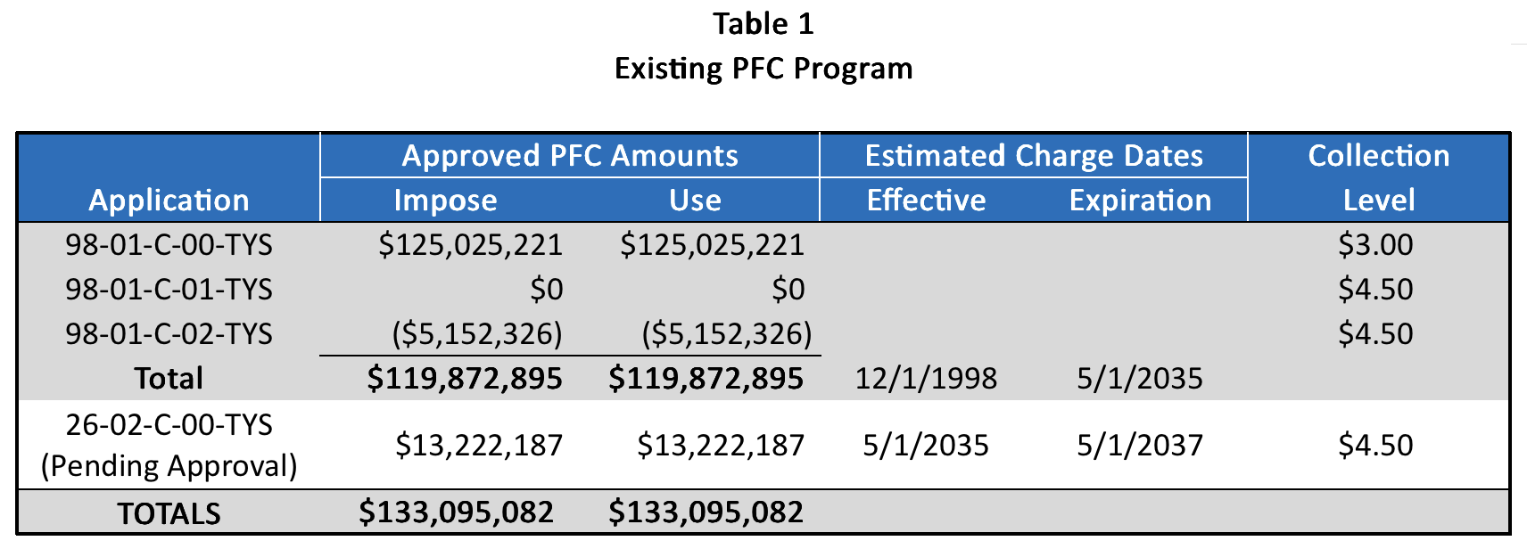

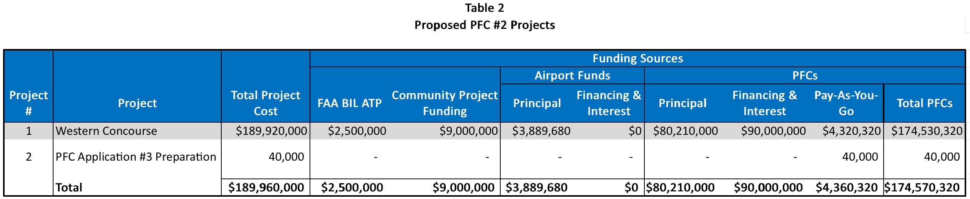
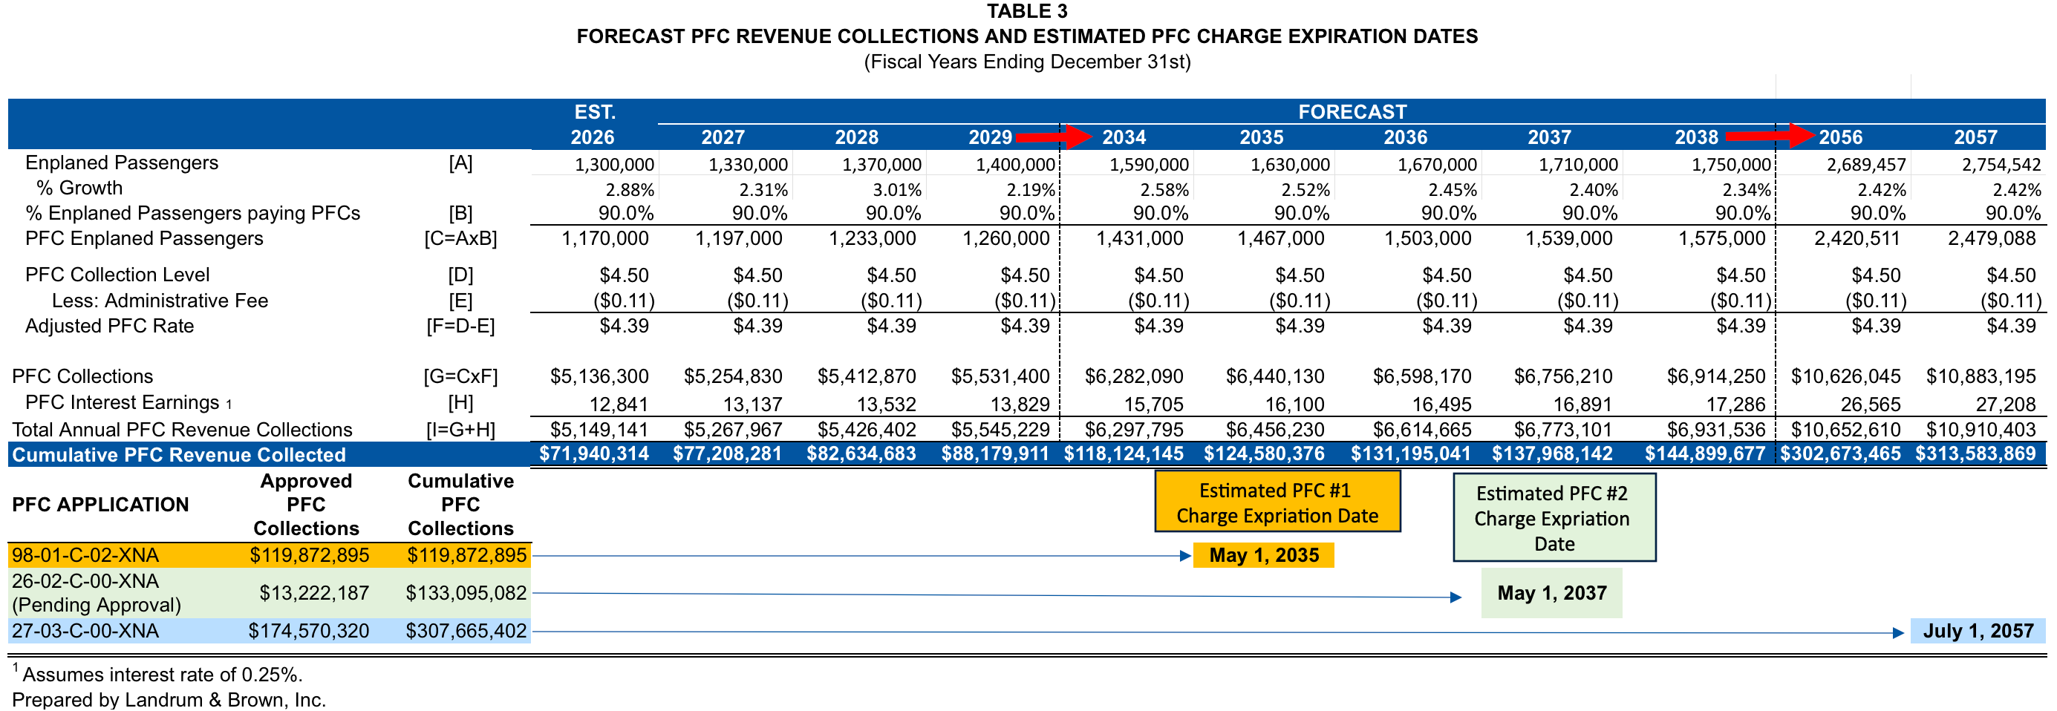

ATTACHMENT A
PFC 27-03-C-00-XNA
PROJECT DESCRIPTIONS, JUSTIFICATIONS AND OBJECTIVES

PROJECT #1 – Western Concourse
PFC Amount: $174,530,320
Project Description:
The existing passenger terminal at Northwest Arkansas National Airport (XNA) was originally constructed in 1998 with aircraft gates and passenger boarding bridges serving the main terminal building. In 2011, the terminal configuration was expanded with the opening of Concourse A. Today, the majority of commercial aircraft operations are accommodated at Concourse A, while a smaller number of aircraft utilize the B and C gate areas and require passengers to access aircraft from the ground level via walkways, and these gates are rarely used.
XNA currently has 14 aircraft gates (excluding the ground loading C gates). Concourse A provides ten (12) aircraft gates equipped with passenger boarding bridges, along with passenger holdroom areas, public restrooms, and the primary terminal concessions area. Two (2) additional B-gates with passenger boarding bridges were subsequently constructed on the west side of the terminal’s second floor. The existing C-gates are located below the B-gates and share a departure lounge and gate podium area. These gates require passengers to access aircraft from the apron using ground-level walkways.
The Western Concourse Expansion Project will replace the existing B-gate and C-gate facilities and associated airfield infrastructure with a modern, two-level passenger concourse designed to substantially improve passenger circulation, boarding operations, amenities, and overall terminal capacity. The project will provide seven (7) new narrow-body, Design Group III aircraft gates at opening, representing a net increase of five (5) gates compared with the existing facilities being replaced. The concourse will also be configured to allow for future expansion to accommodate up to twelve (12) aircraft gates as passenger demand increases.
The new Western Concourse will provide approximately 111,000 square feet of modern passenger terminal facilities, including:
- Seven (7) narrow-body aircraft gates, with new jet bridges, each designed to accommodate Design Group III aircraft, representing a net increase of five (5) gates.
- Approximately 23,500 square feet of passenger holdroom space, including passenger seating, airline podiums, and associated passenger information and screening elements.
- A 3,400-square-foot mezzanine level providing additional passenger seating and quiet rooms.
- Approximately 6,000 square feet of concessions space, including a restaurant, bar, news and gift shop, and coffee shop, providing passengers with additional food, beverage, and retail options.
- Three public restroom areas, including family restrooms and a mothers’ room.
- Public corridors and an atrium area supporting improved passenger circulation throughout the concourse.
- Approximately 3,300 square feet of airline support space to support airline operations.
- Approximately 15,000 square feet of storm shelter and corridor space providing required life-safety and passenger circulation functions.
- Associated janitorial, storage, mechanical, and electrical spaces necessary to support the new concourse as well as the furnishings, fixtures, lighting, and equipment necessary to support the operation of the new concourse.
The project will replace aging and operationally constrained gate facilities with a modern passenger concourse that provides improved passenger amenities, increased aircraft gate capacity, enhanced passenger circulation, and more efficient aircraft boarding operations. The project will also reduce the reliance on ground-level passenger boarding and aircraft stairs associated with the existing C-gate facilities and provide additional passenger amenities and concessions consistent with the needs of a growing commercial service airport.
The Western Concourse Expansion will provide XNA with the capacity and facilities necessary to accommodate current and forecast passenger demand while establishing a flexible platform for future expansion. The project will enhance the overall passenger experience, improve the efficiency and functionality of terminal operations, and provide larger aircraft gates, passenger holdrooms, and circulation areas capable of supporting the Airport’s long-term commercial aviation needs.
Project Justification:
The proposed Western Concourse project is needed to accommodate significant and sustained growth in passenger demand at XNA, address deficiencies in the Airport’s existing passenger terminal facilities, and provide aircraft gate and passenger processing facilities that are appropriately sized for the aircraft currently serving and expected to serve the Airport.
From 2015 through 2025, XNA’s annual enplaned passengers increased from 649,741 to a record 1,263,634, representing a compound annual growth rate of approximately 7.0 percent. Passenger growth has continued into 2026. Through the first six months of 2026, XNA recorded 630,275 enplanements, an increase of 31,740 passengers, or 5.3 percent, compared with 598,535 enplanements during the first half of 2025. Based on this continued growth, annual passenger activity is expected to remain at or above the levels anticipated in the Airport’s Terminal Area Plan (TAP).
In addition to passenger growth, the aircraft fleet serving XNA has changed significantly. Over the past decade, air carriers have increasingly replaced smaller 50- to 70-seat regional jets with larger and more fuel-efficient regional and narrow-body aircraft. The Airport’s June 2021 TAP, prepared by Mead & Hunt, anticipated that this trend would continue, with smaller regional aircraft being retired and replaced by larger 75- to 110-seat regional aircraft and 125- to 180-seat narrow-body aircraft. This fleet transition increases both the number of passengers that must be accommodated at individual gates and the amount of gate, holdroom, circulation, and boarding area required to provide efficient passenger service.
The existing Concourse A facilities were originally planned around the operational characteristics and passenger loads of smaller regional aircraft. As a result, the concourse has significant limitations when accommodating the larger aircraft now being introduced into the XNA fleet mix. The existing gates have limited gate frontage and undersized departure holdrooms, and the spacing between boarding bridges was originally established based on the wingspans of regional jet aircraft without winglets. These conditions restrict the ability of the existing gates to efficiently accommodate larger narrow-body aircraft and limit the Airport’s flexibility to respond to airline fleet changes and passenger demand.
The existing holdrooms also provide insufficient seating and circulation space for the larger aircraft serving XNA. Each A-gate has a designated holdroom; however, the usable seating area is constrained by the approximately 700 square feet occupied by gate podiums and backscreens at each gate, leaving approximately 1,150 square feet for passenger seating and associated holdroom functions. Further expansion of the holdrooms within the existing concourse is constrained by the physical configuration of the facility. The approximately 75-foot-wide concourse was originally configured to accommodate the passenger loads associated with regional jet aircraft and provides limited opportunity to expand seating and circulation areas to accommodate larger aircraft.

Additional physical constraints prevent efficient sharing of passenger space between certain gates. The separation between gates A1 and A2 and holdrooms A4 through A11 limits the ability of adjacent holdrooms to share available space. Similarly, the change in floor elevation between A3 and the A5 area physically separates A3 from holdrooms A4 through A11. Consequently, passenger holdroom and circulation areas can become congested when multiple departures are operating simultaneously, particularly at gates A4 through A6, despite the fact that the overall concourse contains sufficient gross floor area.
These deficiencies are becoming increasingly significant as passenger volumes grow and larger aircraft become a greater portion of the XNA fleet mix. The limitations of the existing concourse reduce the Airport’s ability to accommodate larger aircraft efficiently, constrain airline scheduling and fleet flexibility, and create congestion in passenger holdroom and circulation areas during periods of concentrated activity. Without additional appropriately sized gates and passenger facilities, these conditions will become more pronounced as passenger demand continues to increase.
The Airport’s TAP evaluated future passenger and aircraft activity through a series of Planning Activity Levels (PALs). The TAP established the following enplaned passenger thresholds and corresponding aircraft gate requirements:
FORECAST AIRCRAFT GATE REQUIREMENTS BY PLANNING ACTIVITY LEVEL (PAL)
PAL | Enplaned Passenger Level | Aircraft Gate Requirements
I | 900,000 | 12
II | 1,100,000 | 14
III | 1,300,000 | 17
IV | 1,500,000 | 18
V | 1,700,000 | 19
Source: Terminal Area Plan, June 2021. Prepared by Mead & Hunt.

Actual passenger activity has significantly outpaced the TAP forecast. XNA recorded 1,263,634 enplanements in 2025, substantially exceeding the PAL II threshold of 1.1 million enplanements. Based on passenger activity through the first half of 2026 and the Airport’s continued growth, XNA is approaching the PAL III level of 1.3 million annual enplanements substantially earlier than anticipated in the TAP. The corresponding PAL III forecast identified a need for 17 aircraft gates.
The TAP therefore recommended expanding the Airport’s gate capacity and increasing the flexibility of the gate system to accommodate the transition toward larger aircraft. In particular, the TAP recommended that new gates in a Western Concourse be designed to accommodate Airport Design Group III (ADG III) aircraft. Providing gates capable of accommodating larger aircraft will allow airlines greater flexibility to adjust aircraft size in response to daily and seasonal peak demand, passenger growth, and changes in airline network schedules, while reducing the operational limitations associated with the existing regional-jet-oriented gate configuration.
The proposed Western Concourse directly addresses these identified deficiencies and forecasted capacity requirements. The new concourse will provide additional aircraft gates designed to accommodate ADG III aircraft, along with appropriately sized passenger holdrooms and circulation areas. The concourse will be double-loaded and approximately 100 to 120 feet wide, providing sufficient space for passenger circulation and holdroom functions associated with larger aircraft. The concourse will also be constructed with a full-story elevation above the aircraft apron, allowing for efficient boarding bridge configurations and improved passenger access between the terminal and aircraft.
The project will therefore provide capacity and functionality that cannot be efficiently achieved through continued reliance on the existing Concourse A facilities. By adding appropriately sized gates and passenger facilities, the Western Concourse will increase XNA’s ability to accommodate continued passenger growth, support the ongoing transition to larger aircraft, reduce passenger congestion, improve operational flexibility, and provide sufficient gate capacity to meet the Airport’s demonstrated and forecasted demand.
The substantial increase in passenger enplanements since the TAP was prepared, together with the continuing transition to larger aircraft and the documented limitations of the existing concourse, demonstrates a present and continuing need for additional passenger terminal capacity. The Western Concourse is a necessary component of the Airport’s program to provide adequate, efficient, and appropriately sized passenger facilities to accommodate current and future demand.
Project Objective:
The primary objective of this project is to enhance the capacity of the Airport and the national air transportation system. This will be achieved by increasing the capacity of aircraft gates and passenger holdrooms, as well as facilitating airline transitions to larger capacity aircraft. Additionally, the Western Concourse expansion project aims to improve the overall passenger experience at the Airport.

PROJECT #2 – PFC Application #3 Preparation
PFC Amount: $40,000
Project Description:
This project includes the costs to develop the proposed new PFC #3 application, consult with the airlines, provide for public comment, prepare and file Application No. 27-03-C-00-XNA, related attachments, and notify airlines of collection requirements.
Project Justification:
The preparation costs (as delineated in the description for this project) incurred to prepare the new PFC #3 application will be reimbursed under this project. These costs will be incurred in conjunction with the projects that are proposed for approval under either Section 158.15(b)(1), (b)(2), (b)(3), or (b)(6) of the Regulation. Therefore, the Airport submits these costs as reasonable and necessary costs of preparing the PFC program submitted under this Application as prescribed under Section 158.3 of the Regulation.
Project Objective:
This project recovers, as a separate project, the PFC application preparation costs (as described in the foregoing description) related to Project 1 included in this Application and, therefore, relies on the objectives that are described in those projects for PFC approval. Therefore, this project supports the objectives of enhancing capacity of the Airport and the national air transportation system pursuant to the objectives of Section 158.15(a)(1) of the Regulation.

