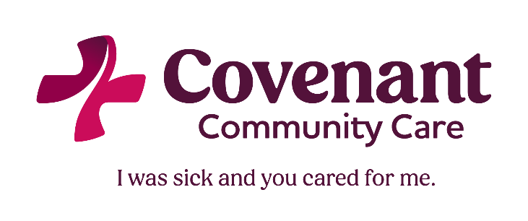

**Sliding Fee Discount Schedule: Medical & Counseling**

|  |  |  |  |  |
| --- | --- | --- | --- | --- |
| **SLIDE LEVEL** | **FEDERAL POVERTY LEVEL (FPL) RANGE** | **MEDICAL PER VISIT** | **INDIVIDUAL COUNSELING PER VISIT** | **GROUP COUNSELING PER VISIT** |
| **A** | Up to 100% of FPL | $20 | $20 | $5 |
| **B** | 101 – 150% of FPL | $30 | $30 | $10 |
| **C** | 151 – 175% of FPL | $40 | $40 | $15 |
| **D** | 176 – 200% of FPL | $50 | $50 | $20 |
| No sliding fee discount above 200% of FPL – please inquire about our prompt pay discount | | | | |

**Sliding Fee Discount Schedule: Dental**

|  |  |  |  |  |
| --- | --- | --- | --- | --- |
| **SLIDE LEVEL** | **TIER 1: Preventive Dentistry** | **TIER 1: Other Core Services** | **TIER 2: Additional Services** | **TIER 3: Elective Services** |
|  | **One fee per visit** | **One fee per procedure per visit\*** | **One fee per procedure per visit\*** | **One fee per procedure per visit\*** |
| **A** | $40 | $40 | $80 | $120 |
| **B** | $60 | $60 | $100 | $140 |
| **C** | $70 | $70 | $110 | $150 |
| **D** | $80 | $80 | $120 | $160 |
| **\* Some Procedures have an additional Lab/Material Fee – you may request a Treatment Plan explaining all costs prior to any non-preventative dental services** | | | | |

**Tier 1: Preventive Services:** Exams, x-rays, cleanings, fluoride treatments, and sealants

**Tier 1: Other Core Services:** Fillings, simple extractions, pulp capping & pulpotomy, denture adjustments & repairs, removal of space maintainers

**Tier 2: Additional Services:** Periodontal treatment, space maintainers, dentures, denture rebasing & relining, surgical extractions, other surgical procedures

**Tier 3: Elective Services:** Root canals, crowns, bridges, bleaching