Context
This toolkit is the product of a study commissioned by the Environment Agency Oxford to Cambridge team in 2023. It has been updated in January 2025 following changes to the National Planning Policy Framework.
The study was designed to support Local Planning Authorities to create and apply robust policies to support positive outcomes for the water system (flood risk, water resources, water quality and environment, and wastewater). Study outputs have been designed to help build capability and knowledge across our external partner organisations and beyond. This will help ensure that interventions are delivered in the right place at the right time to maximise opportunities for water alongside sustainable economic growth. The project explored how water is currently considered within policy and if local planning policy could better support positive outcomes for the water system.
The full suite of project outputs can be found on our website alongside our wider programme of works – www.oxcamlncp.org.

Purpose and scope
As part of this study the Environment Agency commissioned Eunomia Research & Consulting Ltd. (Eunomia) and Land Use Consultants Ltd. (LUC) to create a Planning and Water toolkit for use by Local Planning Authorities to maximise the potential of local planning for the water system.
The toolkit was intended to present the findings of the project in an actionable and accessible format to assist Local Planning Authorities in improving their approach to planning for water.
It should be noted that while the toolkit was prepared based on evidence gathered from across the Oxford to Cambridge geography we believe that it could be easily applied to other Local Authority areas across England. The following briefing material is designed to familiarise users with the basic functionality of the toolkit.
The toolkit covers both Policy Development and Development Management functions, split into nine sub-stages as indicated. It consists of a series of checklists and supporting resources for Local Planning Authorities to consider at each of these stages.

Policy Development | Development Management
Developing the evidence base | Pre-application
Engaging with stakeholders | Submission and validation
Drafting the plan and policies | Consultation
Examination | Determination
Monitoring and review

Navigating the toolkit
To begin you should use the ‘click here to get started’ button to navigate from the homepage to the toolkit contents page. From this page you can click to access the various sections of the toolkit.
Homepage:
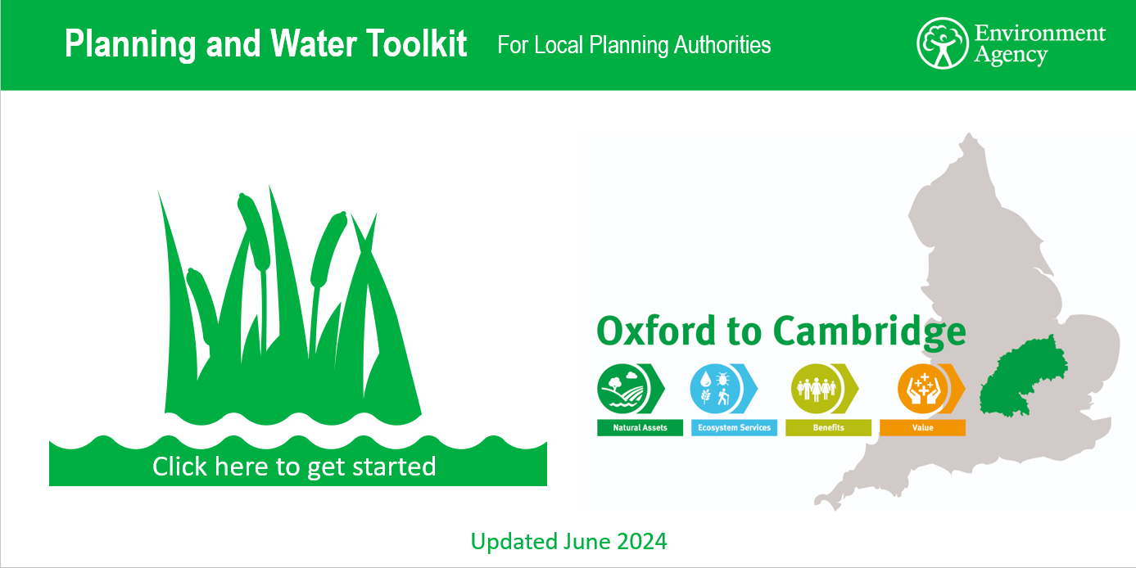
Contents page:
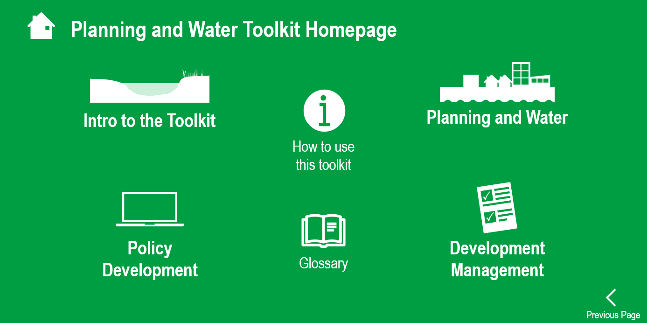

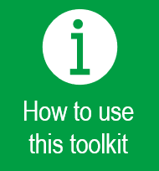 | This button will take you to a page which explains how to navigate the toolkit by clicking on links and buttons (rather than reading one page at a time). The toolkit is not intended to be used as a static document to be read through in its entirety.
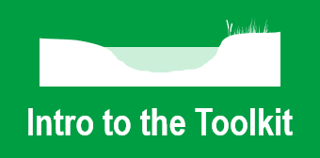 | This button will take you to the pages of the toolkit which explain the purpose and scope of the toolkit. The pages in this section introduce and define the four water disciplines which are used throughout. The introduction section also contains a page with links to allow you to download the checklists, technical notes, and pre-application guidance contained within the toolkit.
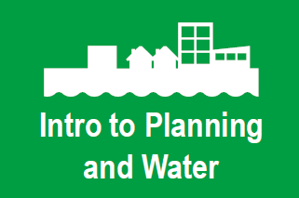 | This button will take you to the pages of the toolkit which provide background context to planning and the water environment. These pages summarise key policy and legislative documents and define and explain concepts used throughout the toolkit.
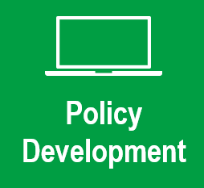 | This button will take you to the pages of the toolkit which are concerned with policy development.
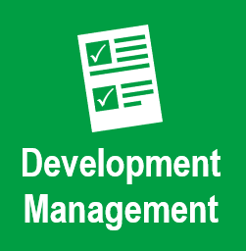 | This button will take you to the pages of the toolkit which are concerned with development management.
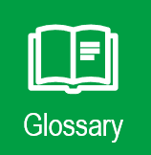 | This button will take you to the glossary where all terms and acronyms used are defined.

From any part of the toolkit you can select the home button to return to this contents page.

Policy development
When you select the policy development section of the toolkit you will reach this navigation page. This page outlines the process of policy development and divides toolkit content into five clear sub-stages involved in preparing a local plan.

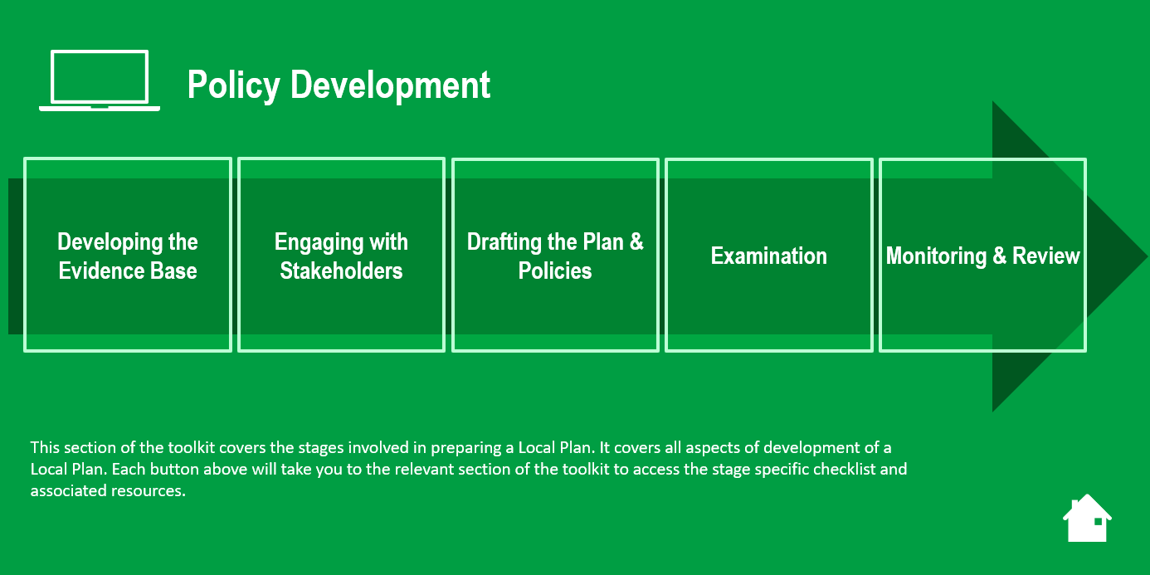

Selecting any one of these sub-stages will take you to the relevant section of the toolkit, starting with an overview of the content covered in the stage selected. The navigation bar down the left-hand side of the page (see circled area) can be used as a reminder of which part of the toolkit you are currently using.
Once you have selected the appropriate sub-stage, detailed information can be found by selecting either the ‘checklist’ or ‘resources’ button at the bottom of the page.
Example sub-stage page:
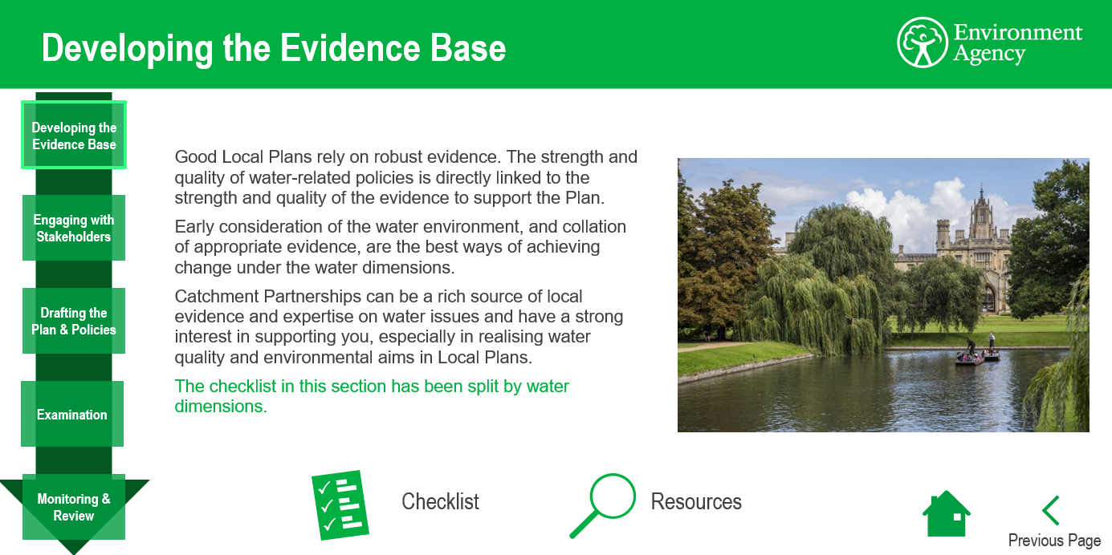

Example checklist page:
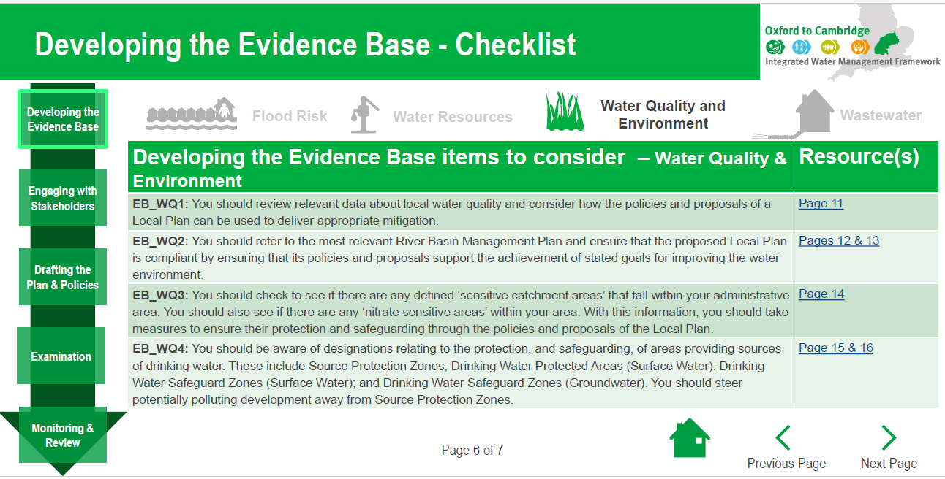

Where appropriate, information has been organised by water discipline for ease of navigation (this is indicated by the icons at the top of the screen).
The resources pages contain hyperlinks to further relevant information. Checklist and resources pages are cross referenced for ease of use. For example, when preparing appropriate evidence to support preparation of a local plan you can use the checklist page to determine the steps required and associated resources page to identify the relevant supporting information and guidance.
Example resources page:
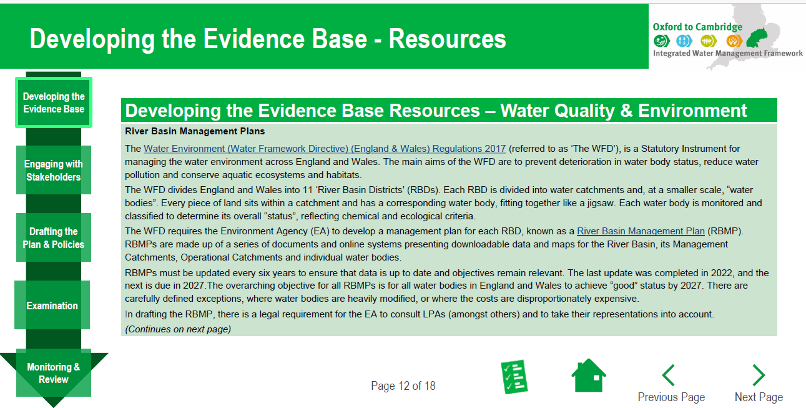

Development management
When you select the development management section of the toolkit you will reach this navigation page. This page outlines the process of development management and divides toolkit content into four clear sub-stages.

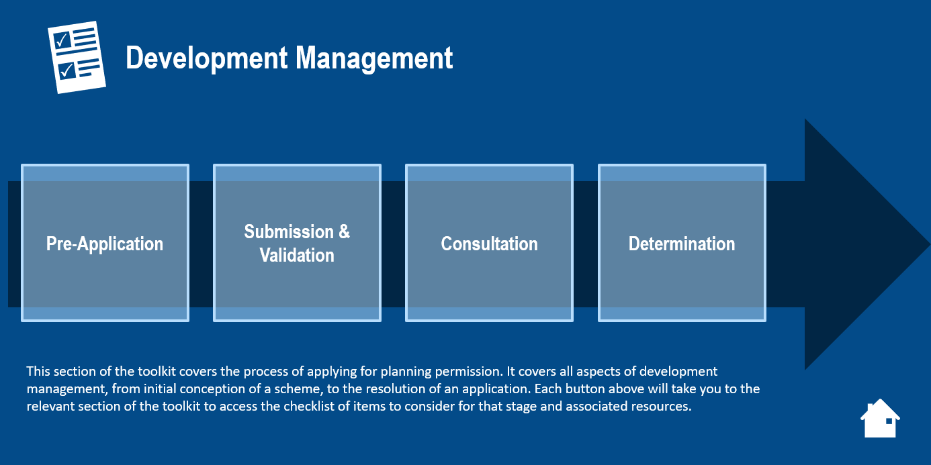

Selecting any one of these sub-stages will take you to the relevant section of the toolkit, starting with an overview of the content covered in the stage selected. The navigation bar down the left-hand side of the page (see circled area) can be used as a reminder of which part of the toolkit you are currently using.
Example sub-stage page:
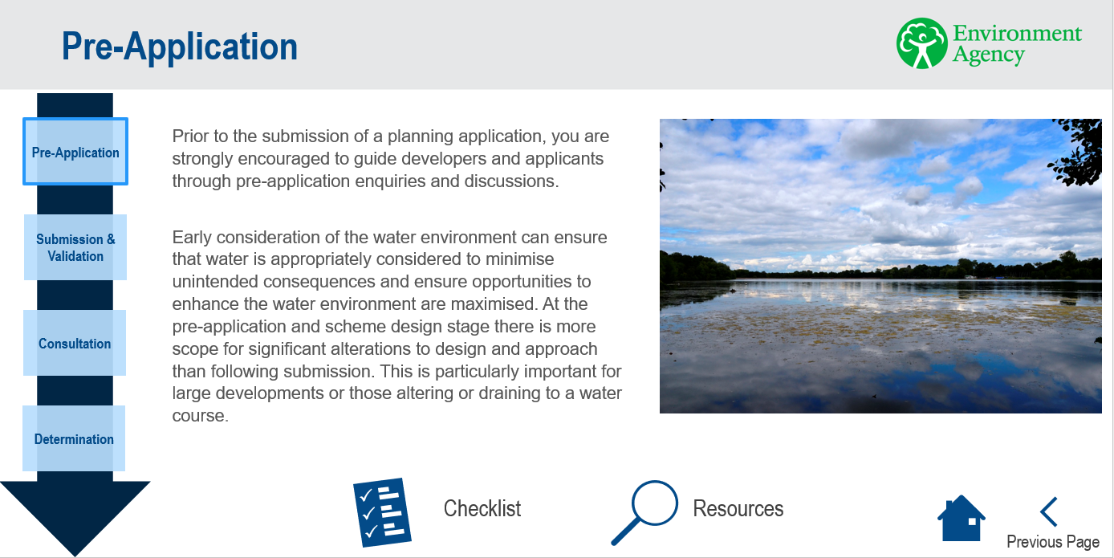

Once you have selected the appropriate sub-stage detailed information can be found by selecting either the ‘checklist’ or ‘resources’ button at the bottom of the page.
Example checklist page:
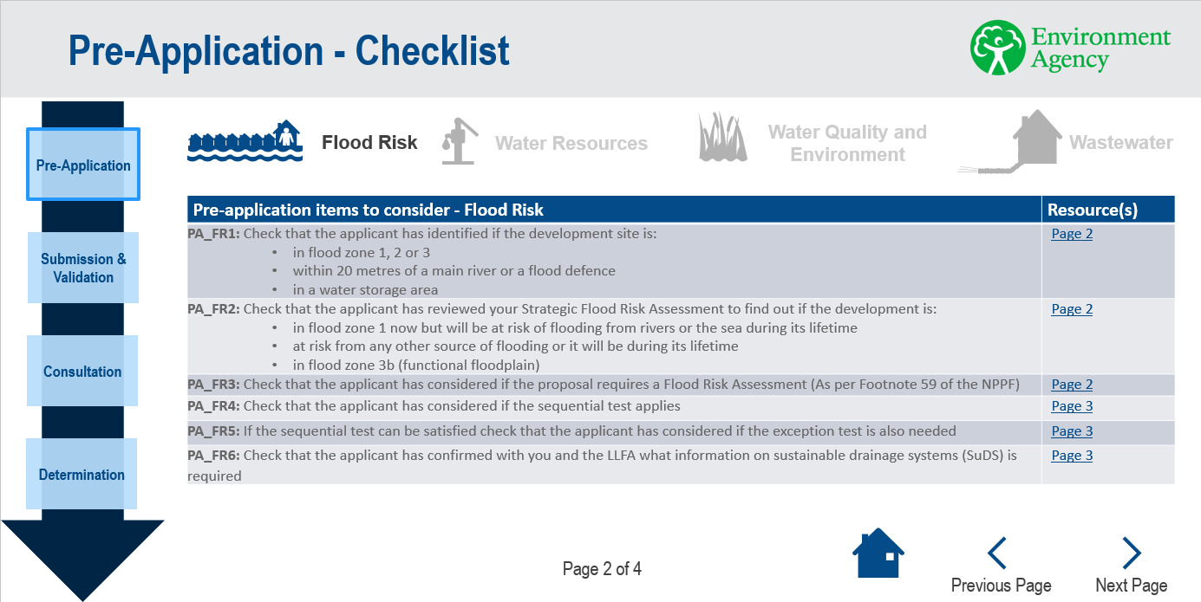

Where appropriate, information has been organised by water discipline for ease of navigation (this is indicated by the icons at the top of the screen).
The resources pages contain hyperlinks to further relevant information. Checklist and resources pages are cross referenced for ease of use. For example, when considering flood risk at pre-application stage you can consult the checklist to determine whether the applicant has considered the relevant factors as part of their application. You can then navigate to the resources page for further information on the relevant stakeholders and advice that can be drawn on when preparing their application. This advice can then be fed back to the applicant as applicable.
Example resources page:
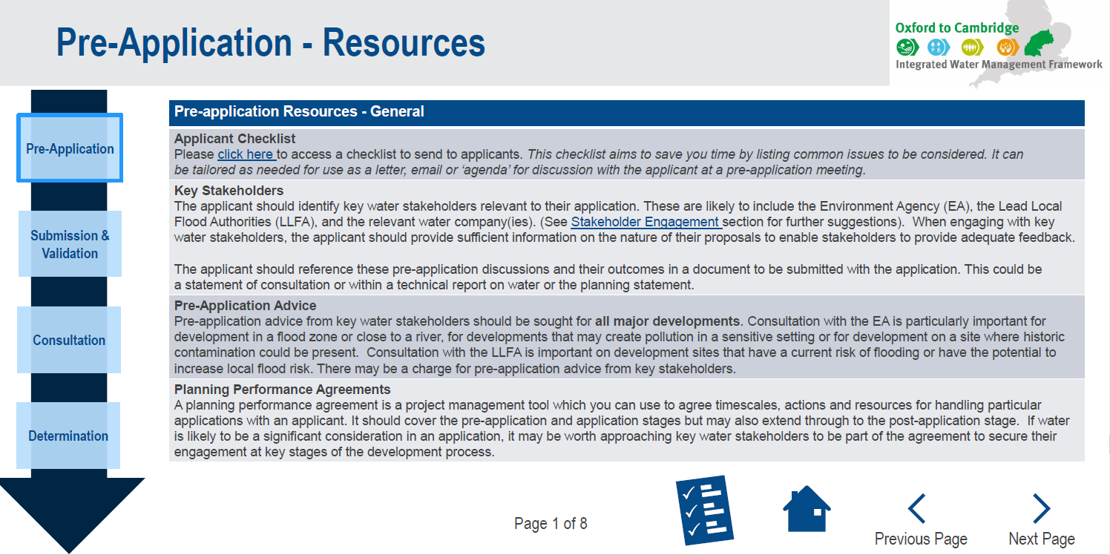

Downloads

Remember, navigating to the ‘intro to the toolkit’ page will allow you to download several helpful documents. These can also be accessed directly from the resources page on our website;
- Policy development checklist
- Development management checklist
- Water considerations guidance for applicants at the pre-application stage
- Conditions guidance
- Policy case studies technical note

Closing comments and links
Thank you for taking the time to familiarise yourself with the Planning and Water Toolkit. We hope it helps you to maximise the positive impacts of your work on our water systems and would welcome any feedback.
If you would like to find out more about the Oxford to Cambridge Team’s wider programme of works at the Environment Agency please visit our website – https://www.oxcamlncp.org/projects/integrated-water-management/home – or email ox.cam@environment-agency.gov.uk to subscribe for newsletter updates.

