SFMOMA AND MoAD ANNOUNCE THE APPOINTMENT OF
CORNELIA STOKES AS INAUGURAL ASSISTANT CURATOR OF THE ART OF THE AFRICAN DIASPORA

Stokes Will Work Across Both Institutions to Advance Scholarship and Public Engagement with Contemporary Art from the African Diaspora

Position Generously Supported by the KHR McNeely Family Foundation

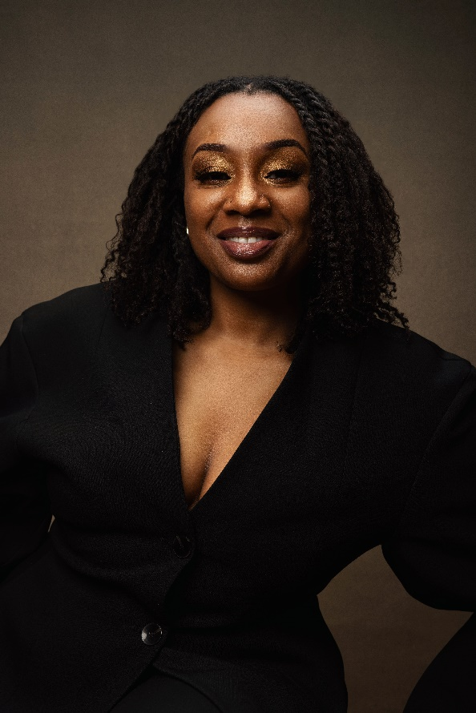

SAN FRANCISCO, CA (December 17, 2026)—The San Francisco Museum of Modern Art (SFMOMA) and the Museum of the African Diaspora (MoAD) announced today the appointment of Cornelia Stokes as the inaugural Assistant Curator of the Art of the African Diaspora. Stokes has more than a decade of experience in the art and museum field. Throughout her career, she has championed diasporic art histories as a curator, researcher and educator. In her new role, Stokes will work across both institutions to develop new scholarship on contemporary art from the African Diaspora, generate research on a range of exhibitions and public programs and support SFMOMA’s work to diversify its collection. Stokes starts in her position on January 5, 2026.

The full-time curatorial position has a three-year term and is part of a broader long-term partnership between SFMOMA and MoAD established to foster greater visibility and understanding of the art of the African Diaspora. The position ensures that new and distinct voices, perspectives and approaches are a significant part of the development of subject programming and supports professional development opportunities for curators invested in new paradigms in art history. The first term of the position has been generously funded by the KHR McNeely Family Foundation. This critical funding advances the institutions’ shared goal to support and elevate artistic and curatorial talents.

Stokes comes to SFMOMA and MoAD from Emblazon Arts LLC, where she served as an independent curatorial consultant, and from Casa Arturo and The Locke Estate, where she worked as a production assistant and a curatorial consultant, respectively. Previously, Stokes held the role of research assistant for artist Amy Sherald. Recent exhibitions that Stokes has curated or co-curated are the New York premiere of Paul Rucker’s solo exhibition REWIND RESURRECTION, CoatTails: Celebrating Black Life Through Style at Notre Dame of Maryland University, Extinguish at Southside Contemporary Art Gallery, S E E N at L’Atalier Yaffe Gallery, RECLAMATION at Sean Kelly Gallery and Not For Sale at NXTHVN. Throughout her presentations, Stokes illuminates a deep belief in curating as a tool for civic engagement and cultural transformation.

Among Stokes’ numerous awards, grants and fellowships are the NXTHVN curatorial fellowship and The High Museum of Art’s Mellon Summer Academy curatorial fellowship; the NMAAHC OSP Travel Scholar from the Association of African American Museums; several Graduate Student Organization (GSO) travel grants; and a Pan-African Studies fellowship from Syracuse University. She also recently completed a residency at Derrick Adams’ The Last Resort Artist Retreat in Baltimore, Maryland. Stokes’ publications include “We Can All Build Castles in the Air” for the New Gallery at Austin Peay State University, and “What’s Understood Should Not have to Be Explained” and “Reclamation: Embodying the Multiplicities of Human Experience” for the NXTHVN 04 Yearbook. Stokes holds an MA in Pan-African Studies from Syracuse University and a BA in Art with a concentration on Art History and Curatorial Studies from Spelman College.

“Welcoming Cornelia Stokes into this new role strengthens our commitment to placing the African Diaspora at the center of artistic conversations across the world. We are excited to work alongside our neighbors at SFMOMA to support a curatorial practice that is expansive, pushes boundaries and creates new ways to creatively engage with Black artists,” said Monetta White, Executive Director and CEO of MoAD. “This partnership with SFMOMA nourishes our shared local communities, while continuing to fortify San Francisco as a global destination to experience art and culture.”
“We are thrilled by this next monumental step in our partnership with MoAD and greatly look forward to welcoming Cornelia to our team,” said Christopher Bedford, SFMOMA’s Helen and Charles Schwab Director. “Telling a more expansive art history in our galleries and supporting a broad range of artistic voices and perspectives in our programming and collection is essential to our work at SFMOMA. I am energized by the opportunity to collaborate with Cornelia and MoAD to develop highly relevant and meaningful projects together.”

The joint curatorial role and broader partnership bolsters both MoAD’s and SFMOMA’s ability to expand traditional narratives of art history, highlight underrepresented artists, support audience engagement and cultivate connections within the Yerba Buena cultural district where both institutions are located. Stokes will work closely with Jenny Gheith, SFMOMA’s Curator and Interim Head of Painting and Sculpture, and Key Jo Lee, MoAD’s Chief of Curatorial Affairs and Public Programs, along with teams across both institutions, to develop collaborative exhibitions, public programs and artist-led projects.

SUPPORT
The first term of the Assistant Curator of the Art of the African Diaspora position is generously funded by the KHR McNeely Family Foundation.
San Francisco Museum of Modern Art
151 Third Street
San Francisco, CA 94103

The San Francisco Museum of Modern Art is one of the largest museums of modern and contemporary art in the United States and a thriving cultural center for the Bay Area. Our remarkable collection of painting, sculpture, photography, architecture, design and media arts is housed in a LEED Gold-certified building designed by the global architects Snøhetta and Mario Botta. In addition to our seven gallery floors, SFMOMA now offers more than 45,000 square feet of free art-filled public space open to all.

Visit sfmoma.org or call 415.357.4000 for more information.

** Follow us on X for updates and announcements: @SFMOMA_Press

Museum of the African Diaspora
San Francisco’s Museum of the African Diaspora (MoAD) is a contemporary art museum whose mission is to place the contemporary art and artists of the African Diaspora at the center of the global cultural conversation. MoAD is one of only a few museums in the United States dedicated to the celebration and interpretation of art, artists and cultures from the African Diaspora. The Museum presents exhibitions highlighting contemporary art and artists of African descent and engages its audience through education and public programs that interpret and enhance the understanding of the African Diaspora’s impact. Founded in 2005, the Museum continues to be a cultural beacon where the African Diaspora shapes contemporary art.

For more information about MoAD, visit the museum’s website at moadsf.org.
###
Media Contacts
SFMOMA: Clara Hatcher Baruth, chatcher@sfmoma.org, 415.357.4177
MoAD: Darius Sabbaghzadeh, darius@hellothirdeye.com, 551.804.8055

Image credit:
Photo by Kelvin Bulluck

