Trust Funnels
By: Brandon Michael West
Click the image to watch the Trailer:
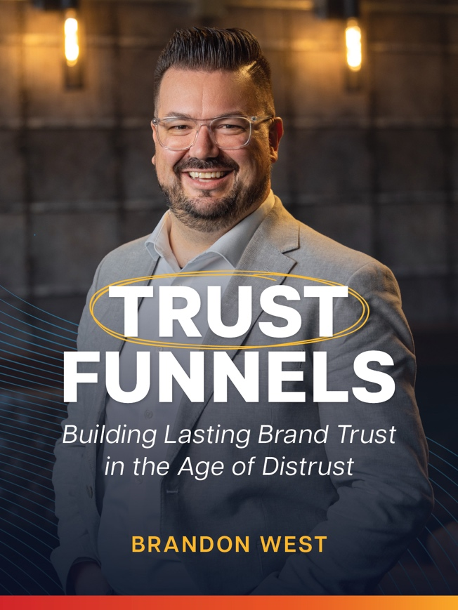

We are living in the least trusting generation in recorded history. Customers no longer just ask, “What do you do?” They want to know, “Can I trust you?” In today’s low-trust, high-skepticism marketplace, trust has become one of the most valuable currencies in business. Trust Funnels is a practical framework designed to help leaders and organizations build lasting trust in the people they serve. This six-part series explores how trust is built—or broken—across four key factors: competency, credibility, authenticity, and empathy. Each session unpacks the trust builders that move people toward your brand and the trust breakers that quietly push them away. Through engaging stories, humor, and real-world examples, you will learn how to:
- Demonstrate your competency so people know you can deliver.
- Strengthen credibility through what others say about you.
- Lead with authenticity so your message matches your reality.
- Show empathy that proves you genuinely care about the people you serve.
- Audit your current brand experience to identify gaps and strengthen trust at every touchpoint.

More than a marketing strategy, Trust Funnels is a leadership challenge. It calls leaders and teams to take an honest look at where trust is being lost and to build habits that create confidence and loyalty. Whether you are leading a nonprofit, a business, or a team, this series will equip you with a clear path to earn trust in an age of distrust. Because when people know you and trust you, they take action—and that is how real growth begins.

Register for RightNow Media @ Work by clicking here:


