Rise & Lead
By: Phyllis Newhouse
Click the image to watch the Trailer:
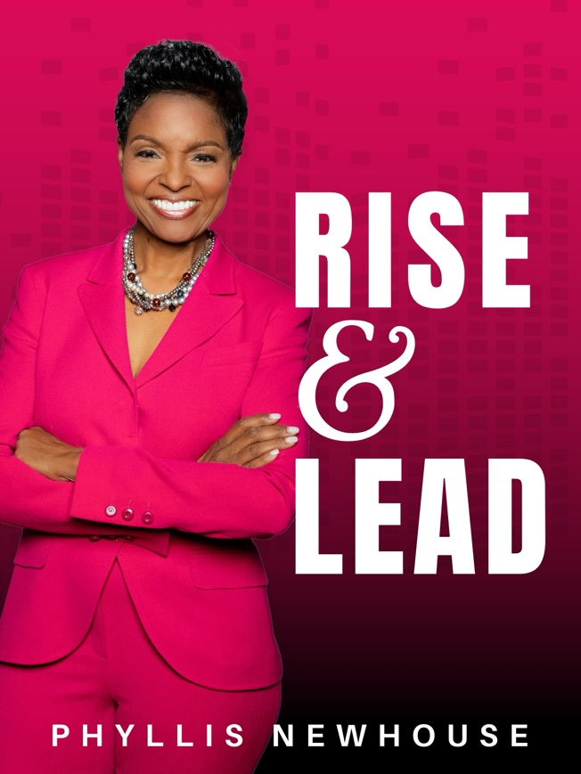

Rise & Lead with Phyllis Newhouse is a powerful series designed to guide women on a journey of impactful leadership. Drawing from Phyllis’s personal stories and extensive experience, each session empowers women to navigate challenges, lead with authenticity, and create a legacy of resilience. With a focus on values-driven leadership, adaptability, and empowering others, Phyllis helps women harness their potential, become unbreakable leaders, and leave a lasting impact on the people and places they influence. This series is for women ready to rise, lead with purpose, and uplift others along the way.
Register for RightNow Media @ Work by clicking here:


