Getting Access to Full Medical Records

Medical records hold information about you. They are also sometimes called health records. You'll have separate records for any NHS service you go to including your GP surgery, hospital, dentist or opticians.

How to get your Online GP Medical Record

Your GP record includes information like any conditions or allergies you have and any medicine you're taking, appointments, consultation and clinical hospital letter.

The 1st November 2023 Island Health Primary Care LTD will enabling online medical access to patients over 18 years old.
Should you want access to you past & full medical records please complete the declaration table below

Of note your records will be reviewed by a GP prior to release. Please allow 40 working days for this process to be completed.

Declaration: I would like full access to my Records

Print Name
Date of Birth
Signed Signature
Date

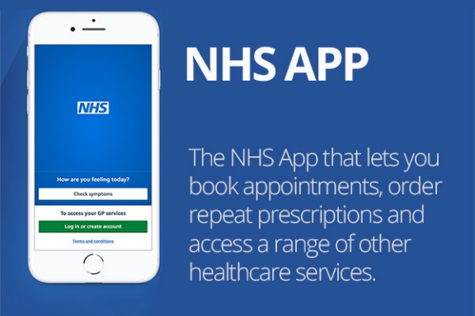

Using your NHS account

You can get your GP record by logging into your account using the NHS app or NHS website. First, you need to register for online services and prove who you are. You can do this when you create an account.

PTO – Office Use Only

Office Use Only
EMIS No
Doctor Tasked
Signature When Check Completed
Date Completed

