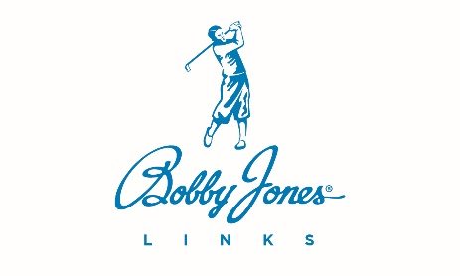
<Date>

<Mr. or Ms. Candidate>
<Address>
<City, State Zip Code>

Dear <Candidate Name>,

We are pleased to offer you full-time employment as <"Food and Beverage Manager"> of <The Club>, subject to the following terms and conditions of employment.

- Your position will be <"Food and Beverage Manager"> at <The Club>.
- Your starting salary will be <$XX,000> annually and will be effective on your start date. We’re anticipating your start date on or around <Month DD, YYYY>. You will have the opportunity to earn additional dollars in the form of a Net Operating Income and a year-end subjective bonus.
- You will be eligible to participate in Bobby Jones Links' excellent benefits program which currently includes the following:
  - Health, dental, vision, life, and LTD Insurance which will begin the first of the month following your start date (subject to you enrolling within 30 days of hire date),
  - 20 paid personal days, your birthday, and one community service day, accrued according to company policy, and
  - Paid company holidays: New Year’s Day, Memorial Day, Fourth of July, Labor Day, Thanksgiving Day, and Christmas Day.
  - Participation in the 401k plan after one year of continuous service (Must be 21 years of age to participate). <Include information on club match as applicable>
- You will receive a $75 per month phone allowance.

You will be paid on a salary basis, which will compensate you for all responsibilities assigned to you. The position may require more than 40 hours per week, and you will have the responsibility to complete the work assigned regardless of the amount of time necessary. All Bobby Jones Links team members are employed at 'will'. I have attached a job description for your review.

We hope you find this both fair and exciting. Thank you for your hard work in advance.

Sincerely,

Name
Title

