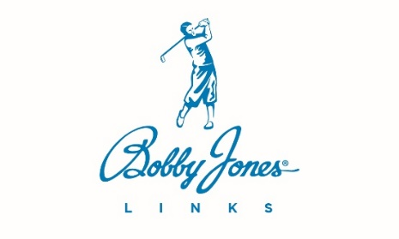

PERFORMANCE REVIEW

Team Member’s Name
January 1, 2025

CORE VALUES REVIEW

- MAKE PEOPLE HAPPY + +/- -
- Service First
- Solve Customer Problems
- Have Fun

- DO WHAT YOU SAY + +/- -
- Be Loyal
- Be Dedicated
- Be Dependable
- Do the Right Thing

- STRIVE FOR EXCELLENCE + +/- -
- Be Humble
- Be Confident

- BE DRIVEN + +/- -
- Be Proactive
- Be Innovative
- Go the Extra Mile

- GROW EVERY DAY + +/- -
- Willing to Learn
- Be Adaptive
- Stay Curious

GWC PEOPLE ANALYZER
- GETS IT Yes No
- Does the team member understand what this job requires and what needs to be done?

- WANTS IT Yes No
- Does the team member genuinely want to do the job?

- CAPACITY Yes No
- Does the team member have the mental, physical, time, knowledge, and emotional capacity to do the job?

SUBJECTIVE REVIEW

In this section, please provide comments on what our team members did well and in what ways they can do better. Your input should be based on our core values and GWC review as well as how and if they made a difference. In this area, you should also review if they completed their rocks and are fulfilling their roles within their position on the accountability chart.
WHAT YOU DID WELL
(Where you Made a Difference)

WHAT YOU CAN DO BETTER

PERSONAL AND PROFESSIONAL DEVELOPMENT GOALS

We care about your growth, both personally and professionally. What are some areas you’d like to improve in the coming period? What can we help you with? Goals should be Specific, Measurable, Attainable, Results-Oriented, and Timely (SMART.)
All information in this section is provided by the team member in a self-review.

Team Member’s Signature: ______________________________________ Date: ___________________

Supervisor’s Signature: _____________________________________ Date: ___________________

A copy is to be given to the team member, and a copy is to be placed in the team member’s file.
Create a 555 Review Performance Discussion Form in Paycom and attach this document.

