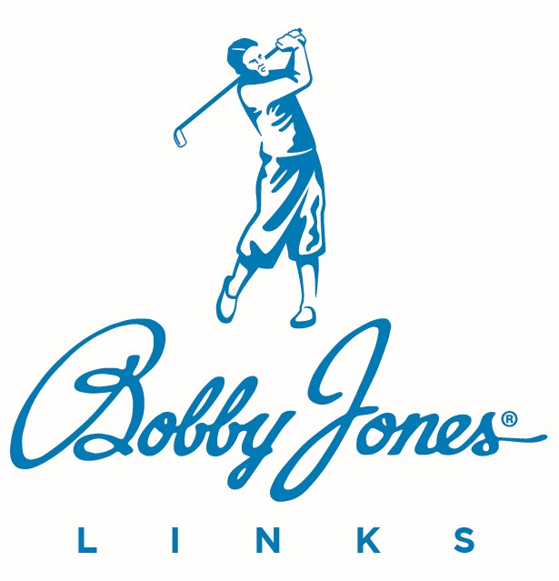

Food and Beverage Manager
Job Description
____________________________________________________________

The Food and Beverage Manager manages all aspects of the club’s food and beverage operation.
Responsible for the club’s dining services and all food and beverage production throughout the club. Manages outlets such as snack bars, half-way houses, etc. Plans, implements, and monitors departmental budgets. Hires, trains and supervises subordinates and applies relevant marketing principles to assure that the wants and needs of club members and guests are consistently exceeded.

REPORTS TO: Club’s General Manager
SUPERVISES: Executive Chef; Catering Manager; Beverage Manager; Banquet Manager; Dining Room Manager, Servers
CLASSIFICATION: Exempt

CORE COMPETENCIES

- Food and beverage cost controls and operating procedures
- Accounting
- Menu design
- Marketing and promotions
- Wine, spirits, and bar operations
- Point-of-sales systems
- Strong interpersonal and organizational skills
- Polished, professional appearance and presentation
- Manage stress and time
- Build a team, train, and maintain employee teams
- Effective communication through all department levels and throughout the club
- Knowledge of and ability to perform required role during emergency situations
- Strong leadership and people management skills
- Proficiency in Excel, Word, and club point of sales systems
- Familiarity with food handling, safety, and other restaurant guidelines
- Significant experience in the food and beverage industry

SPECIFIC JOB RESPONSIBILITIES

- Oversee the recruitment, training, evaluation, and scheduling of food and beverage staff.
- Periodically evaluates restaurant equipment for repairs and maintenance.
- Handles customer complaints, resolving issues in a diplomatic and courteous manner.
- Works closely with the kitchen to ensure expedient ticket times, excellent food quality, and proper plate presentation.
- Plans, promotes, and directs all restaurant activities.
- Manages the sale, operation, billing and collection of all banquet functions.
- Along with the Executive Chef, ensures that the ordering of food and beverage is accurate based on inventory needs and menu items listed.
- Maintains product quality and consistency by conducting ongoing inspections of seasonings, portions, and presentation of food
- Develop food and beverage sales and promotions as the business dictates.
- Incorporates safe work practices and safe food handling standards.
- Complies with all local liquor laws.
- Develops an operating budget for each of the department’s revenue outlets; monitors and takes corrective action as necessary to help assure that budgeted sales and cost goals are attained.
- Develops a capital budget for all necessary food and beverage equipment and recommends facility renovation needs
- Ensures that adequate cash procedures are followed and that documentation is reported in an accurate and timely manner
- Responsible for proper cash and charge procedures, guest check analysis, tips reports, ticket controls and daily sales reports and analysis.
- Manages the depratment’s long-range staffing needs.
- Helps plan and approves the scheduling plans.
- Monitors employee records to minimize overtime and keep labor costs within budget. Assures that all standard operating procedures for revenue and cost control are consistently followed.
- Assures that all club policies and procedures are followed.
- Helps plan and approves external and internal marketing and sales promotion activities for the department’s outlets and special club events
- Approves menu items, pricing, and menu designs for all outlets, special events and banquet events
- Establishes quantity and quality output standards for personnel in all positions within the department
- Ensures all legal requirements are consistently followed, including wage/ hour and federal, state or local laws for food safety and the sale/consumption of alcoholic beverages
- Ensure all energy management, preventive maintenance and other standards are consistently met
- Ensures that all new employees receive the appropriate safety instructions and training; establishes and enforces all safety policies and procedures including OSHA regulations and ensures that appropriate proof of training is documented to the employees’ personnel files
- Researches new products and evaluates their cost and profit benefits.
- Maintains food and beverage personnel records
- Monitors purchasing and receiving procedures to ensure proper quantity, quality and price for all purchases
- Reviews new techniques for food preparation and presentation to maximize member and guest satisfaction and minimize food costs
- Consults daily with the Executive Chef, Catering Director, Purchasing Agent and other club administrators to help assure the highest level of member satisfaction at minimum cost.
- Greets guests and oversees actual service on a routine, random basis
- Helps develop wine lists and wine sales promotion programs
- Establishes, updates and maintains all written standards and procedures for the department as needed
- Addresses member and guest complaints and advises the General Manager about appropriate corrective actions taken
- Serves as an ad hoc member of appropriate club committees
- Monitors appearance, upkeep and cleanliness of all food and beverage equipment and facilities
- Monitors employee dress codes according to policies and procedures
- Approves all product invoices before submitting to the Accounting Department
- Monitors or manages physical inventory verification and provides updated information to the Accounting Department
- Responsible for the proper accounting and reconciliation of the point-of-sale and member revenues
- Maintains records of special events, house counts, food covers and daily business volumes
- Ensures that an accurate reservation system is in place
- Audits and approves weekly payroll
- Approves all entertainment
- Responsible for long-range planning for the department in concert with the club’s planning process
- Establishes and maintains professional business relations with vendors
- Works with the club’s Controller or Chief Financial Officer to identify and develop operating reports and for ongoing control of the department
- Recommends operating hours for all food and beverage outlets
- Serves as manager-on-duty on a scheduled basis
- Ensure timely correspondence with all catering guests including inquiry, follow-up, contracts, billings and thank-you letters
- Complete periodic china, glass, and silverware inventories
- Implement and monitor sanitation and cleaning schedules
- Completes other appropriate assignments from the General Manager
- Oversee the recruitment, training, evaluation, and scheduling of food and beverage staff
- Periodically evaluates restaurant equipment for repairs and maintenance
- Handles customer complaints, resolving issues in a diplomatic and courteous manner
- Works closely with the kitchen to ensure expedient ticket times, excellent food quality, and proper plate presentation
- Plans, promotes, and directs all restaurant activities
- Manages the sale, operation, billing and collection of all banquet functions
- Along with the Executive Chef, ensures that the ordering of food and beverage is accurate based on inventory needs and menu items listed
- Maintains product quality and consistency by conducting ongoing inspections of seasonings, portions, and presentation of food
- Develop food and beverage sales and promotions as the business dictates
- Incorporates safe work practices and safe food handling standards
- Complies with all local liquor laws

REQUIRED SKILLS

The Food and Beverage Manager of a Bobby Jones Links club must have the following skills:

- Strong leadership and people management skills.
- Proficiency in Excel, Word, and club point of sales systems.
- Familiarity with food handling, safety, and other restaurant guidelines.
- Significant experience in the food and beverage industry.

LICENSES AND SPECIAL REQUIREMENTS

- Food safety certification
- Alcoholic beverage certification

EDUCATION AND/OR EXPERIENCE

Four-year college or university degree in Hospitality Management or Culinary Arts
- Ten years or more as a food and beverage manager with five of those years in a similar position in a fine dining situation

PHYSICAL DEMANDS & WORK ENVIORNMENT REQUIREMENTS

The physical demands described here are representative of those that must be met by an employee to successfully perform the essential functions of this job. While performing the duties of this job, the employee is frequently required to:
- Walk, sit, stand for long periods of time, bend, use hands to finger, handle, or feel; and talk or hear, stoop, kneel, crouch, close vision, distance vision, peripheral vision depth perception and ability to adjust focus.
- Required to stand for long periods and walk, climb stairs, balance, stoop, kneel, crouch, bend, stretch and twist or reach
- Lift up to 25 lbs. regularly; up to 50 lbs. occasionally and to lift overhead and push/pull, move lighter objects.
- Continuous repetitive motions
The work environment characteristics described here are representative of those an employee encounters while performing the essential functions of this job.
- Indoor conditions that may be warm.
- Work near: grill and fryer.
- Noise level in the work environment is frequently loud.

_____________________________________________________________

IMPORTANT POLICY SPECIFIC RESPONSIBILITIES

- Learn and work following Bobby Jones Links’ Core Purpose, Core Values, and 17 Service Standards. These are the rules by which we serve.
- Abide by the employment rules in Bobby Jones Links Associate Handbook.
- Follow the guidelines in Carpe Diem, our master company operations handbook.

OUR CORE PURPOSE

Our core purpose is to make a difference.

Whether it is improving your club’s profitability, providing excellent customer service, enhancing course conditions, or improving a customer or fellow associate's day through small acts of service, we empower you to make a difference.

Our core values are the essential and enduring tenets of Bobby Jones Links. They are the glue that holds us together and will stand the test of time, permeating everything we do in our pursuit to make a difference.

OUR CORE VALUES

What follows are characteristics – the core values - of the people who make a difference at Bobby Jones Links.

- MAKE PEOPLE HAPPY

- Service First
- Solve Customer Problems
- Have Fun

- DO WHAT YOU SAY

- Be Loyal
- Be Dedicated
- Be Dependable
- Do the Right Thing

- STRIVE FOR EXCELLENCE

- Be Humble
- Be Confident

- BE DRIVEN

- Be Proactive
- Be Innovative
- Go the Extra Mile

- GROW EVERY DAY

- Willing to Learn
- Be Adaptive
- Stay Curious

OUR 17 SERVICE STANDARDS

- “Yes, is the answer. What is your question?”
- We regularly surprise and delight our customers.
- When a customer says, “thank you,” we always respond genuinely with “my pleasure.”
- We read our customers, focusing on their pace and specific situation to deliver a more personalized service.
- We use our customers’ names whenever possible to deliver a more personalized experience.
- We make eye contact first with each customer within eyesight while sharing a smile, speaking enthusiastically, and connecting personally. We believe in interactions, not transactions.
- We use elevated service language to create a memorable experience for our customers. We use phrases such as “good morning” and “good afternoon” instead of “hi.”
- We answer the phone in three rings or less with a smile in our voice. We identify ourselves and ask, “how may I serve you?”
- We are empowered to take care of any customer situation that arises. We solve issues quickly and go above and beyond to create member satisfaction.
- Rather than pointing, we escort customers toward their destination until they are comfortable with the directions.
- We make a difference in our customers’ day. We go above and beyond to impact their lives in a positive way.
- Service excellence is a team effort. We step out of our usual duties to assist our teammates.
- We create a positive and supportive teamwork environment, treating each other with respect and dignity.
- We are responsible to report and correct defects or problems before they affect the customer. We deliver product and service excellence.
- Our attire and demeanor reflect positively on our club and brand.
- We respond to customer and associate requests in a timely manner. We answer customer emails and voice mails within 24 hours.
- We are Bobby Jones. Be positive both inside and out of the workplace and honor his character and legacy.

__________________________________ ________________
Associate Signature Date
___________________________________ _________________
Supervisor Signature Date

