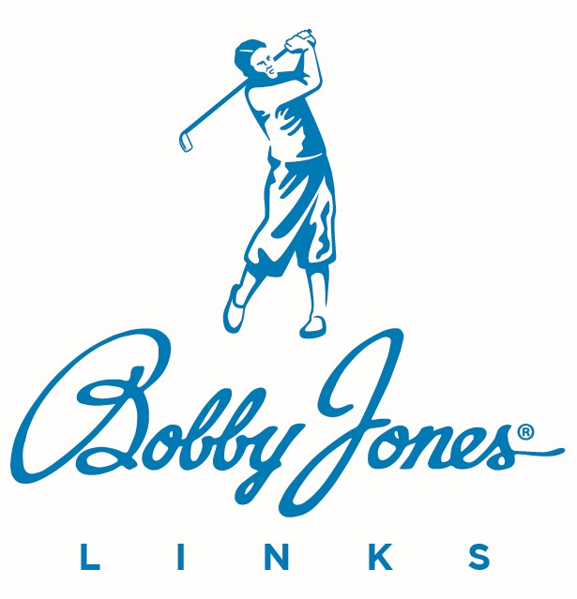

Head Golf Professional
Job Description
_____________________________________________________________

The Head Golf Professional manages all aspects of the club’s golf operation. This position reports to the club’s General Manager.

SPECIFIC JOB RESPONSIBILITIES

- Prepare annual and monthly budgets for golf operations while taking corrective actions to meet financial goals.
- Reconcile daily, weekly, and monthly activities.
- Oversee all golf tournaments, including sales, operations, and billing collection.
- Order merchandise for the golf shop to ensure the best selection possible within inventory constraints and guarantee that the shop achieves at least a 30% profit annually.
- Provide golf lessons to members and guests while supervising the club's instruction program, offering expert advice on golf techniques, equipment selection, and course management.
- Collaborate with marketing to advertise services and activities to potential customers and members to develop and conduct junior golf clinics.
- Coordinate with the golf course superintendent regarding playability and course conditioning issues.
- Order supplies related to golf activities.
- Maintain an attractive, clean, and organized appearance in the golf pro shop, cart staging area, and driving range.
- Hire, train, supervise, and evaluate all golf department personnel.
- Plan professional development and training activities for the staff.
- Collect charges and fees for all golf-related activities.
- Organize and conduct club tournaments and related events.
- Interpret and enforce club policies, rules, and regulations.
- Maintain records related to player and guest rounds and other statistics.
- Plan social golf events to promote golf and fellowship among members and guests.
- Follow all federal, state, and local health, safety, and employment laws.
- Assist in developing short- and long-term plans to enhance club facilities and courses.
- Collaborate with the food and beverage director on event food and beverage requirements.
- Maintain a visible presence on the course or in the golf shop during peak play times.
- Ensure starting times comply with the club’s rules and regulations.
- Provide for the collection and distribution of all prizes associated with competitions.
- Implement a comprehensive safety program for the golf department that aligns with OSHA standards.
- Stay informed about current and projected industry developments.
- Attend club management staff meetings.
- Perform other relevant tasks assigned by the General Manager.

REQUIRED SKILLS

The Head Golf Professional of a Bobby Jones Links club must have the following skills:

- Excellent leadership, problem-solving, communication, and organizational skills.
- Comprehensive understanding of the game and its rules.
- Proficiency in Excel, Word, and club point of sales systems.
- Ability to develop and monitor annual and monthly budgets.
- Experience in golf course retail, inventory management, and merchandising.
- Proficiency in tournament software.

PHYSICAL DEMANDS & WORK ENVIRONMENT REQUIREMENTS
The physical demands described here are representative of those that must be met by an employee to successfully perform the essential functions of this job. While performing the duties of this job, the employee is frequently required to:
- Walk and or stand for long periods of time, sit, bend, use hands to finger, handle, or feel; and talk or hear, stoop, kneel, crouch, close vision, distance vision, peripheral vision depth perception and ability to adjust focus.
- Lift up to 50 lbs. occasionally and to lift overhead and push/pull, move lighter objects.
The work environment characteristics described here are representative of those an employee encounters while performing the essential functions of this job. While performing the duties of this job, the employee will frequently:
- Be exposed to outside weather conditions including temperatures over 90 and below 40 degrees.
- Work near: moving mechanical parts, fumes, toxic or caustic chemicals.
- Noise level in the work environment is frequently loud.

_____________________________________________________________

IMPORTANT POLICY SPECIFIC RESPONSIBILITIES

- Learn and work following Bobby Jones Links’ Core Purpose, Core Values, and 17 Service Standards. These are the rules by which we serve.
- Abide by the employment rules in Bobby Jones Links Associate Handbook.
- Follow the guidelines in Carpe Diem, our master company operations handbook.

OUR CORE PURPOSE

Our core purpose is to make a difference.

Whether it is improving your club’s profitability, providing excellent customer service, enhancing course conditions, or improving a customer or fellow associate's day through small acts of service, we empower you to make a difference.

Our core values are the essential and enduring tenets of Bobby Jones Links. They are the glue that holds us together and will stand the test of time, permeating everything we do in our pursuit to make a difference.

OUR CORE VALUES

What follows are characteristics – the core values - of the people who make a difference at Bobby Jones Links.

- MAKE PEOPLE HAPPY

- Service First
- Solve Customer Problems
- Have Fun

- DO WHAT YOU SAY

- Be Loyal
- Be Dedicated
- Be Dependable
- Do the Right Thing

- STRIVE FOR EXCELLENCE

- Be Humble
- Be Confident

- BE DRIVEN

- Be Proactive
- Be Innovative
- Go the Extra Mile

- GROW EVERY DAY

- Willing to Learn
- Be Adaptive
- Stay Curious

OUR 17 SERVICE STANDARDS

- “Yes, is the answer. What is your question?”
- We regularly surprise and delight our customers.
- When a customer says, “thank you,” we always respond genuinely with “my pleasure.”
- We read our customers, focusing on their pace and specific situation to deliver a more personalized service.
- We use our customers’ names whenever possible to deliver a more personalized experience.
- We make eye contact first with each customer within eyesight while sharing a smile, speaking enthusiastically, and connecting personally. We believe in interactions, not transactions.
- We use elevated service language to create a memorable experience for our customers. We use phrases such as “good morning” and “good afternoon” instead of “hi.”
- We answer the phone in three rings or less with a smile in our voice. We identify ourselves and ask, “how may I serve you?”
- We are empowered to take care of any customer situation that arises. We solve issues quickly and go above and beyond to create member satisfaction.
- Rather than pointing, we escort customers toward their destination until they are comfortable with the directions.
- We make a difference in our customers’ day. We go above and beyond to impact their lives in a positive way.
- Service excellence is a team effort. We step out of our usual duties to assist our teammates.
- We create a positive and supportive teamwork environment, treating each other with respect and dignity.
- We are responsible to report and correct defects or problems before they affect the customer. We deliver product and service excellence.
- Our attire and demeanor reflect positively on our club and brand.
- We respond to customer and associate requests in a timely manner. We answer customer emails and voice mails within 24 hours.
- We are Bobby Jones. Be positive both inside and out of the workplace and honor his character and legacy.

__________________________________ ________________
Associate’s Signature Date

___________________________________ _________________
Supervisor Signature Date

