On 15th-16th second change 50 years of experience to "50+ Years of Service"
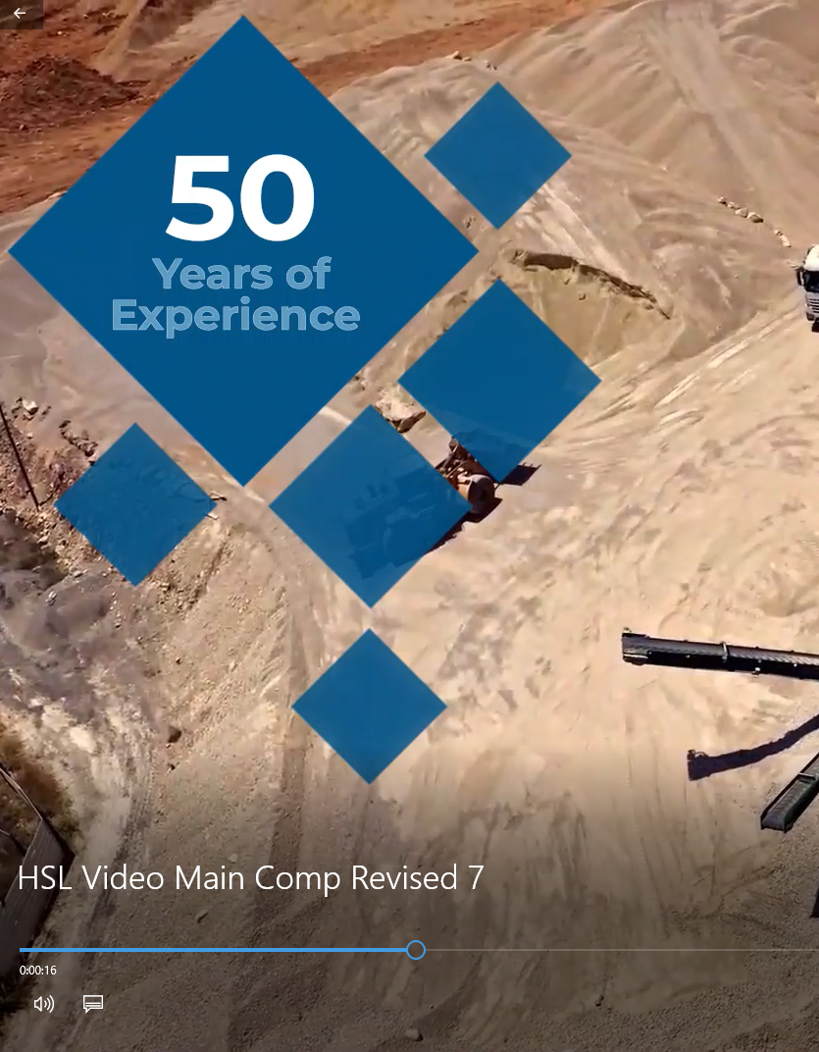

On 47th second change Tons/Volume Handled 2021-2022 to “Tons/Volume Handled Per Year”
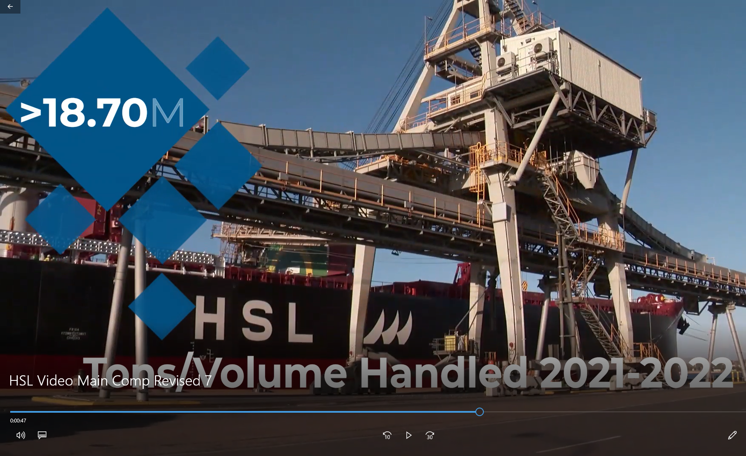

At 1:06 Change CO2 reduction initiative to “CO2 Reduction Initiative ” capitalize first letter of each word
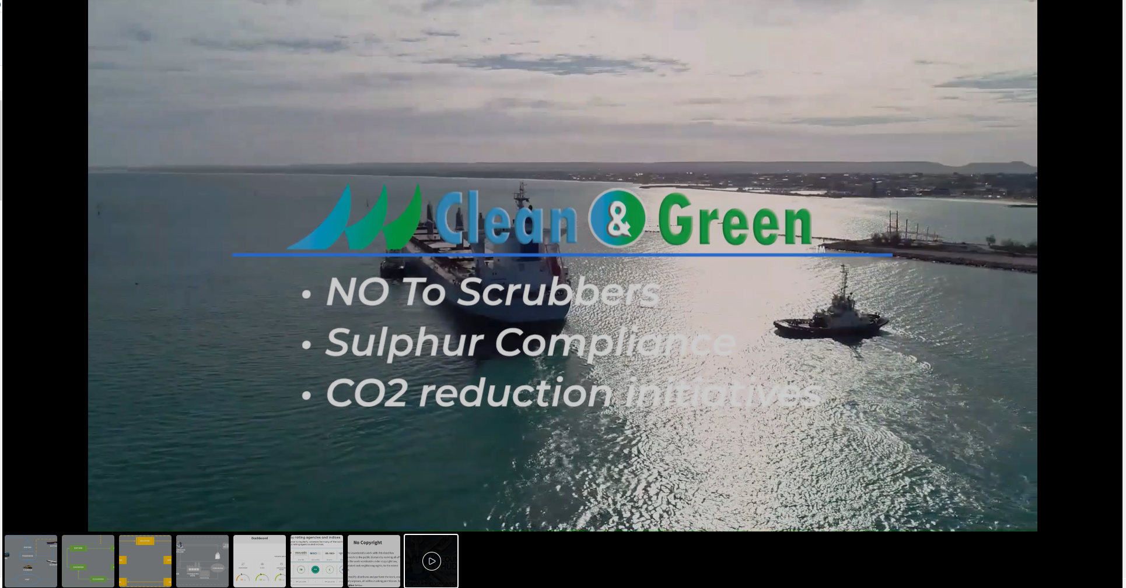

And keep both revision of videos7(you already made) and 8( you are going to make changes)

