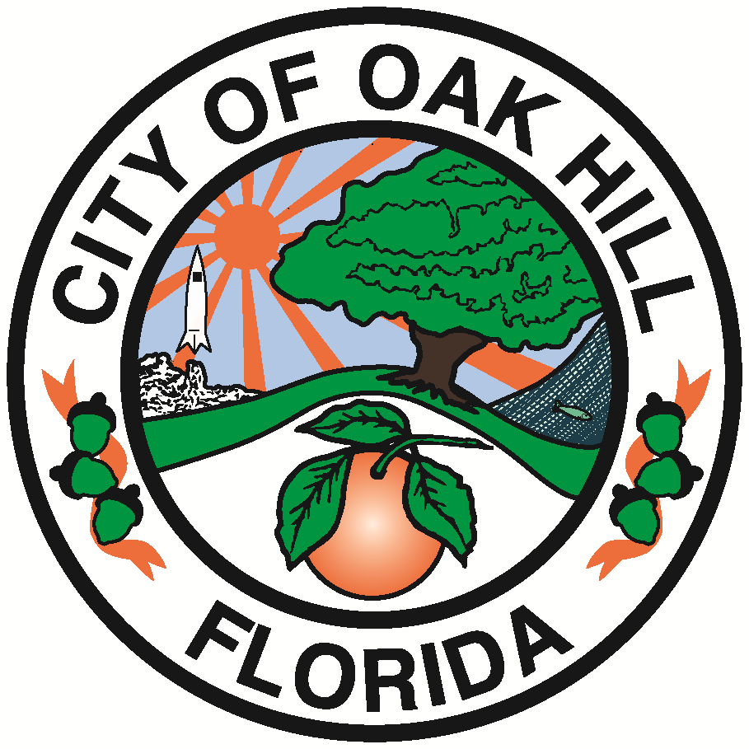
Fiscal Year 2026-2027
Budget Schedule

Budget Schedule

June 22, 2026 FY 26-27 Budget Workshop – Process Overview

July 20, 2026 FY 26-27 Budget Workshop

July 27, 2026 Finalize Tentative Budget

August 24, 2026 Adopt Tentative Budget/Millage Rate

September 7, 2026 Adopt Final Budget/Millage Rate

October 1, 2026 Fiscal Year 2026-27 Begins

Framework for Adoption of the Budget by the Commission

- Each municipality shall establish a Fiscal Year beginning October 1 of each year and ending September 30 of the following year.

- The City Budget must be adopted by Ordinance or resolution each year unless otherwise specified in the respective municipality’s charter. The amount available from taxation and other sources, including balances brought forward from prior fiscal years, must equal the total appropriations for expenditures and reserves.

- The City Fee City Schedule must be adopted by Resolution each year per the City Charter.

- The Tentative Budget must be posted on the municipality’s official website at least 2 days before the budget hearing. The final adopted budget must be posted on the municipality’s official website within 30 days after adoption and must remain on the website for at least 2 years.

- By October 15, the municipal budget officer shall electronically submit the final budget and the municipality’s economic status (specific details, i.e. expense per capita) to the Office of Economic and Demographic Research in the format specified by the office.

- The City at any time within the fiscal year may amend a budget for that year. The adopted amendment must be posted on the official website of the municipality within 5 days after adoption and must remain on the website for at least 2 years.

Assumptions as we approach FY 25-26:

- The City’s anticipated General Fund Balance from FY 25-26 is $58,000.

- The City’s current Ad Valorem (real estate) tax rate is $5.682.

- Current projections based on the City’s FY 25-26 estimate for total assessed valuation are as follows:
Working Ad Valorem Taxes
Calculation:
 | Assessed Value | Millage | Est. Tax Revenue |  | Net Tax
Total Taxes at Rollback | 233,054,898 | 5.3948 | $1,257,280 |  | 1,206,989
Total Taxes – Current | 233,054,898 | 5.6820 | $1,324,218 |  | 1,271,249

Florida Statute Allows:
- The City to adopt the roll-back rate by a majority vote, or quorum of the Commissioners.
- The City to levy a millage of up to 110% of the prior year’s revenues by a majority 2/3 vote.
Next Budget Workshop (Revenues and Expenditures) August 11, 2025

Commissioners’ Discussion

Public Comments

