CITY OF OAK HILL
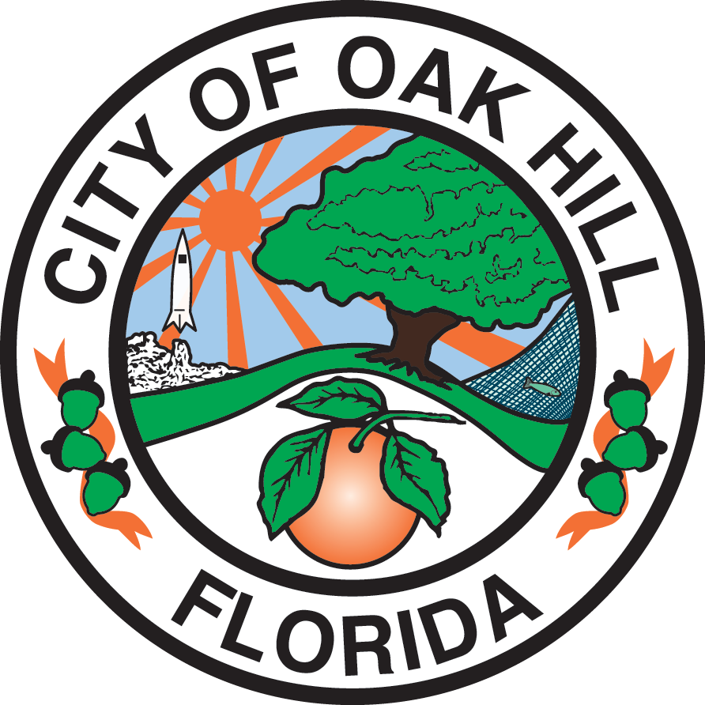

BUDGET WORKSHOP

6:00 P.M. – COMMISSION CHAMBERS - CITY HALL

June 22, 2026

AGENDA

- OPENING
  - Call to Order
  - Invocation
  - Pledge of Allegiance
  - Roll Call

- COMMISSION DISCUSSION – Overview of the FY 2026-27 Budget Process

- PUBLIC INPUT

- FINAL COMMENTS FROM MAYOR AND COMMISSIONERS

- ADJOURNMENT

LIVE STREAMING OF MEETINGS
This meeting is being streamed live on the City’s YouTube channel and the recording will be available after the meeting on Commission’s website. Those viewing the live stream will not be able to give input, post comments, call in to the meeting or otherwise interact with the Commission. Anyone wishing to provide input, must physically come to the meeting at the Commission Chambers. All care is taken to maintain your privacy. It is not intended that members of the public will be visible in a live stream of a meeting, however as a visitor in the public gallery, your presence may be recorded. By remaining in the public gallery, it is assumed your consent is given in the event your image is broadcast.

PUBLIC PARTICIPATION
In accordance with Resolution 2006-17, a three (3) minute time limitation per speaker will be imposed. A speaker may address the Commission for a maximum of three (3) minutes during the Public Participation portion of the meeting, and for a maximum of three (3) minutes during any specific Agenda topic. Pursuant to Florida Statute 166.041 (3) (A), if an individual decides to appeal any decision made with respect to any matter considered at a meeting or hearing, that individual will need a record of the proceedings and will need to ensure that a verbatim record of the proceedings is made.

