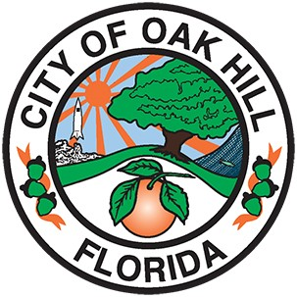 | City of Oak Hill  234 South U.S. Hwy. #1  Oak Hill, Florida 32759  Phone 386-345-3522

CITY OF OAK HILL
Planning and Land Development Regulation Commission
June 18, 2026
5:30 P.M.

AGENDA

- ROLL CALL

- APPOVAL OF THE MINUTES
  - Approval of the PLDRC Minutes, April 16, 2026

- PRESENTATION

  - Application for Annexation: 370 N. Brooks Circle, Oak Hill, FL 32759

Parcel ID# 8531-00-00-0244

- BOARD COMMENTS/CONCERNS

- ADJOURNMENT
Members of the Commission may attend this meeting for informational purposes.
Note: In accordance with Resolution 2006-17, a three (3) minute time limitation per speaker will be imposed. A speaker may address the Committee for a maximum of three (3) minutes during the Public Participation portion of the meeting, and for a maximum of three (3) minutes during any specific Agenda topic. Pursuant to Florida Statute 166.041 (3) (A), if an individual decides to appeal any decision made with respect to any matter considered at a meeting or hearing, that individual will need a record of the proceedings and will need to ensure that a verbatim record of the proceedings is made.

