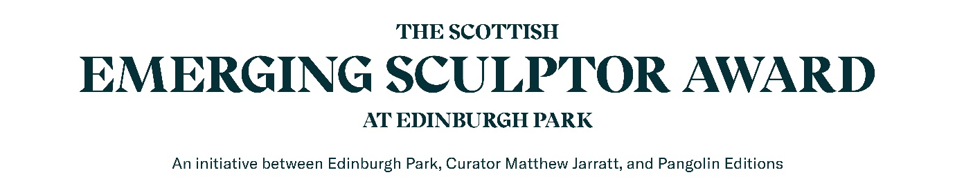
We are seeking emerging and early career artists and designers to make proposals for contemporary sculpture commissions in the new public realm at Edinburgh Park.
This is the second edition of the award which is open to visual artists who are either from Scotland or based in Scotland. This opportunity is open to artists who are in the final year of their BA or studying a Masters, or who have graduated in the last five years.
All shortlisted artists will receive mentoring and support from Curator Matthew Jarratt, and advice on developing proposals for public art commissions.
Our aim is to shortlist and support five artists to make proposals which will be exhibited at 1 New Park Square from May 2027 and then to select a proposal to be realised within the new public realm at Edinburgh Park.
We will provide mentoring, advice and support along with a £750 Bursary for each of the shortlisted artists and then a budget for the selected artist to realise their proposals working with Pangolin Editions who have a world class reputation for bronze casting and sculpture fabrication.
Edinburgh Park has already established a leading collection of major sculpture and poetry commissions including artists such as Eduardo Paolozzi and Kenneth Armitage. Our aim for the Scottish Emerging Sculptors Award is to create new opportunities for early career artists in Scotland to develop new proposals and create permanent public sculpture at Edinburgh Park.
For more information on the artworks at Edinburgh Park and to read our new Edinburgh Parks Art Strategy please visit : https://www.myedinburghpark.com/arts

Application Process: Please complete the application form below or via Edinburgh park website
and send us 6 images of your current work on a single PDF by 2nd November 2026.
- Design Stage We aim to shortlist 5 artists from this application process, who will each be awarded £750 to visit Edinburgh Park and develop ideas and proposals between January and May 2027. Curator Matthew Jarratt will offer advice and support and each of the shortlisted artists will be expected to produce a model and drawings of their idea for the exhibition of proposals.
- Exhibition of proposals The 5 selected artists will receive advice and support to develop their proposals for contemporary sculpture leading to an exhibition of proposals at 1 New Park Square, Edinburgh Park in May 2027. Edinburgh Park will produce design boards and online information to communicate the project and promote the artists proposals.
- Selection Stage A judging panel will select an artist to fully realise their proposals. The judging panel decision will also be informed by a public vote which will take place during the exhibition. Following the exhibition of design proposals the selected artist will be supported through the next stage of technical design, budgeting and production.
Application criteria:
- Applicants should be based in Scotland (or returning to the Scotland after studying away) and committed to establishing their artistic practice in Scotland.
- Applications should complete the short one page pro-forma below outlining their work as an artist and art education, and supply up to six images of previous art work.
- Please supply all written material as a word document and all images together on one PDF file (1mb per image). Applications should be emailed to info@matthewjarratt.com

APPLICATION FORM
Name

Email

Phone

Address

University / education / course / studio
Please tell us about your current work (max 200 words)
Accessibility
Please let us know if you have any access issues that we should be aware of and may be able to assist you with (please note Edinburgh Park is a new development and fully accessible)
Please attach up to 6 images of previous work on a single PDF

Please confirm that you live in Scotland or are originally from the Scotland? | Yes | No
Please email your application to info@matthewjarratt.com by 2nd November 2026
We will acknowledge the receipt of all applications and shortlisted artists will be notified in December 2026 and will be invited to a site visit and briefing about how to develop their proposals in Jan 2027.

