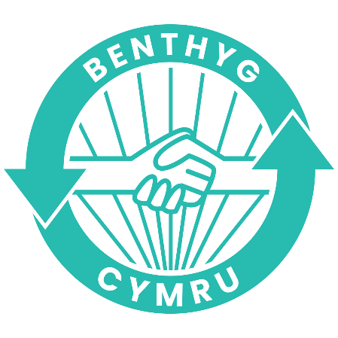

Building Community Connections

At the heart of our ethos is community. Libraries of Things (LoTs) in the Benthyg Cymru network are run by and for the communities they serve. Knowing your community is central to your LoT being successful. This guide will show you some ways of building up a picture of what's going on in your community and who you need to reach out to and build relationships.
Building relationships takes a long time and takes hard work and can be challenging but communities are stronger when they are united. As well as reducing waste we are trying to make borrowing as common as popping out for a loaf of bread, so community alliances and awareness are key.
Build a picture of what’s going on in your area
Draw some concentric circles. As a group write down any group, organisation, individuals in your area that you think of. Those you have relationships with already go closest to the centre.
This will give you a good picture of not only who you know about but should highlight gaps and places you might need to reach out.
It’s a good idea to build a contact list using your community map

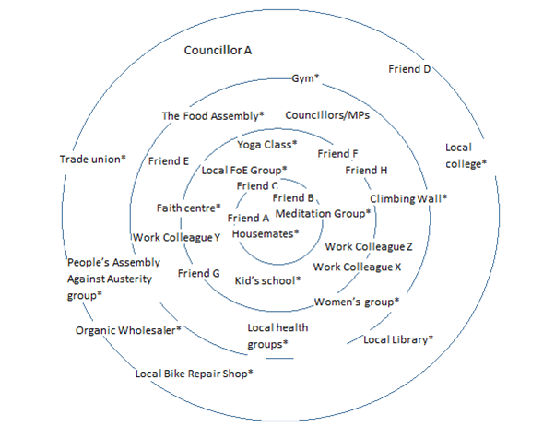
Think about groups with similar aims to you but also think about people and places that might be less obvious. Are there any existing networks that you could link in with?

