COSHH Risk Assessment
THIS RISK ASSESSMENT MUST BE USED IN CONJUNCTION WITH THE SUBSTANCE SAFETY DATA SHEET

Product Name: |  |  |  | Supplier Name:
Description of use:
Reference Number: |  |  |  | Storage Location:
Name of Assessor: |  |  |  | Date of Assessment:
Is substance mixed with others? (Yes or No) |  |  | If “Yes” specify chemical(s):

Routes of Exposure (û if appropriate) |  |  |  |  |  |  |  |  |  |  |  |  | Persons at Risk (û if appropriate)
Inhalation |  |  | Cuts / Abrasions |  |  |  | Ingestion |  |  |  |  |  | User |  |  |  |  | Members of Public |  |  |  |  | Exp. / New Mothers
Absorption |  |  | Eyes |  |  |  | Skin Contact |  |  |  |  |  | Other Workers |  |  |  |  | Young Persons |  |  |  |  | Visitors
Substance Form |  | Powder |  |  | Liquid |  |  | Solid |  |  |  |  |  |  | Granular |  |  |  | Gas |  |  | Aerosol
PPE  Required  (û if appropriate) |  | Overalls / Lab Coat |  | Eye Protection |  |  |  |  | Gloves |  |  |  |  | Respiratory Protection |  |  | Face Shield |  |  | Safety Shoes / Boots |  |  |  | Other
 |  | û |  | û |  |  |  |  | û |  |  |  |  | û |  |  | û |  |  | û |  |  |  | û
Specify PPE Type

Types of Hazard (û if appropriate)
 | 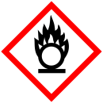 | 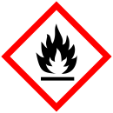 |  | 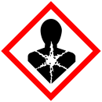 |  | 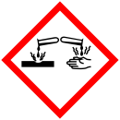 | 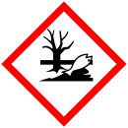
Explosive | Oxidiser | Flammable | Toxic | Serious Health Hazards | Health Hazards | Corrosive | Dangerous for the environment | Other

Current Control Measures |  | Monitoring Requirements |  | Storage Requirements

COSHH RISK ASSESSMENT
Hazard |  | Risk | Persons Affected | Before recommended controls in Place |  |  |  | Remedial Action | With Recommended Controls in Place |  |  |  | Responsibility By Date | Complete
 |  | Risk | Persons Affected | Pb | Sv | Ex | RPN | Remedial Action | Pb | Sv | Ex | RPN | Responsibility By Date | Complete
1
2
3
4
5
Risk Priority Number (RPN) = Probability x Exposure x Severity
Probability | Severity | Exposure |  | Risk Rating
1 Unlikely | 1 First Aid | 1 Irregular |  | 1 – 10 LOW
2 Possible | 2 Minor | 2 Occasional |  | 11 – 20 MEDIUM
3 Probable | 3 Major | 3 Frequent |  | 21+ HIGH
4 Inevitable | 4 Death | 4 Continuous

