
Layout and storage of your Library of Things
The layout of your LoT and the storage solutions you opt for will depend on the size of your space and other resources.
The size of your space will inform what kind of storage solutions you use and how many you will need – as well as how many items you can keep.
Consider whether the space is shared with other activities, will it be accessed by multiple people? Do you want the inventory to be browsable by members, or just accessed by staff/volunteers? If the space will be accessible to members of the public, you will need to store items securely.
If the area won’t be accessible to members of the public, you can consider large, open shelves.
If you need them to be stored securely, consider sourcing some wire mesh lockers (second-hand if possible) and combination padlocks.
You can get the wire lockers in different configurations to store different-sized items and you can add shelves, poles and hooks to arrange items inside them to ensure they are visible and easy to find. You will need to secure these to the walls.
For larger items, such as lawnmowers, wheelchairs etc, you may wish to consider a larger storage locker, heavy-duty hooks, or keep them in a space that is not accessible to visitors. Remember that they will need to be accessed easily.
As well as storing the inventory, you’ll need a place to greet visitors such as a desk, and ideally some space to make tea and coffee. You’ll also need a space to store donated items before they are added to the inventory, and a maintenance space where items requiring work can be kept, with space to store tools (consider a toolbox, tool drawers and/or pegboard – just keep items safely away from visitors).
If you are quarantining items between borrows (dependent on Covid-19 guidance) you will need a space set aside for this.
Think about where your power sockets are and access to running water – you will need power near the maintenance area and ideally near the front desk too, to make it easy for plug-in items to be switched on before and after check-in.
Think about the flow of the space and how everyone who uses it will move around and bring items in and out of the venue; make sure you leave space for wheelchairs to manoeuvre easily.
In keeping with our ethos of reuse and waste reduction, please try to source items second-hand / refurbished where possible. Try searching on Facebook Marketplace, Ebay, Freecycle, Local community donate don’t dump/ selling groups on social media, local upcycling centres and charity shops.

Racking

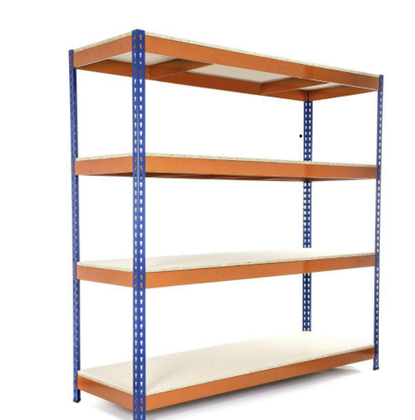

Wire Mesh Lockers
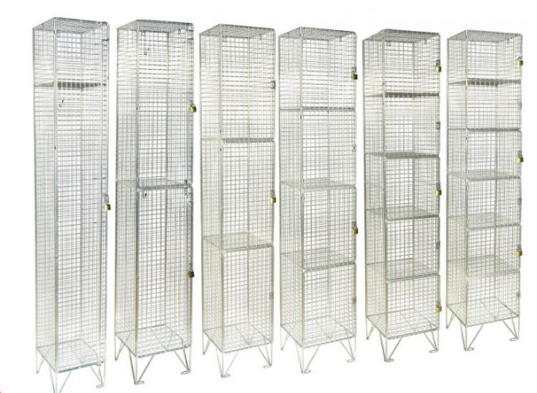
Photos of storage/ display examples from the Network
RE:MAKE Newport – Front Window
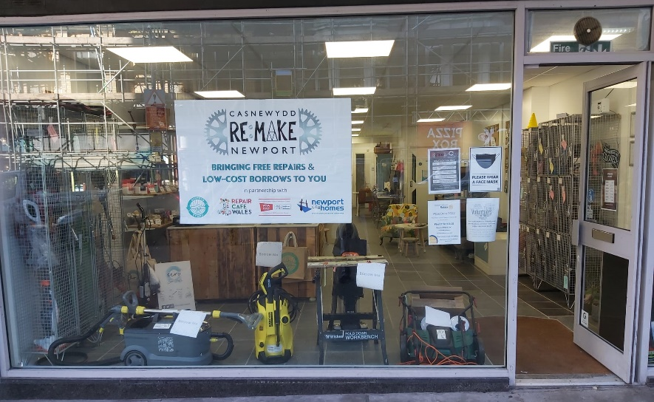

RE:MAKE Newport – Lockers on Main Floor with combination padlocks

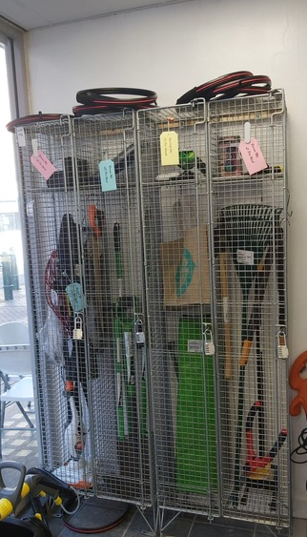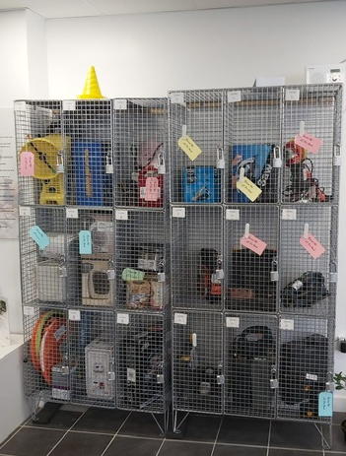

RE:MAKE Newport – Main Floor open display
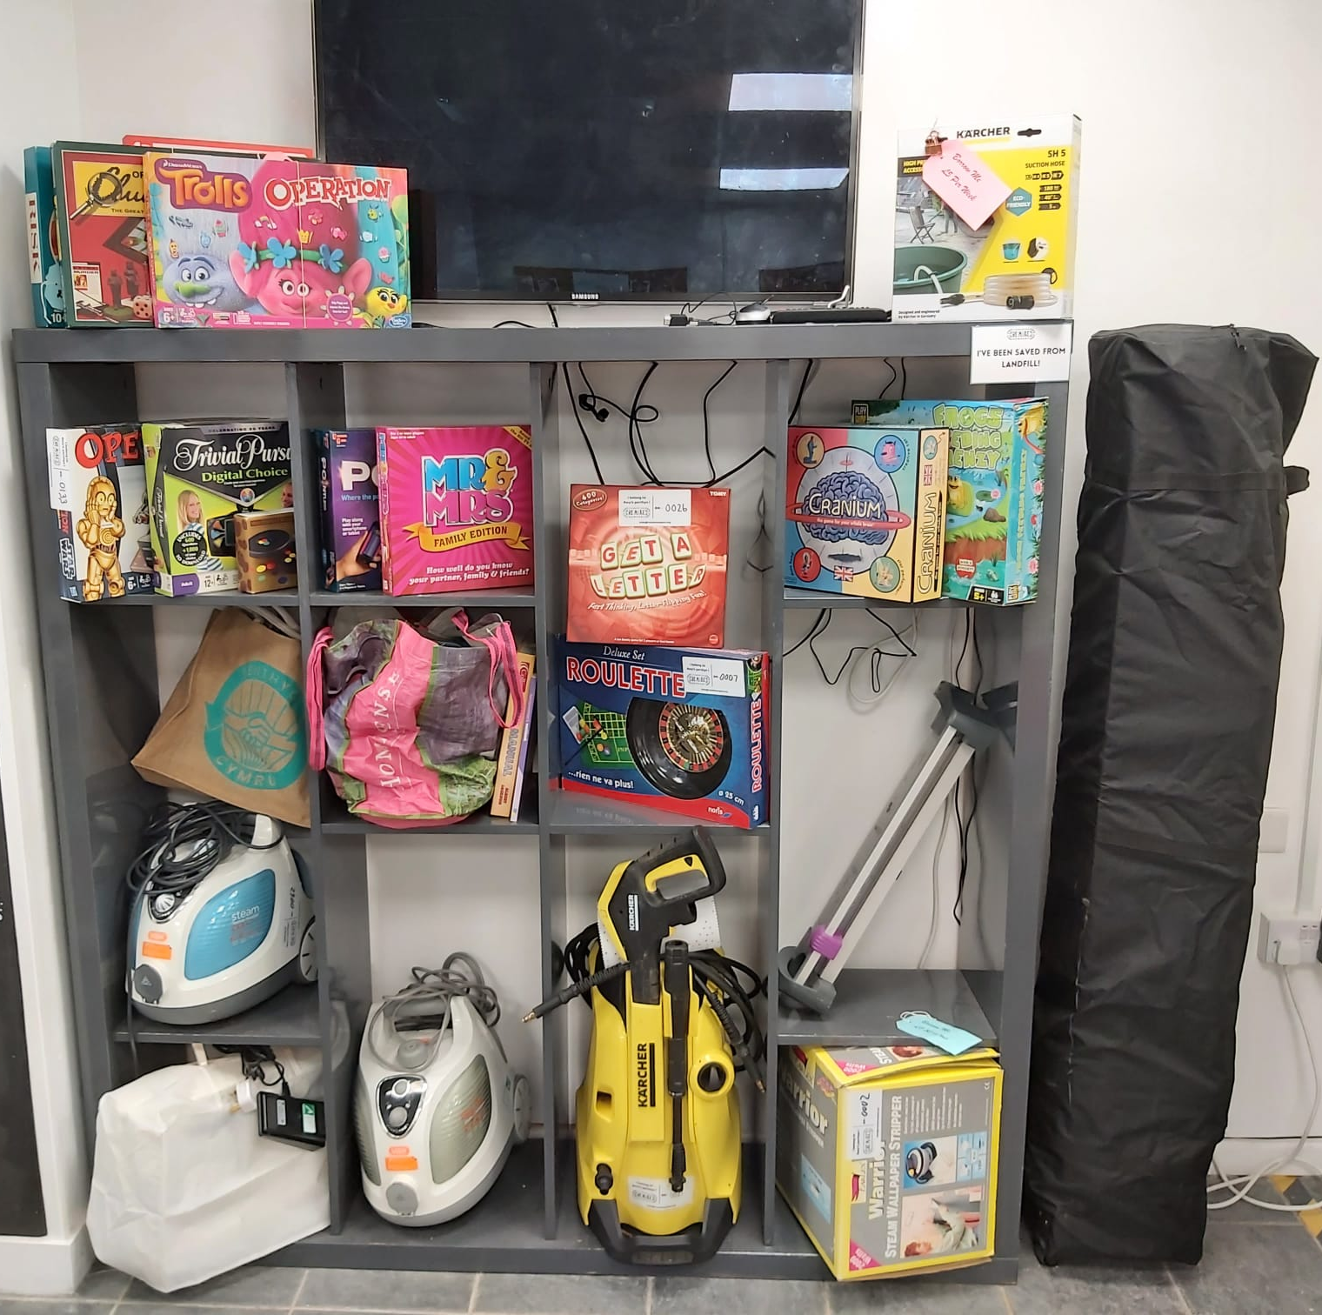

Barry Benthyg @ Awesome Wales Zero Waste Shop & Café – Front Window Display

