Insert branch logo

Portable Appliance Testing (PAT)

Benthyg Code of Practice and Guidance notes:

Each member of the Benthyg Cymru network has legal duties to ensure that electrical items remain in a safe condition, both as a coordinator of volunteers and as a tester/fixer of electrical items. Establishing a robust system of regular portable appliance testing (PAT) is the best means of controlling risks in the functionality testing, repair, and use of electrical appliances.

The PAT test includes:
- Preliminary visual inspection
- Using a PAT device:
  - Earth continuity tests (for Class 1 equipment)
  - Insulation testing (which may sometimes be substituted by earth leakage measurement)
  - Functional checks
All users of portable appliances should carry out a visual inspection each time the appliance is used. However, electrical testing with a PAT device must only be performed by a person who is competent in the safe use of the test equipment and knows how to interpret the test results. This person must be capable of inspecting the equipment and, where necessary, dismantling it to check the cable connections.
A Competent Person is a person who has received suitable and sufficient training in Portable Electrical Appliance Inspection and Testing and has passed the PAT testing qualification
All branch leaders must implement a robust system of PAT testing, as outlined in this document.

Policy on Portable Electrical Appliance Inspection and Testing

LoT leaders/project managers must comply with the Electricity at Work Regulations (1989) made under the Health and Safety at Work Act (1974) and all future statutory requirements concerned with the inspection and testing of portable electrical appliances.

LoT leaders/project managers are responsible for determining the policy on Portable Electrical Appliance Inspection and Testing.

LoT leaders/project managers hold ultimate responsibility to ensure that their LoTs comply with all statutory health and safety requirements, and that their PAT testing policy is implemented effectively (using the Benthyg Cymru template as appropriate). They may share this responsibility with suitably competent persons that undertake the PAT testing.

Arrangements
Portable Electrical Appliances must be inspected and tested by competent persons. This should always occur after an item has been donated or repaired and, where necessary, before they are plugged in for testing or repair purposes.
Following independent advice from the Loosemores regulatory team and further input from the Health and Safety Executive, Benthyg Cymru has amended our guidance on PAT testing frequency. We now recommend that electrical items are PAT tested after each item is returned. This prevents risk to the next borrower and to staff and volunteers inspecting and testing items.
“Every time” PAT testing guidance was already in place for higher-risk electrical items, for ex: those that come into contact with water as part of their functionality, such as carpet cleaners and pressure washers.
This inspection and testing will include:
- Visual Inspection for signs of damage or deterioration and
- Electrical Tests, i.e.
  - an Earth Continuity test; and
  - relevant Insulation tests.
Test results must be recorded on Lend Engine. A pass/fail sticker must be attached.
A Portable Electrical Appliance is any electrical equipment capable of being carried and, in general, connected to the mains supply by a flexible lead and a plug. The definition includes appliances with their own power sources. The definition does not include equipment which is "hard" wired, e.g., heavy equipment supplied by a fixed armored power cable, which is tested using other regimes.
Class I appliances rely on the earthing of the conductive case and one layer of insulation covering its live internal parts for protection against electric shock.
Class II appliances are "double insulated", i.e. they rely on two layers of insulation between live internal parts and the user for protection against electric shock.
Competent Person- has sufficient training and experience, or knowledge and other qualities that allow them to assist you properly. The level of competence required will depend on the complexity of the situation and the particular help you need. They also need to hold a PAT testing qualification.

Visual inspection
Since over 80% of electrical faults are discovered by visual inspection, this is the most important element of Inspection and Testing. The following inspection schedule as a minimum is recommended:
- Cracked casing, bent pins
- Incorrectly rated fuse
- Incorrectly connected wires
- Loose connections
- Loose cable clamp
- Cuts, fraying, brittle
- Kinked, coiled
- Taped joints
- Overloaded (overheated)
- Male connector (if fitted), non-standard (IEC 320, BS4491, CEE22)
- Not secured by grommet/clamp on appliance
- Damage/faulty operation of off/on switch
- Damage to casing
- Loose parts
- Missing screws
- Evidence of overheating
- Evidence of moisture
- Missing double insulation mark on insulating casing (where appropriate)
- Accessible fuse holders: damage or removal of carrier permits live part to be touched
- Exposed output connections have marked voltage rating >50V

Electrical testing

- Earth Continuity Test (Class 1)
- Insulation Resistance Test (Class 1 & 2)
- Functional Check (Class 1 & 2)

Recording of Inspection and Testing Results
When relevant electrical items have been PAT tested, the tester should provide:
- A dated test label indicating PASS or FAIL, and its identification must be affixed to the appliance (and to the plug, if the lead is detachable).

- The inspection and test results must be saved on Lend Engine (or equivalent borrowing platform).

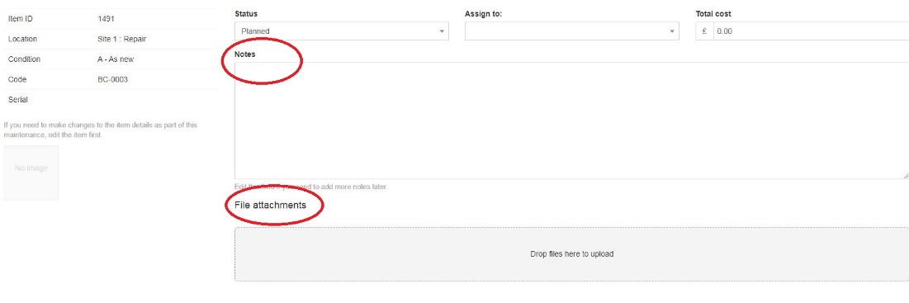

Remedial Action
If inspection and testing show the appliance is faulty before functionality testing or repair, the branch leader and all volunteers should be notified, it should be taken out of service so it cannot be reserved on Lend Engine (or equivalent online borrowing platform), and it should not be plugged in until it can be made safe.
When an appliance has failed, it should be made safe. If this is not possible then the item should not be used, marked with a FAIL sticker and disposed of appropriately.

Training
Inspection and Testing must be carried out by Competent Persons (see definition above). The decision as to whether an individual is competent to undertake a particular task is left to the branch leader. Benthyg Cymru can signpost training courses for anyone who wishes to gain PAT testing certification.
Insurance
Check with your insurance provider if they recommend a particular PAT Test course, require a specific process or stipulate a minimum interval between PAT-tests for your insurance policy to be valid.

https://www.hse.gov.uk/pubns/books/hsr25.htm

