How To Take Receipt of a Donation
Guidance on accepting donations
We recommend a flexible approach to accepting donations, recognising that members may wish to borrow a wide range of items from us, and we play an important role in keeping items out of landfill. When offered a donation, we would encourage you to consider the following questions:
- Would someone be likely to borrow this?
- Do we have space to store it?
- Can it be maintained, or (if broken) can it be fixed?
- Are all the pieces/parts included and functional?
- Are spare parts/ replacement component parts available and not too expensive
- Does it need consumables, and if so, are they readily available (e.g., batteries, cleaning fluid)

The answers to those questions can help you decide whether to accept the item into your inventory. If you decide not to accept it, explain your rationale to the person offering the item and signpost them to other potential recipients to avoid it going to a landfill.
Have a list of organisations in your community that might take donations that you can’t make use of to refer people to.

Note to branch leaders: Please review and amend the following section to ensure it reflects any exclusions identified by your insurance provider and your own risk assessments.

There are some categories of items that you are unlikely to be able to accept due to the risk they create if used incorrectly. They are:
- Any baby equipment such as sleep aids, car seats, bouncy chairs and door bouncers. LOT’s can accept robust plastic toys if they are in good condition, but even so, exercise caution and ensure there are no broken parts. Make sure any toys have a CE mark.

- Hazardous equipment such as chain saws and anything that needs a license to operate.

- Diesel or petrol-powered items will likely be stored with fuel in them.

Carry out regular risk assessments and check with your insurance provider to ensure you understand any exclusions.
If you decide to accept it, ask the donor to complete a ‘Donation Agreement’ form. Sometimes, people may not be inclined to fill out the form.

It is good practice to keep a record of who has donated items:
- Ask the donor to complete your branch version of the ‘Donation Agreement’ paper form where possible-
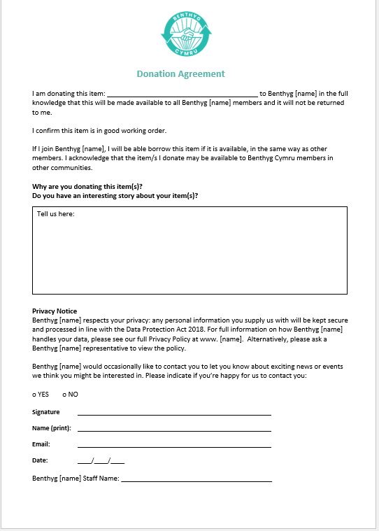

Top Tip: Make sure you have a few ‘Donation Agreement’ forms printed out and ready to use

- You will need to store the form electronically. Scan the form onto your PC or laptop and save it to a secure location that only you (and your volunteers, if you wish) have access to.
Top Tip: By saving an electronic version of the Donation Agreement to refer back to, you avoid the scenario of a donor returning to your Benthyg branch and requesting their item be returned to their ownership.

- Once the Donation Agreement is digitally stored, you will need to destroy the paper version by shredding or burning it. This is for GDPR (General Data Protection Regulation) purposes, as it holds personal information on an individual.
Top Tip: Until you can shred the Donation Form, please ensure it is stored in a locked area that you can only access until you destroy the documents appropriately. Fingers crossed, your inventory will include a donated paper shredder!
- If the donated item is electrical, capable of being carried, and can be connected to mains supply by a flexible lead and a plug, it must undergo a PAT Test before it can be added to your borrowing platform. Follow the instructions in the “How To—PAT Test an Item” document.
- If the item does not need PAT testing, add the item digitally to your borrowing platform.
- If you are a lend engine user, you can add a custom field to designate the item as donated.

