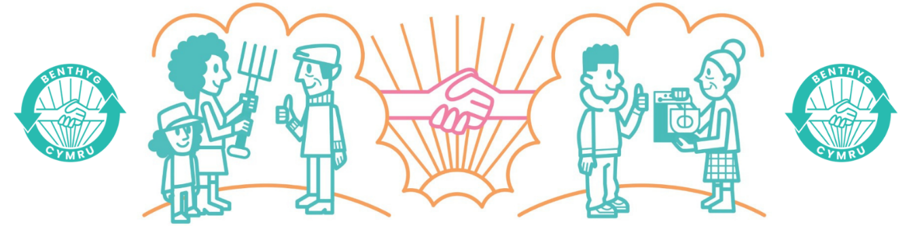

**Network Development Officer North Wales**

|  |  |
| --- | --- |
| **Role Title** | **Network Development Officer** |
| **Salary** | **£ 30k FTE 17.5 hours (2.5 days a week)** |
| **Time Required** | **FTC Ends 31/03/2026** |
| **Start Date** | 1st September 2025 |

**Based in North Wales (home-based with travel)**   
**Reports to: Head of Operations**

**Purpose of the Role**  
To increase borrowing and strengthen the Library of Things network across **North Wales** by supporting local projects, building partnerships, unlocking funding opportunities, and amplifying the value of sharing.  
You’ll act as Benthyg Cymru’s regional lead — rooted in place, plugged into community infrastructure, and working to grow our impact at a local level.

**Key Responsibilities**

**Library of Things Development**  
Support new and existing Library of Things (LoTs) with onboarding, troubleshooting, and best practice

Deliver 1:1 support via visits, calls, and ongoing peer check-ins

Keep the regional pipeline (from enquiry to launch) updated and active

Help members adapt and use the Benthyg Cymru toolkit confidently

Encourage peer learning and collaboration across the region

**Increase Borrowing Locally**

Work with LoTs to understand and remove barriers to borrowing

Share stories, data, and visuals to promote regional borrowing

Feed regional insights into national campaigns and communications

**Build Local & Regional Partnerships**

Forge relationships with councils, housing associations, universities, businesses, community groups, repair networks and others

Develop joint initiatives that support borrowing, reuse, and community benefit

Look for shared delivery or funding opportunities that meet local needs

**Collaborative Fundraising**

Seek joint funding bids between LoTs and Benthyg Cymru

Identify regional funders and build relationships

Support partners to embed borrowing in their work

**Regional Influence**

Raise awareness of borrowing with local politicians, public service boards, and anchor institutions

Help position LoT’s as essential community infrastructure

Feed local policy insight into Benthyg Cymru’s national influencing work

**Documentation & Reporting**

Keep CRM and regional records up to date

Share learning, risks and successes with the wider team

Contribute to impact tracking and evaluations

**You’ll Work Closely With:**

Fellow Network Development Officers (South + West)

Director & Head of Ops (national partnerships, policy, strategy)

Data and Comms Officer (data and funding alignment)

**Person Specification**

Deep understanding of North Wales communities and systems

Welsh Essential

Experience in community development, organising or capacity-building

Confident relationship builder and communicator

Some experience of partnership or funding work (or a strong appetite to learn)

Practical, warm, and able to work independently

Committed to the values of sharing, equity, and sustainability

Applications in by 23rd July 2025

Apply with CV and covering letter to info@benthyg-cymru.org

Interviews: Will be held virtually via Teams week commencing 4th August 2025