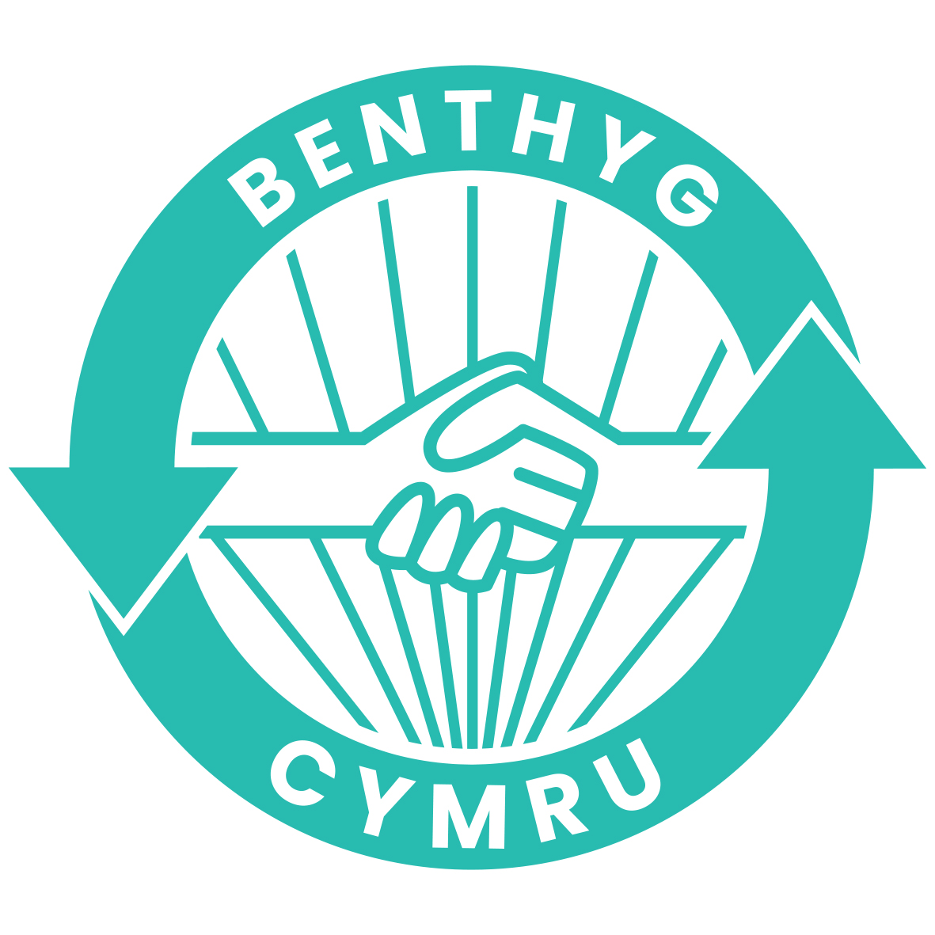

Communications, PR & Marketing Lead

Role Overview

Job Title: Communications, PR & Marketing Lead

Hours: 28 hours per week (Negotiable)
Location: Wales (remote), with travel across Wales
Salary: £34,271 (actual) | 3% Pension
Benefits: 25 days annual leave plus bank holidays | Wellbeing Days | EA programme
Contract: 1-year (with view to extend)
Reports to: Director
Language Requirement: Welsh essential

Welcome from the Director
Thank you for your interest in this role.
Benthyg Cymru is building a national borrowing infrastructure for Wales. We support and connect Libraries of Things and sharing projects across the country, working with community organisations, public bodies, and partners to make borrowing a normal, accessible, and aspirational choice.
We sit at the intersection of circular economy, community action, access, and equalities
Borrowing instead of buying helps people save money and live more sustainably. Everyone should have access to the things they need regardless of income. There is so much stuff in the world – let’s share it out.
We are at an important stage in our development. Our network now spans 35+ sites, with growing public-sector interest in lockers, vans, and new access models. We are strengthening digital systems, refining national standards, and expanding partnerships with local authorities and Welsh Government.
Communications is central to this work. Borrowing does not grow by accident. It grows through clear storytelling, culturally intelligent marketing, and consistent public visibility. It grows when people understand the benefits, see themselves reflected in the offer and trust the model.

This role is about increasing borrowing and participation across Wales. It requires someone who can translate strategy into tangible outputs, who understands behaviour change, and who is confident operating in a national, mission-led environment.
We are looking for a proactive communicator who enjoys producing work, testing ideas, and contributing and collaboration in a fast-moving organisation with high ambition and public value.
About Benthyg Cymru
Benthyg Cymru is a not-for-profit national network supporting Libraries of Things and borrowing initiatives across Wales.
Our work includes:
- Supporting 35 borrowing sites across Wales
- Strengthening national governance, safety standards, and digital systems
- Delivering behaviour-change campaigns promoting reuse and sharing
- Supporting local authorities to embed borrowing in public spaces
- Developing locker-enabled and innovative access models
- Monitoring and reporting carbon and household cost savings
- Building partnerships to grow a circular, fair, and community-led economy
We work bilingually and are committed to inclusive access, cultural relevance and delivery aligned with the Well-being of Future Generations Act.
We operate as a remote, national team and expect colleagues to work with autonomy, sound judgement, and accountability.
Our network members are the foundation of Benthyg Cymru. We support them to deliver strong, safe, and sustainable borrowing services, while enabling collaboration and shared learning across Wales. We take a co-production approach, recognising that communities understand their own context and strengths, and that national infrastructure should amplify rather than override local knowledge.

Purpose of the Role
To increase borrowing and participation across Wales by delivering high-quality, behaviour-change communications, marketing and storytelling that translate Benthyg Cymru’s strategy into clear, compelling public narratives.
The postholder will support national campaigns, public engagement, and profile-building, ensuring borrowing is visible, understood and trusted across Wales. The role will also contribute communications support to organisational projects, partnerships, and pilots, helping to communicate innovation, impact and learning as work develops.
This is a hands-on delivery role focused on producing work, testing approaches, and responding to insight within a fast-moving, mission-led environment.
We are looking for someone who can bring life and personality to our communications, who is not afraid to balance risk and messaging.

Key Responsibilities

Communications & Borrowing Growth
- Lead the development and delivery of the organisational communications and marketing strategy, working closely with the Director and wider team.
- Contribute directly to measurable increases in borrowing and participation across the network.
- Work with Development and Operations colleagues to align campaigns with site-level growth targets.
- Translate organisational strategy into clear, engaging communications across digital, print and campaign channels.
- Deliver content and campaigns that support behaviour change and increased participation.
- Test messaging and formats, adapting based on insight and performance.

Digital Content & Cultural Literacy
- Create and manage culturally aware, responsive digital content.
- Manage social and digital channels.
- Develop and maintain email marketing pipelines for different audiences (currently using Mailchimp).

Project & Partnership Communications
- Provide communications support to national pilots, public-sector partnerships, and innovation projects.
- Produce briefing materials, case studies and presentations that support external engagement.
- Support events and identify strategic opportunities for organisational visibility.

PR & Media
- Lead the development of media angles and narratives in collaboration with the Director and Board
- Draft press releases, pitches, and media materials.
- Build and maintain media relationships across Wales and beyond.
- Operate with awareness of reputational context and political sensitivity.

Network Communications
- Work with the Network Development Team to deliver newsletters and communications for member organisations.
- Support communications around training sessions and national guidance updates.

Design & Production
- Deliver basic in-house design (e.g. campaign graphics, one-pagers).
- Brief and manage external designers where required.
- Maintain quality and consistency of brand assets.

Website & Content Management
- Maintain and update website content to ensure accuracy, relevance, and latest accessibility standards.

Welsh-Language Delivery
- Deliver meaningful, accurate bilingual communications.
- Contribute to strengthening Welsh identity and accessibility across outputs.

Insight & Continuous Improvement
Work with Impact and data lead to:
- Set Metrics and monitor communications performance.
- Use data and feedback to improve approach.
- Make recommendations to improve systems and work streams
- Balance creativity with accountability to funders and partners.
Policy & Procedures
- Implement and maintain comms policies e.g. Welsh Language policy, Social Media policy etc
- Work with team to ensure GDPR compliance across systems

Person Specification

Essential
- Fluent Welsh speaker/writer
- Proven communications, marketing, or PR experience in the Welsh third sector or comparable mission-led context.
- Strong writing skills for public, media, and stakeholder audiences.
- Ability to translate strategy into tangible, high-quality outputs.
- Strong digital and cultural literacy.
- Experience producing work directly, not solely managing others.
- Ability to manage competing priorities and exercise sound judgement.

Desirable
- Experience delivering national-level PR and existing networks.
- Basic graphic design skills (e.g. Canva).
- Experience working with networks or infrastructure bodies.
- Understanding of behaviour change communications.

Role Fit and Expectations
This role is:
- Lead level.
- Delivery-focused.
- Visible and outward facing.
- Proactive rather than instruction led.
- Suitable for someone confident operating in a national context.
- Ideal for someone who enjoys making things and seeing them land.
This role is not suitable for:
- Someone seeking a purely strategic advisory position.
- Someone uncomfortable with public profile or media engagement.
- Someone who prefers managing others rather than producing work.

Equality & Inclusion
Benthyg Cymru is committed to creating an inclusive organisation and network. We welcome applications from candidates of all backgrounds and particularly encourage applications from underrepresented communities.
Welsh language skills are essential for this role. We operate bilingually and are committed to strengthening Welsh identity across our work.

Application Process
- Closing date: 18th March 2026 (midnight)
- Interviews: 26th & 27th March (online)
- To apply: CV & Covering letter (no more than 2 sides of A4) or a 5-minute video outlining why you are a good for the role. 2 examples of comms work related to this role.
- Informal enquiries: becky@benthyg-cymru.org 07446055818
- Submit applications to info@benthyg-cymru.org

