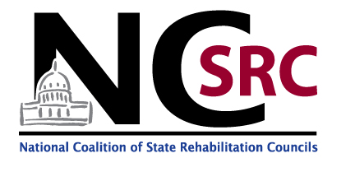
OUR MEMBERS

53 SRCs have signed onto the NCSRC Resolution!
Alabama State Rehabilitation Council Combined
(Alaska) State Vocational Rehabilitation Committee Combined
Arizona State Rehabilitation Council Combined
Arkansas State Rehabilitation Council General
California State Rehabilitation Council Combined
Commonwealth of the Northern Mariana Islands Combined
State Rehabilitation Council
(Connecticut) Board of Education & Services for the Blind Blind
State Rehabilitation Council
Connecticut State Rehabilitation Council General
Delaware State Rehabilitation Council General
Florida Rehabilitation Council for the Blind Blind
Florida Rehabilitation Council General
Georgia State Rehabilitation Council Combined
Guam State Rehabilitation Council Combined
Hawaii State Rehabilitation Council Combined
Idaho State Rehabilitation Council Combined
Illinois State Rehabilitation Council Combined
Indiana Commission on Rehabilitation Services Combined
Iowa State Rehabilitation Advisory Council General
Kentucky Statewide Council for Vocational Rehabilitation General
Louisiana Rehabilitation Council Combined
Maine State Rehabilitation Council General
Maryland State Rehabilitation Council Combined
Massachusetts State Rehabilitation Council General
Michigan Council for Rehabilitation Services Blind + General
Minnesota State Rehabilitation Council General
Mississippi State Rehabilitation Council Combined
Montana Vocational Rehabilitation Council Combined
Nebraska State Rehabilitation Council Combined
Nevada State Rehabilitation Council Combined
New Hampshire State Rehabilitation Council General
New Jersey State Rehabilitation Council General
New Mexico Commission for the Blind Blind
State Rehabilitation Council

New Mexico State Rehabilitation Council General
State Rehabilitation Council for Blind
New York State Commission for the Blind
New York State Rehabilitation Council General
North Carolina State Rehabilitation Council General
North Dakota State Rehabilitation Council Combined
Oklahoma Rehabilitation Council Combined
Oregon State Rehabilitation Council General
Pennsylvania Rehabilitation Council Combined
Rhode Island State Rehabilitation Council General
State Rehabilitation Council of Tennessee Combined
Rehabilitation Council of Texas Blind + General
U.S. Virgin Islands State Rehabilitation Council Combined
Utah State Rehabilitation Council Combined
Vermont State Rehabilitation Council General
(Virginia) The Old Dominion Council Blind
of the Blind & Visually Impaired
Virginia State Rehabilitation Council General
Washington State Rehabilitation Council Blind
for the Blind
Washington State Rehabilitation Council General
West Virginia State Rehabilitation Council Combined
Wisconsin Rehabilitation Council Combined
Wyoming State Rehabilitation Council Combined

www.ncsrc.net

April 2016

