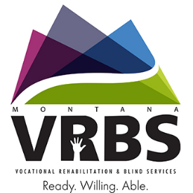

**2018**

Figure 2 Purple, grey, blue, green mountains Montana VRBS Ready, Willing, Able.

Figure 1 Montana. DPHHS with outline of mountain. Healthy People. Healthy Communication.

**MONTANA'S STATE REHABILITATION COUNCIL**

**GOVERNOR'S REPORT**

|  |  |
| --- | --- |
| 4,564 | Individuals served by Vocational Rehabilitation and Blind Services (VRBS) |
| 2,300 | Individuals served by  Independent Living Services |
| 421 | Individuals served by Older Blind Services |
| 249 | Individuals served by Extended Employment Services |

**VOCATIONAL REHABILITATION & BLIND SERVICES (VRBS)**

**SUCCESSFUL JOB PLACEMENTS**

|  |  |
| --- | --- |
| **2018** | **292** |
| **2017** | **511** |
| **2016** | **723** |

30 copies of this DPHHS public document were published at an estimated cost of 32 cents per copy, for a total of $9.60, which includes $8.60 for printing and $1.00 for distribution. Primary distribution of the document will be through email and placement on the program website.

Alternative accessible formats of this publication will be provided upon request. For further information call 406-444-2590.

For more information on VRBS, please visit our website: [www.vocrehab.mt.gov](http://www.vocrehab.mt.gov).

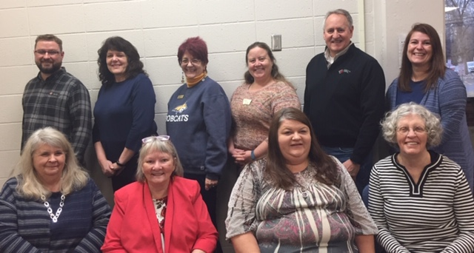**STATE REHABILITATION COUNCIL**

Figure 3 Back row - 6 standing persons; front row - 4 sitting persons

|  |  |
| --- | --- |
| Back row: | Andy Kemp of Bozeman; Kathy Hampton of Helena; Michele Letendre of Bozeman; Brook Hodge of Missoula; Vice Chair Scott Trent of Missoula; Ex Officio Chanda Hermanson-Dudley of Helena |
| Front row: | Sue Nielson of Miles City; Barbara Davis of Missoula; Chair Tiffany Costa of Billings; Coreen Faulkner of Missoula |
| Not pictured: | Wayne Dagel of Billings; Frank Podobnik of Helena; Barbara Kriskovich of Butte; Denise May of Missoula; Kathy Meier of Great Falls; Diana Tavary of Helena |

**MESSAGE FROM THE STATE REHABILITATION COUNCIL**

In order to meet its mission, the State Rehabilitation Council (SRC) actively promoted and supported the funding and operation of Vocational Rehabilitation and Blind Services (VRBS) through many activities across the state during the past year. This report highlights many of those activities.

In conjunction with the Workforce Innovation and Opportunity Act (WIOA), the SRC leverages their collective voice by supporting the program to lead and innovate services for Montanan’s with disabilities. The SRC endeavors to help individuals with disabilities gain pride, dignity, and a sense of purpose by empowering them to reach their full potential and independence through meaningful, integrated and competitive employment while serving Montana’s Governor.

*Tiffany Costa, SRC Chairperson*

**Mission**: The State Rehabilitation Council advises the Vocational Rehabilitation and Blind Services program to improve policies, programs, and delivery of services through a collaborative effort with other agencies.

**BLIND AND LOW VISION SERVICES (BLVS) SUCCESS STORY**

A 23-year-old male had recently been diagnosed with a visual of atypical macular dystrophy.  He was working to complete some college credits in addition to completing his high school diploma. He encountered problems with reading due to his visual impairment. He wants to further his education, so he completed low vision evaluations with instructional staff and did some vocational exploration with tools his counselor provided to him.   After further demonstration and discussion, it was determined a CCTV, a portable handheld electronic magnifier, and another device that projects a whiteboard classroom image onto his computer would all be required for completing school tasks.  These tools assisted him in completing his high school diploma and some college coursework.  Further vocational exploration led to a work goal of civil engineering. After some coursework at a local community college in this direction, he decided that this goal was not the best fit and had some other ideas including auto body work and physical therapy.  Given his age and limited amount of work history, he struggled to reach a decision about a vocational direction. He took time off from school and worked different jobs without agency assistance while doing vocational exploration with this counselor.  After a couple of years of ideas and indecision, he discovered that he was passionate about fitness and nutrition. The agency supported him in obtaining his personal training certification. He obtained a position at a local fitness center as a personal trainer working 30 hours a week with the expectation of increasing to likely 50 hours a week.  Significant services contributing to this person’s successful employment included counseling and guidance, instructional evaluation, occupational/vocational training assistance and adaptive equipment assistance.

**BLACKFEET VOCATIONAL REHABILITATION**

**BLACKFEET MANPOWER PROGRAMS ONE STOP CENTER**

C:\Users\cs2387.STATE\AppData\Local\Microsoft\Windows\Temporary Internet Files\Content.Outlook\3QUDGU7U\BVR - Logo 2018      5-24-18 (003).TIFThe Blackfeet Vocational Rehabilitation (BVR) program is in the second year of a fourth 5-year grant (2017-21) under the Department of Education, Rehabilitation Services Administration, and American Indian Vocational Rehabilitation Services. The BVR provides services to the Blackfeet enrolled members with disabilities who reside on or near the Blackfeet Reservation. They are the eligible consumers in need of assistance to get, keep, or maintain employment. The BVR offers services, training, and education to help them overcome barriers in workplace. The BVR program is a partner within the Blackfeet Manpower Programs One-Stop Center Programs. We also have good collaborative working relationships with Montana Vocational Rehabilitation, Native American Task Force, and University of Wisconsin-Stout in the 3E Targeted Population grant. The BVR is a member of the Consortia of Administrators for Native American Rehabilitation. The BVR is connected with the Northwest Indian College of Bellingham, WA for their online classes in the Tribal Vocational Rehabilitation Services. The BVR program uses the American Indian Vocational Rehabilitation Training and Technical Assistance Center for technical assistance and training in American Indian vocational rehabilitation on-site and online. The first annual report for FY17 showed that BVR completed their goals successfully by providing services to 22 of 20 projected eligible consumers with IPE and successfully closed 14 of 11 cases projected. The BVR program staff includes a director, deputy director, a counselor and administrator/counselor.

Figure 4 Blackfeet Vocational Rehabilitation around circle; inside circle is a person with headress sitting in wheelchair with laptop; 7 feathers hanging below circle.

**TRANSITION SUCCESS STORY**

A student who was diagnosed with social phobia and major depression contacted Vocational Rehabilitation in the spring of her junior year in high school. With assistance from her high school and Vocational Rehabilitation counselor, the student utilized job exploration activities such as Montana Career Information Systems to complete an interest assessment (Pre-Employment Transition Services). She was able to narrow down her employment interest to the field of computer science. She then worked with her high school to explore college options that would prepare her for the computer science field and received assistance applying for college and financial aid. The counselor and a Community Rehabilitation Program worked with her to set up a work-based learning experience at a local software company. The work-based learning experience was originally set up for 40 hours, but the employer felt that she had a lot of potential and requested an additional 40 hours to offer her additional training opportunities and exposure to the field. She did that and the employer was so impressed with her that he offered her a part time job assisting with web development. The student accepted the job and then graduated from high school. She is now attending the University of Montana majoring in computer science and is still working part time for the computer software company. The student and her Vocational Rehabilitation counselor worked with Disability Student Services to determine accommodations that she was eligible for and could utilize in college. She has maintained interest in the field of computer science.  Through Vocational Rehabilitation and Pre-Employment Transition Services, this student was able to get a jump start on her future!

**VOCATIONAL REHABILITATION BLIND SERVICES (VRBS) SUCCESS STORY**

This young lady started receiving Vocational Rehabilitation services when she was a junior in Havre High School. The junior did not know what she wanted to do. Due to her autistic disability, she was scared to attend college. She loves to read books and to be in the library. (more on the next page)

**STATE REHABILITATION COUNCIL RECOMMENDATIONS:**

**INTERNAL CONTINUOUS IMPROVEMENT**

* VRBS needs to review current rules & procedures and to make revisions that reflect WIOA values of:
  + Preparing youth with disabilities for meaningful careers,
  + Competitive/integrated employment for all persons with disabilities, and
  + Services to employers
* participants to engage staff in WIOA changes to enhance outreach to business partners.
* VRBS should enhance the staff’s ability to assist all consumers in achieving competitive/integrated employment.
* VRBS needs to continue to handle the financial situation to deal with staff vacancies and to continue to move off the order of selection.

**PROVIDE 21st CENTURY QUALITY SERVICE**

* VRBS should coordinate with service providers to make sure consumers can financially benefit from employment.
* VRBS, along with WIOA partners, should continue and improve outreach efforts to employers.
* VRBS will continue to collect data and refine the approach to Pre-Employment Transition Services, Competitive/Integrated Employment and Employer Services provided under the WIOA.

**NETWORK WITH OTHER AGENCIES & EMPLOYERS**

* With order of selection in place, VRBS should work to build strong relationships with other community partners to facilitate access to a broader array of services for Montanans with disabilities.
* VRBS should continue to partner with middle school, high school, and post-secondary levels of education.
* VRBS has completed multiple contracts with high schools around the state to establish pre-employment transition services.

**SRC ACHIEVEMENTS:**

* Continued to participate in the Windmills module trainings.
* Actively recruiting members to serve on the Council.
* Orientation Training was provided for the first time.
* Continue to review and provide guidance to VRBS on changes necessary to meet the challenges of WIOA and Montana’s State Plan.
* The Council continues to watch the expenses of SRC.
* Had a Joint Meeting with Statewide Independent Living Council.
* Established committees: Planning and Review; Consumer Satisfactions & Needs Assessment; Education & Membership, and Policy, Procedure, & Personnel Development.

**(VRBS) SUCCESS STORY (continued)**

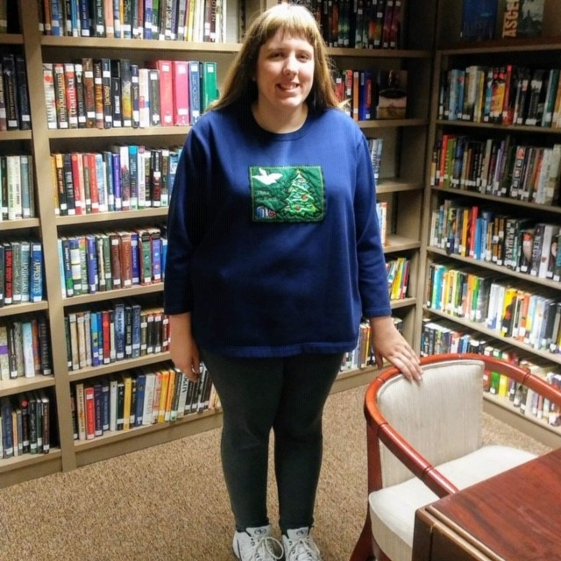Advised by her VR counselor, she used her first period class as a work-based learning experience by working in her high school library. Working in a library as a paying job is something she would like to do but it requires a college degree. Her VR counselor talked with a local library in Havre to see if this consumer could work there while VR pays her wages during the summer. She also explained that this consumer would be bringing her library skills as she already gained work-based learning experience at her high school library. During this time, the library was struggling with funding and cannot hire any new employees, so they were thrilled for this opportunity -- it would allow them to stay open on Saturdays. At the end of the summer, the library staff really enjoyed her so much that they wished to have the fund to hire her permanently. As it turned out, the Hill county had the mill levy voting on additional funding for the library. It passed and the library hired this consumer and to stay open on Saturdays. The consumer really appreciates everything the VR counselor did for her and to help her get her dream job. The VR counselor expressed the importance of getting work based learning experiences and having the connection to better employment outcomes for transition youth.

Figure 5 Woman standing in front of books on shelves