Cover page
California State Rehabilitation Council
2018 Annual Report
October 1, 2017 - September 30, 2018
Voice of the Department of Rehabilitation Stakeholder Community
Images of speech ballons in various colors

**Table of Contents**

Message from the SRC Chair 3

Message from the DOR Director 4

The Rehabilitation Act and the SRC 5

California SRC Overview 6

Collaboration between the SRC and DOR 9

SRC Quarterly Meetings 12

2018 SRC Recommendations 17

2018 Consumer Satisfaction Survey (CSS) 21

VR Services Portion of the Unified State Plan 22

Current SRC Members (as of December 2018) 24

Completed SRC Appointments 27

Interested in Becoming an SRC Member? 27

About the Department of Rehabilitation 28

DOR District Office Locations 29

# Message from the SRC Chair

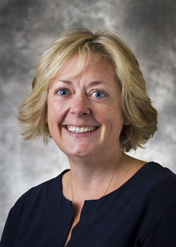December 2018

To the Honorable Governor Jerry Brown and

Carol Dobak, Acting RSA Commissioner

On behalf of the California State Rehabilitation Council (SRC), I’m honored to present our 2018 Annual Report covering the October 1, 2017 – September 30, 2018 term. It has been an exciting year for the SRC filled with growth, strength and change. The SRC’s diversity was enhanced through the appointment of five new members. As a Council, we bring our diverse backgrounds, experience, perspectives and constituencies to the table and unite with a common goal – to partner with the California Department of Rehabilitation (DOR) to maximize the employment and independence for Californians with disabilities. These new voices are bringing additional insight, and creativity to our discussions.

Highlights from this year include collaborating with the DOR Strategic Initiatives Office, examining the Consumer Satisfaction Survey, discussing the implementation of DOR Student Services, and exploring business engagement strategies. We connected with several advisory bodies, including the Assistive Technology Advisory Committee, the California Association of Local Behavioral Health Boards and Commissions, and the State Independent Living Council.

I would like to extend my sincerest gratitude to my fellow SRC members who have dedicated their time over the past year to learn, participate, ask questions, advocate and advance vocational rehabilitation. In addition, I’m extremely grateful to the numerous DOR representatives who frequently engaged with the SRC. The DOR’s ongoing support and partnership is recognized, valued and much appreciated. We are proud of the Council’s accomplishments this year which are highlighted throughout the Annual Report. Thank you for your support of the SRC and the DOR.

Lesley Ann Gibbons

Chair, State Rehabilitation Council

# Message from the DOR Director

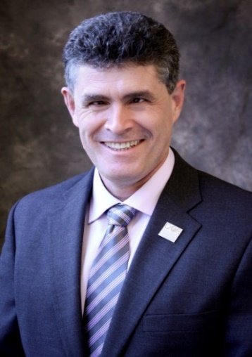December 2018

To the Honorable Governor Jerry Brown and

Carol Dobak, Acting RSA Commissioner

I would like to recognize the active partnership between the SRC and DOR during the 2017 – 2018 term, which has focused on vision and innovation. DOR and the SRC engaged in timely and significant discussions on topics such as business engagement, DOR Student Services, and updating the State Plan goals and objectives. We are grateful for the input and ideas offered by the SRC.

During this term, I’ve had the honor of welcoming five new SRC members – Kecia Weller (Disability Advocacy Groups), Nicolas Wavrin (Department of Education, Theresa Comstock (Disability Advocacy Groups), Eddie Zhang (Community Rehabilitation Programs), and Benjamin Aviles (Current or Former DOR Consumer). DOR looks forward to the new ideas, connections and opportunities these relationships will generate. One of DOR’s core values is to ensure that our decisions and actions are informed by interested individuals and groups. The SRC helps DOR carry out this core value and we count on the SRC members to voice the perspectives of their networks and constituencies. The SRC members also have a critical role in keeping their communities updated on DOR’s programs and services.

The SRC’s efforts to support DOR’s programs and services is valued and appreciated. We look forward to ongoing collaboration with the SRC in 2019 as we work together to identify changes that will both improve services and mitigate the risk of insufficient funding to serve all Californians with disabilities who seek DOR services, meet California’s business needs for quality personnel and support Californians with disabilities in reaching their potential.

Joe Xavier, Director

California Department of Rehabilitation

# The Rehabilitation Act and the SRC

When new members join the SRC, they are provided with information on how and why the SRC exists in relation to findings, purpose and principles of the Rehabilitation Act of 1973 (as amended). This foundational information provides context and helps to frame subsequent SRC discussions and activities.

## Rehabilitation Act – Findings

In the Rehabilitation Act, Congress identified that individuals with disabilities have the right to: Live independently, enjoy self-determination, make choices, contribute to society, pursue meaningful careers, and enjoy full inclusion and integration in society. Also in the Act, Congress also identified the need to support students with disabilities as they transition from school to postsecondary life.

## Rehabilitation Act – Purpose

Based upon these findings, the purpose of the Rehabilitation Act is to empower individuals with disabilities to maximize competitive integrated employment, economic self-sufficiency and inclusion into society. The purpose of the Rehabilitation Act also includes:

* Ensuring that youth with disabilities have opportunities for post-secondary success.
* Having vocational rehabilitation (VR) service providers and employers provide meaningful input, thereby increasing employment opportunities and outcomes for individuals with disabilities.
* Ensuring that the federal and state governments support the employment of individuals with disabilities.

## The DOR and SRC Partnership

The DOR and the SRC partner together to carry out the Rehabilitation Act to maximize the employment and independence for people with disabilities. The partnership is a call to action to advocate and hear the voices of individuals served by VR in California. The partnership between the SRC and DOR ensures that individuals with disabilities have resources and support to achieve their goals, while also ensuring that the California VR program is effective and in compliance with federal regulations.

# California SRC Overview

Section 105 of the Rehabilitation Act of 1973 (as amended) requires consumers, advocates and other representatives of individuals with disabilities to participate in the administration and oversight of a state’s VR program. The SRC fulfills this mandate in California and is required in order for DOR to be eligible for and maintain federal VR funds.

## Mission Statement

The SRC, in collaboration with the DOR and other community partners, reviews and analyzes policies, programs and services, and advises DOR on the quality and performance in meeting the Department’s mission.

## Vision Statement

The voice of DOR’s stakeholder community.

## Membership and Meetings

The SRC consists of 16 members appointed by California’s Governor, representing a variety of perspectives from the VR program and disability community. Members can serve up to two consecutive three year terms. The SRC holds four quarterly in-person meetings throughout the year, typically in DOR’s central office in Sacramento. Members of the public are noticed of the meetings in accordance with California’s Open Meeting Act.

## Responsibilities and Activities

* Evaluation and Recommendations: The SRC reviews, analyzes and evaluates DOR on the performance of California’s VR program. A particular focus is given to eligibility, service provision, and activities that impact employment outcomes. As a result of this process, the SRC adopts recommendations which are submitted to DOR for consideration.
* Comprehensive Statewide Assessment: To identify and assess the needs of Californians with disabilities, the SRC collaborates with DOR on the triennial Comprehensive Statewide Assessment.
* State Plan: The SRC advises DOR on the development of California’s VR Services Portion of the Unified State Plan. The SRC and DOR partner to develop, agree to and review the plan’s goals and priorities.
* Assessing Consumer Satisfaction: The SRC partners with DOR to develop the annual Consumer Satisfaction Survey and to evaluate the survey results.
* Coordination and Participation: The SRC actively engages with other councils and advisory bodies in California to enhance the number of individuals served. SRC members also participate in work groups, public meetings and stakeholder forums.

## SRC Committee Structure

The SRC utilizes a committee structure to provide for greater discussion, analysis and oversight of the SRC’s mandated responsibilities and to assist with carrying out the SRC’s administrative functions. Each SRC committee may prepare recommendations for the full Council’s consideration. The SRC examines the committee structure for efficiency and alignment with the council’s priorities. The SRC current committees include:

* Monitoring and Evaluation: Assigned areas include partnering with DOR on the Consumer Satisfaction Survey and the Comprehensive Statewide Assessment; reviewing and analyzing trends in Office of Administrative Hearing decisions; and, reviewing DOR’s progress on federal and state performance measures.
* Policy: Analyzes, evaluates and develops recommendations regarding DOR’s current (and proposed) programs, policies and services.
* Unified State Plan: Partners with DOR on the Comprehensive Statewide Assessment and the VR Services Portion of the Unified State Plan.
* Executive Planning: Comprised of the SRC Officers and Committee Chairs, this committee convenes to plan for the quarterly meetings and address any time-sensitive leadership issues that may arise.

SRC Highlights and Accomplishments
October 1, 2017 - September 30, 2018
Images of three blue speech bubbles

# Collaboration between the SRC and DOR

Throughout the October 1, 2017 – September 30, 2018 term, the SRC frequently collaborated with DOR to work towards the shared goals of increased employment, independence and equality for Californians with disabilities. The SRC is appreciative of DOR’s many efforts to provide SRC members with the opportunity to learn about DOR’s programs and policies and to provide substantive feedback. Collaboration highlights include:

* DOR Directorate and SRC Partnership: Each SRC quarterly meeting includes an in-depth report from the DOR Directorate on federal, state and department issues of interest. SRC members engage with the Directorate to ask questions, provide input, discuss challenges and identify opportunities. The SRC Chair and Vice-Chair have monthly informal conversations with the DOR Directorate to strengthen the DOR and SRC partnership. Leadership topics and areas of shared interest and concern are discussed.
* DOR Participation: DOR executives, managers and staff frequently attend the SRC quarterly meetings to listen, provide updates, engage in interactive discussions and gather feedback from the SRC members. DOR subject matter experts regularly participate in SRC committee meetings to provide information and resources that inform the SRC’s recommendation development process.
* SRC Executive Officer: DOR employs a Staff Services Manager I (Specialist) to serve as the SRC Executive Officer, providing fulltime support to the Council. Kate Bjerke has served in this position since May 2017.
* Adopt a DOR District: Each SRC member is assigned to meet with a DOR District Administrator on a quarterly basis. Through these discussions, SRC members build connections and learn about issues and opportunities from the local perspective. SRC members provide a report out from their District Administrator meetings at the end of each SRC quarterly meeting.
* Focus Groups: The SRC and DOR collaborated to host focus groups throughout California to gather information on the needs of youth and students with disabilities. Twelve focus groups and two informant interviews were conducted between September – October 2017. Over 400 comments from 128 stakeholders were collected. Focus groups were held in Riverside, San Bernardino, Fresno, Sunnyvale, Lawndale, San Diego, Chula Vista, and Sacramento. The stakeholder groups represented the Regional Centers, local school districts, Independent Living Centers, America’s Job Center of California, DOR staff, students and youth with disabilities, parents, and parent advocates. The results of the focus groups were included in the 2018 modification to the VR Services Portion of the Unified State Plan.
* National Disability Employment Awareness Month (NDEAM): Leading up to NDEAM in October 2018, DOR partnered with SRC member, Theresa Comstock, and her organization, the California Association of Local Behavioral Health Boards and Commissions to create a social media toolkit specific to celebrating NDEAM in California. The toolkit contains banners, posts, and more that can be used to socially to celebrate NDEAM in California.
* Business Engagement Roundtable: In February 2018, SRC Vice-Chair Marcus Williams participated in a business engagement roundtable between DOR, the US Government Accountability Office and other stakeholders. The purpose of the roundtable was to gather information on how the VR program is engaging with and meeting the needs of businesses.
* RSA Review: SRC Chair Lesley Gibbons and Vice-Chair Marcus Williams participated in the Rehabilitation Services Administration’s (RSA) March 2018 monitoring and technical assistance visit.
* Risk Mitigation & Innovative Efficiencies: The Workforce Innovation and Opportunity Act redirects 15 percent of VR funds for pre-employment transition services (also referred to as DOR Student Services) along with other new requirements. As a result, a potential risk is that DOR may not have sufficient funds to provide VR services to all individuals who apply.

Also, another potential risk facing DOR is relying upon volunteered support from cooperative agreements with education and mental health agencies, which amounts to approximately thirty percent of resources.

Throughout the term, the SRC and DOR engaged in active discussions to identify innovative approaches to providing VR services that will result in employment outcomes through more efficient and less costly practices. Also discussed were potential alternative sources to meet state match requirements in the event that DOR’s cooperative partners decrease or stop providing state match.

# SRC Quarterly Meetings

The SRC met as a full Council four times during the October 1, 2017 – September 30, 2018 term. Each meeting was two days in length and held in DOR’s Central Office in Sacramento. During the quarterly meetings, breakout sessions were held for the SRC committees.

## November 2017 Meeting Highlights

The November 2017 quarterly meeting began with DOR Director, Joe Xavier, administering the oath of office to new SRC member, Kecia Weller. A robust discussion was held with DOR’s Workforce Development Section on business engagement. The SRC approved a new administrative law judge and reviewed the administrative hearing decisions from May – September 2017. Representatives from the California Department of Finance joined the SRC to provide information on the “mission based review” taking place at DOR. An open discussion was held to identify challenges and successes, and this feedback was incorporated in the mission based review process.

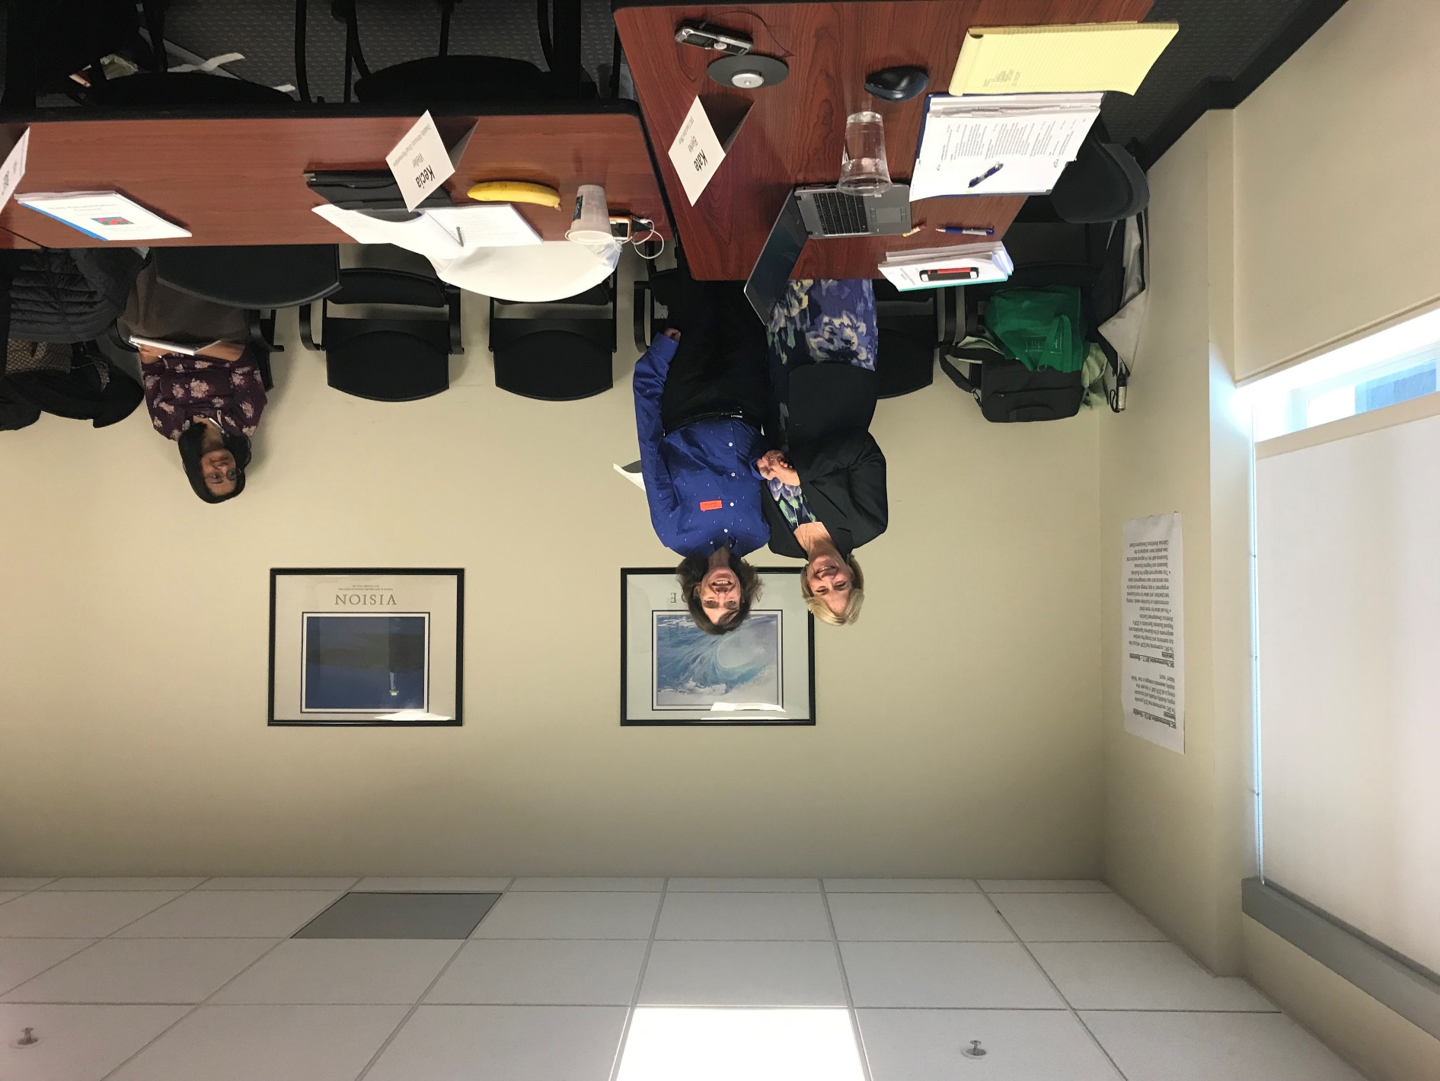The second day of the November 2017 quarterly meeting was held in conjunction with the California State Independent Living Council (SILC). Per 34 CFR 361.17, a function of the SRC is to coordinate activities with the SILC, and to support the working relationship between DOR, the SILC and California’s independent living centers. During the joint meeting, the SILC and SRC had interactive discussions regarding job readiness for consumers and identified data and resources that would improve community conditions for youth with disabilities. Presentations were given on the state budget development process and the State Council on Developmental Disabilities. The meeting concluded with an interactive discussion between the two councils and the DOR Directorate.

Picture of DOR Deputy Director, Kathi Mowers-Moore, welcoming Kecia Weller to the SRC.

## February 2018 Meeting Highlights

A focus of the February 2018 quarterly meeting was continued, in-depth discussions on business engagement and employment outcomes. SRC members and DOR representatives discussed job readiness, resume development, job placement circles, business engagement at the national level, consumer self-employment, and engaging federal, state, nonprofit and other employers that are not corporations.

The SRC received an important update on the implementation of DOR’s Student Services. Information was provided on DOR’s coordination with the Department of Education, the redirection of DOR staff to focus on student services, and work experience opportunities for students.

Other notable items from the February 2018 meeting included an interactive report out with the DOR Directorate and a discussion with Theresa Comstock, President of the California Association of Local Behavioral Health Boards and Commissions. Theresa spoke about her organization, opportunities for collaboration, and topics of interest - particularly Individual Placement and Support. Also during this meeting, the SRC reviewed and approved the 2018 – 2020 modification to the VR Services Portion of the Unified State Plan. Leading up to this approval, the SRC actively collaborated with DOR to develop the State Plan goals and objectives.

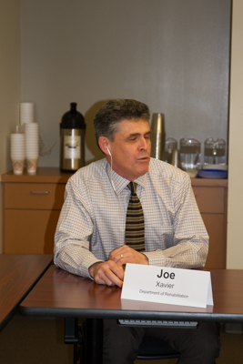

Picture of DOR Director, Joe Xavier, providing an update to the SRC.

## May 2018 Meeting Highlights

Many of the May 2018 quarterly meeting topics centered on the theme of innovation. The meeting began with a report out from the DOR Directorate and a presentation on DOR’s Expedited Enrollment process which is accelerating the ability for consumers to enroll for services and modernizing DOR’s business processes. The SRC learned about informing and shaping state policy, and how to use the SRC’s collective voice to respond to opportunities for input and think in ways that are new, innovative and creative. The SRC received information on DOR’s newly formed Strategic Initiatives Office and their focus on optimization, innovation and strategic thinking. A highlight of the meeting was the interactive brainstorming session held with the SIO and SRC on the Consumer Satisfaction Survey.

Chair Gibbons provided a leadership update from her participation at the April 2018 National Coalition of State Rehabilitation Conference (NCSRC). A representative from the Assistive Technology Advisory Committee provided the SRC with information on the committee and the grant program that offers assistive technology lending libraries, devices, self-advocacy support, and more. Members reviewed the administrative hearing decisions from the prior six months and reviewed proposed updates to the SRC bylaws.

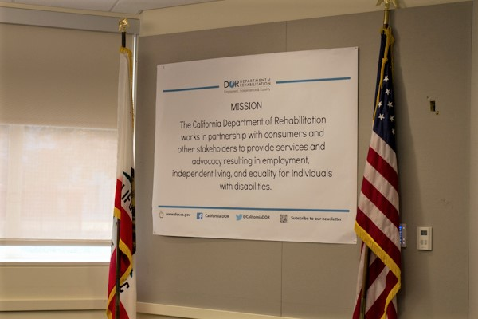

Picture of the DOR mission statement poster and the California and US flags displayed in the meeting room used by the SRC.

## August 2018 Meeting Highlights

The August meeting began with the identification of next steps for the “Adopt-a-District” program, approval of new administrative law judges, and an update on the State Price Schedule for Assistive Technology. The SRC’s Policy Committee held a robust discussion regarding the use of labor market information in the VR process. The SRC’s Unified State Plan Committee collaborated with new researchers and analysts from the DOR Planning Unit. DOR Director, Joe Xavier, administered the oath of office to new SRC members Nicolas Wavrin and Theresa Comstock and acknowledged the appointment of new members Benjamin Aviles and Jia Nai “Eddie” Zhang. The SRC held an active question and answer session on DOR Student Services with leaders from the DOR VR Employment Division. During this meeting, the SRC continued their collaboration with the DOR Strategic Initiatives Office on the Consumer Satisfaction Survey and also discussed DOR’s organizational climate survey. Members approved the proposed updates to the SRC bylaws. The meeting concluded with a working session during which the SRC developed and adopted four recommendations for submission to DOR.

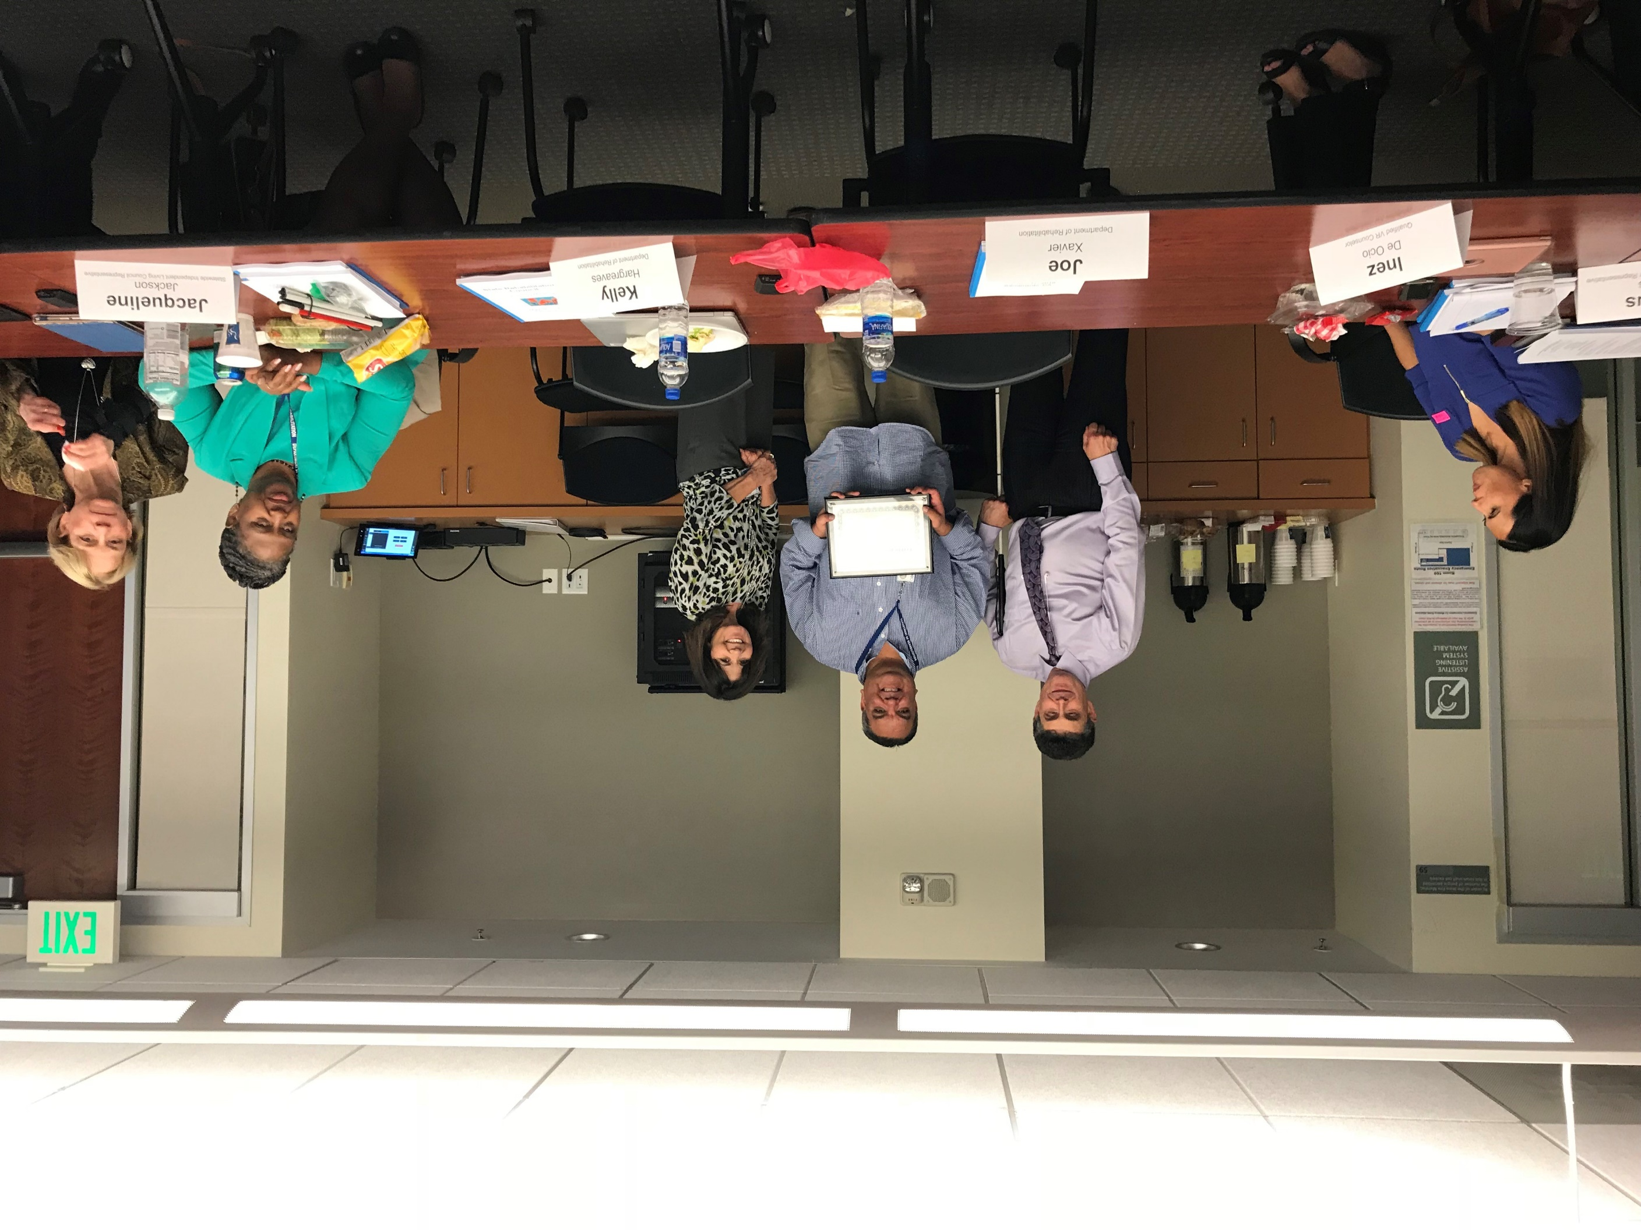

Picture of DOR Director, Joe Xavier, and DOR Chief Deputy Director, Kelly Hargreaves, presenting a certificate of appreciation to exiting SRC member, Marc Espino.

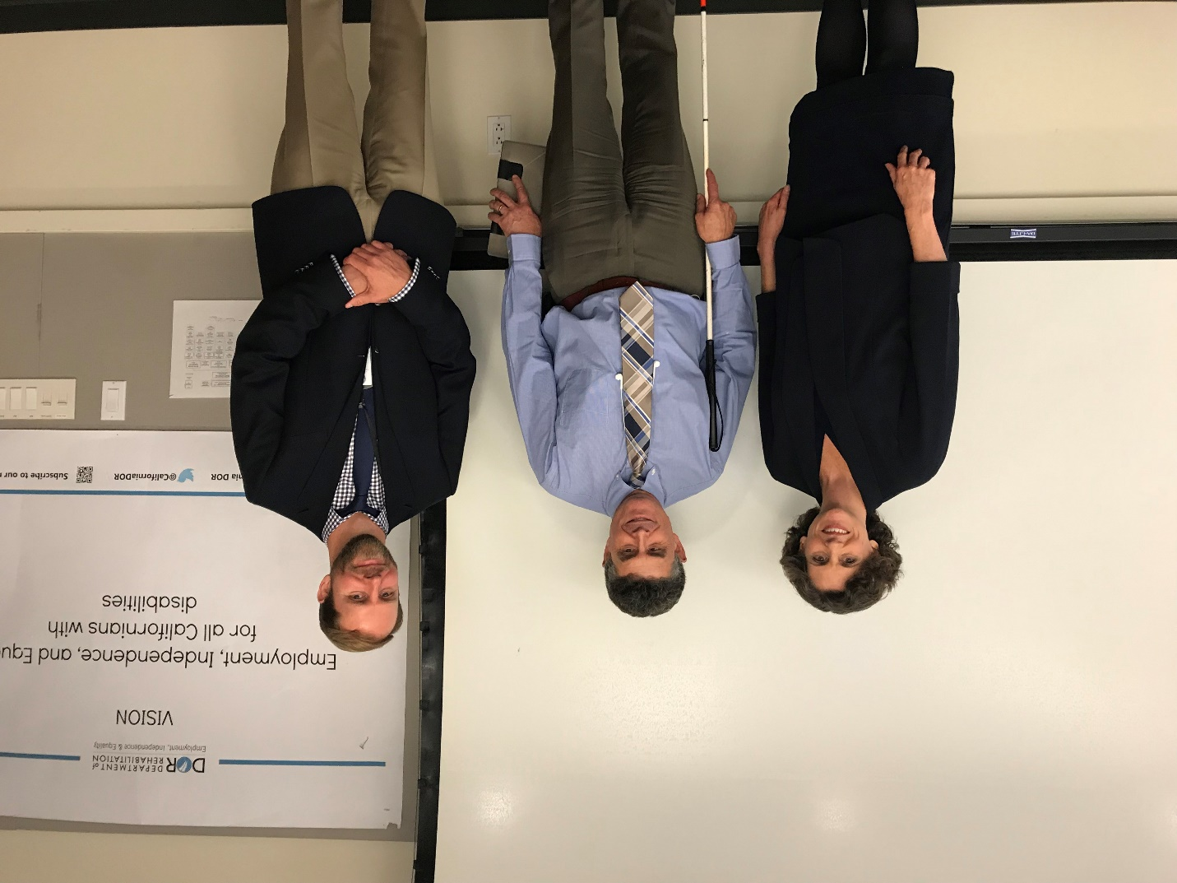

Picture of SRC member Theresa Comstock, DOR Director Joe Xavier, and SRC member Nicolas Wavrin.

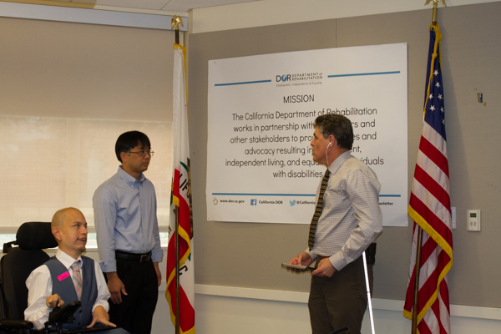

Picture of SRC members Benjamin Aviles, Eddie Zhang, and DOR Director Joe Xavier.

# 2018 SRC Recommendations

As a result of the many productive and active discussions between the SRC, DOR and other stakeholders during the October 2017 – September 2018 term, the SRC adopted the following recommendations. These recommendations reflect the SRC’s efforts to review, analyze and advise DOR regarding the performance and effectiveness of California’s VR program. The SRC looks forward to working closely with DOR on these areas of interest.

## 2018.1 - Rehabilitation Administrative Manual

The SRC recommends that the Rehabilitation Administrative Manual be posted on the Department of Rehabilitation’s external website. This will support consumer self-advocacy, informed choice, promote transparency, and clarity of understanding.

August 16, 2018 Update: The SRC recommends that the Department prioritize the posting of the following Rehabilitation Administrative Manual chapters that pertain to consumer services:

* Chapter 0: Contents and Introductions
* Chapter 1: Organization
* Chapter 7: Contracts
* Chapter 9: Procurement
* Chapter 11: Authorizing, Encumbering and Disencumbering
* Chapter 12: Vocational Rehabilitation Goods and Services
* Chapter 15: Case Service Property
* Chapter 29: Individual Service Providers
* Chapter 30: Record of Services
* Chapter 31: Supported Employment Program
* Chapter 34: Other Consumer-Related Topics

DOR Response to Recommendation 2018.1

We agree that posting the Rehabilitation Administration Manual (RAM) chapters pertaining to consumer services will inform and empower consumers, stakeholders and the public. In early 2019, DOR is launching a redesigned website. We will post RAM chapters 0, 1, 7, 9, 11, 12, 15, 29, 30, 31, and 34 in the “Public Information” section on the redesigned DOR website.

## Recommendation 2018.2 – Leveraging Partnerships

The SRC recommends that the Department prioritize efforts to leverage partner programs and resources to improve consumer services and outcomes.

DOR Response to Recommendation 2018.2

We agree that leveraging partnerships leads to improved services and outcomes for consumers. Examples of DOR’s current partnerships include the following:

* DOR recently developed a relationship with the Foundation for California Community Colleges, a non-profit designed to improve higher educational opportunities that benefit students, colleges, and college foundations in California. This collaboration is creating more work experience opportunities for students with disabilities.
* DOR partnered with the Department of Education, the Department of Developmental Services, and stakeholders to develop the California Competitive Integrated Employment Blueprint. This will increase opportunities for Californians with intellectual and developmental disabilities in obtaining competitive wage employment in community integrated settings. A critical component of implementing the Blueprint is establishing local partnership agreements between local educational agencies, DOR districts, and regional centers to identify ways to work together.
* DOR entered into an interagency agreement with the Department of Education to create a coordinated system of educational and vocational rehabilitation services for students with disabilities.
* DOR has 178 cooperative agreement partnerships with county mental health agencies, secondary education agencies, adult schools, community colleges, and University and California State colleges. Through these agreements, DOR consumers and family members receive training in vocational readiness skills, career exploration, work experience placements, and employment services.
* DOR serves as a resource and provides training to local Workforce Development Boards and America’s Job Center of California to support the hiring, retention and promotion of adults and youth with disabilities.

To further advance DOR’s priority of building and leveraging partnerships, DOR is developing a team to map both existing and potential partner programs and resources. We will look to the SRC’s knowledge and expertise to inform this effort. Ultimately, these efforts will assist DOR and our partners with achieving the policy objective identified in California’s Unified State Plan of “aligning, coordinating, and integrating programs and services to economize limited resources while also providing the right services to clients, based on each client’s particular and potentially unique needs so as to facilitate skills-attainment.”

## Recommendation 2018.3 – Consumer Satisfaction

The SRC recommends that the Comprehensive Statewide Assessment (2018–20) be used to gather information from consumers regarding effective methods to elicit feedback about their DOR experience. This information could be utilized by the SRC and the Department to develop the Consumer Satisfaction Survey.

DOR Response to SRC Recommendation 2018.3

We agree that having deeper insight into the most effective ways to collect feedback from consumers about their DOR experience would be beneficial. DOR is currently developing the 2018-2020 Comprehensive Statewide Assessment (CSA). Through this effort, DOR will reach out to consumers through interviews, focus groups, surveys, etc. about providing feedback on their DOR experience. This will help us update and modify the methodology for receiving consumer feedback so we can use the information to its maximum potential and make positive changes to better serve consumers. We look forward to collaborating with the SRC on the 2018-2020 CSA.

## Recommendation 2018.4 – Labor Market Information

The SRC recommends that the Department should ensure each consumer has a clear understanding of labor market information and its integral role in determining an employment goal. Labor market information should be made readily available to job seekers.

DOR Response to Recommendation 2018.4

We agree that the use of labor market information (LMI) is a critical component of the vocational rehabilitation process. Available to all DOR staff are online training modules that contain current information on how to utilize LMI to provide important information to consumers about their employment goal. DOR staff, including the Business Specialists, regularly receive opportunities for training on businesses’ needs and hiring practices either during monthly calls or at district and unit meetings. Additionally, we are excited to announce that in early 2019, we will launch a redesigned DOR website that will include user-friendly, current and accessible labor market information available to all job seekers. DOR welcomes the opportunity to have further discussions with the SRC on LMI and informed choice.

# 2018 Cons**u**mer Satisfaction Survey (CSS)

The Rehabilitation Act calls for the SRC to review and analyze the effectiveness of, and consumer satisfaction with, DOR’s delivery of VR services and the employment outcomes achieved by consumers.

To carry out this responsibility, the SRC collaborates with DOR to conduct an annual Consumer Satisfaction Survey (CSS). The SRC’s activities include: developing and modifying questions, advising on methodology, reviewing findings and data, and preparing a response for inclusion in DOR’s survey report. The survey results are utilized by DOR to increase the effectiveness of the service delivery process, both internally and externally.

During the 2017 – 18 term, efforts took place to revisit the survey’s objectives, design and data analysis methods. To kick start the discussions, DOR’s Program Policy Implementation Unit presented the SRC with an expanded analysis of the 2017 CSS results and critical findings. In May 2018, the SRC and the DOR Strategic Initiatives Office held a brainstorming session to explore the following: What questions should a consumer satisfaction survey answer, and what data is needed to answer those questions? Using the generated ideas and feedback, researchers from the Strategic Initiatives Office joined the SRC in August 2018 and presented ideas on: question addition and modification, demographics, rating systems, other mechanisms (besides a survey) for collecting consumer satisfaction data, and more. As a result of the information sharing and discussions, the SRC adopted the following recommendation:

“Recommendation 2018.3 – Consumer Satisfaction

The SRC recommends that the Comprehensive Statewide Assessment (2018–20) be used to gather information from consumers regarding effective methods to elicit feedback about their DOR experience. This information could be utilized by the SRC and the Department to develop the Consumer Satisfaction Survey.”

The SRC looks forward to continued collaboration with DOR during the 2018 – 19 term on the CSS. For more information, including the current CSS report, please visit [www.dor.ca.gov](http://www.dor.ca.gov).

# VR Services Portion of the Unified State Plan

The Workforce Innovation and Opportunity Act (WIOA) requires each state to submit a Unified or Combined State Plan that outlines a four-year strategy for the State’s workforce development system. For 2016 – 2020, California elected to submit a Unified State Plan, which includes six core programs: Adult, Dislocated Worker, Youth, Adult Education and Family Literacy Act, Wagner-Peyser Services and VR. The SRC’s Unified State Plan Committee met quarterly with the DOR’s Planning Unit to receive updates on State Plan progress and activities, and to monitor DOR’s priorities, goals, objectives and strategies.

The State Plan was modified in the spring of 2018 and is available online at [www.dor.ca.gov](http://www.dor.ca.gov). For the VR portion of the plan, DOR and SRC jointly developed the following four priorities and eight goals for 2018 – 2020. These priorities and goals to ensure the VR and supported employment programs are in alignment with WIOA and include transition services for youth and students with disabilities, business engagement, program partnerships and competitive integrated employment.

## Priority 1: Youth

Goal: Fully implement pre-employment transition services through a realignment of staff and service delivery methods.

Goal: Increase coordination of services between CDOR and other partners to support students with disabilities.

Goal: Expand and improve California’s infrastructure and capacity for making available pre-employment transition services to students with disabilities in need of such services by utilizing pre-employment transition services Authorized Activities.

Goal: Collaborate with partners to provide information and referral to out-of-school youth with disabilities who are identified as unserved or underserved in the Comprehensive Statewide Assessment.

## Priority 2: Business Engagement

Goal: Increase partnerships with local businesses to develop or expand work experience, internship, and employment opportunities for adults and youth with disabilities.

Goal: Both internally and with CDOR’s partners, develop systems capacity, knowledge, skills and abilities, in order to effectively meet the needs of businesses.

## Priority 3: Capacity Building

Goal: Establish or enhance partnerships to increase the capacity of CDOR and the WIOA core program partners to improve service delivery for adults and youth with disabilities.

## Priority 4: Competitive Integrated Employment

Goal: Increase competitive integrated employment opportunities, and outcomes and supports for adults and youth with disabilities, particularly those with the most significant disabilities, including those receiving Supported Employment services, and those underserved.

# Current SRC Members (as of December 2018)

| SRC Member | Picture |
| --- | --- |
| Lesley Ann Gibbons, Chair  * Business, Industry, and Labor representative * Co-owner and Director at Sterling Adaptives * Re-elected as SRC Chair on November 15, 2018 for a one-year term * Serving second SRC term (September 2016 – September 2019) | Lesley Ann Gibbons Photo |
| Marcus Williams, Vice-Chair  * Business, Industry, and Labor representative * Military and Disability Recruitment Programs Leader for Kaiser Permanente * Re-elected as SRC Vice-Chair on November 15, 2018 for a one-year term * Serving second SRC term (September 2018 – September 2021) | Picture of Marcus Williams |
| Inez De Ocio, Treasurer  * VR Counselor representative * Senior Vocational Rehabilitation Counselor, Qualified Rehabilitation Professional in DOR’s Visalia Branch * Re-elected as SRC Treasurer on November 15, 2018 for a one-year term * Serving second SRC term (September 2018 – September 2021) | Inez De Ocio Photo |
| Jacqueline Jackson  * Statewide Independent Living Council representative * Independent Nonprofit Management Consultant * Serving second SRC term (September 2016 – September 2019) | Jacqueline Jackson photo |
| Vicki Benson  * Parent Training and Information Center representative * Adult Transition Project Coordinator at the Exceptional Parents Unlimited Region 3 Parent Training and Information Center * Serving second SRC term (September 2016 – September 2019) | Victoria Benson Photo |
| Michael Thomas Policy Committee Chair   * Client Assistance Program representative * Coordinator and Senior Advocate at Disability Rights California * Serving second SRC term (September 2018 – September 2021; term limits do not apply to this position) | Michael Thomas Photo |
| **Jia Nai “Eddie” Zhang**  Community Rehabilitation Program representative   * Director of Supported Employment at AbilityFirst * Serving first SRC term (August 2018 – September 2020) | Jia Nai “Eddie” Zhang photo |
| LaQuita Wallace  * Business, Industry, and Labor representative * Human Resources Specialist at the U.S. Bureau of Reclamation * Serving second SRC term (September 2018 – September 2021) | LaQuita Wallace Photo |

| SRC Member | Picture |
| --- | --- |
| Theresa Comstock  * Disability Advocacy Group representative * Executive Director, California Association of Local Behavioral Health Boards & Commissions * Serving first SRC term (August 2018 – September 2020) | Theresa Comstock photo |
| Benjamin Aviles  * Current or Former DOR Consumer representative * Financial Professional at World Financial Group/Revolution Financial Management * Serving first SRC term (August 2018 – September 2020) | Benjamin Aviles Photo |
| Abby Snay Unified State Plan Committee Chair   * California Workforce Development Board representative * Chief Executive Officer at Jewish Vocational Services of San Francisco * Serving second SRC term (September 2016 – September 2019) | Abby Snay Photo |
| Kecia Weller  * Disability Advocacy Group representative * Self-advocacy and Community Liaison at the UCLA Tarjan Center * Member of the California State Council on Developmental Disabilities * Serving first SRC term (October 2017 – September 2020) | Kecia Weller Photo |

| SRC Member | Picture |
| --- | --- |
| Nicolas Wavrin  * California Department of Education (CDE) representative * educational programs consultant of the Quality Assurance Unit at the California Department of Education since 2018 * Serving first SRC term (June 2018 – September 2020) |  |
| Joe Xavier, Ex-Officio Member  * Director, Department of Rehabilitation * Serving second SRC term (September 2016 – September 2019) | Joe Xavier Photo |

| SRC Member | Picture |
| --- | --- |
| Marc Espino Monitoring and Evaluation Committee Chair   * American Indian VR Project representative * Sycuan Inter-Tribal VR Program * Completed first SRC term (September 2015 – September 2018) | Marc Espino Photo |

# Completed SRC Appointments

# Interested in Becoming an SRC Member?

Would you like to advocate for the employment, independence and equality for people with disabilities? Are you interested in joining a council that ensures consumers and other stakeholders have a voice in California’s VR program? If so, then a position on the SRC may be for you! The SRC is always looking for new members to fill positions on the Council. If you are interested in serving on the SRC and would like more information about the application process, please send your contact information to [SRC@dor.ca.gov](mailto:SRC@dor.ca.gov) or call (916) 558-5897. Thank you for considering the SRC!

# About the Department of Rehabilitation

DOR administers the largest VR program in the country. DOR has a three-pronged mission to provide services and advocacy that assist people with disabilities to live independently, become employed and have equality in the communities in which they live and work. DOR provides consultation, counseling and VR, and works with community partners to assist the consumers we serve.

**For additional information about DOR, including the Department’s current Annual Report, visit** [www.dor.ca.gov](http://www.dor.ca.gov)

## DOR Vision Statement

Employment, independence and equality for all Californians with disabilities.

## DOR Mission Statement

The California Department of Rehabilitation works in partnership with consumers and other stakeholders to provide services and advocacy resulting in employment, independent living and equality for individuals with disabilities.

## Our Core Values

* We believe in the talent and potential of individuals with disabilities.
* We invest in the future through creativity, ingenuity and innovation.
* We ensure our decisions and actions are informed by interested individuals and groups.
* We pursue excellence through continuous improvement.
* We preserve the public's trust through compassionate and responsible provision of services.

## Our Guiding Principles

* Delivering effective VR services, and other programs and services in an efficient, caring, professional and prompt manner.
* Attracting, developing, and retaining a competent, creative, and highly motivated workforce.
* Maintaining public trust by being fiscally responsible and ensuring quality programs and services.
* Sustaining our role as a respected leader in the disability community; inspiring hope in those we serve.

# DOR District Office Locations

| Northern California | Southern California |
| --- | --- |
| Greater East Bay District (925) 602-3953  (844) 729-2800 (TTY)  1485 Civic Court , Suite 1100  Concord, CA 94520-5228 | Greater Los Angeles District (213) 736-3904 (Voice)  (844) 729-2800 (TTY)  3333 Wilshire Blvd., Suite 200  Los Angeles, CA 90010-4101 |
| Northern Sierra District (916) 558-5300  (844) 729-2800 (TTY)  721 Capitol Mall  Sacramento, CA 95814 | Inland Empire District (951) 782-6650  (844) 729-2800 (TTY)  2010 Iowa Avenue , Suite 100  Riverside, CA 92507 |
| Redwood Empire District (707) 576-2233  (844) 729-2800 (TTY)  50 "D" Street, Suite 425  Santa Rosa, CA 95404-4764 | Los Angeles South Bay District (562) 422-8325  (844) 729-2800 (TTY)  4300 Long Beach Blvd., Suite 200  Long Beach, CA 90807-2008 |
| San Francisco District (415) 802-2330  (844) 729-2800 (TTY)  455 Golden Gate Ave. Suite 7727  San Francisco, CA 94102 | Orange / San Gabriel District (714) 991-0800  (844) 729-2800 (TTY)  222 S. Harbor Blvd., Suite 300  Anaheim, CA 92805-3701 |
| San Joaquin Valley District (559) 445-6011  (844) 729-2800 (TTY)  2550 Mariposa Mall, Room 2000  Fresno, CA 93721-2270 | San Diego District (619) 767-2100 (Voice)  (844) 729-2800 (TTY)  7575 Metropolitan Drive, Suite 107  San Diego, CA 92108-4402 |
| San Jose District (408) 277-1355  (844) 729-2800 (TTY)  100 Paseo de San Antonio, Room 324  San Jose, CA 95113-1479 | Van Nuys / Foothill District (818) 901-5024 (Voice)  (844) 729-2800 & (818) 901-4509 (TTY)  15400 Sherman Way , Suite 140  Van Nuys, CA 91406 |
| Santa Barbara District (805) 560-8130  (844) 729-2800 (TTY)  509 East Montecito Street, Suite 101 Santa Barbara, CA 93103-3216 |  |

California State Rehabilitation Council
721 Capitol Mall
Sacramento, CA 95814
SRC@dor.ca.gov
(916) 558-5897