

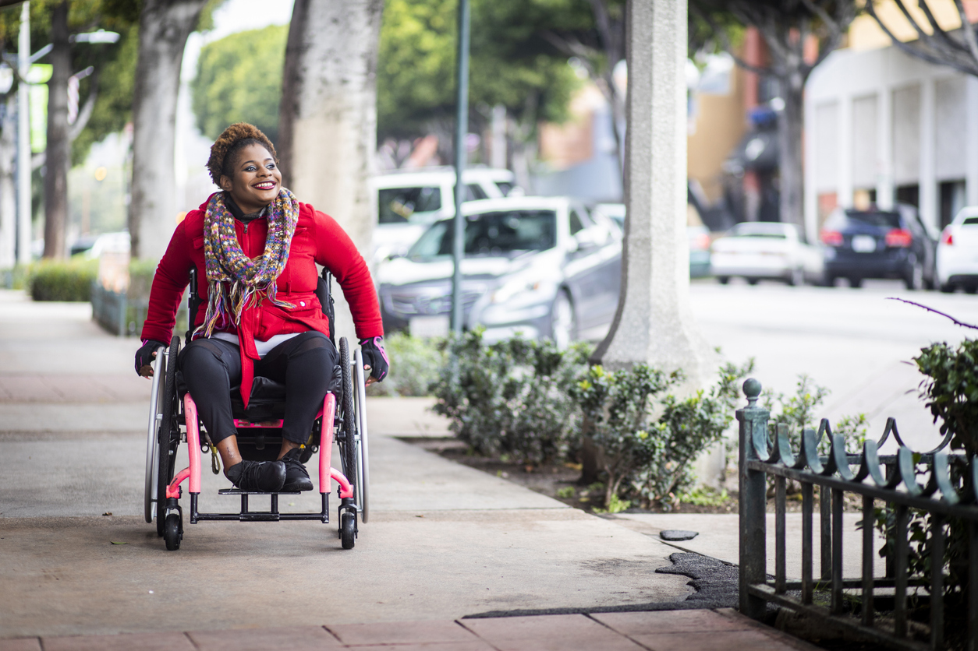

**California**

**2019 Annual Report**

**October 1, 2018 – September 30, 2019**

**Table of Contents**

Message from the Incoming SRC Chair 3

Message from the Former SRC Chair 5

Message from the DOR Director 6

The Rehabilitation Act and the SRC 7

California SRC Overview 8

SRC Highlights and Accomplishments 11

SRC Quarterly Meetings 14

SRC Recommendations 16

Consumer Satisfaction Survey 21

VR Services Portion of the California Unified State Plan 26

Current SRC Members (as of Dec. 2019) 28

Completed Appointments (as of Dec. 2019) 31

Interested in Becoming an SRC Member? 32

About the Department of Rehabilitation 33

# Message from the Incoming SRC Chair

December 2019

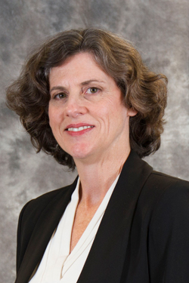

To the Honorable Governor Gavin Newsom and

RSA Commissioner Mark Schultz

It is an honor to present this annual report on behalf of the California State Rehabilitation Council (SRC). The SRC works in an advisory capacity to California’s Department of Rehabilitation (DOR). DOR administers the largest vocational rehabilitation (VR) and independent living programs in the country.

The SRC understands the critical importance of employment. In the spirit of listening and collaboration with stakeholders and the DOR, our goal is to see California’s VR programs provide offerings that ultimately result in sustained competitive employment for Californians with disabilities. This annual report details the SRC’s work, including recommendations, activities and information on the SRC’s diverse, engaged membership.

As we move forward into the coming year, anticipated areas of focus include:

1. VR Workforce: Reviewing and advising regarding workforce needs, to ensure an adequate, and sustained VR workforce that provides effective VR services.
2. Cross-Agency Collaboration: Reviewing and advising regarding cross-agency collaboration (state, county and local) with emphasis on:
   1. Seamless access to services for individuals of all ages and disabilities (to include agencies involved with children and youth (including foster youth), criminal justice, mental/behavioral health, and older adults).
   2. Increasing integration of funding streams.
3. Business Engagement: Reviewing and advising regarding increasing the variety and supply of potential employers.

Finally, we note the accomplishments of the DOR and thank their staff and leadership. Through approximately 85 field offices, the DOR provided services to 108,916 individuals, with 29,562 students receiving services in FY 2018-19.

Thank you for your support of the SRC and the DOR as we work to increase equality and employment for Californians with disabilities.

Theresa Comstock

Chair, State Rehabilitation Council

# Message from the Former SRC Chair

December 2019

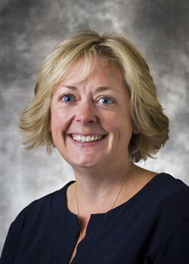To the Honorable Governor Gavin Newsom and

RSA Commissioner Mark Schultz

It has been a wonderful opportunity and honor to serve as an SRC member since 2014, and as SRC Chair over the past two years.

I’m proud of the SRC’s many accomplishments, including the advancement of the SRC’s policy efforts, in-depth work on the Consumer Satisfaction Survey and much-needed council logo.

I want to extend my appreciation for fellow SRC members who dedicate their time to participate, be involved, and support the work of the Department. I'd also like to acknowledge the many DOR representatives who’ve frequently engaged with the SRC over the past years.

May I take this opportunity to wish the SRC all the best as the Council continues to evolve, strengthen, and advocate for the employment and independence for Californians with disabilities.

Lesley Ann Gibbons

Former Chair, State Rehabilitation Council

# Message from the DOR Director

December 2019

To the Honorable Governor Gavin Newsom and

RSA Commissioner Mark Schultz

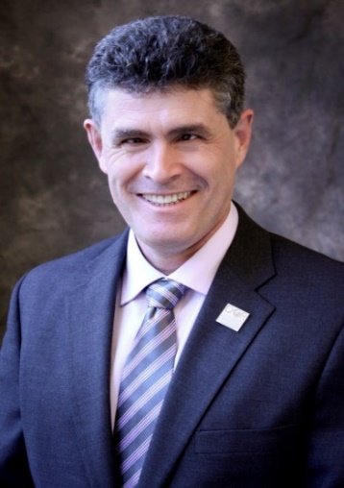

I would like to recognize the active partnership between the SRC and DOR during the 2018 – 2019 term. The SRC and DOR engaged in timely and significant discussions on topics such collaboration with mental/behavioral health programs, consumer financial participation, and the implementation of DOR student services. We are grateful for the input and ideas offered by the SRC.

One of DOR’s core values is to ensure that our decisions and actions are informed by interested individuals and groups. The SRC helps DOR carry out this core value and we count on the SRC members to voice the perspectives of their networks and constituencies. The SRC members also have a critical role in keeping their communities updated on DOR’s programs and services. We appreciate and recognize the importance of this ongoing communication.

We continue to welcome the SRC’s partnership as DOR works to meet California’s business needs for quality personnel and support Californians with disabilities in reaching their potential. This next year will present opportunities for collaboration with many stakeholders and partners, including Health and Human Services, Labor and Education, as we work together to build a California for all, including individuals with disabilities.

Joe Xavier, Director

California Department of Rehabilitation

# The Rehabilitation Act and the SRC

When new SRC members are appointed by the Governor, they are provided with information on how and why the SRC exists in relation to findings, purpose and principles of the Rehabilitation Act of 1973 (as amended). This foundational information provides context and helps to frame subsequent SRC discussions and activities.

## Rehabilitation Act – Findings

In the Rehabilitation Act, Congress identified that individuals with disabilities have the right to: Live independently, enjoy self-determination, make choices, contribute to society, pursue meaningful careers, and enjoy full inclusion and integration in society. In the Act, Congress also identified the need to support students with disabilities as they transition from school to postsecondary life.

## Rehabilitation Act – Purpose

Based upon these findings, the purpose of the Rehabilitation Act is to empower individuals with disabilities to maximize competitive integrated employment, economic self-sufficiency and inclusion into society. The purpose of the Rehabilitation Act also includes:

* Ensuring that youth with disabilities have opportunities for post-secondary success.
* Having vocational rehabilitation (VR) service providers and employers provide meaningful input, thereby increasing employment opportunities and outcomes for individuals with disabilities.
* Ensuring that the federal and state governments support the employment of individuals with disabilities.

## The DOR and SRC Partnership

The DOR and the SRC partner together to carry out the Rehabilitation Act to maximize the employment and independence for people with disabilities. The partnership is a call to action to advocate and hear the voices of individuals served by VR in California. The partnership between the SRC and DOR ensures that individuals with disabilities have resources and support to achieve their goals, while also ensuring that the California VR program is effective and in compliance with federal regulations.

# California SRC Overview

Section 105 of the Rehabilitation Act of 1973 (as amended) requires consumers, advocates and other representatives of individuals with disabilities to participate in the administration and oversight of a state’s VR program. The SRC fulfills this mandate in California and is required in order for DOR to be eligible for and maintain federal VR funds.

## Mission Statement

The SRC, in collaboration with the DOR and other community partners, reviews and analyzes policies, programs and services, and advises DOR on the quality and performance in meeting the Department’s mission.

## Vision Statement

The voice of DOR’s stakeholder community.

## Membership and Meetings

The SRC consists of 16 members appointed by California’s Governor, representing a variety of perspectives from the VR program and disability community. Members can serve up to two consecutive three year terms. The SRC holds four quarterly in-person meetings throughout the year, typically in DOR’s central office in Sacramento. Members of the public are noticed of the meetings in accordance with California’s Open Meeting Act.

## Responsibilities and Activities

* Evaluation and Recommendations: The SRC reviews, analyzes and evaluates DOR on the performance of California’s VR program. A particular focus is given to eligibility, service provision, and activities that impact employment outcomes. As a result of this process, the SRC adopts recommendations which are submitted to DOR for consideration.
* Comprehensive Statewide Assessment: To identify and assess the needs of Californians with disabilities, the SRC collaborates with DOR on the triennial Comprehensive Statewide Assessment.
* State Plan: The SRC advises DOR on the development of California’s VR Services Portion of the Unified State Plan. The SRC and DOR partner to develop, agree to and review the plan’s priorities and goals.
* Assessing Consumer Satisfaction: The SRC partners with DOR to develop the annual Consumer Satisfaction Survey and to evaluate the survey results.
* Coordination and Participation: The SRC actively engages with other councils and advisory bodies in California to enhance the number of individuals served. SRC members also participate in work groups, public meetings and stakeholder forums.

## SRC Committee Structure

The SRC utilizes a committee structure to provide for greater discussion, analysis and oversight of the SRC’s mandated responsibilities and to assist with carrying out the SRC’s administrative functions. Each SRC committee may prepare recommendations for the full Council’s consideration. The SRC examines the committee structure for efficiency and alignment with the council’s priorities. The SRC current committees include:

* Monitoring and Evaluation: Assigned areas include partnering with DOR on the Consumer Satisfaction Survey and the Comprehensive Statewide Assessment; reviewing and analyzing trends in Office of Administrative Hearing decisions; reviewing DOR’s progress on federal and state performance measures.
* Policy: Analyzes, evaluates and develops recommendations regarding DOR’s current (and proposed) programs, policies and services.
* Unified State Plan: Partners with DOR on the Comprehensive Statewide Assessment and the VR Services Portion of the Unified State Plan.
* Executive Planning: Comprised of the SRC Officers and Committee Chairs, this committee convenes to plan for the quarterly meetings and address any time-sensitive leadership issues that may arise.

# SRC Highlights and Accomplishments

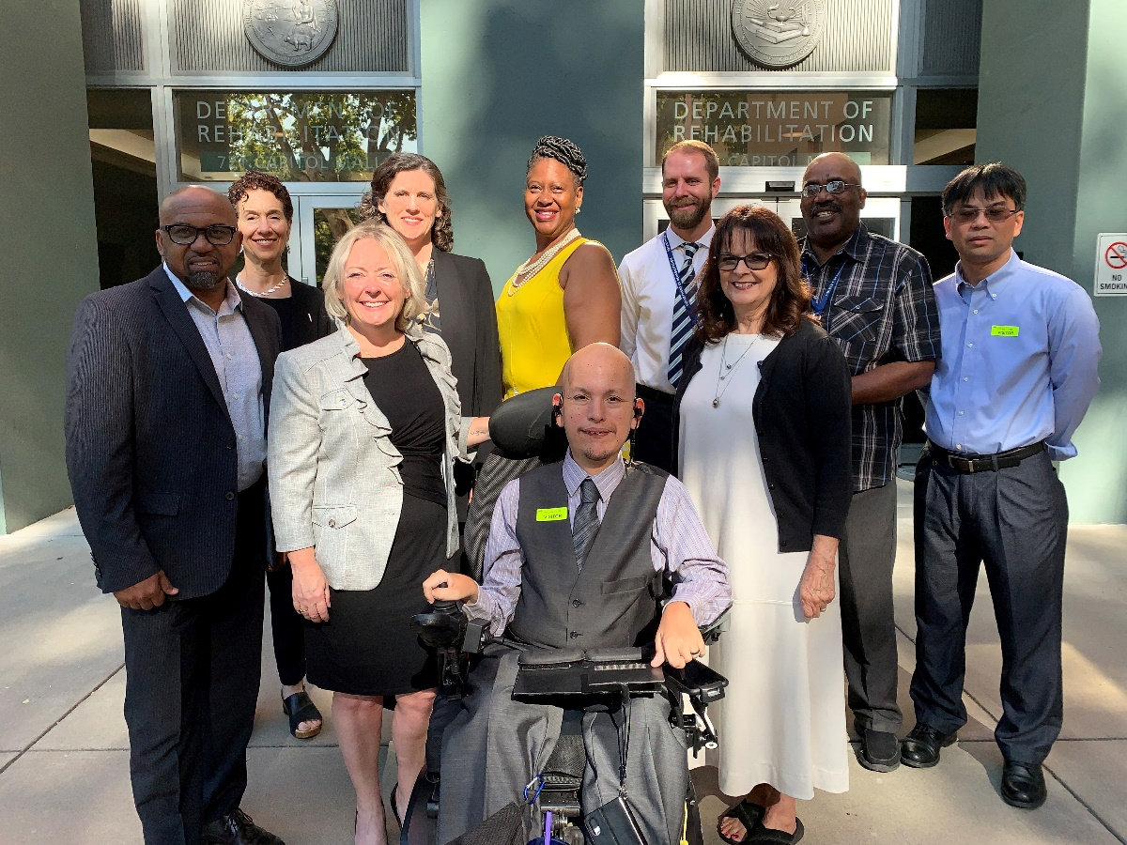

August 2019 SRC member group photo in front of DOR’s Central Office in Sacramento, California. Back row: Abby Snay, Theresa Comstock, Jacqueline Jackson, Nicolas Wavrin, Michael Thomas, Eddie Zhang. Front row: Marcus Williams, Lesley Ann Gibbons, Benny Aviles, Vicki Benson.

## Collaboration between the SRC and DOR

Throughout the October 1, 2018 – September 30, 2019 term, the SRC frequently collaborated with DOR to work towards the shared goals of increased employment, independence and equality for Californians with disabilities. The SRC is appreciative of DOR’s many efforts to provide SRC members with the opportunity to learn about DOR’s programs and policies and to provide substantive feedback. Collaboration highlights include:

* DOR Directorate and SRC Partnership: Each SRC quarterly meeting includes an in-depth report from the DOR Directorate on federal, state and department issues of interest. SRC members engage with the Directorate to ask questions, provide input, discuss challenges and identify opportunities. The SRC Chair and Vice-Chair have monthly informal conversations with the DOR Directorate to strengthen the DOR and SRC partnership. Leadership topics and areas of shared interest and concern are discussed.
* DOR Participation: DOR executives, managers and staff frequently attend the SRC quarterly meetings to listen, provide updates, engage in interactive discussions and gather feedback from the SRC members. DOR subject matter experts regularly participate in SRC committee meetings to provide information and resources that inform the SRC’s recommendation development process.
* SRC Executive Officer: DOR employs a Staff Services Manager I (Specialist) to serve as the SRC Executive Officer, providing fulltime support to the Council. Kate Bjerke has served in this position since May 2017.
* Adopt-a-District Program: Each SRC member is assigned to meet with a DOR Regional Director on a quarterly basis. Through these discussions, SRC members build connections and learn about issues and opportunities from the local perspective. SRC members provide a report out from their Regional Director meetings at the end of each SRC quarterly meeting.
* Collaboration with Mental/Behavioral Health: On February 6, 2019 in Sacramento, and on May 17, 2019 in Pasadena, DOR convened stakeholder roundtable meetings, which included an SRC representative, to discuss successful employment programs for individuals with behavioral health disabilities. The meetings focused on identifying collaborative goals and next steps to assist individuals with behavioral health disabilities to decrease poverty, increase health stability, and achieve competitive integrated employment. A Steering Committee has been created to continue advancing this work and collaboration.
* Financial Participation: On May 21, 2019, the SRC and DOR jointly hosted a public forum to gather feedback from the stakeholder community on proposed changes to state regulations on consumer financial participation policies. During the forum, the following topics were discussed:
* Implementing a fair and equitable method of calculating consumer financial participation for most DOR services.
* Sharing the cost of postsecondary education services with those who are most financially able, supported by federal regulations.

The SRC considered this stakeholder feedback as the Council developed a financial participation policy recommendation.

* Innovative Efficiencies: The Workforce Innovation and Opportunity Act redirects 15 percent of VR funds for pre-employment transition services (also referred to as DOR Student Services) along with other new requirements. As a result, this has created pressure to serve all individuals who apply for VR services with only 85% of the VR funds previously available. Throughout the term, the SRC and DOR engaged in active discussions to identify innovative approaches to providing VR services that will result in employment outcomes through more efficient and less costly practices.

## Highlights

* Logo: On June 12, 2019, the SRC formally adopted a logo. The SRC’s goals for having a logo include building internal cohesion, developing trust with external constituents, projecting a professional image, increasing recognizability, and incorporating the logo into collateral materials to assist with new member recruitment. The SRC appreciates the graphic design services provided by DOR’s Legislation and Communication team. The logo includes a graphic of 16 interconnected dots, representing the 16 SRC members and their networks. The logo is as follows:



* National Coalition of State Rehabilitation Councils (NCSRC): In October 2018, SRC members Jacqueline Jackson, Theresa Comstock and SRC Executive Officer Kate Bjerke attended the NCSRC conference in Long Beach, California. Conference discussion highlights included: building a strong SRC, efforts taking place to accomplish ‘Vision 2020’, state plan participation and management, strategies for how SRCs impact public policy, and SRC involvement with informing the order of selection process. In April 2019, SRC Chair Lesley Ann Gibbons attended the NCSRC conference in Bethesda, Maryland. Discussion highlights included development of the Comprehensive Statewide Assessment, reviewing State VR Agency policy changes, student services outreach efforts, and rethinking VR program performance.

# SRC Quarterly Meetings

The SRC met as a full Council four times during the October 1, 2018 – September 30, 2019 term. Each meeting was two days in length and held in DOR’s Central Office in Sacramento. During the quarterly meetings, breakout sessions were held for the SRC’s Policy and Unified State Plan committees. At each meeting, the DOR Directorate joined the SRC and reported on leadership and policy topics of interest, and provided national, state and departmental updates. For additional information on the SRC’s quarterly meetings, including agendas and meeting minutes, visit [dor.ca.gov/Home/SrcMeetingArchive](https://dor.ca.gov/Home/SrcMeetingArchive)

## November 2018 Meeting Highlights

* Welcome of new members Benjamin Aviles and Eddie Zhang
* Acknowledgement of member reappointments: Marcus Williams, Inez de Ocio, LaQuita Wallace and Michael Thomas
* Review of case service reporting requirements (referred to as the Rehabilitation Services Administration 911 report)
* Approval of three new administrative law judges
* Election of the SRC Officers (Chair: Lesley Ann Gibbons, Vice-Chair: Marcus Williams, Treasurer: Inez de Ocio)
* Discussion of Individual Placement and Support (IPS), a model of supported employment for individuals with serious mental illness
* Review of Office of Administrative Hearing decisions from April – September 2018
* Update on the implementation of DOR student services

## February 2019 Meeting Highlights

* Analysis of expanded Consumer Satisfaction Survey data
* Continued discussions on opportunities for collaboration with mental/behavioral health programs
* Presentation on the redesigned DOR website
* Interactive discussion on DOR’s proposed changes to financial participation policies
* Update on the California Assistive Technologies, Services and Devices Supplier Directory
* Information on CalFresh/Assembly Bill 1811 and the CalABLE program
* Interactive discussion on measuring the impact and quality of DOR student services

## June 2019 Meeting Highlights

* Identification of numerous updates, modifications and considerations for the 2020 Consumer Satisfaction Survey
* Adoption of the SRC logo
* Review of Office of Administrative Hearing decisions from October 2018 – March 2019
* Report of the April 2019 National Coalition of State Rehabilitation Councils conference
* Updates from the DOR VR Employment Division leadership
* Continued discussion on the financial participation policy proposal
* Interactive discussion and brainstorming session on informing the next reauthorization of the Rehabilitation Act

## August 2019 Meeting Highlights

* Development of responses to the Rehabilitation Services Administration’s request for input regarding improving program performance, technical assistance, and effective communications
* Update on DOR’s state regulations project
* Continued discussion on the financial participation policy proposal
* Presentation on the VR Connections project, an effort to expand the DOR website with new tools to enhance collaboration between DOR staff, consumers and vendors
* Overview of the DOR Blind Enterprise Program
* Review of quarterly case report data
* Acknowledgment of members terming off the SRC: Lesley Ann Gibbons, Abby Snay, Jacqueline Jackson, and Victoria Benson

# SRC Recommendations

As a result of the many productive and active discussions between the SRC, DOR and other stakeholders during the October 2018 – September 2019 term, the SRC adopted the following recommendations. These recommendations reflect the SRC’s efforts to review, analyze and advise DOR on the performance and effectiveness of California’s VR program. The SRC looks forward to working closely with DOR on these areas of interest.

## SRC Recommendation 2018.5 – Rebranding

*(adopted on November 15, 2018)*

The SRC recommends the rebranding of individuals who receive DOR services from consumer to students, job seekers or workers. This rebranding will strengthen DOR’s business engagement and partnerships; align with Workforce Innovation and Opportunity Act and terminology used by businesses, industry and labor; convey DOR’s expectations; and, empower those served by the Department.

DOR Response to SRC Recommendation 2018.5

The DOR recognizes and appreciates the impact of language and terminology. In addition to the SRC’s perspective, DOR is also interested in hearing feedback from the broader disability community regarding the modification of the term “consumer” and what impacts this would have. Prior to moving forward with such a significant change, conducting a policy and impact study (which could be informed by focus groups) would be critical. Based on the results of the study, DOR would need to develop a communication and change management plan to ensure successful implementation. The DOR welcomes the opportunity to collaborate and have further discussions with the SRC regarding this recommendation. The topic of terminology and re-branding is particularly timely as the SRC has been asked to provide feedback and insight at both the state and national levels in anticipation of the next reauthorization of the Rehabilitation Act.

## SRC Recommendation 2018.6 – State Price Schedule

*(adopted on November 15, 2018)*

The SRC understands that efforts are taking place to cancel the State Price Schedule for Assistive Technology and replace it with an alternative purchasing mechanism that may have implications for students, job seekers and workers. The SRC recommends that DOR provide the SRC with all policy documentation for review and feedback before implementation.

In the VR Services Portion of the Unified State Plan, DOR assures that “The designated State unit regularly consults with the Council regarding the development, implementation, and revision of State policies and procedures of general applicability pertaining to the provision of vocational rehabilitation services” (34 CFR 361.16)

DOR Response to Recommendation 2018.6

In January 2019, State of California agencies and departments transitioned from using the State Price Schedule for Assistive Technology (SPS-AT) to the new California Assistive Technology, Services and Devices (Cal-ATSD) Supplier Directory. The Cal-ATSD is a statewide change (not limited to vocational rehabilitation) that offers a streamlined supplier application, a user-friendly online directory, and expands the use of existing, flexible procurement methods available to all state buyers.

Due to the limited timeframe between issuance of the SRC’s recommendation and launch of the statewide Cal-ATSD on January 1st, a comprehensive review by the full SRC of all policy documentation was not feasible; however, DOR did actively update and engage the SRC in the months leading up to this statewide change. Opportunities included:

* On June 18, 2018, DOR and the Department of General Services (DGS) held a public forum to inform stakeholders (including the SRC and other advisory bodies) of efforts to reform the SPS-AT.
* During the SRC’s August 15, 2018 and November 16, 2018 quarterly meetings, DOR representatives provided an update on the SPS-AT, stakeholder involvement and offered an opportunity to address questions.
* Between September through December 2018, DOR and DGS convened stakeholder focus groups to discuss issues and policy changes.
* DOR representatives attended the SRC’s Executive Planning Committee meeting on December 19, 2018 and shared information regarding the policy changes.

The DOR commits to joining the SRC during the June 2019 SRC quarterly meeting to provide an update on Cal-ATSD, answer questions and engage in a collaborative discussion. Additionally, SRC members are welcome and encouraged to participate in stakeholder forums taking place now through December 2019 to support implementation and continuous improvement of the statewide Cal-ATSD. For details on how to participate, please contact your SRC Executive Officer. Aligned with our core values and mission, DOR is committed to transparency and continually enhancing the Cal-ATSD to ensure an expeditious and effective procurement process for the State of California.

## SRC Recommendation 2019.1 – Client Assistance Program Materials

*(Adopted on June 13, 2019)*

The SRC recommends that all local DOR offices consistently and prominently display Client Assistance Program materials in the reception areas. The Client Assistance Program will provide these materials free of charge to DOR.

DOR Response to SRC Recommendation 2019.1

The Client Assistance Program is an excellent service available to support DOR consumers. The SRC Executive Officer will coordinate with CAP and DOR VR Employment Division representatives on next steps for distributing and displaying the materials. DOR encourages CAP to also provide materials in alternative formats.

## SRC Recommendation 2019.2 – Financial Participation

*(Adopted on June 13, 2019)*

In light of DOR’s funding challenges, the SRC appreciates the communication and partnership to identify cost mitigation strategies. As a result, the SRC supports DOR’s proposed conceptual changes to the financial participation policy. The SRC would like to continue discussions with DOR regarding resulting policy changes and impacts.

Additionally, the SRC appreciates DOR’s thorough communication during the June 12 – 13, 2019 meeting (along with prior meetings) regarding funding changes and considerations, and that as a result, a potential challenge is that DOR may not have sufficient funds to provide VR services to all individuals who apply. The SRC would like to remind DOR of the following federal guidance: “There is no Federal requirement that the financial need of individuals be considered in the provision of vocational rehabilitation services” (34 CFR § 361.54) and encourages all DOR team members to keep this guidance in mind during discussions with consumers.

July 22, 2019 Addendum: to provide clarify to the above statement, the SRC’s Executive Planning Committee offers the following addendum:

DOR field staff should be reminded that an individual's case expenditures should not be discussed with consumers or be a consideration in the provision of goods and services.

DOR Response to SRC Recommendation 2019.2

The SRC’s consideration, feedback and support of the proposed changes to DOR’s financial participation policy is greatly appreciated. DOR will keep the SRC involved as an active partner, particularly regarding policy changes that may impact consumers.

Per federal and state regulations, DOR is required to provide information related to cost of services to assist an applicant or consumer with exercising informed choice. Additionally, the DOR is required to ensure that the Individualized Plan for Employment (IPE) is developed and implemented in a manner that provides the individual with the opportunity to exercise informed choice in selecting services, service providers, and methods for procuring services. The information is not used to persuade or influence a consumer, but rather is provided as part of the informed choice and the IPE development process. Regulatory language details the purpose and utilization of communication regarding cost and expenditures. For the regulatory language, please refer to the following sections of the California Code of Regulations. DOR representatives are available to discuss and review this regulatory language with the SRC during a future meeting.

* [§ 7029.6. Informed Choice](https://govt.westlaw.com/calregs/Document/I95D10090D45311DEB97CF67CD0B99467?viewType=FullText&originationContext=documenttoc&transitionType=DocumentItem&contextData=%28sc.Default%29)
* [§ 7130. Mandatory Procedures for Development of the Individualized Plan for Employment (IPE); Review; Amendment](https://govt.westlaw.com/calregs/Document/IA47A8300D45311DEB97CF67CD0B99467?viewType=FullText&originationContext=documenttoc&transitionType=CategoryPageItem&contextData=(sc.Default)).

# Consumer Satisfaction Survey

On July 22, 2019, the SRC submitted the following memorandum to DOR leadership regarding the CSS. Since summer 2019, an interdisciplinary workgroup of DOR staff has met regularly to review and consider the SRC’s recommendations for incorporation into the 2020 CSS.

Throughout the 2017-18 and 2018-19 federal fiscal years, the SRC has engaged in many collaborative discussions with DOR regarding the Consumer Satisfaction Survey (CSS). The following topics have been discussed:

* The CSS scope, methodology and goals.
* Brainstorming new strategies for gathering consumer feedback.
* The need for an expanded data analysis.
* Review of CSS data trends and findings.
* Report outs from the National Coalition of SRCs on how other states are conducting satisfaction surveys.
* Review of the CSS survey timeline.

In August 2018, the SRC adopted the following recommendation: “The SRC recommends that the Comprehensive Statewide Assessment (2018 – 20) be used to gather information from consumers regarding effective methods to elicit feedback about their DOR experience. This information could be utilized by the SRC and the Department to develop the Consumer Satisfaction Survey.” The SRC understands this is a long-term research initiative and looks forward to partnering with the DOR Planning Unit on next steps.

In the meantime, the SRC recognizes that many beneficial updates and improvements can be made to the existing CSS. During the June 12 – 13, 2019 SRC meeting, the Council was joined by representatives from the Blind Advisory Committee (BAC) and the Deaf and Hard of Hearing Advisory Committee (DHHAC) to identify and summarize feedback for the 2020 CSS. The SRC recommends that the following updates, modifications and considerations be incorporated into the 2020 CSS:

* Survey name: Rename the CSS to increase understanding and relatability. Example: *Voice of the DOR Community.*
* Cover letter: In the survey cover letter, expand the following statement by describing the types of support that are available, such as ASL interpretation of the survey, Braille copies, etc.

*“Thank you in advance for participating in the enclosed survey. If you have any questions or need assistance, please contact [DOR staff name, phone number, email]…”*

* Executive summary: Expand the data analysis in the CSS executive summary to include the following elements:
  + Notable data trends, fluctuations and findings.
  + Significant data increases and decreases.
  + High and low satisfaction rates by District and disability.
  + Programmatic interpretation of the data.
  + When feasible, a multi-year analysis.
* Sample size: Standardize the sample size for each DOR District.
* Rating system: Update survey to utilize a seven-point rating system (example below).

Photo of a seven point rating scale with 1 being not satisfied at all and 7 being extremely satisfied.

* Demographics: Add demographic questions for the respondents.
  + Age (Important now with the emphasis on DOR Student Services).
  + City (This will help us determine if location was a barrier to services).
  + Using a method identified by DORs researchers, modify the survey instrument so the survey results clearly indicate which consumers are receiving services through the Blind Field Services District.
* Question order: Reorder the survey questions so all questions pertaining to service providers are grouped together, and all questions pertaining to DOR services and counselors are grouped together.

Question Specific Feedback

* Question 3: “Overall, I am satisfied with the services directly provided by the DOR”.
  + Expand this question to ask about satisfaction with the quality and timeliness of services, thereby aligning with the service provider satisfaction questions.
* Question 4: “I found the level of vocational guidance and quality of counseling received from my DOR adequate for my needs.”
  + Correct grammatical error - change the word “my” to “the.”
* Question 9: “My counselor helped me understand my disability and how it may affect my work.”
  + The role of the VR Counselor is to discuss job training and supports. Reframe this question so the focus is on “did your VR Counselor provide you with examples of employment success stories for individuals with similar types of disabilities.”
* Question 13: “My counselor and/or DOR team clearly explained all services available to me.”
  + How would a consumer know if they had been informed about all available services? Reframe question so the focus is on “My counselor explained that other services (such as [list examples] were available.”
* Question 17: “My quality of life has improved because of DOR services.”
  + Modify the question so it is more specific: What does “quality of life” mean?
* Question 22: “The services provided by DOR were instrumental in my becoming employed.”
  + Move this question to immediately after the section break that reads “IF YOU ARE CURRENTLY EMPLOYED THROUGH THE EFFORTS OF DOR, PLEASE ANSWER THE STATEMENTS BELOW:”
  + Add an option for consumers to specify (and comment on) if they obtained employment on their own, without the assistance of DOR.
* Question 23: “Check all the reasons below that prevented your ability to become employed”
  + Add: “Not applicable, I’m currently a student” as an option.
* Add the following qualitative questions to the end of the survey:
  + Can you tell us about your previous experiences with the DOR?
  + For what purpose have you used the DOR services in the past? (maintaining employment, finding employment, advancing in your career, etc.)?
* Using language identified by DOR’s researchers, reword the survey questions in plain language to increase comprehension while retaining the original intention of the questions.
* Many DOR consumers do not differentiate between services received from providers and the Department. The SRC welcomes DOR’s recommendation(s) on how to clarify the survey questions accordingly.

DOR’s Response: The DOR is committed to partnering with the SRC to support the Council in carrying out its federal mandate to review and analyze consumer satisfaction. The DOR also acknowledges receipt of the SRC’s July 22nd memo entitled “2020 Consumer Satisfaction Survey” and thanks its members for their ongoing efforts to improve the CSS. In order to address the recommendations outlined for an updated CSS in 2020, the DOR will create a workgroup consisting of at least one member/volunteer from the Administrative Services Division, the VR Employment Division, the VR Policy and Resources Division, and the Specialized Services Division. This workgroup will work alongside the SRC to measure the *(i) The functions performed by DOR; (ii) The VR services provided by State agencies and other public and private entities responsible for providing VR services to individuals with disabilities under the Rehabilitation Act; and (iii) The employment outcomes achieved by eligible individuals receiving services under this part, including the availability of health and other employment benefits in connection with those employment outcomes* as per * 34 CFR § 361.17 - Requirements for a State Rehabilitation Council.

# VR Services Portion of the California Unified State Plan

The Workforce Innovation and Opportunity Act (WIOA) requires each state to submit a Unified or Combined State Plan that outlines a four-year strategy for the State’s workforce development system. For 2016 – 2020, California elected to submit a Unified State Plan, which includes six core programs: Adult, Dislocated Worker, Youth, Adult Education and Family Literacy Act, Wagner-Peyser Services and VR. The SRC’s Unified State Plan Committee met quarterly with the DOR’s Planning Unit to receive updates on State Plan progress and activities, and to monitor DOR’s priorities, goals, objectives and strategies.

The State Plan was modified in the spring of 2018 and is available online at [www.dor.ca.gov](http://www.dor.ca.gov). For the VR portion of the plan, DOR and SRC jointly developed the following four priorities and eight goals for 2018 – 2020. These priorities and goals to ensure the VR and supported employment programs are in alignment with WIOA and include transition services for youth and students with disabilities, business engagement, program partnerships and competitive integrated employment.

## Priority 1: Youth

* Goal: Fully implement pre-employment transition services through a realignment of staff and service delivery methods.
* Goal: Increase coordination of services between CDOR and other partners to support students with disabilities.
* Goal: Expand and improve California’s infrastructure and capacity for making available pre-employment transition services to students with disabilities in need of such services by utilizing pre-employment transition services Authorized Activities.
* Goal: Collaborate with partners to provide information and referral to out-of-school youth with disabilities who are identified as unserved or underserved in the Comprehensive Statewide Assessment.

## Priority 2: Business Engagement

* Goal: Increase partnerships with local businesses to develop or expand work experience, internship, and employment opportunities for adults and youth with disabilities.
* Goal: Both internally and with CDOR’s partners, develop systems capacity, knowledge, skills and abilities, in order to effectively meet the needs of businesses.

## Priority 3: Capacity Building

* Goal: Establish or enhance partnerships to increase the capacity of CDOR and the WIOA core program partners to improve service delivery for adults and youth with disabilities.

## Priority 4: Competitive Integrated Employment

* Goal: Increase competitive integrated employment opportunities, and outcomes and supports for adults and youth with disabilities, particularly those with the most significant disabilities, including those receiving Supported Employment services, and those underserved.

Throughout the October 2018 – September 2019 term, the DOR Planning Unit and the SRC’s Unified State Plan Committee met six times to track DOR’s progress on meeting these four priorities and related goals. In addition, the DOR Planning Unit collaborated with the committee on the development of the 2018 – 2020 Comprehensive Statewide Assessment. Notably, the committee members provided feedback on questions for key informant phone interviews that will be conducted to gather information on unserved and underserved individuals with disabilities in California. The SRC Unified State Plan Committee also provided feedback and insight on DOR’s draft priorities and goals for the 2020 – 2024 State Plan.

| Current SRC Members (as of Dec. 2019) |  |
| --- | --- |
| Theresa Comstock, Chair Disability Advocacy Group representative   * Executive Director, California Association of Local Behavioral Health Boards & Commissions * Serving second SRC term (September 2019 – September 2022) | Theresa Comstock photo |
| Marcus Williams, Vice-Chair Business, Industry, and Labor representative   * Military and Disability Recruitment Programs Leader for Kaiser Permanente * Re-elected as SRC Vice-Chair on November 15, 2018 for a one-year term * Serving second SRC term (September 2018 – September 2021) | Picture of Marcus Williams |
| Inez De Ocio VR Counselor representative   * Senior Vocational Rehabilitation Counselor, Qualified Rehabilitation Professional in DOR’s Visalia Branch * Re-elected as SRC Treasurer on November 15, 2018 for a one-year term * Serving second SRC term (September 2018 – September 2021) | Inez De Ocio Photo |
| LaQuita Wallace Business, Industry, and Labor representative   * Human Resources Specialist at the U.S. Bureau of Reclamation * Serving second SRC term (September 2018 – September 2021) | LaQuita Wallace Photo |
| Benjamin Aviles Current or Former DOR Consumer representative   * Financial Professional at World Financial Group/Revolution Financial Management * Serving first SRC term (August 2018 – September 2020) | Benjamin Aviles photo |
| Kecia Weller Disability Advocacy Group representative   * Self-advocacy and Community Liaison at the UCLA Tarjan Center * Former member of the California State Council on Developmental Disabilities * Serving first SRC term (October 2017 – September 2020) | Kecia Weller Photo |
| Nicolas Wavrin California Department of Education (CDE) representative   * Educational programs consultant of the Quality Assurance Unit at the California Department of Education since 2018 * Serving first SRC term (June 2018 – September 2020) | Nicolas Wavrin Photo |
| Jenny Braunlin Community Rehabilitation Program representative   * Director, Jobs – Best Buddies International * Serving first SRC term (September 2019 – September 2022) | Picture of Jenny Braunlin |
| Joe Xavier, Ex-Officio Member Director, Department of Rehabilitation   * Serving third SRC term (September 2019 – September 2022) | Joe Xavier Photo |

*“As one of the Disability Advocacy Group Representatives on the State Rehabilitation Council, I truly value how I have the responsibility and duty to advocate for issues within the Department of Rehabilitation system for people with disabilities who otherwise don’t have a voice in getting services with the Department of Rehabilitation.*  – Kecia Weller, SRC Member

| Completed Appointments (as of Dec. 2019) *The following SRC members served throughout the October 2018 – September 2019 term and completed their appointments. The SRC and DOR are grateful for their dedicated service.* |  |
| --- | --- |
| Lesley Ann Gibbons  * Business, Industry, and Labor representative * Co-owner and Director at Sterling Adaptives * Re-elected as SRC Chair on November 15, 2018 for a one-year term * Completed second SRC term (September 2016 – September 2019) | Lesley Ann Gibbons Photo |
| Jacqueline Jackson  * Statewide Independent Living Council representative * Independent Nonprofit Management Consultant * Completed second SRC term (September 2016 – September 2019) | Jacqueline Jackson photo |
| Vicki Benson  * Parent Training and Information Center representative * Adult Transition Project Coordinator at the Exceptional Parents Unlimited Region 3 Parent Training and Information Center * Completed second SRC term (September 2016 – September 2019) | Victoria Benson Photo |
| Abby Snay  * California Workforce Development Board representative * Chief Executive Officer at Jewish Vocational Services of San Francisco * Completed second SRC term (September 2016 – September 2019) | Abby Snay Photo |
| **Completed Appointments (as of Dec. 2019)**  *The following SRC members served throughout the October 2018 – September 2019 term and completed their appointments. The SRC and DOR are grateful for their dedicated service and partnership.* |  |
| **Jia Nai “Eddie” Zhang**   * Community Rehabilitation Program representative * Director of Supported Employment at AbilityFirst * Completed first SRC term (August 2018 – September 2019) | Jia Nai “Eddie” Zhang photo |
| Michael Thomas Client Assistance Program representative   * Coordinator and Senior Advocate at Disability Rights California * Completed second SRC term (September 2018 – November 2019) | Michael Thomas Photo |

# Interested in Becoming an SRC Member?

Would you like to advocate for the employment, independence and equality for people with disabilities? Are you interested in joining a council that ensures consumers and other stakeholders have a voice in California’s VR program? If so, then a position on the SRC may be for you! The SRC is always looking for new members to fill positions on the Council. If you are interested in serving on the SRC and would like more information about the application process, please send your contact information to [SRC@dor.ca.gov](mailto:SRC@dor.ca.gov) or call (916) 558-5897. Thank you for considering the SRC!

# About the Department of Rehabilitation

DOR administers the largest VR program in the country. DOR has a three-pronged mission to provide services and advocacy that assist people with disabilities to live independently, become employed and have equality in the communities in which they live and work. **For additional information about DOR, including the Department’s current Annual Report and office locations, visit** [www.dor.ca.gov](http://www.dor.ca.gov)

DOR Vision Statement: Employment, independence and equality for all Californians with disabilities.

DOR Mission Statement: The California Department of Rehabilitation works in partnership with consumers and other stakeholders to provide services and advocacy resulting in employment, independent living and equality for individuals with disabilities.

Our Core Values

* We believe in the talent and potential of individuals with disabilities.
* We invest in the future through creativity, ingenuity and innovation.
* We ensure our decisions and actions are informed by interested individuals and groups.
* We pursue excellence through continuous improvement.
* We preserve the public's trust through compassionate and responsible provision of services.

Our Guiding Principles

* Delivering effective VR services, and other programs and services in an efficient, caring, professional and prompt manner.
* Attracting, developing, and retaining a competent, creative, and highly motivated workforce.
* Maintaining public trust by being fiscally responsible and ensuring quality programs and services.
* Sustaining our role as a respected leader in the disability community; inspiring hope in those we serve.



California State Rehabilitation Council

721 Capitol Mall

Sacramento, CA 95814

(916) 558-5897 / [SRC@dor.ca.gov](mailto:SRC@dor.ca.gov)

[dor.ca.gov/Home/SRC](https://dor.ca.gov/Home/SRC)