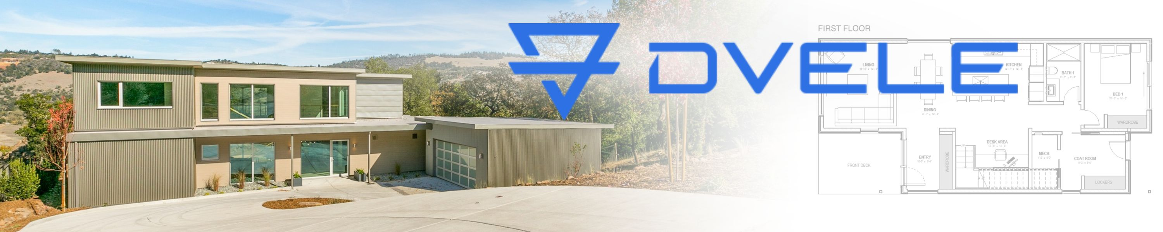
Redefining the Science of Homes
Traditional home-building methods release millions of tons of carbon dioxide and other harmful chemicals into the atmosphere. It’s estimated that 42% of U.S. energy-related emissions come from our homes and the machines we use every day. Dvele evolves home production.
Story Ideas
Pioneering New Science of Homes: Dvele, a leader in sustainable housing, introduces net-zero energy homes equipped with solar panels, intelligent energy management, and eco-friendly materials. Reducing carbon emissions and utility costs, these innovative homes redefine sustainable living and promote a greener future.
Tech Future | Smart and Sustainable Homes: Dvele integrates cutting-edge smart home technology into its sustainable homes, enabling homeowners to remotely control lighting, climate, and security systems. With a focus on energy efficiency and occupant well-being, Dvele's smart homes offer an unparalleled level of comfort, convenience, and sustainability.
Eco-Friendly Homes and the Communities Behind Them: Dvele actively engages with local communities, government agencies, and environmental organizations to promote sustainable development practices. By incorporating eco-friendly materials, energy-efficient systems, and architectural innovation, Dvele builds sustainable neighborhoods that inspire and empower residents to embrace a greener lifestyle, without sacrifices.

Your Health and High-Performing Homes:
Dvele's high-performance homes strike the perfect balance between aesthetics, advanced technology, superior manufacturing and sustainability. Through intelligent design, natural light optimization, and healthy indoor environments, Dvele homes create harmonious spaces that prioritize occupant comfort while minimizing environmental impact.

Dvele is a groundbreaking company that is revolutionizing sustainable housing. By combining cutting-edge technology, innovative design, and a commitment to environmental stewardship, Dvele provides sustainable and high-performance homes for the future.
Dvele’s Self-Powered™ homes are among the most advanced products available on the market today. They produce clean energy that occupants can immediately use, store in the home’s batteries, or sell back to the electric company’s grid, making each home net-positive. Dvele homes exceed the Passive House airtight standard (unlike a typical new home built today, with 12x the energy loss of 6 ACH, compared to Dvele’s 0.5 ACH). Airflow and water are purified. An in-house monitoring system called Dvele IQ™ keeps occupants updated 24/7 on the home's performance. It’s Learning, not Spying™.
“The way we have evolved the home and how they are produced is having a radical, positive effect on our planet and economy.” – Kurt Goodjohn, Co-founder and CEO, Dvele.com
About: Kurt and his brother Kris Goodjohn previously co-founded Karoleena, Canada’s preeminent and most well-known designer prefab home company, which was successfully acquired in 2016. They co-founded Dvele in December of 2016. A recognized leader in the prefab industry, Kurt has been featured in The National Post, Avenue Magazine, Vancouver Sun, Globe and Mail, CBC and dozens of other media outlets. Because the most valuable learning comes from difficult times, Kurt’s personal motto is “Never give up.” As an innovator and visionary, Kurt notes, “I want to leave the world better off than I found it.” Kurt has a BS in Computer Engineering from Union College, where he played Division I Hockey. Kurt raises his three young children alongside his wife, a fellow entrepreneur. Learn more at dvele.com.
Online Press Kit: Dvele.OnlinePressKit247.com
Public Website: dvele.com
PRESS CONTACT
Michelle Tennant, Publicist
828.749.3200 or 828.817.4034
Michelle@WasabiPublicity.com
SearchPressKits.com or PitchRate.com
PRESS CONTACT
Michelle Tennant, Publicist
828.749.3200 or 828.817.4034
Michelle@WasabiPublicity.com
SearchPressKits.com or PitchRate.com

PRESS CONTACT
Michelle Tennant, Publicist
828.749.3200 or 828.817.4034
Michelle@WasabiPublicity.com
SearchPressKits.com or PitchRate.com

PRESS CONTACT
Michelle Tennant, Publicist
828.749.3200 or 828.817.4034
Michelle@WasabiPublicity.com
SearchPressKits.com or PitchRate.com

