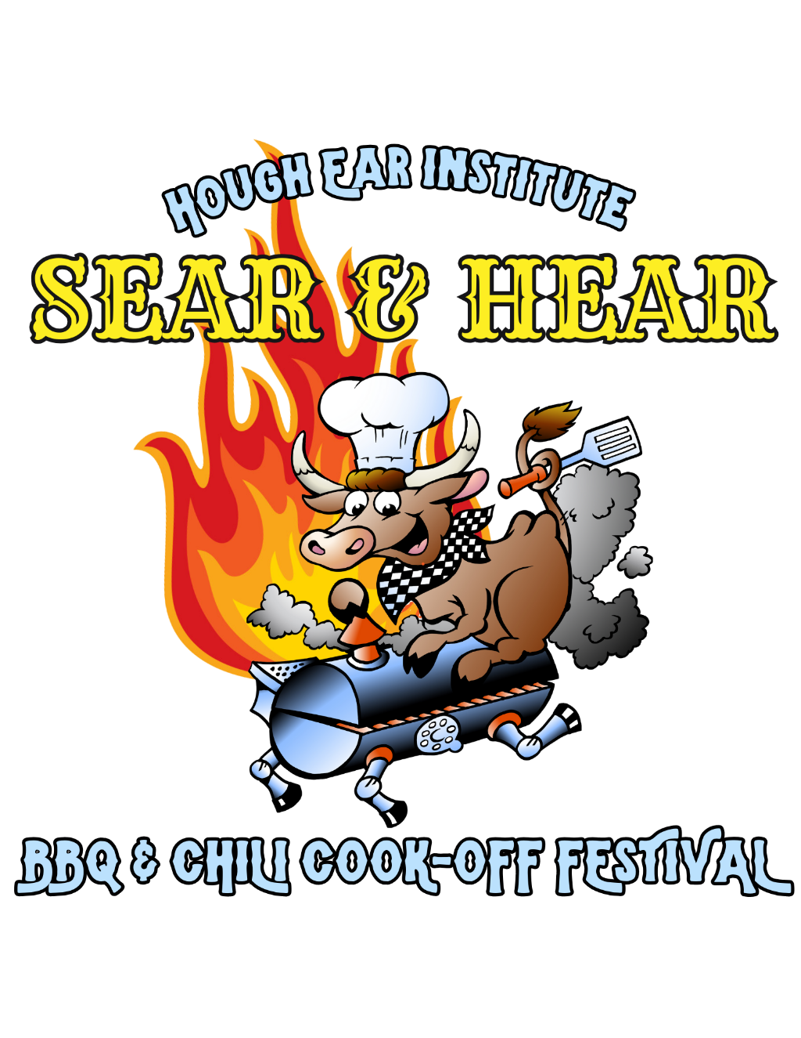

**2025 BBQ & Chili Competition**

Official Rules, Regulations, and Judging Procedures

*The following rules, regulations, and judging procedures were inspired by those of the Kansas City Barbeque Society.*

***Remington Park***

***1 Remington Pl, C3 Parking Lot***

***Oklahoma City, OK 73111***

***Questions? Email cpepper@houghear.org or call 405-820-1102***

# **BBQ Competition Rules & Regulations**

## **Team Logistics & Setup**

1. The decision and interpretations of these Rules and Regulations are at the discretion of the Hough Ear Institute staff members present at the contest. Their decisions and interpretations are final.
2. Each team shall consist of a chief cook and as many assistants as the chief cook deems necessary.
3. Each team will be assigned a cooking space. Pits, cookers, props, trailers, motor homes, vehicles, tents or any other equipment (including generators) shall not exceed the boundaries of the team’s assigned cooking space. All seasoning and cooking of product shall be done within the assigned cooking space.
4. Contestants shall provide all needed equipment and supplies, including electricity, water, ice, chairs, tables, canopies, generators, smokers, grills or any other items. A fire extinguisher shall be near all cooking devices and shall be provided by each team. We highly recommend you bring a canopy to provide shade for your cook-site. Be sure to bring HEAVY weights to tie down your canopy.
5. It is the responsibility of the contestant to see that the team’s assigned cooking space is clean and orderly following the contest. All fires must be put out, and all equipment removed from the site.
6. Electrical accessories such as spits, augers, or forced drafts are permitted. No open pits or holes are permitted. Fires shall not be built on the ground.
7. Your vehicle will be allowed to stay within the event grounds as long as it fits within your cook team site. If there is not enough space for your vehicle and cooking setup, your vehicle must be parked in the cook team parking area. You will be allowed to enter the event and drop off your equipment.
8. When unloading, please unload quickly and do not block other teams’ sites. Do not leave a parked vehicle on any other teams’ site.
9. Please remember this is a family event and consider this when choosing the music played at your cook team site on Saturday.

## **Cooking & Meat Rules**

1. Each team should expect to cook enough meat in each category for approximately 200 people to have a small sample of each. Please reach out to us if you need a closer estimate, though attendance is never certain until we see who will show up!
2. All competition meat shall start out raw. No pre-seasoned meat is allowed other than manufacturer enhanced or injected products, as shown on label EXCLUDING but not limited to: teriyaki, lemon pepper or butter injected. Parboiling, Sous-vide, and/or deep-frying competition meat is also not allowed. Competition meat not meeting these qualifications shall be disqualified.
3. The four BBQ meat categories that will be judged are:
   1. **Chicken** - Chicken includes Cornish Game Hen and Kosher Chicken.
   2. **Pork Ribs** - Ribs shall include the bone. Country style ribs are prohibited.
   3. **Beef Brisket** - May be whole brisket, flat, or point. Corned beef is not allowed.
   4. **Pork** - Pork is defined as Boston Butt, Boston Roast, Picnic and/or Whole Shoulder. After trimming, pork shall be cooked whole (bone in or bone out), however, once cooked, it may be separated and returned to the cooker at the cook’s discretion. It may be turned in chopped, pulled, chunked, sliced, or a combination of any of those.
4. Garnish is optional. If used, it is limited to chopped, sliced, shredded, or whole leaves of fresh green lettuce, curly parsley, flat leaf parsley, and/or cilantro. Kale, endives, red tipped lettuce, lettuce cores and other vegetation are prohibited.
5. Sauce is optional. If used, it shall be applied directly to the meat and not be pooled or puddled in the container. No side sauce containers will be permitted. Chunky sauce is allowed.
6. The following cleanliness and safety rules will apply:
   1. No use of any tobacco products while handling meat.
   2. Cleanliness of the cook, assistant cooks, cooking device(s) and the team’s assigned cooking space is required.
   3. A shirt and shoes are required to be worn.
   4. Sanitizing of work area is required.
   5. Prior to cooking, meat must be maintained at 40° F or less.
   6. After cooking all meat:
      1. Must be held at 140F or above OR
      2. Cooked meat shall be cooled as follows:
         1. Withing 2 hours from 140F to 70F within and Within 4 hours from 70F to 41F or less
   7. Meat that is cooked, properly cooled, and later reheated for hot holding and serving shall be reheated so that all parts of the food reach a temperature of at least 165F for a minimum of 15 seconds.

**Causes for Disqualification of a Team:** A cook team is responsible jointly and severally for its chief cook and its assistants.

1. Excessive use of alcoholic beverages or public intoxication with a disturbance.
2. Use of illegal controlled substances.
3. Foul, abusive, or unacceptable language or any language causing a disturbance.
4. Excessive noise, including but not limited to that generated from speakers, such as radios, CD players, TVs, public address systems, or amplifying equipment.
5. Fighting and/or disorderly conduct.
6. Theft, dishonesty, cheating, use of prohibited meats, or any act involving moral turpitude.
7. Violation of any of the rules in this document.

# **Chili Competition Rules & Regulations**

1. Each team should expect to cook enough chili for approximately 200 people to have a small sample of. Please reach out to us if you need a closer estimate, though attendance is never certain until we see who shows up!
2. All chili must be cooked on site the day of the cook-off, from scratch. All chili must be prepared out in the open, no cooking in motor homes, etc. From “Scratch” is defined as starting with raw meat. No marinating is allowed.
3. Commercial chili powder is permissible, but complete chili mixes are NOT permitted, e.g., Wick Fowler’s, Carroll Shelby’s, etc., which contain several premeasured spices.
4. No fillers are allowed in chili such as beans, macaroni, rice, hominy or other similar items.
5. Cooks are to prepare and cook chili in as sanitary a manner as reasonable.

## **Judging Procedures (For both BBQ & Chili)**

This event is judged on a “People’s Choice” basis. Each paying attendee will be able to vote. Chief cooks and their assistants may pay to be tasters; however, they will not be given a voting card, and attempting to get one may be grounds for disqualification.

1. Each paying attendee will be able to vote on a paper card on a scale of 8-2. Each number in descending order will be marked as excellent, very good, above average, average, below average, poor, bad, and inedible respectively.
2. The scores will be tallied at 2:45 p.m., after which the winners will be announced.
3. In the unlikely event of a tie, the winner will be decided by a computer-generated coin toss, the loser of which will take the next place in the rankings.
4. The prizes will be:

**BBQ Prize Payouts (Decided by People's Choice):**

1st Place $1,000

2nd Place $500

3rd Place $400

4th Place $200

5th Place $100

**Chili Prize Payouts (Decided by People's Choice):**

1st Place $200

2nd Place $100

3rd Place $50