Television Match Official Procedures

OVERVIEW
National Collegiate Rugby will assign a Television Match Official (TMO) to assist the Referee in certain high profile matches, including stadium fixtures at Nationals, Collegiate Rugby Championship, and All Stars competitions. All TMO assignments will be made by NCR’s Referee Director.
The TMO has two responsibilities: 1) at the request of the Referee, determine whether or not the ball was properly grounded in goal, and 2) at the request of the Referee, determine whether a player committed an act of Dangerous Play as defined by Law 9, Foul Play. The TMO has no other responsibilities and will not initiate communication with the Referee during the match.

REFEREE AND ASSISTANT REFEREES
This is the team of three on-field officials appointed to the match by NCR’s Referee Director or his delegate. Only the Referee will communicate with the TMO during the match.
Referee Responsibilities
- Immediately upon determining that a TMO review of Grounding In Goal or potential Dangerous Play is required, make the ‘Referee Consults TMO’ signal in the direction of the TMO, who will be sitting at the Scorer’s table between the two Technical Zones.
- Radio your instructions to the TMO.
- For Grounding:
  - State to the TMO, “Check for Grounding. My on-field decision is [try, ball held up, knock-on in goal, etc.].”
  - Await a final decision from the TMO, who will either confirm your on-field decision or inform you that the video replay shows otherwise, e.g., “I confirm your decision of a try,” “The ball was held up in goal,” “The ball was knocked-on in goal by Blue,” etc.
  - Repeat the TMO’s observation and proceed only after confirming that you have correctly understood the TMO’s observation. NOTE: The decision is yours and yours alone to make. The TMO will not “overturn” your decision but will tell you if there is clear evidence showing that your on-field decision was incorrect.
  - Conversely, if the TMO declares, “I do not have the view required. Stay with your on-field decision,” acknowledge and move on to the next step.
  - Make the primary and, as required, secondary signals for your final decision.
- For Dangerous Play:
  - Clearly state what you are asking the TMO to look for, including:
    - The specific act of Dangerous Play.
    - Color and number of player suspected of committing the act of Dangerous Play.
    - Approximately how long before you stopped play the suspected act occurred.
    - Where on the pitch the suspected act occurred.
  - Answer all requests for clarification to the best of your ability.
  - Await the TMO’s decision, which will be either confirmation that an act of Dangerous Play occurred or that the TMO was unable to see a clear act of Dangerous Play.
  - If the TMO observed Dangerous Play, listen to the TMO’s description of the violation and the player details. Ask any clarification questions that will help you determine the appropriate sanction, e.g., whether there was head or neck contact, degree of force, speed, mitigating factors, etc.
  - In the event of a penalty or card for Dangerous Play, acknowledge the TMO’s assistance and proceed with the appropriate primary and secondary signals and follow-on action.
  - In the event that Dangerous Play was not observed or could not be proven, acknowledge the TMO’s assistance and restart play accordingly.

TELEVISION MATCH OFFICIAL
This is an accredited rugby referee who has been trained and certified by NCR as a Television Match Official. The TMO is appointed to the match by NCR’s Referee Director.
TMO Responsibilities
- Before the match:
  - Take your position at the Scorer’s table.
  - Confirm that you are in radio communication with the Referee.
  - Confirm that your Unity Intercom tablet computer is operating properly and that you have intercom communication with the Replay Operator.
  - Confirm that your two replay monitors are operating properly.
  - Confirm your understanding of the location of each of the cameras with the Replay Operator.
- During the match, await any request from the Referee for a TMO review of Grounding In Goal or potential Dangerous Play.
- Following the Referee’s description of what he is asking you to review, repeat it back.
  - For Grounding: “You are asking me to check for Grounding. Your on-field decision is [try, ball held up, knock-on in goal, etc.].”
  - For Dangerous Play: “You are asking me to check if [player color and number] committed a [specific Dangerous Play].”
- Once confirmed, inform the Referee, “I am reviewing the play.”
  - For Grounding: Tell the Replay Operator, “We need to check for Grounding. Show me your best angle.”
  - For Dangerous Play: Tell the Replay Operator, “We need to check for potential Dangerous Play by [player color and number] at about [time before the Referee stopped play] at [the location provided by the Referee]. We are looking for [the specific act of Dangerous Play that the Referee is looking at].”
- The Replay Operator will look for the incident and show you the best angle on TMO1.
- The Replay Operator will then replay the incident forward and backward on TMO1 in slow motion.
- Work with the Replay Operator to find other views from the other five cameras, all of which can be seen, tiled combined on TMO2, instructing him, e.g., “Show me the play on Camera 3.”
- The Replay Operator will then switch TMO1 over to show the view you’ve requested, repeating the process of replay the incident forward and backward in slow motion.
- Throughout the review process, ask any clarification questions of the Referee you might require.
- Continue collaborating with the Replay Operator to confirm that the two of you have either seen or cannot see the incident described by the Referee.
- Once you have finished your review, let the Replay Operator know by stating, “I have seen all the angles I need to see. I have a decision.” The Replay Operator will then repeat back, “You have seen everything I have. Clear to make your decision.”
- Inform the Referee that you have made your decision.
- For Grounding:
  - Either confirm the Referee’s on-field decision or inform the Referee that the video replay shows otherwise, e.g., “I confirm your decision of a try,” “The ball was held up in goal,” “The ball was knocked-on in goal by Blue,” etc.
  - Conversely, if the Replay Operator was unable to provide you with the right view to make a decision, inform the Referee, “I do not have the view required. Stay with your on-field decision.”
  - The Referee will repeat your decision back to you, at which point your review is complete.
- For Dangerous Play:
  - If you have observed Dangerous Play, report the specifics of the act, beginning, “I confirm that there was Dangerous Play,” and then including:
    - The specific act of Dangerous Play.
    - Color and number of the player who committed the act of Dangerous Play.
    - Where on the pitch the act occurred.
  - Respond to any questions that will help the Referee determine the appropriate sanction, e.g., whether there was head or neck contact, degree of force, speed, mitigating factors, etc.
  - In the event that you did not find evidence of Dangerous Play, inform the Referee, “I cannot confirm Dangerous Play. Play on.”
  - The Referee will acknowledge your assistance, at which point your review is complete.

REPLAY OPERATOR
Next Level Rugby (NLR) (Or Eauivalent Partner) is NCR’s livestream broadcast partner. The Replay Operator is a member of the NLR staff with experience in video replay. Replay Operator training is the responsibility of NLR.
NLR Responsibilities
- Set up the seven video cameras in the following configuration:

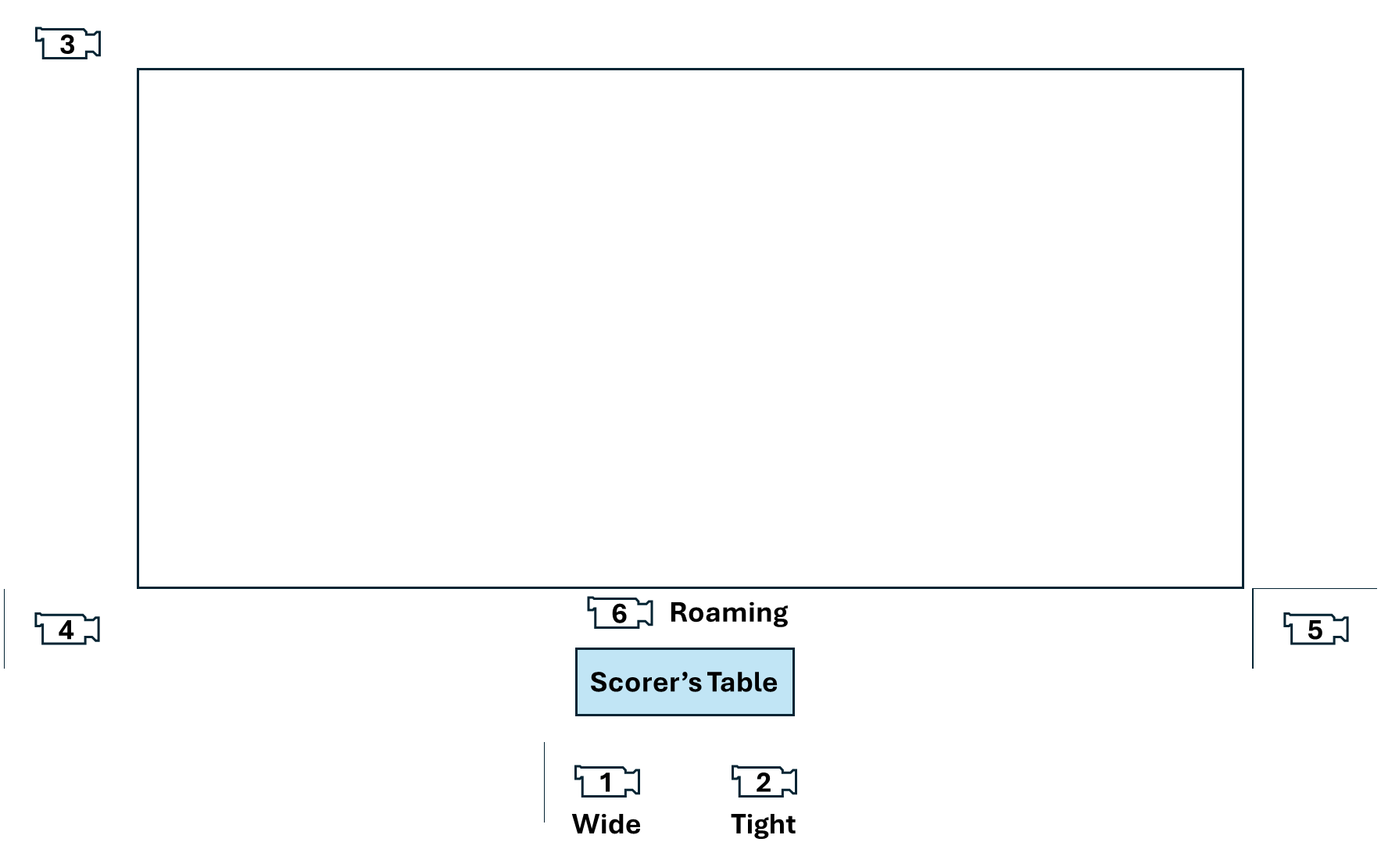
7
- If you are setting up your cameras in a different configuration, inform the TMO accordingly.
- Ensure that the two TMO monitors and the tablet computer to be used for the Unity Intercom system are fully charged and that they are equipped with backup power supplies (portable battery power packs, AC power, or other).
- Set up the two TMO monitors side by side on the Scorer’s table, TMO1 to the left and TMO2 to the right. Adjust them so they are sitting at the same angle.
- Set up the TMO’s Unity Intercom system on its dedicated tablet computer and place the tablet next to the TMO monitors on the Scorer’s table.
- Confirm communication between the TMO and Replay Operator.
- Confirm that all seven cameras are viewable as tiles on monitor TMO2.
Replay Operator Responsibilities
- When the referee signals for a TMO review, NLR will post on the screen “UNDER REVIEW”. No replay will be shown within the stadium until the TMO and Referee have completed their review.
- After listening to the TMO’s requirement, repeat it back to the TMO to ensure an accurate understanding; then dial up the best angle available on monitor TMO1.
- Replay the incident and confirm with the TMO that this is the incident requiring review.
- Once confirmed, collaborate with the TMO to review all relevant angles, switching the camera view on monitor TMO1 as agreed with the TMO.
- Determine with the TMO that the TMO has finished reviewing all of the relevant angles.
- Once the TMO declares, “I have seen all the angles I need to see. I have a decision,” repeat back, “You have seen everything I have. Clear to make your decision.”
- The camera that the TMO used to make his decision will be replayed first. Other angles afterwards are at the discretion of NLR.
- At this point, your role in the review is complete.

Referee Director David Haines and Disciplinary Officer Dean Jorgensen are currently qualified to train and certify NCR TMOs.

