Coaches Challenge

OVERVIEW
During National Championships NCR will introduce the ability of the coaches to challenge a referee decision as it relates to awarding a try.

COACH RESPONSIBILITY

- Each team will be given the opportunity to challenge one try that has been awarded by the referee per match.
- The coach will be presented with a challenge card prior to the match with his substitution cards.
- Once a Try has been awarded, the coach, or his designated proxy, must immediately present his challenge card to the #4 who will announce to the referee that a challenge has been made. Any challenge must be completed before the restart kick has been taken.
REFEREE AND ASSISTANT REFEREES
This is the team of three on-field officials appointed to the match by NCR’s Referee Director or his delegate. Only the Referee will communicate with the TMO during the match.
Referee Responsibilities
- Immediately upon determining that challenge has been made, the ‘Referee Consults TMO’ signal in the direction of the TMO, who will be sitting at the Scorer’s table between the two Technical Zones.
- Radio your instructions to the TMO.
- Try Review:

  - Await a final decision from the TMO, who will either confirm your on-field decision or inform you that the video replay shows otherwise, e.g., “I confirm your decision of a try,” “The ball was held up in goal,” “The ball was knocked-on in goal by Blue,” etc.
  - Once the TMO has made a decision and relayed the information to the referee, the video used in the decision will be displayed on the jumbotron.
  - Repeat the TMO’s observation and proceed only after confirming that you have correctly understood the TMO’s observation. NOTE: The decision is yours and yours alone to make. The TMO will not “overturn” your decision but will tell you if there is clear evidence showing that your on-field decision was incorrect.
  - Conversely, if the TMO declares, “I do not have the view required. Stay with your on-field decision,” acknowledge and move on to the next step.
  - Make the primary and, as required, secondary signals for your final decision.

TELEVISION MATCH OFFICIAL
This is an accredited rugby referee who has been trained and certified by NCR as a Television Match Official. The TMO is appointed to the match by NCR’s Referee Director.
TMO Responsibilities
- Before the match:
  - Take your position at the Scorer’s table.
  - Confirm that you are in radio communication with the Referee.
  - Confirm that your Unity Intercom tablet computer is operating properly and that you have intercom communication with the Replay Operator.
  - Confirm that your two replay monitors are operating properly.
  - Confirm your understanding of the location of each of the cameras with the Replay Operator.
- During the match, await any challenge from the teams.
- Following the Referee’s description of what he is asking you to review, repeat it back.
  - For Grounding: “You are asking me to check for Grounding. Your on-field decision is [try, ball held up, knock-on in goal, etc.].”
- Once confirmed, inform the Referee, “I am reviewing the play.”
  - For Grounding: Tell the Replay Operator, “We need to check for Grounding. Show me your best angle.”
- The Replay Operator will look for the incident and show you the best angle on TMO1.
- The Replay Operator will then replay the incident forward and backward on TMO1 in slow motion.
- Work with the Replay Operator to find other views from the other six cameras, all of which can be seen, tiled combined on TMO2, instructing him, e.g., “Show me the play on Camera 3.”
- The Replay Operator will then switch TMO1 over to show the view you’ve requested, repeating the process of replay the incident forward and backward in slow motion.
- Throughout the review process, ask any clarification questions of the Referee you might require.
- Continue collaborating with the Replay Operator to confirm that the two of you have either seen or cannot see the incident described by the Referee.
- Once you have finished your review, let the Replay Operator know by stating, “I have seen all the angles I need to see. I have a decision.” The Replay Operator will then repeat back, “You have seen everything I have. Clear to make your decision.”
- Inform the Referee that you have made your decision.
- For Grounding:
  - Either confirm the Referee’s on-field decision or inform the Referee that the video replay shows otherwise, e.g., “I confirm your decision of a try,” “The ball was held up in goal,” “The ball was knocked-on in goal by Blue,” etc.
  - Conversely, if the Replay Operator was unable to provide you with the right view to make a decision, inform the Referee, “I do not have the view required. Stay with your on-field decision.”
  - The Referee will repeat your decision back to you, at which point your review is complete.
REPLAY OPERATOR
Next Level Rugby (NLR) (Or Eauivalent Partner) is NCR’s livestream broadcast partner. The Replay Operator is a member of the NLR staff with experience in video replay. Replay Operator training is the responsibility of NLR.
NLR Responsibilities
- Set up the seven video cameras in the following configuration:

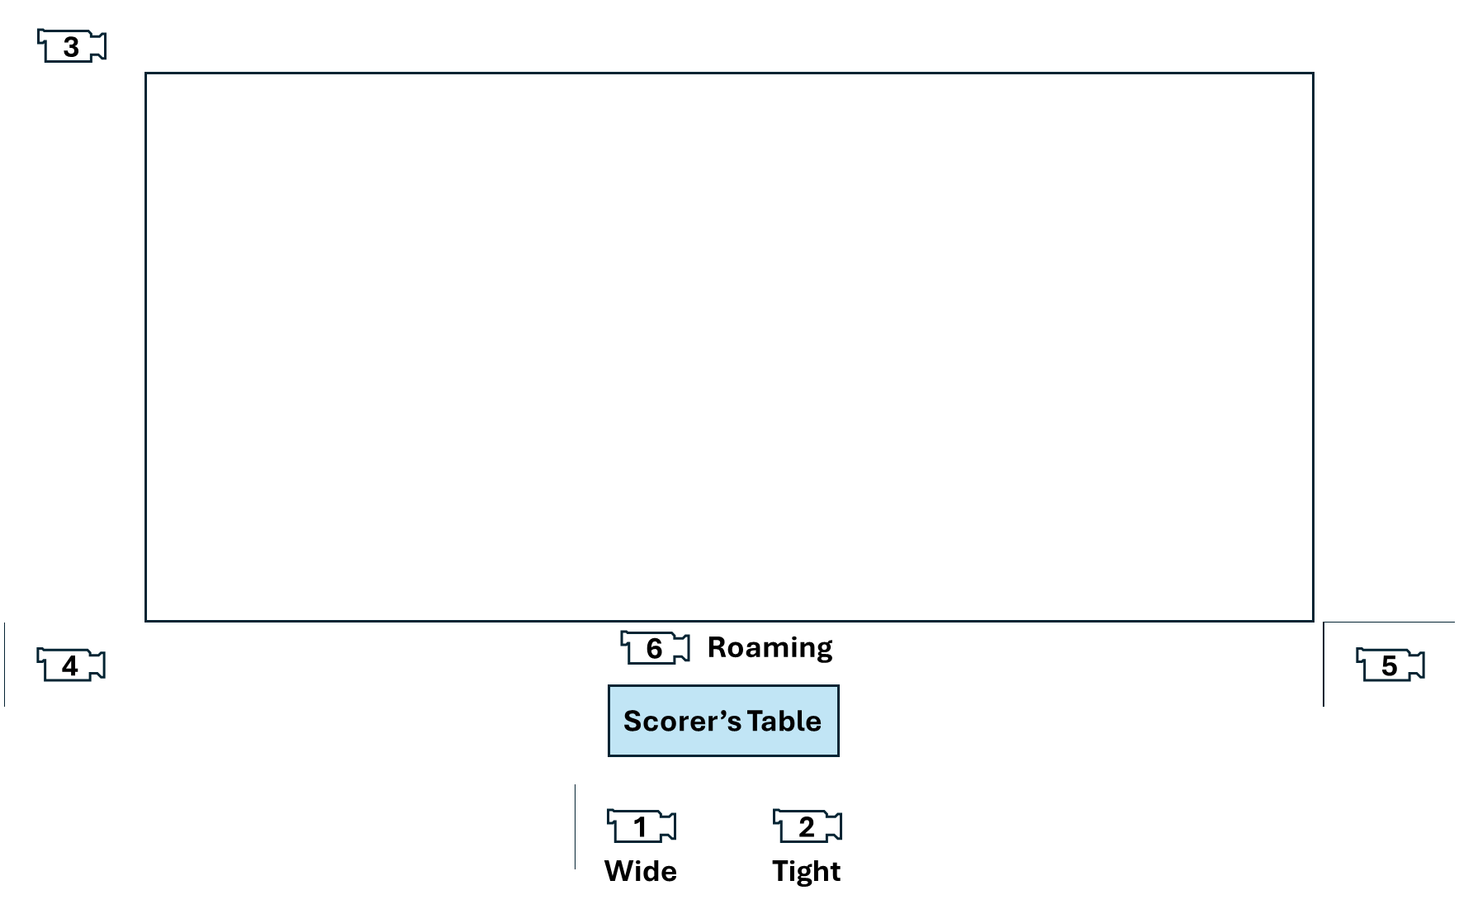
7
- If you are setting up your cameras in a different configuration, inform the TMO accordingly.
- Ensure that the two TMO monitors and the tablet computer to be used for the Unity Intercom system are fully charged and that they are equipped with backup power supplies (portable battery power packs, AC power, or other).
- Set up the two TMO monitors side by side on the Scorer’s table, TMO1 to the left and TMO2 to the right. Adjust them so they are sitting at the same angle.
- Set up the TMO’s Unity Intercom system on its dedicated tablet computer and place the tablet next to the TMO monitors on the Scorer’s table.
- Confirm communication between the TMO and Replay Operator.
- Confirm that all seven cameras are viewable as tiles on monitor TMO2.
Replay Operator Responsibilities
- When the referee signals for a TMO review, NLR will post on the screen “UNDER REVIEW”. No replay will be shown within the stadium until the TMO and Referee have completed their review.
- After listening to the TMO’s requirement, repeat it back to the TMO to ensure an accurate understanding; then dial up the best angle available on monitor TMO1.
- Replay the incident and confirm with the TMO that this is the incident requiring review.
- Once confirmed, collaborate with the TMO to review all relevant angles, switching the camera view on monitor TMO1 as agreed with the TMO.
- Determine with the TMO that the TMO has finished reviewing all of the relevant angles.
- Once the TMO declares, “I have seen all the angles I need to see. I have a decision,” repeat back, “You have seen everything I have. Clear to make your decision.”
- The camera that the TMO used to make his decision will be replayed first. Other angles afterwards are at the discretion of NLR.
- At this point, your role in the review is complete.

Referee Director David Haines and Disciplinary Officer Dean Jorgensen are currently qualified to train and certify NCR TMOs.

