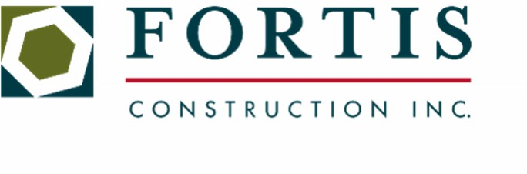
20 November 2025
5 3 3 1 S M a c a d a m A v e P > 5 0 3 + 4 5 9 + 4 4 7 7
S u i t e 1 0 0 F > 5 0 3 + 4 5 9 + 4 4 7 8
P o r t l a n d , O R 9 7 2 3 9 C C B # 1 5 5 7 6 6

Fortis - New Mexico Project Incentive Program

Fortis reserves the right to cancel the Incentive program at any time. Contractors are given permission to distribute the incentive (LARP) as directed, and in alignment with qualifications listed below. The managing contractor is responsible for the execution of the Incentive Plan and may set requirements in the best interest of Fortis and the project. Contractor management will set the available work hours based on the Local Union and Fortis Holidays. Fortis reserves the right to change the wording of the program at any time to ensure it complies with the program’s intent and all laws, rules, and regulations.

Incentives are in place to attract and retain the necessary workforce, and to increase project schedule participation. This program is to reward those working the project schedule.

Incentive Details
- Incentive program to commence June 23, 2025.
- $150.00 per workday for ALL Electrical Union Journeyman and above, except traveling employees receiving a per diem.
- $50.00 per workday for Electrical Union Apprentices and CW/CEs.

Incentive payments will be managed by participating Contractors. The incentive checks may reflect a recalculation of the overtime rate where applicable.

Requirements to Qualify for Incentive
- Employees will be required to work all available scheduled hours for the day.
- If an employee is unable to work all available hours that day, the incentive for the associated workday would be forfeited entirely.
Exception:
  - Apprentices in good standing attending their normally scheduled class according to the JATC provided calendar, but otherwise working all scheduled hours will still be eligible for full workday incentive.
  - Apprentices will be allotted 2 hours prior to their scheduled class as a buffer, all other available hours will need to be worked to qualify for the workday incentive on their respective class day.
  - Make up classes and scheduled tutoring that impact an apprentice’s ability to work all scheduled hours will result in a forfeit of the incentive for the workday in its entirety.
- Any traveling employee, as designated by the contractor, receiving per diem is not eligible for the incentive program.
- Hours to qualify must be actual working hours, Sick Leave Hours will not qualify.
- Saturdays will be scheduled based on the project needs and not guaranteed as the normal work schedule.

Terms Defined
- “Workday(s)” for the purpose of this document are defined as Monday, Tuesday, Wednesday, Thursday, Friday, and Saturday.

Incentive Period (subject to modification at Fortis’s discretion)
- Program to commence June 23, 2025, and is currently projected to run until December 7, 2025
- Any changes to this program will be at Fortis’s discretion.

