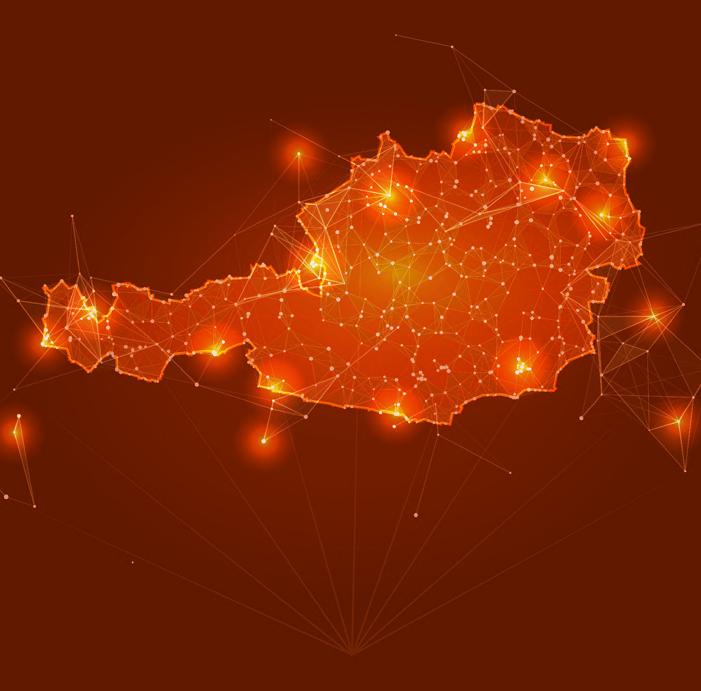

AUSTRIA briefing:
JULY
2024

01 July 2024 - 31 July 2024

VISIT OUR WEBSITE
WWW.CAGE.NGO

NATIONAL SECURITY
& COUNTER-TERRORISM

DR ASIM QURESHI
Research Director



Austria’s immigration & counter-terrorism policies mimic the trajectory of countries such as the UK and France, resulting in a more refined and carefully constructed system of violence.

Court rules deportations
to Afghanistan are permissible

The Constitutional Court has controversially ruled that deportations to Afghanistan are permissible in certain instances, citing what it claims is an "improved security situation" under Taliban rule. This ruling comes in the case of a young Afghan man who was denied asylum and subsidiary protection by the Federal Office for Immigration and Asylum. Despite his appeal, the Constitutional Court has upheld the decision, arguing that the deportation does not violate the Human Rights Convention or other constitutional protections.
This decision is deeply troubling, revealing a disturbing strategy by the Austrian government to use deportation as a punitive measure. Such an approach disproportionately targets vulnerable communities, often from Muslim backgrounds, and instils a pervasive fear of deportation that can have chilling effects. This "whiplash effect" aims to force self-censorship among asylum seekers, effectively making them more compliant and controllable.to Muslims.

Raab presents racist measures for conveying “Austrian values”

- Integration Minister Susanne Raab, known for her involvement in other controversial and Islamophobic measures such as the notorious "Islam Map" and the Vienna Forum, unveiled new steps for promoting “Austrian values” within the integration sector. These steps are based on interim results from the study "Common Core Values and Austrian Leitkultur," presented by OGM Data Scientist Johannes Klotz. Wolfgang Mazal from the University of Vienna also provided insights into the foundational work on Leitkultur.

- Raab emphasised that "integration always involves adaptation, particularly to the values we hold in Austria and Europe," highlighting principles like gender equality, separation of state and religion, and respect for traditions as non-negotiable. This "zero-tolerance" approach to integration reflects a rigid stance on cultural conformity.

- The study included extensive literature reviews and over 80 qualitative interviews, focusing on differing societal values among immigrant groups. According to Klotz, some of these values persist across generations, requiring the majority society to actively communicate and enforce its own standards through education and community initiatives.
- These measures can be viewed as inherently racist, as they disproportionately target vulnerable groups such as asylum seekers and those reliant on social benefits, many of whom are from Muslim and non-white backgrounds. By enforcing a singular "Austrian culture," the policy imposes a narrow, exclusionary identity, dismissing the validity of other cultures. It perpetuates the notion that non-white individuals are uncultured or uncivilised and serves as a state tool to discipline migrant communities, forcing them to adopt the state's perspective on political and social issues.

- The government’s approach, including a mandatory values course and a values clause in federal funding, is seen as a means to control and assimilate migrant communities. Raab’s track record, marked by her involvement in the Islam Map and the Vienna Forum, only underscores the Islamophobic undertones of these policies.

