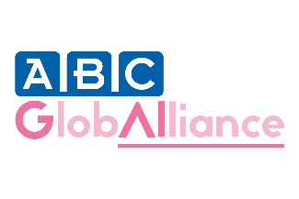
WEBINAR: Tuesday June 23 16:00 CET
Faster and fairer: tools to improve access to ABC medicines in high-income countries
Register here

Why does it take so long for approved new medicines to get to the patients who need them?
For too many advanced breast cancer (ABC) patients, the hope offered by new drugs remains out of reach, even in high-income countries.
What can we all do to ensure faster and fairer access to ABC medicines? Join our free one-hour webinar, where our panel of experts will share the tools and tips that they have seen make a difference. Expect to take away some practical messages and angles that will help you make progress in your own country.

Our speakers:
Unequal rights to ABC medicines in high-income countries | Dr Fatima Cardoso, medical oncologist and president of ABC Global Alliance
Why are we waiting – and what can we do about it? Trends, barriers and clever moves in market access | Christel Jansen, The Access Embassy
Clearing the hurdles – tools from pharma that can help improve access in Europe | Mihai Rotaru, Director Market Access, EFPIA
How to be heard – how advocates have worked successfully in-country | Kirstin Spencer, patient advocate
Better for all – how can clinicians help improve access? | Dr Fatima Cardoso

Register here

