Guidance and Information Booklet Two
Little Wandle Phonics
2025-2026

With thanks to Gerard at LPS
September 2025 version
Updates for 2025-2026 in red

Phonics screeners
There is no expectation to carry out practice phonics screeners with whole classes, but if you wish to do this, you can enter the scores onto Insight, under ‘school assessments’. There is a ‘phonics screener’ option.
Phonics tracking (mandatory)
Every half term, once your phonics teacher assessments have been done through your in scheme processes, please enter onto Insight a simple Y or N.
This is in reference to whether you think each pupil is likely to pass the phonics screener or not, based on what you know so far. The charts below give some additional guidance, particularly those that say where a child should be if they are on track, at the end of every full term.
For every child that has a N next to their name, these should be discussed at pupil progress and additional support put in place.
Please note that this way of assessing was agreed by all the phonics leads in June 2025 as a simpler and more reliable way of tracking our likely phonics outcomes at the end of year 1. Given that the national average is 80% achieving a score of 32+, we expect each school’s tracking to be in line with this % from term to term and not to ‘swing’ wildly.
Inputting a Y should be based on evidence – if tracking shows the % to be well below 80% then there must be a plan to increase the number of pupils who will pass.
Phonics Teacher Assessment Criteria Phases (for LW)
NB – these are best fit, please use your professional judgement. The purpose of this table is to see how the skills being taught and developed are called different things in different schemes.
NB – entering a phonics teacher assessment as below, is no longer needed. Phonics tracking replaces it. The facility is still there for you to use if you would like to. This would be a local decision.
Definitions
A word is phonetically plausible if it can be identified for what it is, even if it is not spelt correctly. Children learning to write will create phonetically plausible versions of words before they learn the correct spellings. This is because they only have a limited range of Grapheme-phoneme Correspondence (GPC) at their disposal. E.g person/persun or because/beecos
 | Level of Security | Assessment description
Phase 1 | Beginning | - Children may show interest in signs and print around them  - Begin to mimic the sounds they hear around them
 | Developing | - Begin to mimic the movements of an adults mouth to articulate individual sounds correctly  - Can hear some phonemes within a word  - Can orally blend individual words or the last word in a sentence turning sound talk into a whole word independently
 | Secure | - Can orally blend and segment individual words  - Some will know sounds or be able to recognise and write letters that are of significance to them e.g. letters in their name  - Can distinguish between speech and sounds  - Some will be able to recognise spoken words that rhyme
Phase 2 | Beginning | - Have experience a wealth of listening activities and can identify and follow during given activities  - Can distinguish between speech and sounds  - Blend and segment words orally  - Some will be able to recognise spoken words that rhyme  - Some will know sounds or be able to recognise and write letters that are of significance to them e.g. letters in their name
 | Developing | - Give the sound for most Phase 2/Level 1+ letters. Securely say the sound when shown set 1 and 2 sounds  - Find most Phase 2/Level 1+ letters, from a display, when given the sound  - Orally blend and segment CVC words  - Blend and segment in order to read and spell some VC words such as: if, am, on, up  - Read some of the tricky/helpful words; the, to, I, no, go
 | Secure | - Give the sound when shown any Phase 2/Level1+ grapheme  - Find any Phase 2/Level 1+ letter, from a display, when given the sound  - Blend some single-syllable words consisting of phase 2/Level 1+ graphemes  - Segment some single-syllable words making phonetically plausible attempts at spelling using phase 2/Level 1+ graphemes  - Read all five tricky/helpful words; the, to, I, no, go  Some children will not have fully grasped CVC blending and segmentation but may know all the Phase Two letters. CVC blending and segmentation continues throughout phase three so children can progress to the next stage even if they have not mastered CVC blending.  Children’s capacity to write letters will depend on their physical maturity and the teaching  approach taken to letter formation. Some children will be able to write all the letters in  pencil, correctly formed. Most children should be able to form the letters correctly in the  air, in sand or using a paint brush and should be able to control a pencil sufficiently well to  write letters such as l, t, i well and h, n and m reasonably well.
Phase 3 | Beginning | - Give the sound when shown any Phase 2/Level 1+ grapheme  - Blend most single-syllable words consisting of Phase 2/Level 1+ graphemes  - Segment most single-syllable words making phonetically plausible attempts at spelling using phase 2/Level 1+ graphemes  - Read some helpful/tricky words: the, to, I, no, go, he, she, we, me, be, was, my, you, her, they, all, are  - All letters written are recognisable, but may not all be correctly formed
Phase 3 | Developing  Children who gain ELG in reading will likely be on the cusp between 3D and 3S | - Give the sound when shown all phase 2/Level 1+ and some Phase 3/Level 2 graphemes (corresponds with the Reading GLD of ‘say a sound for each letter in the alphabet and at least 10 digraphs’  - Blend and read most single-syllable words consisting of Phase 2/Level 1+ and Phase 3/Level 2 graphemes (Read words consistent with their phonics knowledge by sound blending GLD reading)  - Segment most single-syllable words making phonetically plausible attempts at spelling using Phase 2/Level 1+ and Phase 3/Level 2 graphemes (spell words by identifying sounds in them and representing the sounds with a letter or letters GLD)  - Read most tricky/helpful words; the, to, I, no, go, he, she, we, me, be, was, my, you, her, they, all, are  - Write recognisable letters, most of which are correctly formed (GLD)  - Begins to write a simple sentence
Phase 3 | Secure | - Recognises and says the sound when shown most Phase 3/Level 3 graphemes  - Reads most CVC words  - Segment and make a phonetically plausible attempt at spelling CVC words  - Read all tricky/helpful words; the, to, I, no, go, he, she, we, me, be, was, my, you, her, they, all, are  - Write simple phrases and sentences that can be read by others (GLD)
Phase 4 | Beginning | - Give the sound when shown all phase 2/Level 1+ and some Phase 3/Level 2 and 3 graphemes  - Blend and read all Phase 2/Level 1+ and 3/Level 2 and 3 CVC words  - Segment and make a phonetically plausible attempt at spelling most CVC words  - Read all Phase 2/Level 1+ and 3/Level 2 and 3 tricky/helpful words  - Hears additional sounds when two consonants are placed together although may not be able to identify them as individual sounds
Phase 4 | Developing | - Blend and read some words containing adjacent consonants  - Segment and spell some words containing adjacent consonants  - Find any Phase 2 and 3/Levels 1+, 2 and 3 grapheme, from a display, when given the sound  - Read all Phase 2 and 3/Level 1+, 2 and 3 as well as some Phase 4/Level 4 tricky words  - Write each letter from memory, usually forming correctly
Phase 4 | Secure | - Gives the sound when shown any Phase 2 and 3/Level 1+, 2 and 3 grapheme  - Find any Phase 2 and 3/Level 1+, 2 and 3 grapheme, from a display, when given the sound  - Blend and read most words containing adjacent consonants  - Segment and spell most words containing adjacent consonants  - Read all Phase 2, 3 and 4/Level 1+, 2, 3 and 4 tricky/helpful words  - Spell all Phase 2, 3 and 4/ Level 1+, 2, 3 and trick/helpful words  - Write each letter, usually forming it correctly
Phase 5 | Beginning | - Gives the sound when shown any Phase 2 and 3/Levels 1+, 2 and 3 grapheme  - Gives alternative pronunciation for some graphemes  - Find any Phase 2 and 3/Level 1+, 2 and 3 and some Phase 5/Level 5 graphemes, from a display, when given the sound  - Blend and read words containing adjacent consonants  - Segment and spell words containing adjacent consonants  - Read all Phase 2, 3 and 4/Level 1+, 2 and 3 and 4 tricky/helpful words  - Spell all Phase 2, 3 and 4/Level 1+, 2 and 3 and 4 tricky/helpful words  - Write each letter from memory, usually forming it correctly
Phase 5 | Developing | - Gives the sound when shown any Phase 2 and 3/ Level 1+, 2 and 3 grapheme  - Find any Phase 2 and 3/Level 1+, 2 and 3 and some Phase 5/Level 5 graphemes, from a display, when given the sound  - Gives alternative pronunciation for most graphemes  - Uses alternative graphemes for some sounds  - Blend and read words containing adjacent consonants  - Segment and spell words containing adjacent consonants  - Read all Phase 2, 3 and 4/Level 1+, 2 and 3 and 4 tricky/helpful words and some phase 5/Level 5  - Spell all Phase 2, 3 and 4/Level 1+, 2 and 3 and 4 tricky/helpful words and some phase 5/Level 5  - Write each letter from memory, forming it correctly
Phase 5 | Secure  Children who pass the screener are likely 5s | - Give the sound when shown any grapheme that has been taught for any given sound  - Gives alternative pronunciation for most graphemes  - Write the common graphemes for given sounds  - Apply phonic knowledge and skill as the prime approach to reading and spelling unfamiliar words  - Spell unfamiliar and untaught words in a phonically plausible way (national curriculum)  - Spell any familiar and taught words correctly (national curriculum)  - Read and spell phonically decodable two-syllable and three-syllable words  - Read automatically all the words in the list of 100 high-frequency words  - Accurately spell most of the words in the list of 100 high-frequency words;  - Form all letters correctly

For cross checking - Reception phonics judgements
This table indicates ‘on track’ progress for children across Reception and Year 1, which the scheme plans for.
More detailed information around each level descriptor can be found in the assessment guide.

Common Exception words (CE)
On track = during assessment, at least 8 out of 10 words read correctly;
8 out of 10 CE words read correctly
(for end of Reception and Y1, all required CE focus words: the and are I to do we me he she be go)

Key:
b beginning/emerging
d developing
s secure
Reception End of Autumn One
Scheme | Notes | Working At
Little Wandle | Books likely to be around phase 2 set 2 or Pink 1 | Phase 2b+

Reception End of Autumn Two
Scheme | Notes | Working At
Little Wandle | Books likely to be phase 2 set 3 or Pink 2 | Phase 2d+

Reception End of Spring One
Scheme | Notes | Working At
Little Wandle | Books likely to be phase 2 set 5 or Pink 2/Red 1 | Phase 2s+

Reception End of Spring Two
Scheme | Notes | Working At
Little Wandle | Books likely to be Phase 3 set 1 or Red 1 | Phase 3b+

Reception End of Summer One
Scheme | Notes | Working At
Little Wandle | Books likely to be Phase 3 set 2 or Red 2 | Phase 3d+

Reception End of Summer Term
Scheme | Notes | Working At
Little Wandle | See note on CE words  On track = GLD  Books likely to be phase 3 set 2 or phase 4 set 1 | Phase 3s+
If you complete a screener 10+ marks is considered on track
For cross checking - Year 1 Phonics Judgements
Year One End of Autumn One
Scheme | Notes | Working At
Little Wandle | Books likely to be Phase 4 set 2 | Phase 4d

Year One End of Autumn Two
Scheme | Notes | Working At
Little Wandle | Books likely to be phase 5 set 1 | Phase 4s
If you complete a screener - a score of 15+ is considered on track
Year One End of Spring One
Scheme | Notes | Working At
Little Wandle | Books likely to be phase 5 set 3 | Phase 5b

Year One End of Spring Two
Scheme | Notes | Working At
Little Wandle | Books likely to be phase 5 set 3 or set 4 | Phase 5d
If you complete a screener - 25+ marks is considered on track
Year One End of Summer One
Scheme | Notes | Working At
Little Wandle | End of unit assessment includes nonsense words as per Y1 phonics screener  Children who pass the phonics screener are 5s  Books likely to be phase 5 sets 4 or 5 | Phase 5s

Year One End of Summer Two
Scheme | Notes | Working At
Little Wandle | No end of unit assessment in lieu of Y1 phonics screener except for children who did not pass (to ascertain level for Y2 intervention) | Phase 5s
The screener score of 32+ is on track

Children who do not pass the Y1 phonics screener should then be identified to Y2 teachers as needing the Rapid Catch-Up scheme, delivered as either 1:1 or small group intervention.
More details of this can be found at https://www.littlewandlelettersandsounds.org.uk/resources/my-letters-and-sounds/weekly-reading-and-phonics/rapid-catch-up/

Entering phonics onto Insight
Year 2/Year 1/Reception
- Click on ‘Enter Data’
- Click on ‘school assessments’
- Ensure the following options are showing for year 1. For Rec, it will say Rec, and for yr 2 it will say Year 2

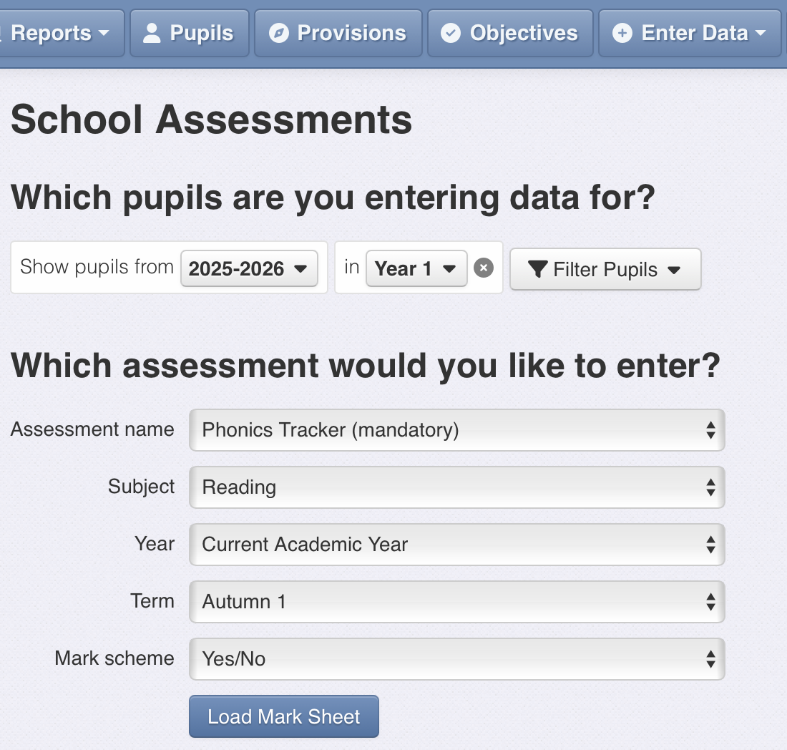

The tracker is a new assessment

Ensure that for the first tracking entry the term says ‘Autumn 1’
The data range is simply Y or N and this loads automatically

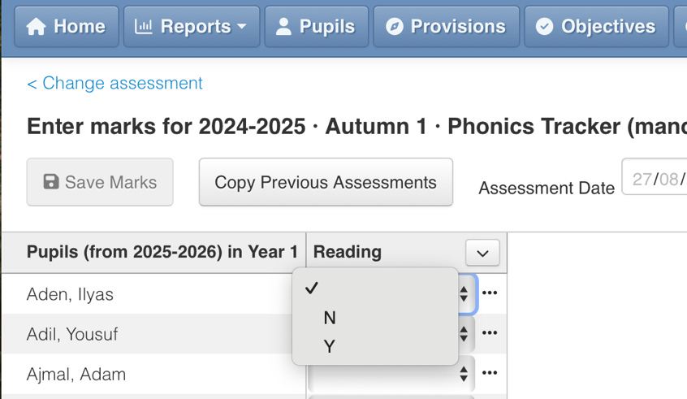
Once ‘Load Mark Sheet’ is clicked this will appear

Click on the empty box next to the child’s name and select Y or N
Don’t forget to save when you have finished!

Entering the actual phonics screener marks onto Insight (summer term year 1)
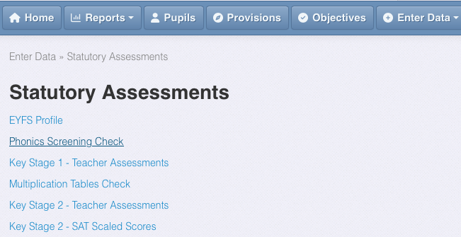

Click on ‘Enter Data’ and select ‘statutory assessments’

Select Phonics Screening Check

You will then click ‘Load Mark Sheet’ and this screen will appear

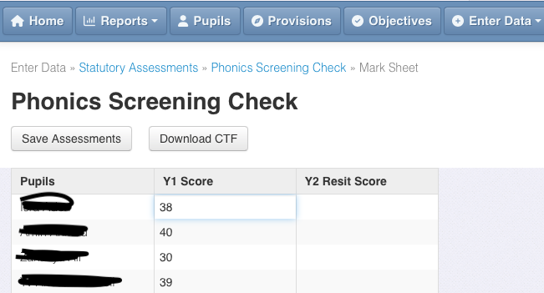

You can enter each child’s score by clicking in the box.
When you have done this you can create a CTF ready to send to the LA
Here is the link to the Insight page for further info

APPENDIX – Progressions of the phonics programmes (for reference)

Little Wandle – teaching sequence

RECEPTION | Autumn 1 phase 2 | Autumn 2 phase 2
Graphemes | s a t p i n m d g o c k ck e u r h b f l | ff ll ss j v w x y z zz qu ch sh th ng nk  - words with –s /s/ added at the end (hats sits)  words ending in s /z/ (his) and with –s /z/ added at the end (bags sings)
Tricky Words | is I the | put* pull* full* as and has his her go no to into she push* he of we me be
RECEPTION | Spring 1 Phase 3 | Spring 2 Phase 3
Graphemes | ai ee igh oa oo oo ar or ur ow oi ear air er  - words with double letters  longer words | Review Phase 3  - words with double letters, longer words, words with two or more digraphs, words ending in –ing, compound words  - words with s /z/ in the middle  - words with –s /s/ /z/ at the end  words with –es /z/ at the end
Tricky Words | was you they my by all are sure pure | Review all taught so far

RECEPTION | Summer 1 Phase 4 | Summer 2 Phase 4
Graphemes | Short vowels with adjacent consonants  • CVCC CCVC CCVCC CCCVC CCCVCC • longer words and compound words • words ending in suffixes:  –ing, –ed /t/, –ed /id/ /ed/, –est | Phase 3 long vowel graphemes with adjacent consonants  - CVCC CCVC CCCVC CCV CCVCC  - words ending in suffixes:  –ing, –ed /t/, –ed /id/ /ed/, –ed /d/ –er, –est • longer words
Tricky Words | said so have like some come love do were here little says there when what one out today | Review all taught so far
Year 1 | Autumn 1 Phases 2–4: | Autumn 2 Phase 5
Graphemes | Review Phase 3 and 4  Phase 5  /ai/ ay play  /ow/ ou cloud  /oi/ oy toy  /ea/ ea each | /ur/ ir bird  /igh/ ie pie  /oo/ /yoo/ ue blue rescue  /yoo/ u unicorn  /oa/ o go  /igh/ i tiger  /ai/ a paper  /ee/ e he  /ai/ a-e shake  /igh/ i-e time  /oa/ o-e home  /oo/ /yoo/ u-e rude cute  /ee/ e-e these  /oo/ /yoo/ ew chew new  /ee/ ie shield  /or/ aw claw
Tricky words | the put* pull* full* push* to into I no go of he she we me be was you they all are my by sure pure said have like so do some come love were there little one when out what says here today | their people oh your Mr Mrs Ms ask* could would should our house mouse water want
Year 1 | Spring 1 Phase 5 | Spring 2 Phase 5
Graphemes | ee/ y funny  /e/ ea head  /w/ wh wheel  /oa/ oe ou toe shoulder  /igh/ y fly  /oa/ ow snow  /j/ g giant  /f/ ph phone  /l/ le al apple metal  /s/ c ice  /v/ ve give  /u/ o-e o ou some mother young  /z/ se cheese  /s/ se ce mouse fence  /ee/ ey donkey  /oo/ ui ou fruit soup | /ur/ or word  /oo/ u oul awful could  /air/ are share  /or/ au aur oor al author dinosaur floor walk  /ch/ tch ture match adventure  /ar/ al a half* father*  /or/ a water  schwa in longer words: different  /o/ a want  /air/ ear ere bear there  /ur/ ear learn  /r/ wr wrist  /s/ st sc whistle science  /c/ ch school  /sh/ ch chef /z/ ze freeze  schwa at the end of words: actor
Tricky words | any many again who whole where two  school call different thought through friend work | once laugh because eye
Year 1 | Summer 1 Phase 5 | Summer 2 Phase 5
 | Repeat Spring 2 | /ai/ eigh aigh ey ea eight straight grey break  /n/ kn gn knee gnaw  /m/ mb thumb  /ear/ ere eer here deer  /zh/ su si treasure vision  /j/ dge bridge  /i/ y crystal  /j/ ge large  /sh/ ti ssi si ci potion mission mansion delicious  /or/ augh our oar ore daughter pour oar more
 | Repeat spring 2

