Guidance and Information Booklet
Cherry Garden Framework
2025-2026

Contents
1. Introduction Cherry Garden Branch Map Assessment Framework 2
2. What are the Cherry Garden Branch Maps for? 2
3. Why Cherry Garden Branch Maps instead of Well Below Reception (WBR)? 4
4. How do I decide whether Cherry Garden Branch Maps are appropriate? 5
1. How do I assess pupils using the Cherry Garden Branch Maps? 6
2. How do I record assessment data on Insight for pupils on Cherry Garden Branch Maps? 6
3. Do I need to record steps of progress within branches on Insight? 7
4. How do I record the objectives in Insight? 7
APPENDIX 10

Part A: Introduction to Cherry Garden Branch Maps

Introduction Cherry Garden Branch Map Assessment Framework
The Cherry Garden Branch Maps is an assessment tool which tracks the detail the typical development of a child from birth to 5 years.
The applicable Cherry Garden Branch Map(s) should be used for children from Nursery to Year 6 and beyond. The table below outlines how it should be used in each key stage.
Year group/Phase | When to use Branch Maps
Nursery & Reception | At the first assessment point (which is baseline in October) and subsequent assessment points, where a child would previously have been assessed as ‘Well Below (WB)’ in Charter Educational Trust EYFS areas (Reading, Maths, Communication, Confidence, Physical, Self help)
Key Stage 1, 2, 3 & 4 | Where children are working below the Year 1 level (i.e. not yet accessing or scoring on Year 1 NFER assessments (<80 scaled score)  Please note: WBR (well below – working at Reception level) has now gone, replaced by the Cherry Gardens assessments (CGB1, CGB2 etc)

What are the Cherry Garden Branch Maps for?
The maps were created and developed by Cherry Garden School, a specialist school in Peckham for children who have severe and complex special educational needs and disabilities. The Branch Maps are shared freely with all schools to support their assessment of pupils with SEND who are working below Year 1 expectations.
The branch maps are intended to be child-centred documents that allow for a flexible approach to assessment – moving away from previous models where the expectation would be that a child makes typical ‘linear’ progress. A child’s learning journey can follow their own unique path, and the straightforward organisation of milestones means that adults can see if a child has missed a key step that is holding them back from moving forward.
There are 6 maps in total, covering the six areas of the Early Years Foundation Stage curriculum. Each Branch Map matches broadly to the in Charter Educational Trust EYFS areas.
Charter Educational Trust EYFS Areas | Cherry Garden Branch Map
Reading | Communication, Language & Literacy
Communication | Communication, Language & Literacy
Maths | Mathematical Development (Cognition)
Confidence (Feelings and relationships) | Personal, Social, Emotional Development
Physical | Physical Development
Self Help | Physical Development

There are two additional Cherry Garden Branch Maps which can be used to relevant areas but these are not areas we record data for on Insight.
- Understanding of the World
- Expressive Arts and Design
Within each Branch map, there are 10 Branches linked with expected progression in typically developing children from 0-5 years.

Cherry Branch | Branch 1 | Branch 2 | Branch 3 | Branch 4 | Branch 5 | Branch 6 | Branch 7 | Branch 8 | Branch 9 | Branch 10
Equiv. typical development | 0-5 months | 5-10 months | 10-15 months | Bridging Branch | 15-22 months | 22-29 months | 29-36 months | 36-48 months | 48-60 months  (If in Reception this might indicate ELG) | Emerging Year 1  (If in Year 1, this would show be considered WTS.

Each Map is divided into strands which are indicated by colour. White boxes give additional information to ensure sufficient evidence of progress for particular objectives.
For example, the Communication, Language and Literacy Branch Map is broken into 4 strands indicated by the colours below:
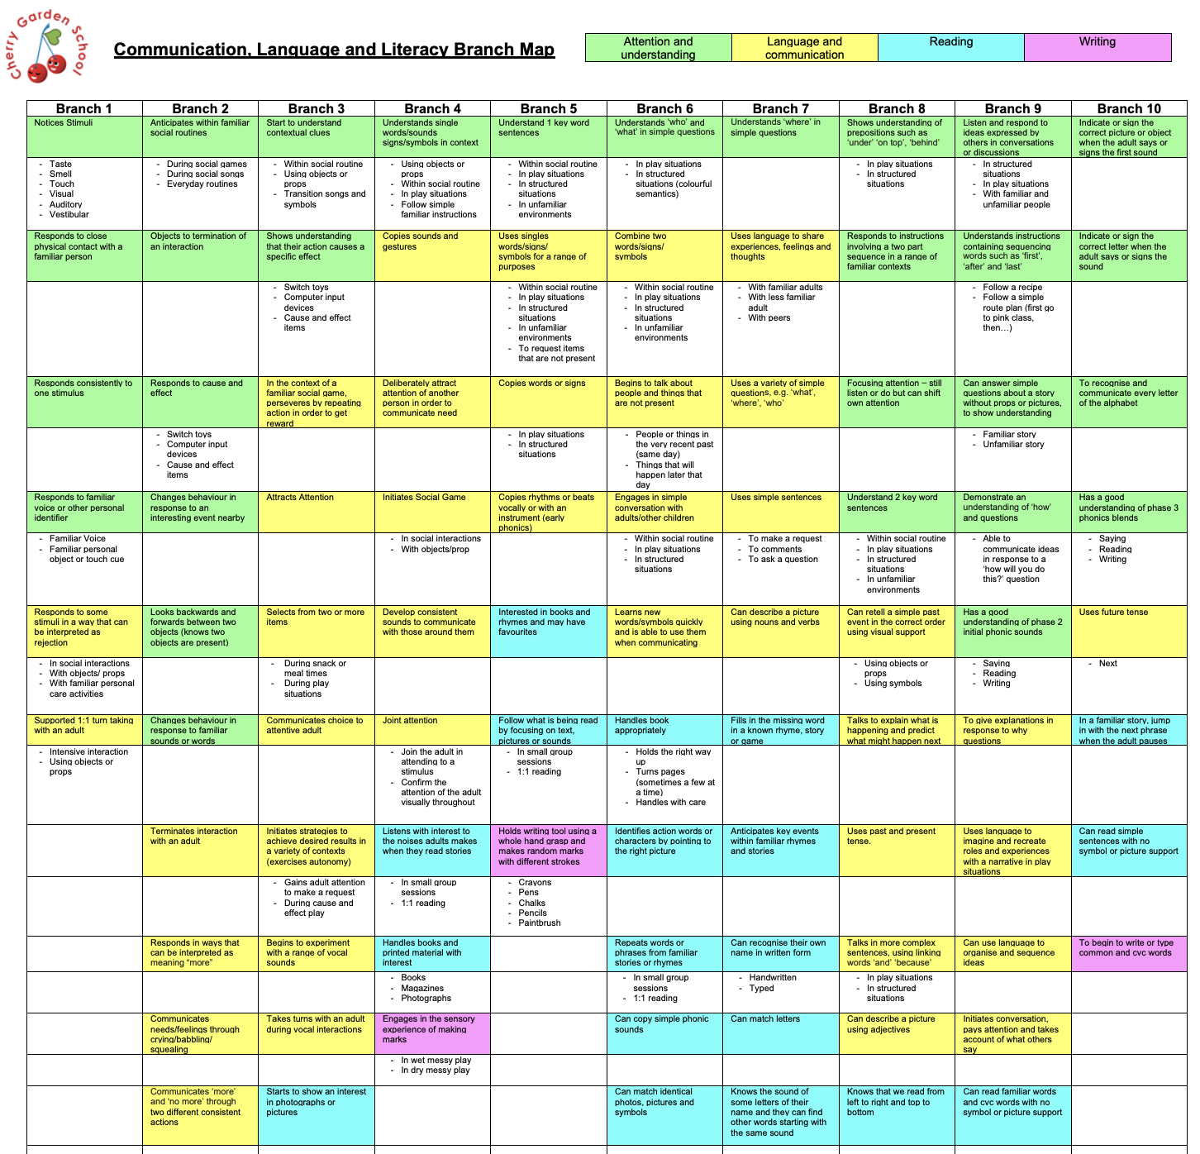
The structure of the Cherry Garden Frameworks reflects that not all progress is linear, recognising that pupils (especially those with SEND), may make progress at different rates in different areas. Progress against the Cherry Garden Map objectives should illustrate how pupils are ‘growing’ in skills across the areas. Where there are gaps in coverage, we can use this information to inform planning and setting personalised targets and implement the associated/recommended strategies to support the development of those skills.

Why Cherry Garden Branch Maps instead of ‘Well Below – working at Reception level’ (WBR)?
The "Well Below – working at Reception" (WBR) assessment outcome is often too broad and lacks the specificity needed to inform meaningful planning. It fails to clearly identify what a pupil can or cannot do, or where their developmental gaps lie, making it difficult—if not impossible—to tailor support effectively. Cherry Garden Branch Maps offer a more granular and developmentally appropriate framework, breaking down milestones from birth to five years. This enables educators to assess progress with greater precision, plan targeted interventions, and celebrate even the smallest steps of success, rather than repeatedly reporting a lack of progress.

How do I decide whether Cherry Garden Branch Maps are appropriate?
In EYFS
Cherry Garden Branch Maps should be used for children in Nursery or Reception, at the first assessment point (which is baseline in October) and subsequent assessment points. It is to be used where a child would previously have been assessed as ‘Well Below (WB)’ in Charter Educational Trust EYFS areas (Reading, Maths, Communication, Confidence, Physical, Self help)
Cherry Garden Branch Maps should only be used in relevant areas e.g. a child is working at expected for self-help and physical development but ‘WB’ for confidence. This is a pupil who would require assessment using the Personal, Social and Emotional Branch Map.
In Key Stage 1 and above
Cherry Gardens Branch Maps should only be used when assessment evidence strongly suggests that a child is working below the Year 1 curriculum in any/all of the core subjects (Reading, Writing and Maths). Currently, this is defined as:
- any child who with reasonable adjustments either cannot yet access the Year 1 assessment materials or;
- a child who is likely to attain a standardised score of <80 in Year 1 assessments (to be discussed with SENCO)
It is best practice to use the EYFS framework only for pupils who are of early years chronological age. Any pupil in years 1-6 who is working below a year 1 level, will be assessed using Cherry Garden Branch Map.
If there is discrepancy between teacher assessment and scaled scores, a discussion with the SENCo is required in considering if Cherry Gardens Branch Maps would be appropriate.

Case Study:
Child J in Year 3, has been given a Y1 NFER reading test and scored comfortably at Year 1 Level for reading in autumn and spring with scores of 107 and 108. However, in the summer term, Child J scored 78 in the Summer Y1 NFER test for reading. There is reasonable doubt that Child J may not be comfortably working at Y1 level and the Cherry Garden Branch Map should be considered. Therefore, for Child J, staff should consult the Communication, reading and literacy Branch map and cross check coverage of the reading Strand (blue).
In writing he has been assessed by the teacher as WBR – working well below the level of reception (using the old assessment guidance), therefore staff should consult the CLL branch map (pink areas) and/or Physical development (blue areas). In the summer, he was given a Y1 Maths assessment and scored 99 Maths.

Part B: Cherry Garden Branch Map Assessment Guide

How do I assess pupils using the Cherry Garden Branch Maps?

Stage | Process
Baselining | - Select the Branch Map(s) you want to focus on  - Baseline the pupil by highlighting each statement that they are secure in (not emerging or developing). If they are secure in a whole branch, just highlight the branch number at the top.  - Identify key next steps to focus on for the coming term – these might be recorded in an individual learning plan or separate central document.  - Best fit -
Data Drop Windows | - At the end of each term (or during assessment weeks), review progress against the statements and indicate the pupil’s refinement level* and highlight with the corresponding colour for the term. This will provide at a glance, where the pupil currently is developmentally. * Refinement level = E – Emerging, D – Developing, S – Secure.  - Use Branch Maps to inform planning and next steps.
Key:
Baseline ………. Autumn 2 ………. Spring 2 ………. Summer 2 ……….

Clarification on ‘refinement levels’
As a rule of thumb, emerging would indicate a child is beginning to demonstrate the skill independently (some of the time). Developing would indicate the child is independently demonstrating the skill some of the time. Secure would indicate the skill is demonstrated most/all of the time, independently.

How do I record assessment data on Insight for pupils on Cherry Garden Branch Maps?
Cherry Gardens Branch Map Assessment codes replace ‘Well Below Reception’ (WBR) across all year groups and key stages. The process will be slightly different for EYFS and Key Stages 1+.
Key Stage | Process
EYFS | When reporting against the Charter Trust EYFS Areas, they match to the following branch maps:  For each area where a pupil would be assessed as ‘WBR’, pupils will now be assessed as CG1-10.  CG represents ‘Cherry Garden’  1-10 represents the most advanced branch of the Branch Map you are focused on which is fully secure.  Example: a pupil assessed as CG3 in maths is secure in all objectives in Branch 3 of the Mathematical Development Branch Map. The pupil may be emerging/developing/secure in discrete skills in more advanced branches but they are not secure in a higher branch until all objectives in a branch are secure.
  Charter Educational Trust EYFS Areas | Cherry Garden Branch Map
  Reading | Communication, Language & Literacy
  Communication | Communication, Language & Literacy
  Maths | Mathematical Development (Cognition)
  Confidence (Feelings and relationships) | Personal, Social, Emotional Development
  Physical | Physical Development
  Self Help | Physical Development
KS1, 2 & 3 | When reporting Cherry Garden Assessments for pupils in KS1+, pupils will be assessed only using the two branch maps linking to the core subjects (where applicable):  - Communication, Language and Literacy  - Mathematical Development (Cognition)  For each area where a pupil would be assessed as ‘WBR’, pupils will now be assessed as CG1-10.  CG represents ‘Cherry Garden’  1-10 represents the most advanced branch of the Branch Map you are focused on which is fully secure.  Example: a pupil assessed as CG3 in maths is secure in all objectives in Branch 3 of the Mathematical Development Branch Map. The pupil may be emerging/developing/secure in discrete skills in more advanced branches but they are not secure in a higher branch until all objectives in a branch are secure.

Do I need to record steps of progress within branches on Insight?
Yes – The Cherry Garden Branch Maps have been uploaded to Insight under objectives. Once the overall assessment ‘code’ has been entered, it is necessary to transfer the objectives which have been observed from a paper copy of the branch map to insight. The same ‘refinement levels’ are used.

OPTIONAL: How can I record the objectives in Insight?
Recording objectives is iptionbal – for guidance on this speak to Lucy or Will

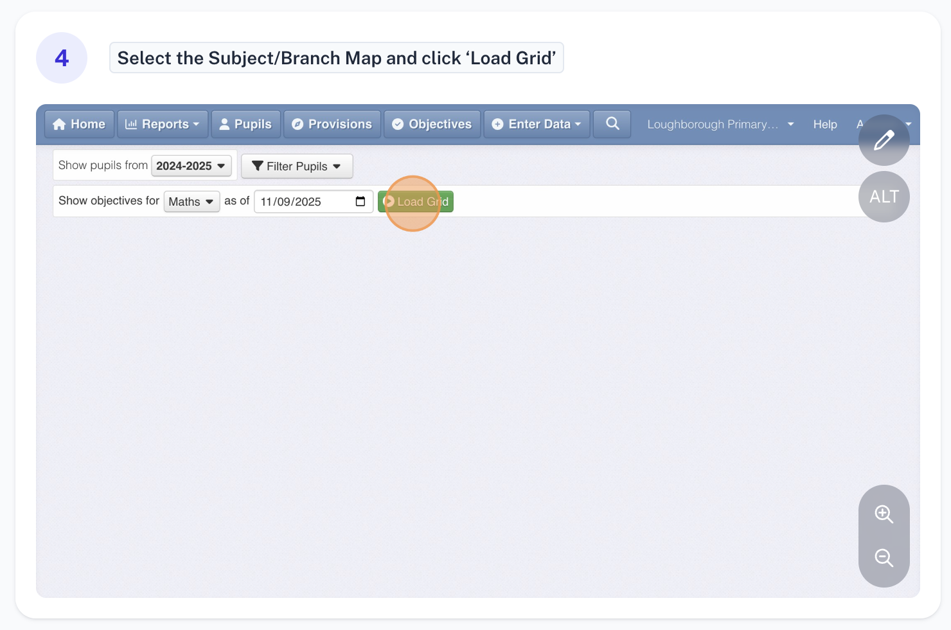
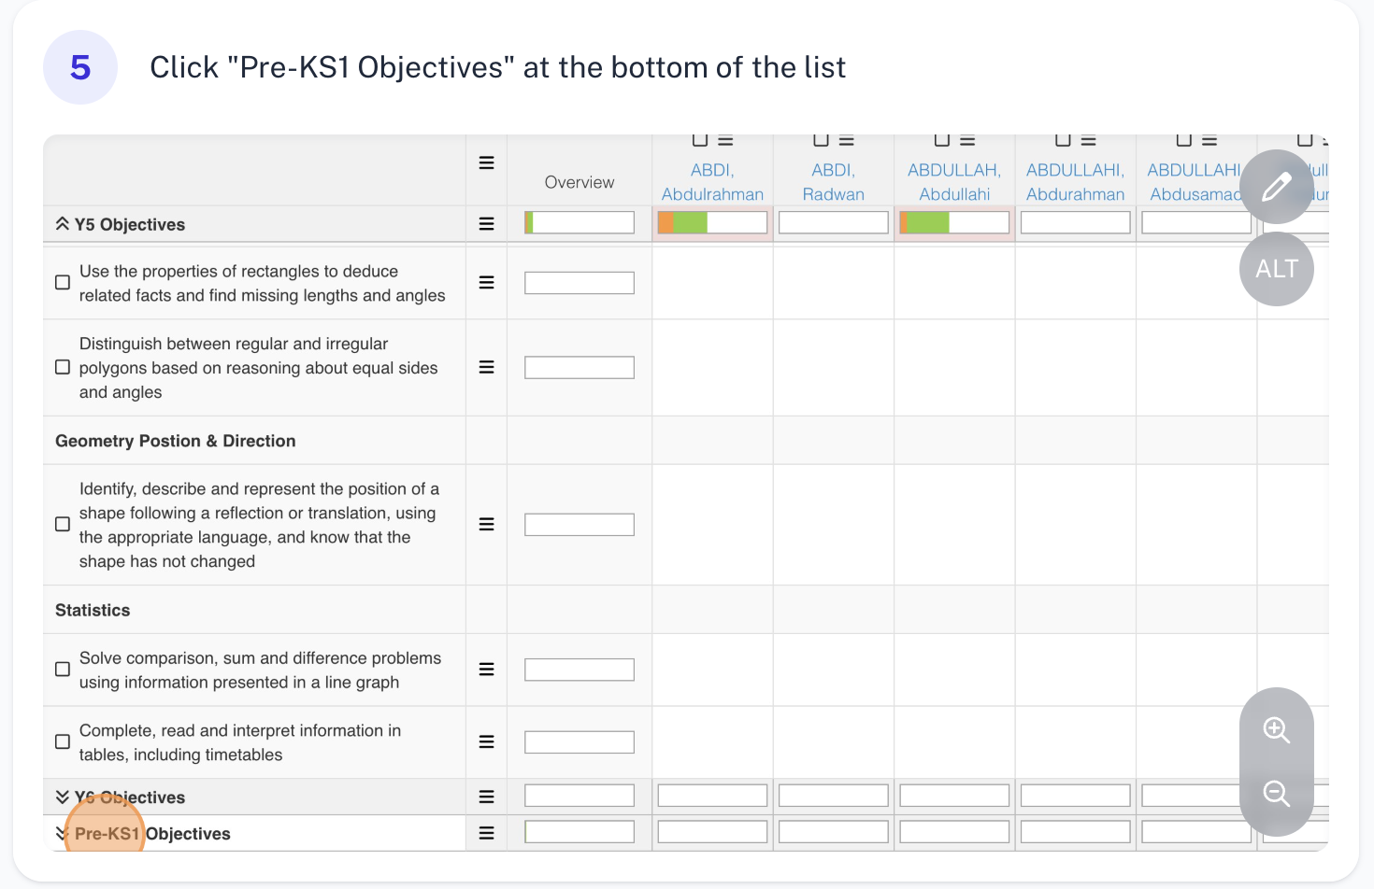
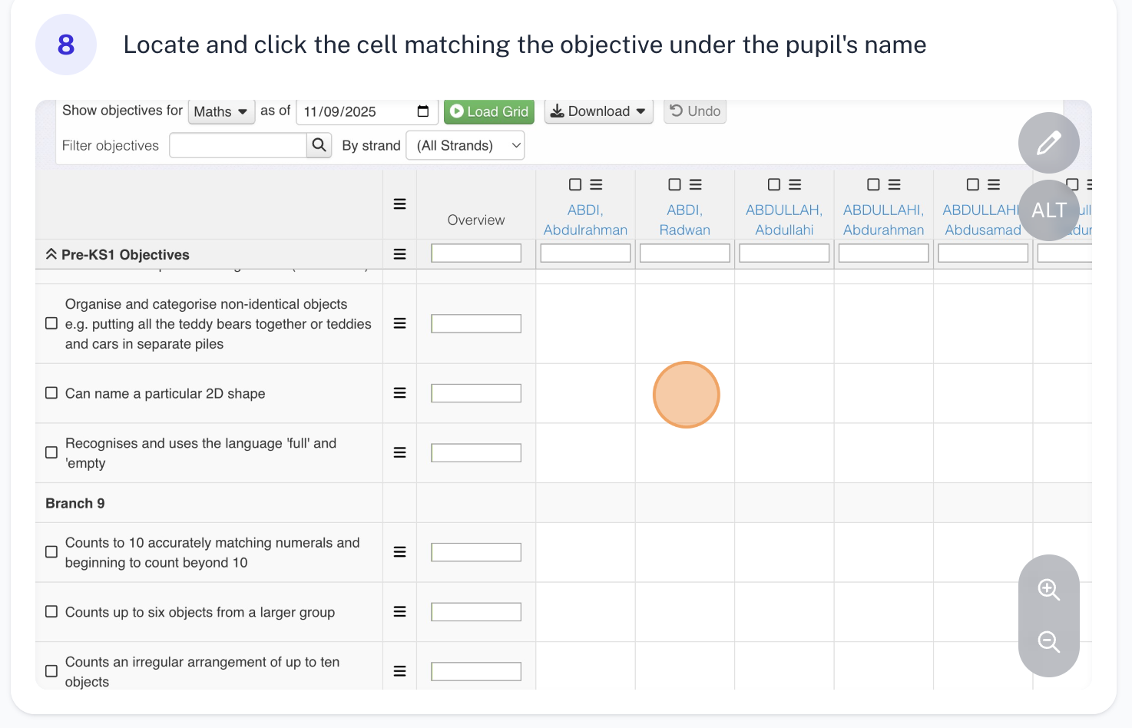
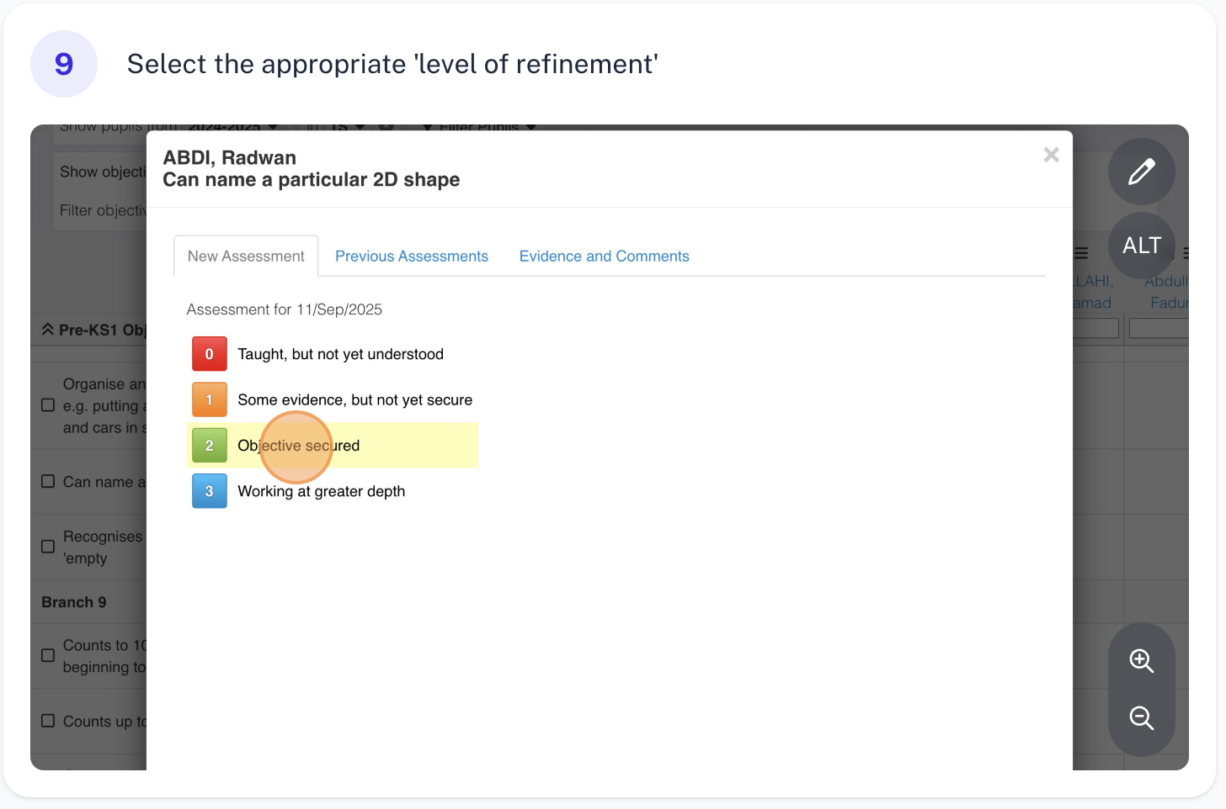
This process can be repeated each term, and will be updated.

APPENDIX

Below are links to each of the Cherry Garden Branch Maps. These should be printed and stored in a folder in your classrooms. All staff working with a child should be supported and encouraged to annotate and note progress on the physical copies of the maps which will make the process most effective and efficient.
Branch Map Links
Communication, Language & Literacy
Mathematical Development (Cognition)
Personal, Social, Emotional Development
Physical Development
Understanding of the World
Expressive Arts and Design

Clarify how this sits along side assessment – logging objective coverage and discussing progress in pupil progress meetings.

