Guidance and Information Booklet
Floppy’s Phonics
2026-2027

with thanks to Charlotte at CDPS

September 2026 version
Red text updates for-26-27
Phonics tracking (mandatory) together with screeners
NB – as of June 2026 the screener pass mark was 31/40
New for 2026-2027

Reception
Complete a phonics tracker only (Y/N for on track to pass the screener at the end of year 1) for Autumn 1 (baseline) Autumn 2, Spring 1 (as part of mid year review) and summer 1for a final push for EYFS Reading ELG at end of year)
There is no expectation that Reception complete any screeners.

Yr 1
Autumn 2 - complete a phonics tracker for every child, PLUS the 2024 screener for any child with a N. (pass mark of 15)
Spring 2 – complete a phonics tracker for every child, PLUS the 2025 screener for any child with a N (pass mark of 25)
Summer 1 – complete a phonics tracker for every child, PLUS the 2026 screener for any child with a N (pass mark of 31)

Yr 2 (only those pupils who are resitting the screener in June 2027)
Autumn 2 – 2024 screening check only (pass mark 31)
Spring 2 – 2025 screening check only (pass mark 31)
Summer 1 – 2026 screening check only (pass mark 31)

Please note that this way of assessing was agreed by all the phonics leads in June 2025 as a simpler and more reliable way of tracking our likely phonics outcomes at the end of year 1. Given that the national average is 80% achieving a score of 31+, we expect each school’s tracking to be in line with this % from term to term and not to ‘swing’ wildly.
Inputting a Y should be based on evidence – if tracking shows the % to be well below 80% then there must be a plan to increase the number of pupils who will pass.
Introducing a screener for those pupils tracked with N is new for 2026
Phonics Teacher Assessment Criteria:
NB – these are best fit, please use your professional judgement. The purpose of this table is to see how the skills being taught and developed are called different things in different schemes.
NB – entering a phonics teacher assessment as below, is no longer needed. Phonics tracking and screeners for some, replaces it. The facility is still there for you to use if you would like to. This would be a local decision.
 | Level of Security | Assessment description
Level 1 | Beginning | - Children may show interest in signs and print around them  - Begin to mimic the sounds they hear around them
Level 1 | Developing | - Begin to mimic the movements of an adults mouth to articulate individual sounds correctly  - Can hear some phonemes within a word  - Can orally blend individual words or the last word in a sentence turning sound talk into a whole word independently
Level 1 | Secure | - Can orally blend and segment individual words  - Some will know sounds or be able to recognise and write letters that are of significance to them e.g. letters in their name  - Can distinguish between speech and sounds  - Some will be able to recognise spoken words that rhyme
Level 1+  (Books 1-6)  Pink books | Beginning | - Beginning to say Level 1+ sounds when shown a flash card/display.  - Blend and segment CV/VC words orally.  - Some will know sounds or be able to recognise and write letters that are of significance to them e.g. letters in their name
Level 1+  (Books 1-6)  Pink books | Developing | - Give the sound for most Level 1+ letters.  - Find most Level 1+ letters, from a display, when given the sound  - Orally blend and segment familiar CVC words  - Blend and segment in order to read and spell some VC words such as: if, am, on, up  - Read some of the tricky/helpful words; the, to, I, no, go
Level 1+  (Books 1-6)  Pink books | Secure | - Give the sound when shown any Level 1+ grapheme  - GPC for all Level 1+ sounds.  - Reads most VC words with Level 1+ sounds.  - Beginning to read CVC words with Level 1+ sounds.  - Orally blending all CVC words.  - Beginning to segment some CVC words making phonetically plausible attempts at spelling using Level 1+ graphemes.  - Read most five tricky/helpful words; the, to, I, no, go, into, little
Level 2  (Book 7-12)  Red Books | Beginning | - Give the sound when shown any Level 1+ grapheme and some level 2.  - Blend most VC words and some CVC consisting of Level 1+ graphemes and some Level 2.  - Segment most single-syllable words making phonetically plausible attempts at spelling using Level 1+ graphemes and some level 2.  - Read most of Level 1+ helpful words and some Level 2.
Level 2  (Book 7-12)  Red Books | Developing | - Segmenting & blending to read most CVC words with Level 2 sounds.  - Making phonetically plausible attempts at spelling CVC words including Level 2 sounds.  - Read most Level 2 helpful words.
Level 2  (Book 7-12)  Red Books | Secure | - Recognises and says the sound when shown any Level 2 graphemes  - Reads most CVC words (linked to taught phonic knowledge so far).  - Segment and make a phonetically plausible attempt at spelling most CVC words  - Read most Level 2 helpful words.  - Write simple captions/phrases that can be read by others.
Level 3  (Books 12-18)  Yellow books  Children who gain ELG in reading will likely be on the cusp between 3D and 3S | Beginning | - Beginning to give sounds when shown Level 3 graphemes.  - Blend and read all Level 1+ and Level 2 CVC words.  - Segment and make a phonetically plausible attempt at spelling most CVC words  - Read most helpful words from Level 1+ and 2 and some from Level 3.  - Write simple captions/phrases that can be read by others.
 | Developing | - Gives sound of most Level 3 sounds when shown on a display.  - GPC for most Level 3 sounds.  - Blend and read most CVC words containing digraphs and trigraphs and some polysyllabic words.  - Blend and read some words containing adjacent consonants.  - Segment and spell some words using digraphs and trigraphs.  - Reading most helpful words.  - Write simple captions/phrases that can be read by others – beginning to write simple sentences.
 | Secure | - Gives the sound when shown any Level 3 grapheme  - Secure GPC to Level 3.  - Blend and read most words containing adjacent consonants.  - Making phonetically plausible attempts at spelling CVC words using at least 10 diagraphs and trigraphs.  - Using strategies such as ‘chunking’ to read polysyllabic words.  - Read most/all helpful words up to Level 3.  - Beginning to spell some helpful words correctly.  - Write simple sentences that can be read by others.
Level 4  (Book 19-24)  Blue / Green books | Beginning | - Gives the sound when shown any graphemes up to Level 4 and some from Level 4.  - Gives alternative pronunciation for some graphemes.  - Secure GPC to level 3 and some level 4.  - Blend and read most words containing adjacent consonants.  - Phonetically plausible attempts at spelling words containing adjacent consonants (CCVC etc)  - Read most helpful words up to level 3 and some level 4.  - Beginning to spell helpful words correctly.
Level 4  (Book 19-24)  Blue / Green books | Developing | - Gives the sound when shown most Level 4 graphemes.  - Good GPC for Level 4 graphemes.  - Correctly uses alternative graphemes for some level 4 sounds  - Blend and read words containing adjacent consonants  - Segment and spell words containing adjacent consonants  - Read most level 4 helpful words.  - Spell most helpful words correctly.
Level 4  (Book 19-24)  Blue / Green books | Secure | - Give the sound when shown any grapheme that has been taught for any given sound.  - Secure GPC to Level 4.  - Gives alternative pronunciation for all Level 4 graphemes.  - Apply phonic knowledge and skill as the prime approach to reading and spelling unfamiliar words  - Beginning to read and spell most phonically decodable two-syllable and three-syllable words
Level 5 (Book 25-36)  Green to Orange books  Children who pass the screener are likely 5s | Beginning | - Gives the sound when shown any grapheme up to Level 4 and some Level 5.  - Gives alternative pronunciation for most graphemes taught so far.  - Secure GPC to level 4 and some level 5.  - Phonetically plausible attempts at spelling words containing adjacent consonants (CCVC etc)  - Read most helpful words up to level 4 and some level 5.  - Beginning to spell most of the 100 helpful words correctly.
 | Developing | - Says the sounds for most graphemes taught so far when shown on a flash card.  - Good GPC to Level 5.  - Gives alternative pronunciation for most graphemes  - Uses alternative graphemes for some sounds when spelling.  - Blend and read words containing adjacent consonants  - Segment and spell words containing adjacent consonants  - Beginning to read and spell most phonetically plausible polysyllabic words.  - Read most of the helpful words from level 4 and 5.  - Spelling nearly all of the 100 helpful words correctly.
 | Secure | - Give the sound when shown any grapheme that has been taught for any given sound  - Gives alternative pronunciation for most graphemes  - Write the common graphemes for given sounds  - Apply phonic knowledge and skill as the prime approach to reading and spelling unfamiliar words  - Spell unfamiliar and untaught words in a phonically plausible way (national curriculum)  - Spell any familiar and taught words correctly (national curriculum)  - Read and spell phonically decodable two-syllable and three-syllable words  - Read automatically all the words in the list of 100 high-frequency words  - Accurately spell most of the words in the list of 100 high-frequency words;  - Form all letters correctly

For cross checking - Reception phonics judgements
Baseline – Autumn Mid
On Track | Working Towards | Working Below
Level 1+s | Level 1+d | Level 1+b or below
End of Autumn Term
On Track | Working Towards | Working Below
Level 2b | Level 1+s | Level 1+ d or below
End of Spring Term
On Track | Working Towards | Working Below
Level 2s | Level 2d | Level 2b or below
End of Summer Term
On Track | Working Towards | Working Below
Level 3s | Level 3d | Level 3b or below

For cross checking - Year 1 Phonics Judgements
End of Autumn Term -
Screener - a score of 15+ is considered on track

On Track | Working Towards | Working Below
Level 4d | Level 4b | Level 3 or below
End of Spring Term
Screener - 25+ marks is considered on track
On Track | Working Towards | Working Below
Level 5b | Level 4s/d | Level 4b or below
End of Summer Term
Screener score of 31+ is on track
On Track | Working Towards | Working Below
Level 5s | Level 5d/b | Level 4 or below

NB for yr 2 screeners – a score of 31+ is on track for any given term

Entering phonics tracking onto Insight
Year 1/Reception
- Click on ‘Enter Data’
- Click on ‘school assessments’
- Ensure the following options are showing for year 1. For Rec, it will say Rec

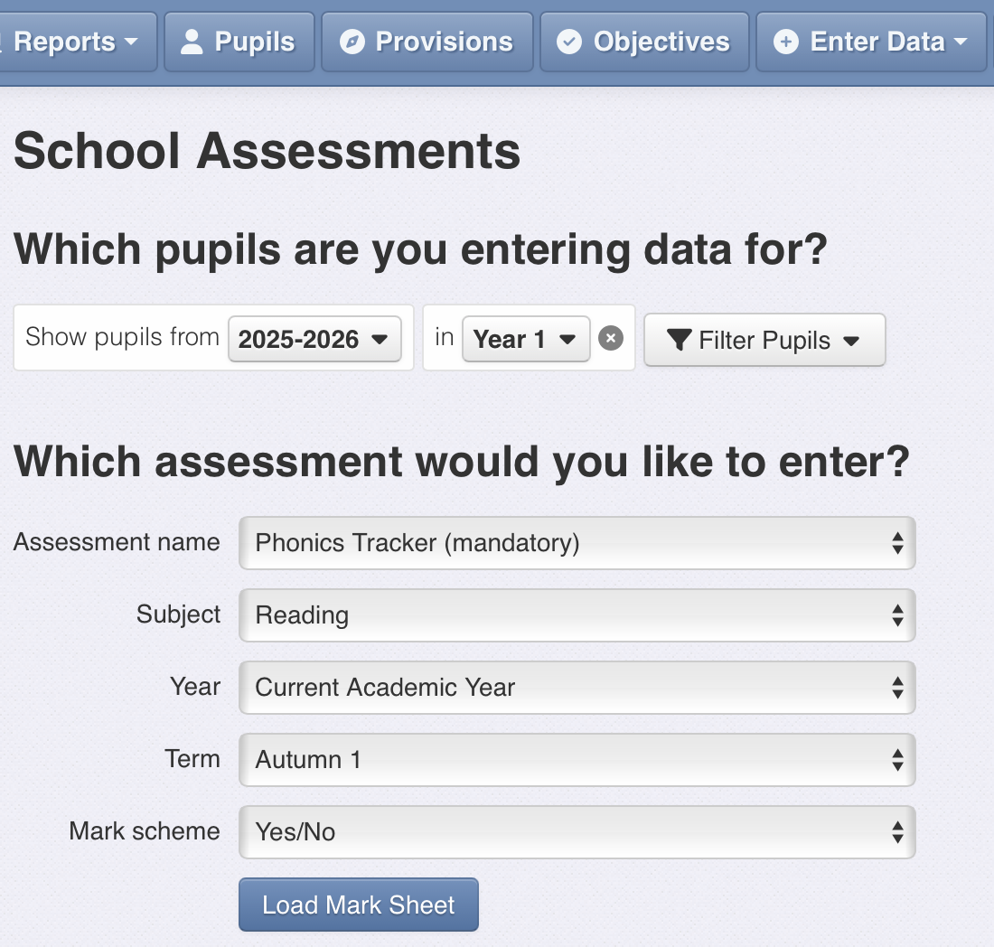

The tracker is a new assessment

Ensure that for the first tracking entry the term says ‘Autumn 1’
The data range is simply Y or N and this loads automatically

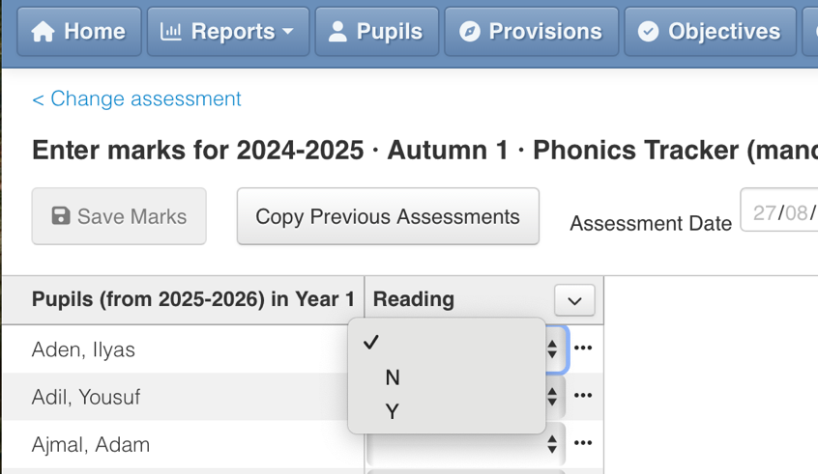

Click on the empty box next to the child’s name and select Y or N
Don’t forget to save when you have finished!

Entering a practice phonics screener onto Insight for those tracked with N in year 1 and all those who are retaking in yr 2
Year 2/Year 1
- Click on ‘Enter Data’
- Click on ‘school assessments’
- Ensure the following options are showing - for year 1 it will say yr 1 and for yr 2 it will say yr 2

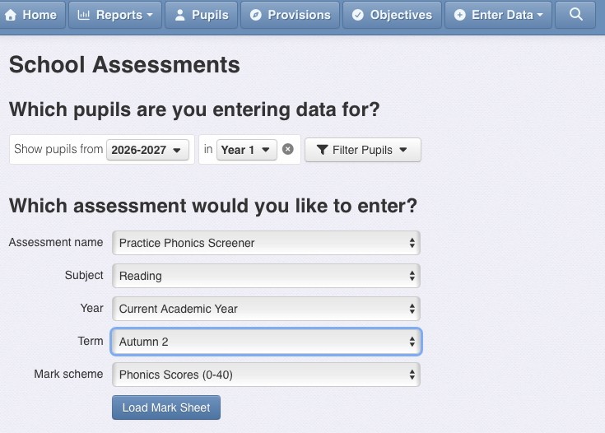
Ensure it says Practice phonics screener under school assessments

Click ‘Load Mark Sheet’
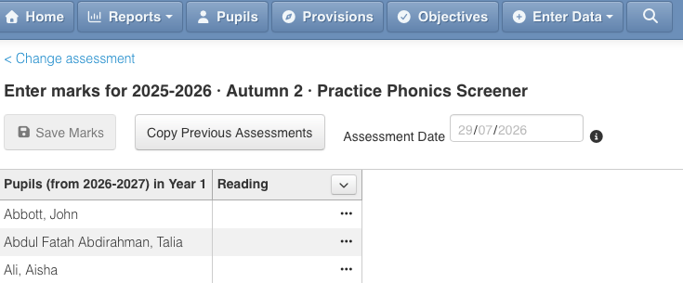
Once ‘Load Mark Sheet’ is clicked this will appear

Click on the empty box next to the child’s name and type in the score
Don’t forget to save when you have finished!

Entering the actual phonics screener marks onto Insight (summer term year 1)
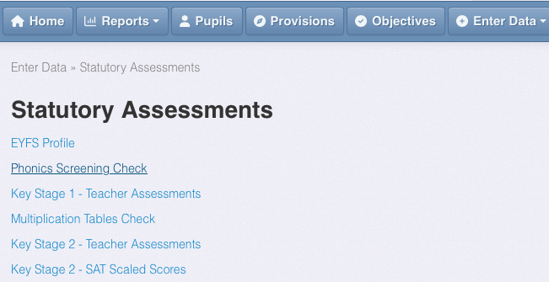

Click on ‘Enter Data’ and select ‘statutory assessments’

Select Phonics Screening Check

You will then click ‘Load Mark Sheet’ and this screen will appear

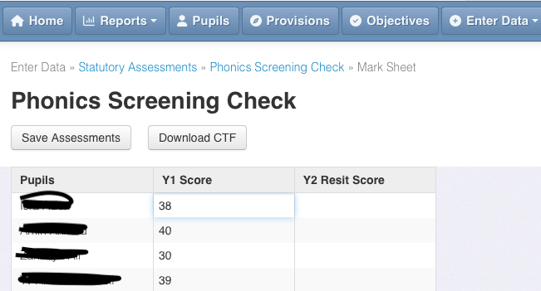

You can enter each child’s score by clicking in the box.
When you have done this you can create a CTF ready to send to the LA
Here is the link to the Insight page for further info

Appendix
Floppy’s phonics teaching sequence

RECEPTION | Autumn 1 Level 1+ | Autumn 2 Level 1+
Graphemes | s a t p i n m d g o c k  Level 1 books 1, 2 and 3 (2 weeks per book) | ck e u r h b f l ff ll -le ss  words with –s /s/ added at the end (hats sits)  Level 1 books 4, 5 and 6 (2 weeks per book)
Helpful Words | It, and, in, did, Dad, am, at, is, I, the, | Get, on, big, up, Mum, but, not, had, go, no, to, his, into, has, of,  Review: the, to, I, no, go
RECEPTION | Spring 1 Level 2 | Spring 2 Level 2
Graphemes | j v w x y z zz qu ch  Level 2 books 7, 8, 9  - words with double letters  - longer words  words ending in s /z/ (his) and with –s /z/ added at the end (bags sings) | sh th ng -dge -ve wh -cks -tch -nk  Level 2 books 10,11 and 12  Review Level 2  - words with double letters, longer words, words with two or more digraphs, words ending in –ing, compound words  - words with s /z/ in the middle  - words with –s /s/ /z/ at the end  words with –es /z/ at the end
Helpful Words | Will, off, can, be, too, she, we, for,  Review: the, to, I, no, go, he, she, we, me, be, was, my, you, her, they, all, are | That, with, from then, just, this, help/s, them, sees, you, her, are, they, all, me, have, out,
RECEPTION | Summer 1 Level 3 | Summer 2 Level 3
Graphemes | ai ee igh oa oo oo ar or ur  Level 3 books 13, 14, 15  Short vowels with adjacent consonants  • CVCC CCVC CCVCC CCCVC CCCVCC • longer words and compound words • words ending in suffixes:  –ing, –ed /t/, –ed /id/ /ed/, –est | ow oi ear air er -ue -ue -ure  level 3 books 16, 17, 18
Helpful Words | Review all taught so far | Said, one, so, down, oh, there, was, it’s, your, like, going, I’ll,
Year 1 | Autumn 1 Level 4 | Autumn 2 Level 4
Graphemes | Level 4 Revise and blend  Book 19  a e i o u s t p n m d g c k -ck r h b f -ff l -ll -le -ss j v w x y z -zz qu  Book 20  ch sh th -ng -nk ai -igh oa -oo oo or ur er -er ow oi ear air  Level 4 Revise and stretch Book 21  /ai/ ai ay /oi/ oi oy /ee/ ee ea /igh/ -igh -ie | Book 22  /oa/ oa ow /yoo/ -ue ew (blue) (rescue) long /oo/ oo -ew (chew, new) /ou/ ow ou (cloud, crowd)  Book 23  /ur/ ur ir (bird), /or/ or aw (claw, raw, store), /eer/ ear eer  /air/ air -are  Book 24  /s/ s -ce /e/ e -ea /u/ u o -ed /d/ /t/
Helpful Words | Said, have, like, so, do, some, come, were, there, little one, when out, what, looked  Made, make, looked, day, put, when, every day, here, our, called, very | Don’t, by, were, could, children, looked, house,  Now, saw, what’s asked, I’ve, here, about,
Year 1 | Spring 1 Level 5 | Spring 2 Level 5
Graphemes | Level 5 Alternative spellings Book 25  /ai/ ai ay eigh -ey (sleigh, rain, way, eight straight grey)  /ai/ a a-e -ae -ea (paper)  /ee/ ee e -y -ey (key, money, tree, donkey, funny)  /ee/ ea e-e -ie (shield)  Level 5 Alternative spellings Book 26  /igh/ -igh i -y (pie, night fly)  /igh/ -ie i-e (crime tiger time)  /oa/ oa ow o (go, grow, road, toad, snow)  /oa/ -oe o-e , ou (home, hoe, stone, toe, shoulder)  -ough -eau (although, doughnut,  Level 5 Alternative spellings Book 27  /s/ s -ss -se -ce (mouse fence)  /s/ ce ci cy (ice)  /s/ sc -st- (whistle, science)  /e/ e -ea (head) | Level 5 Alternative spellings Book 28  /j/ j ge gi gy (large, giant)  /j/ -ge -dge (bridge)  /ul/ -le -el (apple)  /ul/ -al -il (metal)  Level 5 Alternative spelling Book 29  /yoo/ -ue u  /yoo/ ew u-e eu  long /oo/ oo u-e -o (rude, cute)  -ou -ough (through, soup)  long /oo/ -ue -ew  ui u (unicorn, fruit)  Level 5 Alternative spellings Book 30  /oi/ oi oy  /ou/ ow ou -ough (plough)  /or/ or -our (author, floor,pour, tour)  /or/ aw au -al (awful, walk, talk, dinosaur)  war quar (water)
Helpful Words | Oh, their, people, Mr, Mrs, looked, called, asked, could, two, friends, everyone, wasn’t, our | once laugh because eye
Year 1 | Summer 1 Level 5 | Summer 2 Level 5
Graphemes | Level 5 Alternative spellings Book 31  /ur/ ur ir er  /ur/ ear (w)or  (schwa) -re -our  /u/ u o -ou -ough  /ar/ ar a al  Level 5 Alternative spellings Book 32  /zh/ -s -si ge  /w/ w wh -u  /f/ f -ff  /f/ ph -gh  Level 5 Alt pronunciations Book 33  ch /ch/ /k/ /sh/ (school)  -ie /igh/ /ee/ (/i-ee/)  ow /ou/ /oa/  a /a/ /ai/  /o/ as in (w)a & alt | Level 5 Alternative spellings Book 34  /ch/ ch -tch  /chu/ -ture  /sh/ sh ch  /sh/ -ti -ci -ssi -sci (mission, treasure adaptation potion, mission, mansion, delicious)  /g/ g gu -gue gh  Level 5 Alternative spellings Book 35  /eer/ ear eer (deer, here)  -ere -ier  /air/ air -are  -ear -ere  /n/ n -nn kn gn (knee gnaw)  /r/ r -rr wr rh  Level 5 Alternative spellings Book 36  /m/ m -mm -mb -mn (thumb, autumn, climb)  /k/ c k -ck ch qu que  /or/ or ore -our  -oor oar  /or/ aw au -al  augh ough
Helpful Words

