Guidance and Information Booklet Three
Multiplication Tables Check (MTC)
2026-2027

September 2026
New text for 2026-2027
National Curriculum Requirements:
By the end of Year 4, pupils ‘are capable of recalling all 12 times tables up to 12x12’.
The following chart shows where the multiplication tables are covered within the maths national curriculum,
Year | Autumn 1 | Autumn 2 | Spring 1 | Spring 2 | Summer 1 | Summer 2
1 | Count in 2s up to 24  Count in 10s up to 120 |  | Count in 5s up to 60, linking with knowledge of counting in 10s.  Develop fluency in 2’s and 10’s |  | Count in10s, 2s and 5s with growing fluency. | Count in10s, 2s and 5s fluently.
2 | Consolidate counting 2s, 5s and 10s | Count in 2s, 5s fluently.  Recall multiples of 10 in any order, including missing numbers and related division facts with growing fluency | Recall multiples of 2 in any order, including missing numbers and related division facts.  Recall multiples of 10 fluently. | Recall multiples of 2s and 5s  both in any order, including missing numbers and related division facts with growing fluency | Count in 3s in order.  Recall 2s and 5s  Both in any order, including missing numbers and related division facts with growing fluency | Count in 3s in order with growing fluency.  Recall 5s in any order, including missing numbers and related division facts fluently.
3 | Count in 3s in order fluently | Recall 3s in any order, including missing numbers and related division facts with growing fluency.  Count in multiples of 4 in order with growing fluency.  Introduce and begin to count in multiples of 8 | Recall 3s up to 12x3 in any order, including missing numbers and related division facts fluently.  Count in 4s to 12x4 in order fluently.  Count in 8s to 12x8 with growing fluency. | Recall 4s up to 12x4 in any order, including missing numbers and related division facts with growing fluency.  Count in 8s to 12x8 in order fluently | Recall 4s up to 12x4 in any order, including missing numbers and related division facts with fluently.  Recall 8s up to 12x8 in any order, including missing numbers and related division facts with growing fluency | Recall 8s up to 12x8 in any order, including missing numbers and related division facts with fluently
4 | There MUST be daily times table quick recall practice from the start of year 4
4 | Recall 3s, 4s and 8s in any order, including missing numbers and related division facts fluently.  Fluently count in 6’s in order | Recall 6s in any order, including missing numbers and related division facts with growing fluency.  Fluently count in 7’s in order | Recall 6s in any order, including missing numbers and related division facts fluently.  Recall 7s in any order, including missing numbers and related division facts with growing fluency | Recall 7s in any order, including missing numbers and related division facts fluently.  Fluently count in 9’s in order up to 12x9. Fluently count in 11’s in order. | Recall 9s in any order, including missing numbers and related division facts with growing fluency  Recall multiples of 11 in any order, including missing numbers and related division facts fluently.  Fluently count in 12’s in order up to 12x12. | Recall 9s in any order, including missing numbers and related division facts fluently.  Recall 12s in any order, including missing numbers and related division facts with growing fluency  Recall all times tables up to 12x12 in any order, including missing numbers and related division facts fluently

Online resources
Third Space Learning have compiled a list of the best free multiplication games to play at KS1 and 2 for class room engagement here
Our schools recommend - Times Tables Rockstars (TTRS) is as this can be personalised and adjusted to specific requirements. It also has a heat map facility so you can track which areas need focus

The Multiplication Check (MTC)
Further details are in the Multiplication tables check: Administration guidance (April 2025) and in the ARA KS2 booklet (February 2025 section 9) here
Useful information about the MTC (with thanks to Third Space Learning blog)
What is it
- The MTC is taken by pupils at the end of Y4, focused on the fluent recall of multiplication facts up to 12x12. There are 25 multiplication statements NOT presented as division facts.
- There are some circumstances where pupils are not eligible for the test or may require access arrangements. These are detailed in the ARA guidance (April 2025 section 5)
- The MTC will be delivered as an online, on-screen digital assessment, which should take each pupil less than 5 minutes to complete. It will be automatically scored, and results will be available to schools once the assessment window closes.
- The test can be delivered individually or in small groups over two weeks. Please manage this carefully according to the children’s needs.
- There is no official pass mark and pupils will not be required to re-sit.
- Results will also be available to OfSTED and local authorities through ASP (analyse school performance)
- Over the past 2 years, national data has been reported in the following way: The mean average score of all pupils sitting the check, and the % of pupils who scored full marks.

What will happen during the test
- If pupils are receiving access arrangements the set up will be different (section 5). Please also see the STA video on access arrangements for the MTC
- There are 3 practice questions
- Children will be allocated 6 seconds to answer each of the questions – so speed is of the essence. This is 6 seconds from the time the question appears, to input their answer. This means that children must be able to read, recall and enter their response within 6 seconds.
- Whatever is in the answer box at the end of the 6 seconds will be counted at the answer. This means that if a child is mid-way into entering a two-digit answer (e.g. they only enter the 7 out of 72 when answering 8x9) they will be recorded as having answered 8x9 as 7.
- Children will be presented with the questions with a 3 second pause in-between each question, before the next one appears on screen
- Each child will be randomly assigned a set of questions, which the STA refer to as a ‘form’. This is the spread of questions.
- There will be repeated questions across different sets of questions each year, but no more than 30% of the questions will be the same in any two sets of questions. This means if the test gets interrupted and children need to re-start it, will only have a minimal advantage.
- Reversal of questions using the commutative law will not feature in the same check. This means that, for example, 8 x 3 and 3 x 8 won’t be asked to the same pupil.
- The STA state that they are classifying the multiplication tables by the first number in the question. For example, 8 x 3 would fall within the 8 times table.
- This reflects what is now considered to be best practice – for example, that 8 x 3 should be thought of as 8, three times rather than 8 lots of 3.

The content domain
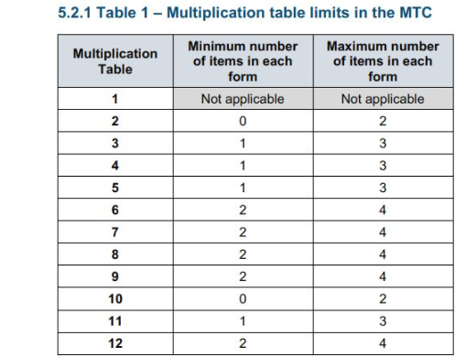
This means that:
- The 6, 7, 8, 9 and 12 times tables are more likely to be asked than the 2, 3, 4, 5, 10 or 11 multiplication tables. The STA state that there is a focus on these as these are the ‘most difficult’ multiplication tables.
- There will always be questions from the 3, 4, 5, 6, 7, 8, 9, 11 and 12 multiplication tables in each test.
- There will be no questions from the 1 times table (i.e 1 x 8 or 8 x 1)
- There will only be a maximum of 7 questions from the 2, 5 and 10 times tables.
- The following 14 multiplication questions (and their commutative equivalents) are more likely to be asked: –
Times table | Questions
6x | 6x6, 6x7, 6x8, 6x9, 6x12
7x | 7x7, 7x8, 7x9, 7x12
8x | 8x8, 8x9, 8x12
9x | 9x9
12x | 12x12

Top tips:
- Start the tests early in the two-week test period. Do your higher attaining pupils first This enable times to ‘catch-up’ if children are absent. You also don’t want your IT malfunctioning on the last week or pupils to be absent on the last day!
- The children need to be familiar with the laptop/i-pad technology as they need to be quick. Make sure their device is matched to what they are familiar with, when doing the test.
- As the facts have to be read by the child (rather than being read to them) it is also important that children are used to giving the correct answer to multiplication questions in a written format rather than only answering questions out loud when they are read to them
- Learn those 14 key facts

TCSET results from 2026 and TCSET expectations
As we are now into the 5th year of the check, the national average for pupils achieving 25/25 has risen from 29% to 44%. Our results are:
School | A | B | C | D | E | F | TRUST | National
ALL % score 25 | 85% | 42% | 47% | 65% | 46% | 67% | 58% | 44%
ALL mean av | 24.77 | 22.70 | 22.60 | 24.00 | 24.20 | 23.00 | 23.55 | 21.6

As the MTC is viewed as ‘phonics for maths’ we are working towards around 80% of pupils achieving 25/25. This means there must be preparation and daily practice over a significant period of time.

Practice checks Autumn 2 and Spring 2
We are tracking how pupils are doing each full term. A score out of 25 for each pupil in year 4 will be entered onto Insight for Autumn 2 and Spring 2. Please use an assessment method that takes into account the 6 second window for answering – we must know about fluency and accuracy when answering

Go to ‘Enter Data’ and then ‘School Assessments’ - and the following should appear

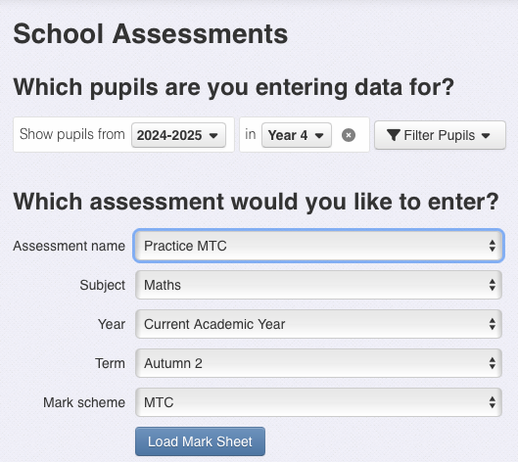
Ensure your correct year group is listed

Ensure it says 2026-2027

Ensure you select Practice MTC from the menu

Instructions for entering MTC check data (summer term yr 4)
Go to ‘Enter Data’ tab at the top middle of the screen

When you click ‘Enter Data’ then ‘school assessments’ this screen should appear with these options. Please ensure these options appear. Click on the drop down menus to change.
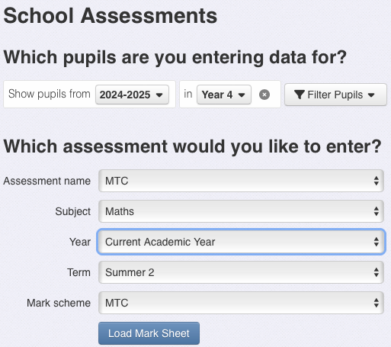

This is at the bottom of this menu under ‘statutory assessments’

This mark scheme should come up automatically – it allows you to enter the score

Click on ‘Load Mark Sheet’ and this should appear
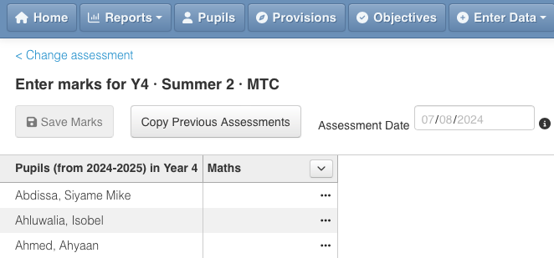

Enter the mark for the child in the ‘maths’ box and click OK.

The mark entered should automatically change colour in the following way.
Mark | Judgement
25 | Full marks
24, 23, 22
21, 20
<20

To upload the CTF from the DfE website with your results please see the link here

