Guidance and Information Booklet Four 2026-2027

Test Name | Page Number
NFER | P2-6
White Rose (1) | P6-7
SATS testing | P8-15

September 2026

NFER Testing Programme
All pupils from years two to five will complete termly tests through NFER in reading and maths, following the timetable laid out in booklet one. Using the tables function in Insight you can upload data directly from NFER

Yr 1 pupils will complete tests in reading and maths in spring and summer terms only. In the autumn term they will complete White Rose assessment materials (see below) to generate a percentage. For reading, we will use the phonics tracker (Y/N)

Yr 6 pupils will complete the 2025 SATS in Autumn term and the 2026 KS2 SATS paper in the Spring term.

What is a standardised test?
A standardised test is any form of test that requires all test takers to answer the same questions in the same way and is then scored in a ‘standard’ or consistent manner. This makes it possible to compare the relative performance of individual pupils or groups of pupils through the use of a standardised score. It allows schools to then benchmark their pupils’ performance against the nationally representative group of children used in the standardisation.

To make the best use of the NFER tests the following needs to happen:
- Using assessments for the purposes for which they were designed – this means all pupils need to sit the test for their year group no matter their ability.
- Following the teacher guides provided with assessments in order to create consistency in the tests administration and marking process.
- Drawing conclusions from assessment data in an appropriate way, considering other factors that may influence pupils’ test scores – e.g. physical, emotional and psychological factors.
- Complete a gaps analysis

Pupils with complex special educational needs, who are working well below, and NFER tests
In the very particular circumstance where a pupil has complex special needs and it would be inappropriate for them to sit the test for their year group, you must discuss testing arrangements for these pupils with your assessment lead and SENCO, well in advance of the testing weeks.
- Identify those pupils (during pupil progress meetings) who are working outside of their year group. As a guide, if the pupil is likely to score 80 or less as a scaled score, then it is worth discussing whether they need to have a test outside of their chronological year group.
- Look through the year group objectives for reading and maths to see which year group they are working within
- Once decided – this should be the NFER test papers this pupil completes e.g. if a pupil in year 4 is deemed to be working within the year 2 objectives, then they should complete the NFER year 2 tests
- Stick the same year group papers for the academic year (unless exceptional progress is made)
- Please ensure that these types of discussions are recorded within the child’s SEND record in some way – this will support for eventual access arrangements in year 6

Interpreting test Standardised Scores
NFER give a range within the standardised score of 85 to 115 for pupils working at the broad standard (i.e. low average to high average) for their age at each assessment point during the year.

It is worth noting that the scaled score of 100 defined by the Department for Education (DfE) as the national expectation at the end of key stage 2 is not the same as, nor equivalent to, a standardised score of 100 on NFER tests. A standardised score of 100 on NFER/QUEST Tests represents the average performance, based on a normal distribution, of the sample of pupils on which the tests were standardised. At the end of key stage 2, the DfE’s scaled score of 100 represents the ‘expected standard’ and is not the average.

As long as NFER tests are administered in an appropriate way, the standardised score is one of our most reliable measures of a child’s attainment and informs us as to whether the child is working at age related expectations.
A score of 95 represents the 37th percentile. In other words, it captures those in the top 63% nationally, and national statistics show that these pupils have a very strong chance of achieving expected standards considering it's around the top 75% nationally that do so (in 2026 KS2 tests, 75% achieved EXS in reading and 74% in maths).

For further information please go to the website
Interpreting test outcomes and reports generated by the NFER Tests Analysis Tool (October 2020)

Standardised Score | Most likely judgement | Commentary
<85 | WTS-  Well below | These pupils are highly unlikely to be working at EXS – though pupils may be WTS if there is enough evidence from teacher assessment to support this.
85-94 | WTS | These pupils are likely to be WTS because although they are working very broadly at a level appropriate for their age their performance in the test is not consistent with working at the expected level nationally.  Where pupils in the 85-94 range are teacher assessed as being EXS it is likely to be the exception rather than the rule. Leaders should be prepared to raise questions to ensure there is compelling enough evidence to support this teacher assessment.
95-114 | EXS | Scores within the range of 95 to 114 should be regarded as the more secure range for supporting a judgment of EXS when we are triangulating test data with teacher assessment. Based on national tests a child with a score of 95 is 63% likely to achieve EXS in the national tests
115 - 140 | GDS | Pupils with a standardised score above 115+ would more typically be regarded as working at ‘greater depth’. However, they might also be regarded as EXS if teachers feel that there is a weight of evidence over time that does not support a greater depth judgment. However, if pupils consistently achieve a standardised score of 115+ in repeated tests then questions should be asked as to why the child is not being judged as GDS.

Test and pupil progress meetings – a guide (not an exact science)

Actual test boundaries are | Consider for PP meetings and target setting
Score | Score
115+ (GDS) | 118+ GDS
106-114 (EXS+) | 112-117 GDS cuspy
95-105 (EXS) | 98-111 EXS
85-94 WTS | 90-97 EXS cuspy
85-94 WTS | 85-89 WTS
<85 well below | <85 well below

The focus is on ‘cuspy’ pupils to discuss

Those who score 112-117 should be talked about in terms of their chances of attaining GDS

Those who score 90-97 should be talked about in terms of their chances of attaining EXS

Cuspy pupils should inform your focus teaching groups and intervention groups

Using scaled scores over time to judge progress

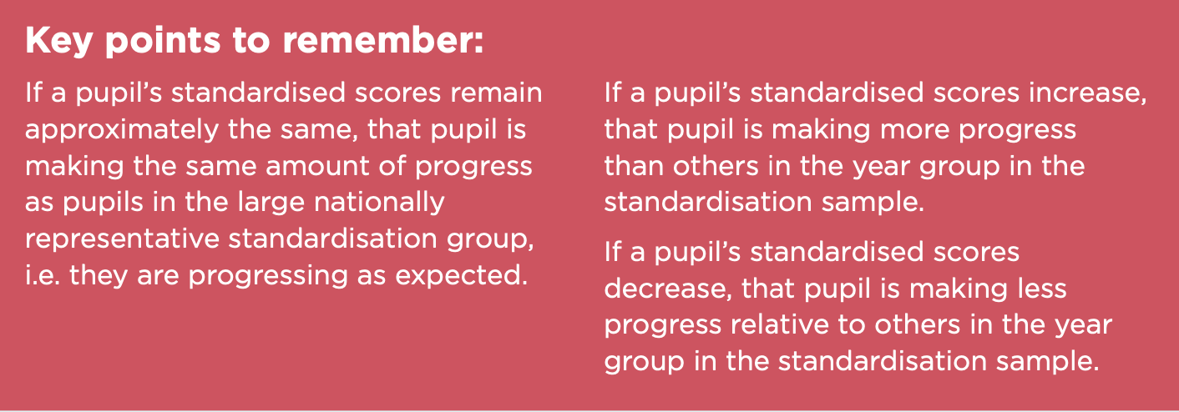
Comparing standardised scores over time gives an indication of how well a pupil is progressing relative to other pupils in the year group. The information below describes what any difference in standardised scores means.

Confidence bands
Confidence bands are used to show the extent of the margin of error in the standardised scores. In other words, they show how accurately the test measures pupil attainment.

The confidence bands are helpful when deciding whether an increase or decrease in successive standardised scores is indicative of progress that is better or worse than expected respectively.
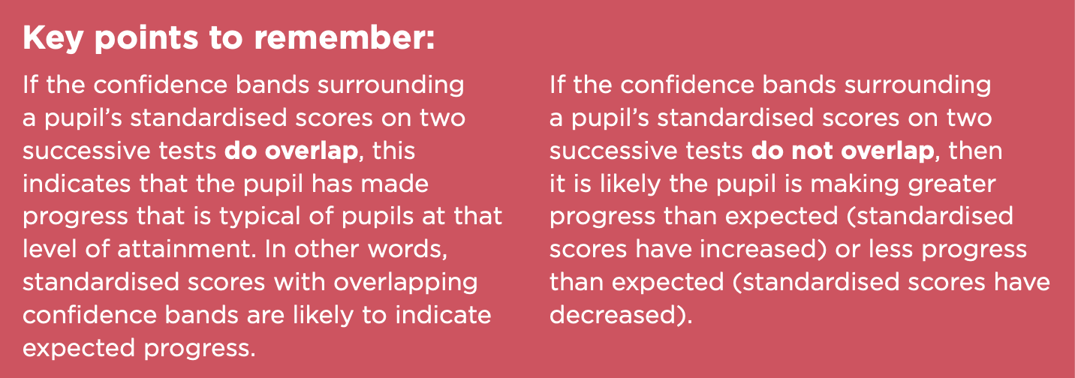

For more information about judging progress using NFER data please click here

How to enter NFER data on Insight We will only collect the scaled score.

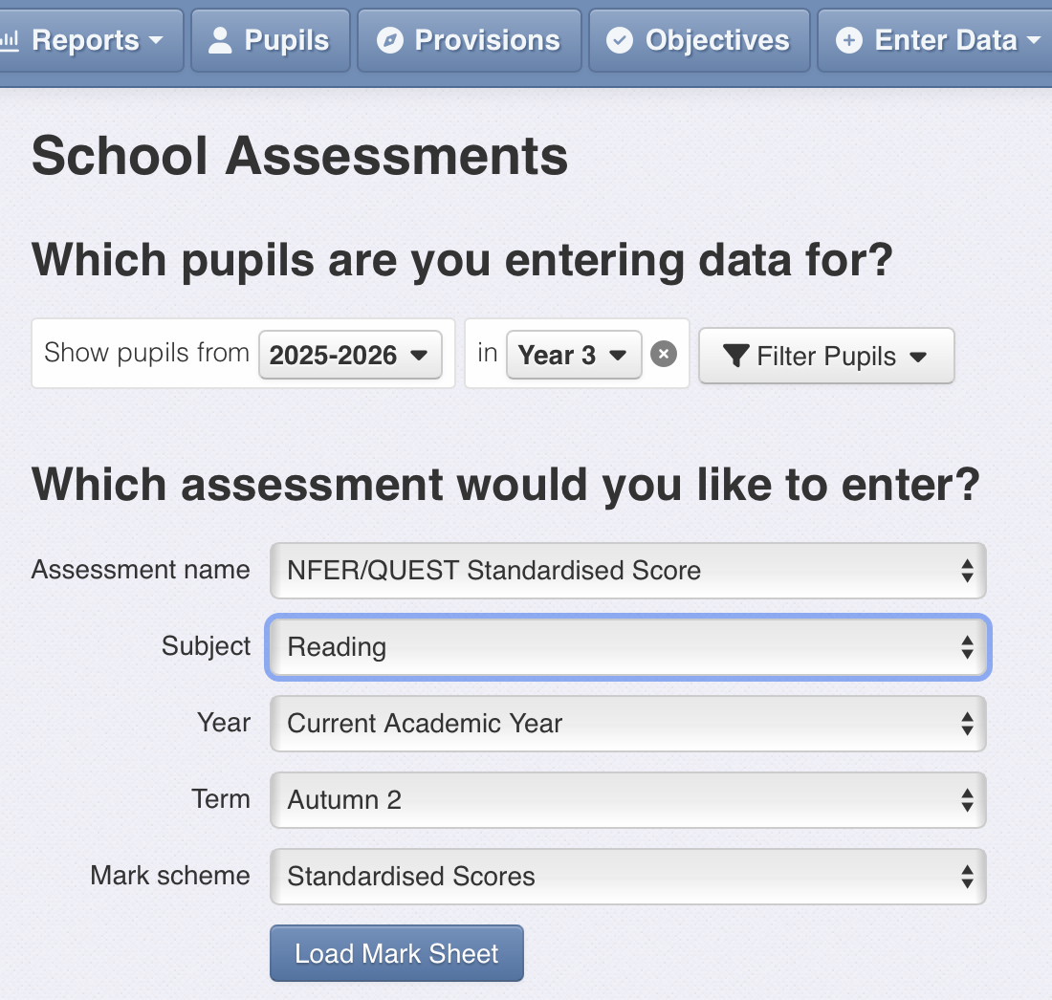

Ensure you select NFER standardised scores

The mark scheme comes up automatically
When the mark sheet is loaded, you can click into each box and enter the score manually.

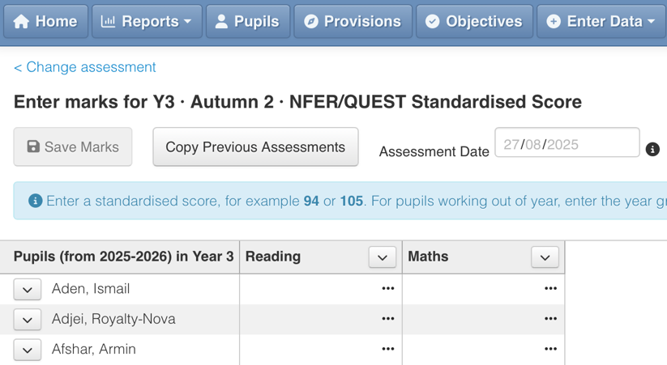
.

If a pupil has taken an out of year group test, e.g. a pupil in year 5 sat a yr 2 test, Insight will allow you to enter that along with a scaled score

So ‘my yr 5 pupil took a yr 2 test and scored 105’ is entered as y2 105 – in Insight. This is then included in the WB calculations automatically.

ALL pupils must have something in the box

Pupils without a score

Reason for a missing score | What you need to do
The pupil was absent on the day of the test | Ensure you make time for them to sit the test
The pupil is not capable of sitting any test due to their SEND | Please enter a score of 0 – which will mean ‘complex SEND did not sit a test’.  When reporting – these pupils will be included in the well below (red) category
The pupil sat the test but did not score any marks | Please enter the lowest possible scaled score available for that test, being sure to be clear about the year group of that test.  e.g. if a child in yr 4 sat a yr 2 test and did not score you would enter Y2 69  When reporting – these pupils will be included in the well below (red) category

White Rose assessment Yr 1 Autumn term only
There are two maths papers
  - Arithmetic paper (calculation) 10 marks available – takes around 15 minutes
  - Reasoning and problem solving paper – 15 marks available – takes around 25 minutes

The arithmetic paper involves pupils finding missing values and solving basic equations, the reasoning and problem solving paper involves assessing if pupils can apply the maths they have learnt and understand what they are doing.

Spreadsheets
For each assessment there is a spreadsheet from White Rose that has formulas within it that can analyse your data by class. For each pupil you will have a % for the arithmetic paper, a % for the reasoning paper, and an overall percentage. It is these percentages that will be entered onto Insight.
The overall percentage is calculated by adding the raw scores of the 2 papers together and then multiplying the final score by 4.
White Rose do not benchmark their percentages so there is no direct link, for example, between a pupil achieving 75% overall and that pupil being considered ‘on track’

Administering the tests
- The White Rose recommendation for the Year 1 assessment is for the teacher to sit with no more than six children, but do not read it to them unless they ask. The papers can be done on different days.
- All pupils, no matter their attainment, can use manipulatives - you might want to put them in the middle of desks so that pupils can use if they want.
- Please do not give pupils a test outside of their year group, no matter how low attaining they are, except by agreement with the assessment lead.
How to enter White Rose assessments into Insight
Go to ‘Enter Data’ tab at the top of the screen
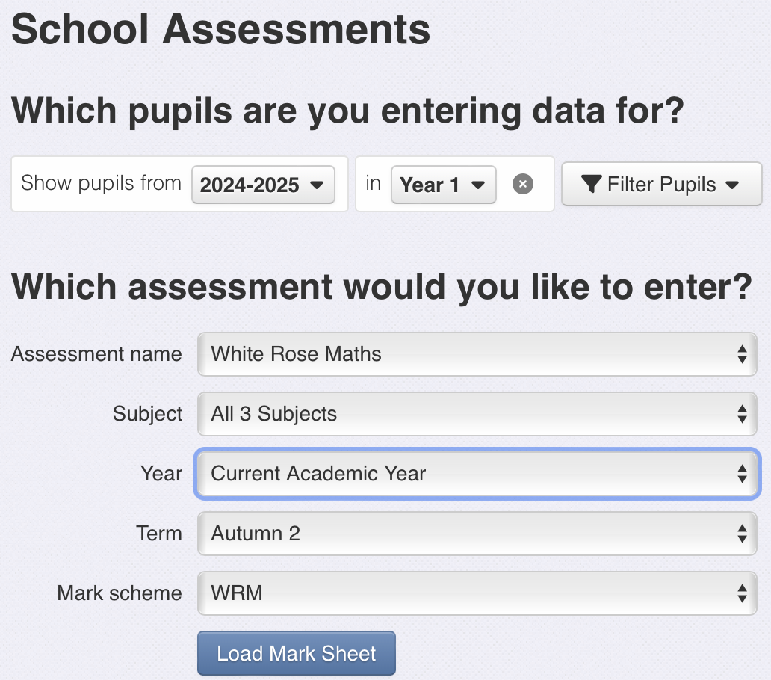

Click on school assessments – on the drop down menu

Ensure the options are set as below

When you click ‘Load Mark Sheet’ the following appears
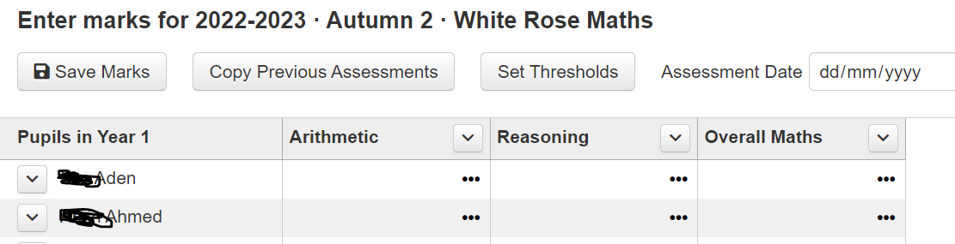
The assessments result in a percentage for each paper, and the spreadsheets from White Rose will automatically calculate the % overall maths for you, so you just need to enter it.
The White Rose spreadsheets can be uploaded onto Insight by clicking ‘Enter Data’ and then ‘Excel Assessments’ and then follow the instructions.

KS1 optional SATS year 2 summer term
NFER do not do a test for summer term – so we do the KS1 optional SATS. Please ensure that you enter the scaled score for the tests for reading and maths and give a NMM writing assessment for writing (in the SATS TA section)
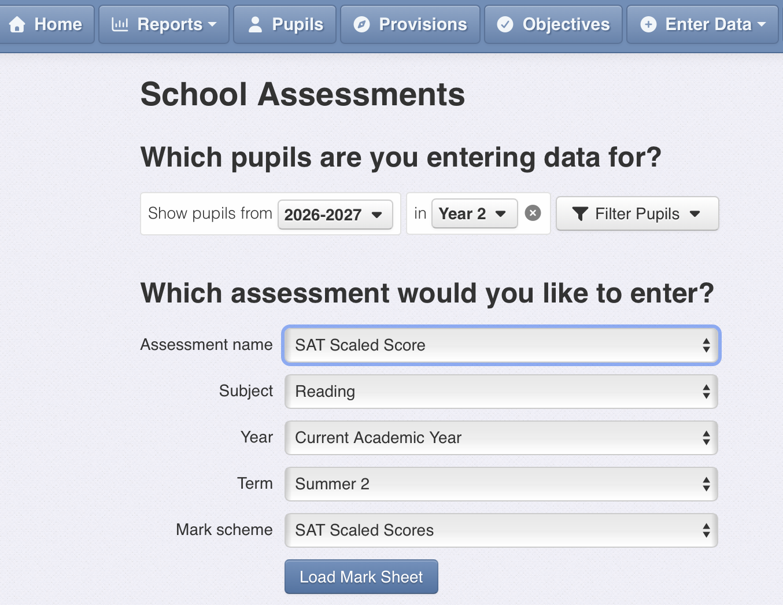
Click on ‘Enter Data’ then school assessment

Scroll down all the way to SAT Scaled score (under statutory assessments) for reading and maths
For SATS TA for writing – choose SATS TA

Entering Practice SATS for Year 6 on Insight
Yr 6 will sit the 2025 tests in Autumn and 2026 tests in Spring. It is very important that the spring SATS are complete before any yr 6 adjusted targets/projections are submitted, as these test scores are vital evidence. There is a facility to collect the GPS data if you choose to complete these tests, but only reading and maths are compulsory.
To reflect that not all of the content will have been taught, the benchmarks have been adjusted on Insight for both Autumn and Spring terms
- Autumn - A score of 97+ is EXS and a score of 107+ is GDS
- Spring – A score of 99+ is EXS and a score of 109+ is GDS

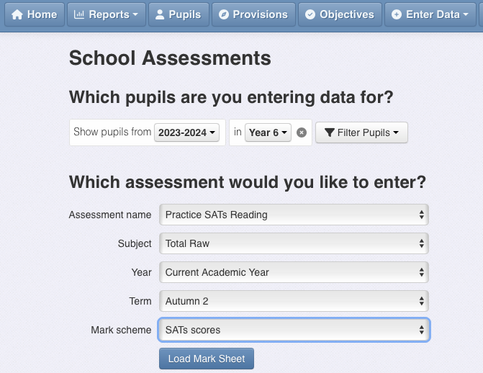
Entering raw scores for the tests
Click ‘Enter Data’

Ensure it says Yr 6 and 2025-2026

Click here for the test you are entering RAW scores for (either reading or maths)

Check that you have the term right, either Autumn 2 or Spring 2

Entering scaled scores for the tests
Because this is a different data range to raw scores, it has to go on a separate section, otherwise the system can’t benchmark and produce reports for you.
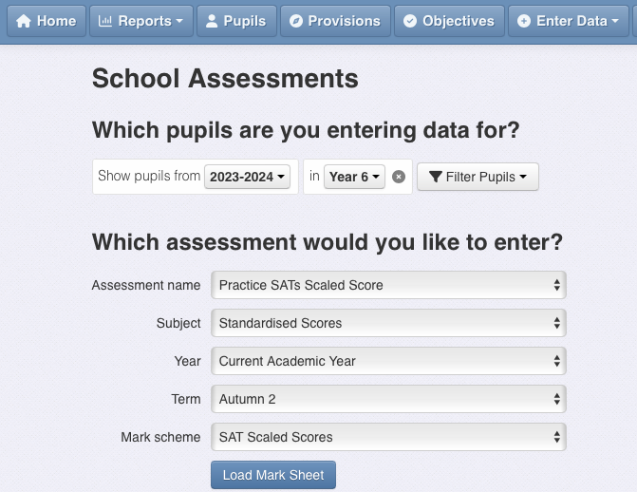

Ensure you select this option

Ensure you select standardised scores

Ensure the term is correct

When you click ‘Load Mark sheet’ you can click in the box next to the child’s name and enter the data.
You can also import results from your own spreadsheet by following the instructions here
Projections for year 6
These are your best hypothesis as to what a pupil will achieve in the SATS tests. Figures set become more accurate as the year progresses.
For example – you may set projections in Autumn term of 95% reading, 90% writing and 93% maths with a combined of 89% but in Spring these are adjusted slightly to reflect that 3 or 4 pupils, now, have only a slim chance of achieving EXS.
The projections then become 90% reading, 86% writing and 88 % maths with a combined of 86%, in the spring term.
Projections must be based on all the evidence you have about a child including
- Current and previous academic attainment from tests, in class performance, comparative judgement in writing, including KS1 data (see coloured NFER table above)
- Pupil attitude to learning and commitment to do well
- Any support from parents
- What the pupil is capable of given intervention, additional classes, tutoring etc to help them catch up
- The amount of time left in the academic year
Projections aim to be as accurate as possible about what you will end up getting, so you need to be within about 80% confidence (in March): If you say a pupil will achieve EXS then you are 80% (or more) confident that this will be the case.
If you are less sure than this, err on the side of caution – projections are always in the spirit of no nasty surprises.
The projection setting process starts in summer term of Year 5
During your usual pupil progress meeting for year 5 in the summer term, we will set initial projections for the end of year 6 for those pupils. At this point in the cycle, with another school year to go and excellent teaching/support, we are ambitious. There are 2 points to the meeting:
- Identifying which pupils are already ‘out’ because they have complex SEND/working well below
- For everyone else what support /intervention do they need in order to gain at least EXS in all subjects and therefore combined.
Benchmarking projections (end of Autumn and Spring terms)
The expectation, given the nature of our cohorts is that we are aiming for projections combined to be at least 80% EXS based on the evidence, so if yours are coming in well under this, then we will look at these together, to identify the ‘golden/cupsy’ pupils where the focus needs to be and put together a plan for the coming term for the year 6 team and senior leaders.
This process should be part of your termly assessment cycle, usually the yr 6 pupil progress meeting. It should be done with members of SLT to provide challenge and support and to agree the year 6 plan for the next term.
Entering onto Insight for Summer, Autumn and Spring terms
The deadlines are in booklet 1, but for ease they are here
- Initial projections - Summer term (of yr 5) – by 22nd July 2026 (50/50)
- Projections- Autumn - by 11th December 2026 (70/30)
- Projections Spring – by 20th April 2027 (80/20)
- Initial projections - Summer (for yr 5 going into yr 6) – by 23rd July 2027 (50/50)

Projections are either GDS, EXS or WTS for each subject and combined. WB is also an option on Insight and this is for pupils where you assess them as working at pre key stage.
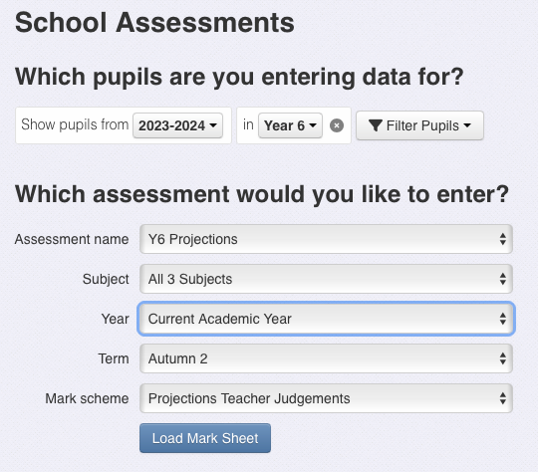

Ensure you have selected yr 5

Select Yr 6 Projections

Ensure the term is correct

Uploading actual SATS scores and teacher assessments in summer 2025 into Insight
SATS results will likely be published on 6th July 2027 (tbc), so as soon as they come in, please upload them to Insight.
KS2 codes for Test data
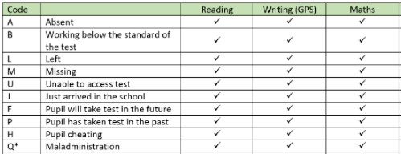
When you receive the data each pupil will have a raw score, a standardised score OR one of these

Click on Enter Data
Click on Statutory (NOT school) assessments
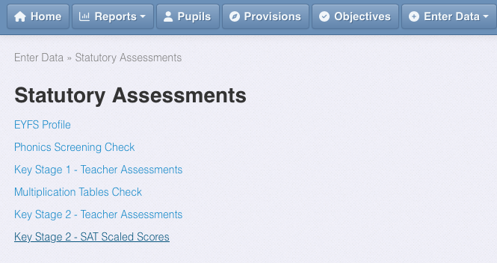

Ensure you click on Key Stage 2 – SAT Scaled Scores

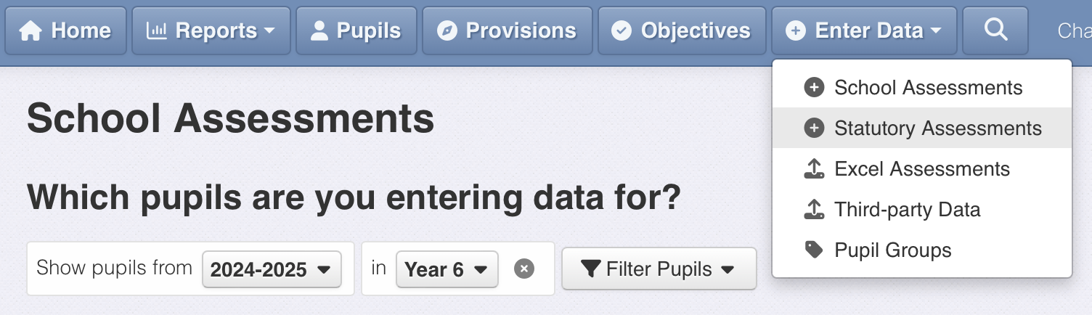

This screen will load – you upload your CTF from the DfE from here – follow the instructions
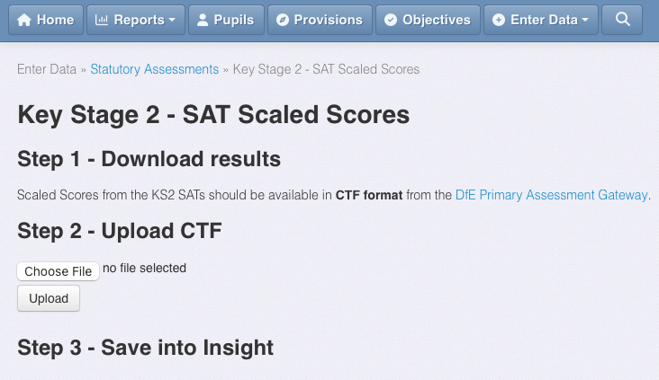

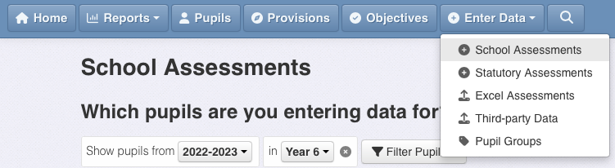
To view your SATS scaled scores, child by child, once you have uploaded them

Ensure you click on school assessments

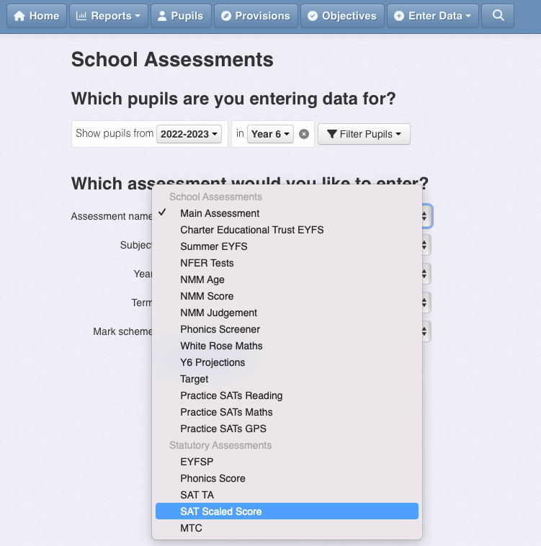

When you click on ‘Assessment Name’ scroll down and select ‘SATS Scaled scores’ under the statutory assessments header on this menu
Under the ‘Subject’ header – you can select ‘All 4 subjects’

When you click ‘Load Mark Sheet’ all the data for reading, maths and GPS scaled scores is loaded, writing is not loaded as this comes under teacher assessment
KS2 codes for Teacher Assessment
Teacher assessments for writing and science for all pupils are required.
Only if a pupil is working within pre key stage standards or the engagement model do they need to submit a teacher assessment for reading and maths.
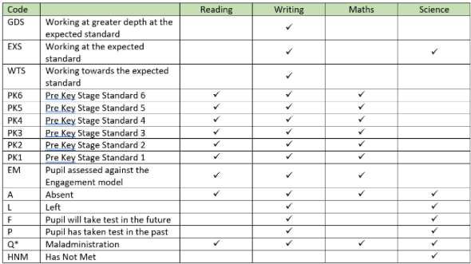
The table shows you the codes you must use when submitting teacher assessments to the LA – these codes are in Insight.

Please ensure you follow the instructions carefully and put the data in the right place
Click Enter Data
Statutory assessments (NOT school – that would take you to a different screen with different options)

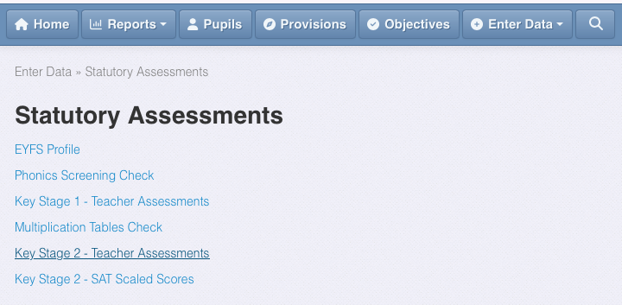
This screen will appear

Select Key Stage 2 Teacher Assessments

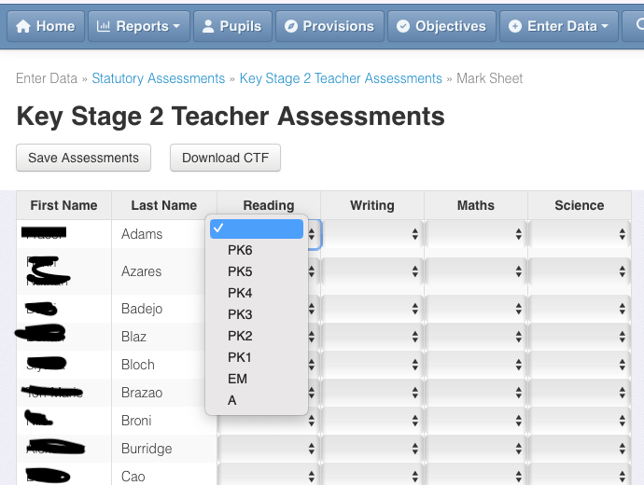

These are the options for reading and maths

These options for writing include GDS, EXS and WTS

The options for science are EXS or HNM

To send all of your yr 6 data to the LA, (when you are ready) follow the instructions here
Data deadlines for local authority for yr 6 writing and any who need a reading or maths teacher assessment
Lambeth 24th June 2027 (tbc)
Southwark 24th June 2027 by 1pm (tbc)
Tables Checking Exercise – each September
The link (to the 2026 guidance) provides details on what to do and how to do it
Getting pupils removed from a school’s results (thank you to James Pembroke from Insight for this blog post)
Initially, all pupils are likely to be included in a school’s percentages achieving expected and higher standards, but the autumn checking exercise provides an opportunity to apply for removal from measures in certain cases. There are four categories:
- Admitted from abroad with English not their first language
- Pupil not at the end of Key stage 2 in all subjects
- Left school roll before the tests
- Other
The first case is by far the most common, but criteria are strict and apply only if:
- they were admitted to an English school for the first time in the last 3 years; and
- they arrived from overseas prior to their admission; and
- English is not an official language of the country they came from; and
- English is not their first language
It is up to the school whether they want to exclude such children from their measures and, obviously, if they do well on tests and meet expected standards, it is unlikely they would seek to remove them.
Evidence required
All information/evidence requirements listed in bold are mandatory and must be provided. Cases submitted without the mandatory information/evidence cannot be accepted:
1. Pupil’s first language, and
2. Pupil’s country of origin, and
3. Pupil’s date of admission to your school, and
4. First date of admission to a school in England, and
5. Date of arrival in England. (which for this year MUST be after 1st September 2022)
The next point – pupils not at the end of KS2 in all subjects – is rather obscure, but tables checking guidance makes it clear that a request will not be accepted if ‘it is related to a pupil’s special educational needs and disabilities (SEND)‘. Such pupils will be included as having not achieved expected standards. This scenario, therefore, most likely applies to those that have been held back a year or have been disapplied from aspects of the national curriculum. As mentioned above, The former will receive an F code to indicate that they will take tests in future. The latter case would, historically, have received D code to show that they have been disapplied from the national curriculum but this code – which has caused so much confusion in previous years – was removed in 2021/22.
The next case – left the school roll before the tests – is not as straightforward as it seems. In most cases, if a pupil has left then the school would want them removed from the list. However, if a pupil changed school on or after the first day of the summer term, then the previous school can request that that pupil’s results are included in their measures rather than the new school’s. This scenario would likely arise if the pupil is a high achieving child. Otherwise, the new school will be accountable for the results and would need to apply to have them excluded via the checking exercise.
This leaves the ‘other’ option. This might include the recent arrival (i.e. On or after the first day of the summer term) scenario mentioned above, or some other seemingly valid case, but applications made under the ‘other’ category are rarely successful if we consider that pupils with SEND and those that are unable to access the tests for whatever reason cannot be discounted.

