Guidance and Information Booklet Five
2026-2027
No More Marking

September 2026 v4

NMM is No More Marking and is a way of marking writing using comparative judgement. The NMM website can be found here No More Marking. If you are new to this process please go to the website and sign up for a free online training session which will familiarise you with what it is and how it works. (Link here for an interesting podcast with Daisy from March 2025)
In summary, all schools follow the national NMM trials (see timetable below). This means every year group (yrs 1-6) completes 2 trials – these are one in either Autumn or Spring and everyone does one in the summer term. We use AI in the judging and use the AI feedback to help inform our teaching.
Yr 6 complete their initial trial in the Spring term and this is marked with AI who also give feedback, then second trial is for pupils to redraft the original piece using the AI feedback.
What is comparative judgement? (from Daisy’s blog 21st September 2020)
Traditional marking and moderation are time-consuming and can be inaccurate. The fact is, individual human beings do make errors, however highly experienced and trained they are. The solution is not to blame humans for human error, but to create a system which minimises the impact of human error. The simplest way of doing that in this context is through aggregation — add up the judgements of lots of humans, average them out, and, the errors will cancel each other out.
However it is very rare that ‘lots of humans’ do look at the work of a single child. Most of the time the marking is done by one (or sometimes two if a moderator looks at it). Comparative Judgements allows you to aggregate judgements, but to do so in a way that is much, much quicker. Instead of judging one script against a rubric, you look at two and say which one is better. This is a much easier and quicker judgement to make, and it’s easy for lots of teachers to make several of these judgements.
What is comparative judgement with AI?
AI-Enhanced CJ is a specific method for assessing student writing that combines the strengths of human judgment with the speed of Artificial Intelligence, using the established technique of Comparative Judgement. Here's how it works:

- Core Method - Comparative Judgement: Instead of assigning an absolute mark (like 7/10 or Grade B), judges (both human and AI) are shown two pieces of student writing side-by-side and simply decide which one is "better." This process is repeated many times.
- AI Integration: An AI is trained to perform these comparative judgments, mimicking the decisions human experts would make.
- Human Oversight (Hybrid Model): The system doesn't rely solely on AI. Human teachers also perform a portion of the judgments (e.g., we suggest a 10% human / 90% AI split). This allows for validation and keeps teachers involved.
- Powerful Statistical Model: All judgments (human and AI) are fed into a sophisticated statistical model developed over years of human-only CJ. This model aggregates the pairwise comparisons to produce a reliable, scaled score for each piece of writing.
- Validation & Disagreement Analysis: The system allows direct comparison between human and AI decisions. Disagreements can be flagged and reviewed. Crucially, our analysis shows disagreements are often small or, in cases of large disagreement, frequently attributable to human error (like handwriting bias or clicking mistakes), not AI "howlers."
- Maintaining Standards: Scores are linked to established national standards through comparison with previously assessed and graded work.
In essence, AI-Enhanced CJ is presented not just as using AI to mark, but as using AI within a proven, statistically robust assessment framework (Comparative Judgement) that includes human oversight and validation, leading to more trustworthy, reliable, and valid results than simply asking a general-purpose LLM for a grade.

Why are Trust schools using NMM and with AI?
Speed/workload reduction
Judging is a collaborative process which involves all teachers at a school participating in the judging of every year group. Working in this way, a typical primary school can judge an entire year group and create whole class feedback for that year group within an hour.
- If you do Comparative Judgement without AI - 2.5 hours
- If you do Comparative Judgement with AI (trialled with 90% AI and 10% human) - 15 minutes

Accuracy
Using Comparative Judgement, teachers agree on Key Stage 2 writing grades 86% of the time, compared to 66% of the time when using the Teacher Assessment framework. Comparative Judgement uses anchor pieces so that from one year to the next teachers are directly comparing writing from previous years to the current year. The direct comparison of the current cohort to our anchor samples ensures standards are maintained year on year without bias, drift, deflation or inflation.
Validity
As all moderation judging is done anonymously by teachers working at other schools there is no possibility for bias based on school or pupil characteristics. All schools and all pupils are on a level playing field.
Initial findings with using AI are that the human and AI judges agree about 80-85% of the time – which is about the same as human-human agreement. Where the humans and AI disagree, we find that often the AI is right and the human is being misled by some superficial features. After every assessment, NMM will produce a report listing all the human and AI disagreements so you can see if you trust the AI.

So, in conclusion, Comparative Judgement combined with AI can reduce your workload by 95% and eliminate obvious human errors.

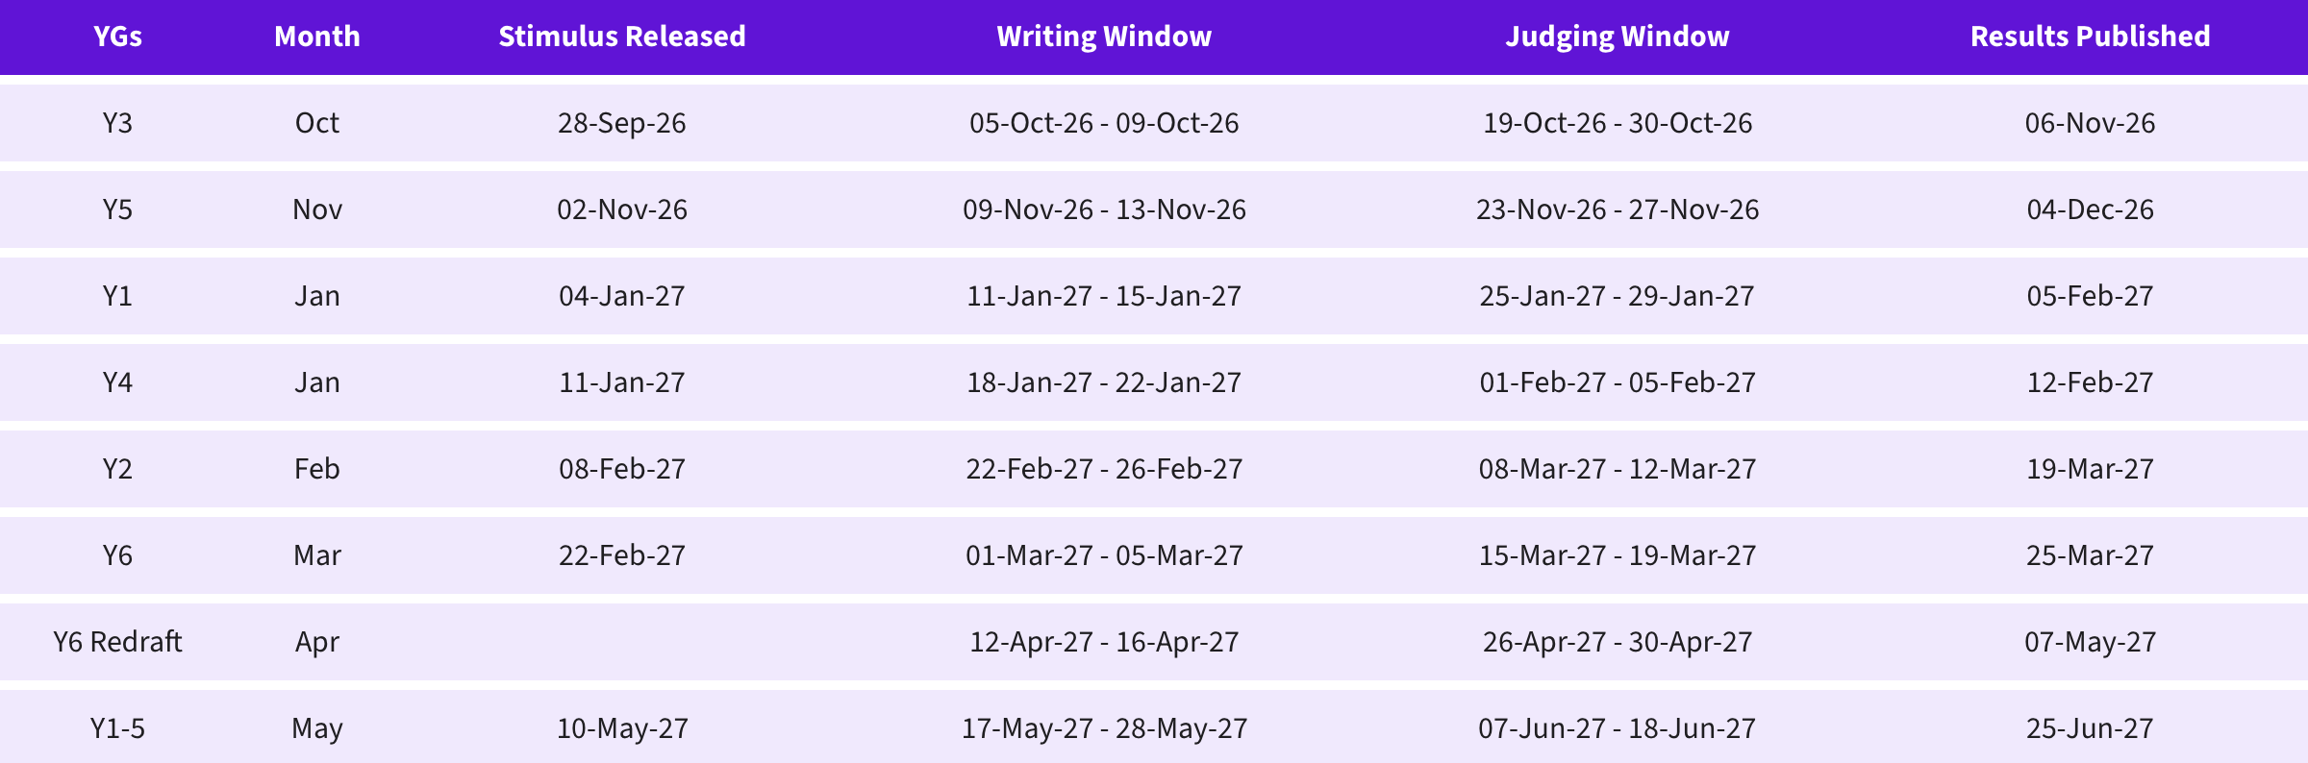
National Timetable 2026-2027

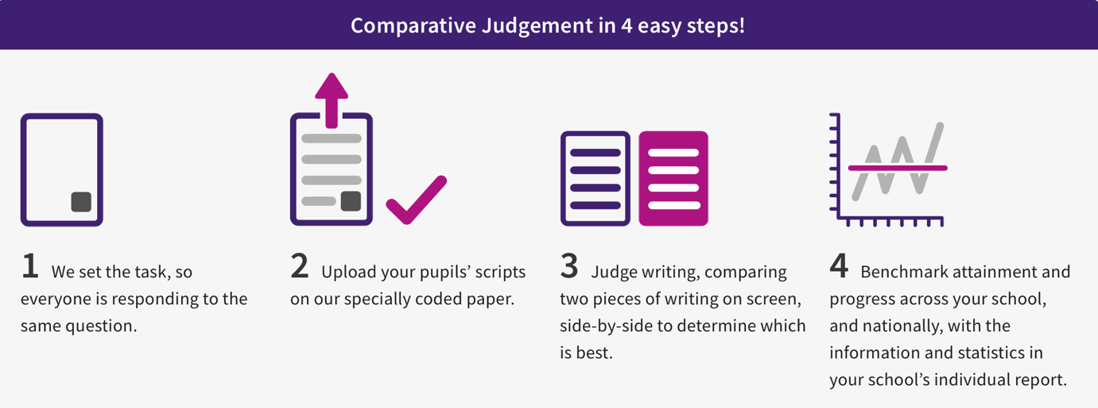

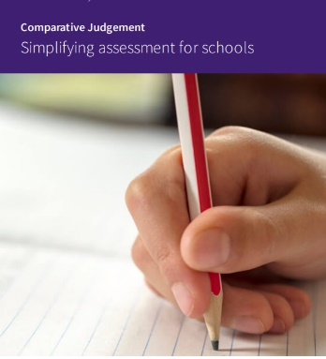
After each assessment event, a report is published giving detailed scores and information for each pupil. The content of each report is explained here.
Judgements on the pupils' responses are converted into a score. Every time a pupil's response is judged, there is a degree of error in the judging. The more judgements that are made on a response, the less error is associated with their score. Ideally, each response will be judged around 15 to 20 times. At this point, the error is reduced to its minimum, with any remaining error due to legitimate differences of opinion between judges.

Converting the scores into national judgements (WTS/EXS/GDS) and Insight benchmark
The scaled score and writing age given by NMM provide the schools with more nuanced information about pupil performance.
Thresholds for achieving EXS or GDS are created statistically and differ each academic year as it is dependent on the achievement of the sample that year. The percentage of pupils who achieve EXS and GDS in the national assessments are applied to the NMM scale.
For example, in 2026 in Year 6, 13% of pupils achieved greater depth nationally in writing, and 73% EXS+. Given that NMM have a nationally representative group of schools, a line can be drawn on their distribution at the 13% for GDS and 73% for EXS+ mark

The scaled score point that these thresholds correspond to is identified and used as the grade boundaries.

Perhaps the most important thing to realise about these grades is that they do not represent end-of-year expectations, the represent expectations at the time of completing the task. E.g. If a pupil gets GDS, and it is January, it means that their piece of work has come in the top 13% of a large, nationally representative sample of January writing. (norm referenced). We would expect the same pupils to produce higher quality work in June / July, and for the boundaries to increase accordingly.

Writing age – an example explained
From previous NMM work, there is a relationship between age and writing score. For example, from the data, it can be said that the average scaled score achieved by pupils aged 7 years and 2 months is 471, therefore, by the same logic, a scaled score of 471 is equivalent to a ‘writing age’ of 7 years and 2 months.
From this relationship, a writing age equivalent for every scaled score on the scale can be extrapolated. For example,
- pupils achieving a scaled score of 452 have a writing age of 6 years and 9 months;
- Pupils achieving a scaled score of 504 have a writing age of 8 years and 5 months
- pupils with a scaled score of 520 have a writing age of 9 years and 0 months.
- Pupils with a scaled score of 567 have a writing age of 11 years and 5 months

Data/information to support further with assessing pupils Handwriting bias (with thanks to Daisy’s NMM Blog May 2025

One of the most frequently asked questions is whether handwriting creates bias.
In traditional marking, some markers are influenced by handwriting (Ofqual’s study of hard-to-mark responses 2018). This example came up in this study:
‘ A boy writing about football with scruffy handwriting is likely to receive very different marks from different markers.’

Evidenced by these quotes from markers

‘There’s a lot going on there. Doesn’t like to stretch himself too much this is definitely a boy’
‘You’re right it is a boy’
‘Scruffy writing, can’t be bothered writing too much’

‘I see football, I see WTS straightaway’
‘If you read none of the words, and you see they’ve done 2.5 sides, it’s written paragraphs, the handwriting’s readable, the pupil will get better marks.’

What about Comparative Judgement?
At No More Marking, we set up our Comparative Judgement assessments so that every piece of writing is seen 20 times. This helps mitigate the problem of handwriting bias, and indeed of all errors and biases. By combining together lots of different judgements from different teachers, the errors and biases will cancel each other out. That’s very different from traditional marking, where most scripts are only seen once by one marker.
However, whilst this process might mitigate handwriting bias, we can’t claim that it completely eliminates it. This was brought home to us in our recent trial of AI Comparative Judgement, where we compared the decisions of AI judges and human judges. Whilst they mostly agreed, many of the biggest disagreements were the result of human teachers being biased against bad handwriting. Probably the only surefire way to completely eliminate handwriting bias would be to eliminate handwriting - and there are all sorts of good educational reasons why you wouldn’t want to do that.
But AI can help us solve this problem, and provides us with two ways in which we can retain handwritten responses and reduce or even eliminate handwriting bias.

AI judging
Our AI Comparative Judgement trial shows that we can use AI as a complement to human judging, and one that is largely immune to handwriting bias, because the AI transcribes the scripts (click on link for more detail and information) before judging them. Human judges can also use this function to reduce bias further

Best Practices for Year 1 Judging
When to Use Typed View | When to Use Handwritten View
Checking syntax & structure: Focus entirely on sentence construction, word choice, and vocabulary without being distracted by poor pencil control. | Assessing letter formation: Check if lower-case and capital letters are formed in the correct direction.
Evaluating punctuation: Easily spot missing full stops or random capital letters mid-sentence. | Deciphering phonics: Read words where the AI transcription might misinterpret early phonetic spelling attempts.
Speeding up comparisons: Quickly read through long or messy entries to gauge the overall flow of ideas. | Checking spacing: Ensure the student is leaving distinct spaces between individual words.
Key Reminders for Year 1 Tasks
- Expect OCR errors: Because Year 1 children heavily rely on phonetic spelling (e.g., "sed" for "said"), the AI Optical Character Recognition (OCR) might sometimes generate unusual transcriptions. Always toggle back to the original handwriting if a sentence seems nonsensical.
- Judge composition over penmanship: The primary goal of the toggle is to ensure a student with brilliant ideas but weak fine motor skills is judged fairly against a peer with neat handwriting but weaker writing composition

Infit and the judging sweet spot
Within the data spreadsheet for your pupils there is a column of data called ‘Infit’.
If you are concerned that an indivdual pupil score is too high or too low, or doesn’t seem right, then this will help you to understand how consistently their writing was judged by the different judges.

Infit
0.56977315
1.01331326
1.19677861
1.31708953
0.35046293
1.27722698
0.73442186
1.35088858
0.94940109
0.28711576
The judge infit represents how closely any one judge agrees with the overall scale. The lower the value, the closer the agreement of a judge with the scale. Values above 1.3 are considered to be inconsistent with the final scale.
Where the boxes are yellow, this would suggest that the corresponding piece of writing has beeen judged with more inconsistency than would normally be expected.
Perhaps this is because 1 or 2 of the judges had very differing opinions to the others.

According to NMM research (2017) The highest density of the 1,165 judges, who had done at least 30 judgements, (0.06 or 6%) are shown to be judging at around 12 seconds, with an infit of around 0.65 to 0.9.
So it seems reasonable to say that most judges are working at a good speed with high consistency to the overall scale. Very few judges are working at a level we would consider inconsistent.
Slow judges are hardly ever inconsistent, but overall there is no relationship between the speed of judging and the consistency of judging.
As ever, the advice with judging remains the same. Take the time you need to make your decision, but as soon as you’ve made your mind up, press the button and move on!

How can I give feedback on pupils’ work?
You can choose to leave audio comments on each piece of writing as you judge. Our AI system will combine all the audio comments by all the different teachers, and turn them into a polished written comment for the students and a whole class feedback report for the teacher. If you choose to use audio comments, it may mean you need to do slightly more than 10% of human judgements to ensure each student gets enough detail. It may also slow down your judging a bit more. So if you choose to use audio comments, you may want to budget for a bit more than 15 minutes per teacher.
Our national projects also provide you with two other forms of feedback. One is direct AI feedback, which we make available in teacher and pupil friendly format. The second is sets of multiple-choice questions designed by us and allocated to students depending on their score. These do not require any teacher time.

Pupils who don’t have any scores
It is very important that every pupil has a go at writing something for the task, even if they have complex SEND
Reason for no score | What you need to do
The pupil was absent | If you are still in the judging window please ensure they complete the task
The pupil is unable to complete the task due to complex SEND | These pupils will have * next to their names, this does not translate in Insight. Therefore data will be entered like this:  NMM judgement -a version of WB (WB 1, 2, 3 etc) or Cherry Garden (CG1, 2, 3 etc) (the score and age will be left blank)  When producing school level reports, these pupils will be listed under ‘pupils with no score’ (see below in yellow)

School reports produced centrally
This is the format which gives you an indication of how well your cohort is doing. Not an exact statistical science! The more pupils with no score, the less reliable your score and age averages.
ALL | Year 4 | School A | B | C | D | E | TRUST | National
 | 4 (score) | 537 | 525 | 516 | 554 | 531 | 533 | 516
 | 4 (range) | 430-608 | 362-651 | 397-647 | 372-625 | 387-638 | 362-651
 | 4 (age) | 9 yrs 9 | 9 yrs 0 | 8 yrs 6 | 11 yrs 3 | 9 yrs 4 | 9 yrs 6 | 8 yrs 7
 | 4 (EXS%) | 89.00% | 75.00% | 72.00% | 90.00% | 87.00% | 83.00% | 72.00%
 | 4 (GDS%) | 13.00% | 20.00% | 12.00% | 33.00% | 20.00% | 20.00% | 14.00%
 | 4 no scores | 2 | 0 | 1 | 4 | 2 | 9

Insight and NMM
Insight has the capacity to take the overall writing score (between 100 and 700), the judgement of WTS, EXS or GDS and the writing age (in the format of 8y 10). Please enter all three.

- Click on Enter Data and then click on School Assessments

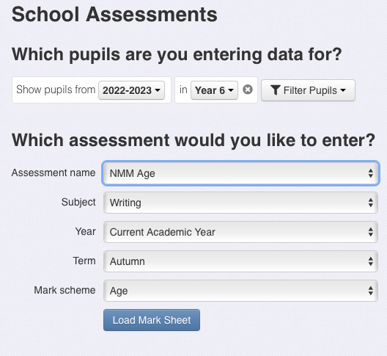

Ensure you have the correct year group

Ensure you have the right assessment – there are 3 NMM categories

Ensure you have the correct term

Insight will only take the 3 judgements generated by NMM separately, so in the drop down menu in ‘Assessment name’ select the right one as only one column can be done at a time. This is because the inputs for each column are different values and cannot be done together.
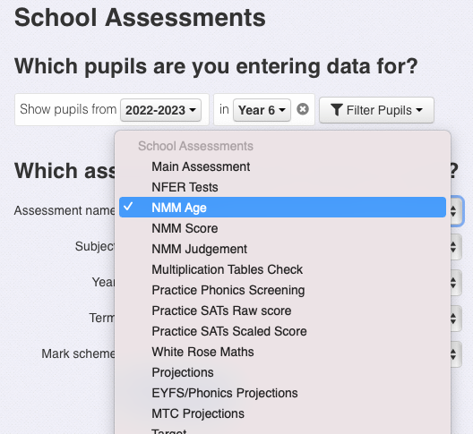

How we use NMM to complement writing teacher assessment
After each national assessment event, teams from across the Trust will meet to discuss what the reports tell us, as practitioners, about the writing within that cohort. The main premise for the discussion will be what do we know about how pupils attained, and how will this inform practice going forward?

Appendix: Historic age related scores for EXS and GDS and national averages
The age related writing scores are capped at 5y 6m at the bottom, and 14y 1m at the top
Choose a colour to track that cohort e.g. choose red to track the current yr 5 cohort.

2026-2027 threshold scores and national averages
Year Group | Year group 26-27 | National average | EXS score | GDS score
1 (spring) | 1
1 (summer) | 1
2 (Spring) | 2
2 (summer) | 2
3 (autumn) | 3
3 (summer)
4 (spring) | 4
4. (summer)
5 (autumn) | 5
5 (summer)
6 (February) | 6
6 (April redraft)

2025-2026 threshold scores and national averages
Year Group | Year group 26-27 | National average | EXS score | GDS score
1 | 2 | 412 | 399 | 482
2 | 3 | 486 | 460 | 541
3 | 4 | 492 | 468 | 535
4 | 5 | 520 | 492 | 562
5 | 6 | 521 | 500 | 557
6 (redraft) | 7 | 548 (556) | 526 | 589

2024-2025 threshold scores and national averages
Year Group | year group 26-27 | National average | EXS score | GDS score
1 | 3 | 409 | 394 | 484
2 | 4 | 474 | 462 | 544
3 | 5 | 487 | 455 | 540
4 (+non-fiction) | 6 | 517 (525) | 491 (497) | 562 (572)
5 (+non fiction) | 7 | 526 (546) | 501 (518) | 569 (591)
6 | 8 | 544 | 524 | 582

2023-2024 threshold scores and national averages
Year Group at the time | year group 26-27 | National average | EXS score | GDS score
1 | 4 | 404 | 383 | 491
2 | 5 | 472 | 454 | 548
3 | 6 | 494 | 456 | 558
4 (+non fiction) | 7 | 516 (526) | 487 (499) | 575 (570)
5 (+ non-fiction) | 8 | 518 (540) | 487 (526) | 576 (594)
6 | 9 | 538 | 513 | 593

2022-2023 threshold scores and national averages
Year Group at the time | year group 26-27 | National average | EXS score | GDS score
1 | 5 | 403 | 389 | 485
2 | 6 | 473 | 461 | 551
3 | 7 | 490 | 468 | 545
4 | 8 | 541 | 514 | 602
5 | 9 | 546 | 527 | 590
6 | 10 | 543 | 519 | 595

