Guidance and Information Booklet Six
EYFS
Being Year One ready
2026-2027

With thanks to all the EYFS team at TCSET
Thanks to Maureen at Lyndhurst for discussions around yr 1 readiness
September 2026 version

Assessment in Nursery and Reception - Rationale
When making judgements about a child’s attainment in each of the areas, use your professional judgement but also take into account contributions from other perspectives (e.g. parents).
We are alert to the general diversity of children’s interests needs and backgrounds when making judgements and understand that children may demonstrate their attainment is a range of ways, particularly if they have SEND or are EAL and are just learning English. We will look for all opportunities for children to demonstrate what they know.
The way teachers record formatively how pupils are progressing and learning from day to day, is up to the individual school and should not be overly burdensome.
Part 1 Assessment Timetable
The tables below show the assessment timetable for Nursery and Reception

Important aspects to note:
- There is a pupil progress meeting each full term to discuss those not developing as expected
- Data is to be entered onto Insight

Nursery
Half term | Assessment Task | Final Date for data to be on Insight
Autumn 1 | Baseline to ensure typicality of development – 4 domains only | 09/10/2026
Autumn 2 | Review of pupils whose development is not typical by end of term | n/a
Spring 1 | Mid year review of 6 domains and knowledge of what has been taught in the curriculum | 05/02/2027
Spring 1 | Review of pupils whose development is not typical by end of term | n/a
Summer 2 | End of year review of 6 domains and knowledge of what has been taught in the curriculum  Review of pupils whose development is not typical by the end of term | 09/07/2027

Reception
Half term | Assessment Task | Final Date for data to be on Insight
Autumn 1 | Narrative statements for pupils who have completed both assessment components of national RBA, are available to view and download
Autumn 1 | Establish the national Reception Baseline Assessment (RBA) | 09/10/2026
Autumn 1 | Establish phonics placement assessments using your scheme  Complete phonics tracker (Y/N) using your placement assessments | 09/10/2026
 | Establish internal baseline for 6 domains (use the RBA data for reading and maths knowledge) | 09/10/2026
Autumn 2 | Headteacher declaration form to be submitted online through the DfE portal | 06/11/2026
Autumn 2 | Phonics tracker (Y/N) (see booklet 2) | 11/12/2026
Autumn 2 | Review of pupils whose development is not typical by end of term | n/a
Spring 1 | Mid year judgements 6 domains  Phonics tracker (Y/N) | 05/02/2027
Spring 2 | Review of pupils whose development is not typical by end of term | n/a
Summer 1 | Phonics tracker (Y/N) (moved here from summer 2) | 21/05/2027
Summer 2 | EYFSP – 17 ELG  Lambeth deadline is 25 June 2027(tbc)  Southwark deadline is 25 June 2027 (tbc) | 18/06/2027
Summer 2 | Review of pupils whose development is not on track | n/a

Our assessment system
All judgements are made ‘in the present’ linked to the curriculum covered so far. Assessment for our youngest pupils is about knowing that they are securing their milestones, and are developing, typically as expected in all areas. In Reception, phonics is assessed more regularly using our phonics tracker (Y/N) which is informed by your regular phonics assessments in your scheme.
Explanation of terminology and shortened forms to judge attainment
Our ‘common language’ is explained below.
At the end of the summer term in Reception, you complete the assessments in the normal way on Insight (as detailed below) and it automatically converts EXS to ‘expected’ and WTS and CG to ‘emerging’
Child Development – securing stage typicality | Insight
No concerns, developing as expected. | EXS
Some but not all aspects of age-typical development. May need time to settle will likely develop independently | WTS
Below age typical – will require support to catch up | Cherry Gardens  CG1-10

Assessing pupils who are attaining well below their year group
We take guidance from the national developmental checks (ASQ-3 Ages and Stages) as to when to be concerned about a young child’s development.
If a child is assessed as being Cherry Gardens, this must be discussed with your team and the SENCO using the Branch Maps as a guide. If needed, a more detailed assessment can be done alongside parents perhaps with other professionals. There is an expectation that children who are not meeting their milestones and are not developing typically, will be discussed every term in the pupil progress meeting
Baselining children in Nursery
Children are assessed within the first 6 weeks of arriving in Nursery to ascertain if they are developing typically, in 4 areas:
COMMUNICATION
How am I speaking and listening? Are they saying mainly one or two-word statements, or speaking in sentences? Can you generally understand what they say and vice versa? What languages do they speak? Can they hear you like other children? Do other children understand them?
CONFIDENCE
How am I playing with others – can I share, take turns, how independent am I? Do children ‘get stuck in’ and start to play from day one? Are they sociable and quick to make friends? Do they struggle to separate from their parent/carer?
PHYSICAL
How is my walking, climbing and running – like other children?
How do I manage steps and equipment for large motor skill development, like slides or tricycles? How do I manage equipment for small motor skills development like constructions kits, colouring pencils etc.
SELF-HELP
Includes how they manage hand-washing, toileting , snack and mealtimes

Domain | What to look out for that suggests typical development | When to be concerned
COMMUNICATION | Can express their needs  Can communicate verbally, making themselves understood  Can say a sentences with 3 or 4 words  Can understand action words like ‘Who’s jumping?’ when looking at a picture book  Can respond to their name  Can say what their first name is when asked  Can point to common parts of their body e.g. eyes, leg, head, ears,  Can understand the difference between up and down  When looking in the mirror and asked ‘Who is that in the mirror?’ they respond ‘me’ or say their own name  Can follow a two-part instruction such as ‘Put the toy away and come to the carpet please’  Know how 2 sounds are different from one another e.g. that is a loud/quiet sound, this sounds like a dog but this like a cat. (phase 1) | Where speech is not easily understood by unfamiliar adults – (hearing test?)  For EAL children is – their home language is developing well? Check in case the child has a speech, language and communication delay.  Won’t respond to their own name  Doesn’t recognise their own reflection
CONFIDENCE | Can move from their parent to a key person happily  Can enjoy the company of other children and wants to play with them  Can play/explore safely alongside others  Can settle to some activities for a while  Can say if they are sad or happy  Can join group time for up to 10 minutes  Can choose what they would like to play with independently | Extremely upset by certain sounds, smells or tastes, and cannot be calmed.  Worried, sad or angry for much of the time.  Does not seek adult support when upset or hurt  Flit from one thing to the next  Won’t include others in play  Intense focus on one thing or the same thing, becoming distressed if they are encouraged to do something different.
PHYSICAL | Can climb confidently  Can pedal a tricycle  Can sit comfortably  Can run and stop without bumping into things  Can kick a ball without holding on for support  Can jump from 2 feet  Can balance on a low level beam  Can sit with feet crossed to ankles  Can copy a vertical line (no tracing)  Can copy a horizontal line  Can string small items like beads or pasta  Can match their thumb to each finger  Can build a tower with blocks  Use one hand consistently for most activities  Can turn the pages of a book | Can’t easily sit comfortably – may need to develop core muscles  Has an unusual ‘waddle like’ walk  Walks predominantly on tiptoes  Gets tired easily  Unable to run or kick a ball  Cannot negotiate stairs  Constantly running around/needing movement to the point where it is disruptive to others
SELF-HELP | Can use the toilet independently (but will need supervision for clothing) and wash hands with some support and encouragement  Can put on shoes (may not be on the correct feet)  Can pull elasticated trousers/skirt up and down  Can put their coat on (may need help with zips and buttons)  Can take their coat off (may need help with zips and buttons)  Can use a fork  Can drink from an open cup without spilling  Can ask for help e.g. if they can’t reach something | Look out for children who appear to be overweight or have poor dental health  Has difficulty feeding themselves with a spoon  Does not know when they need the toilet

Entering data onto Insight for Nursery Baseline
Each child will have 4 assessments entered, one for each of the 4 areas above, using EXS, WTS, WB
When you click on ‘Enter Data’ > ‘school assessments’ please ensure all the options look like this
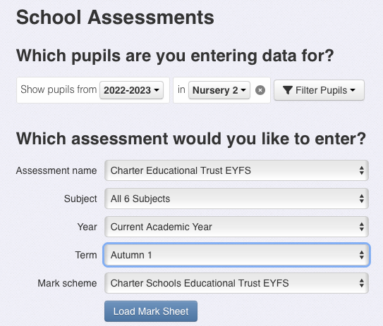

This will say 26-27

Choose Charter EYFS (NOT Main assessment)

Baseline goes here
This comes up automatically
Once the marksheet has been loaded the screen will look like this.
NB Insight automatically shows you all 6 domains (communication, confidence, physical, self-help, reading, maths) for Nursery ignore the last two for Baseline
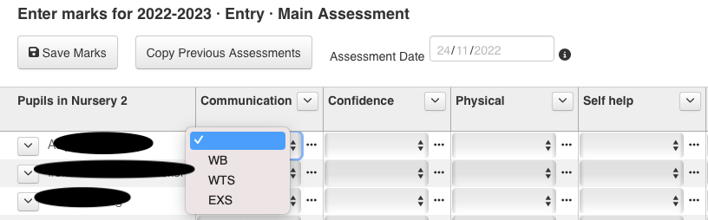

Entering data for Nursery onto Insight for the rest of the year
After baseline there will be a mid year review and an end of year review for most pupils (see calendar above) each child will have 6 assessments entered. These will be the same 4 as above PLUS reading knowledge and maths knowledge

The Nursery Assessment year
NB This is not a checklist, an assessment against each statement is NOT expected
 | Mid year review | By the end of Summer 2  (ready for Reception)
COMMUNICATION | SPEAKING  Can say both first and last name when asked ‘What is your name?’  I can identify some animals and imitate those sounds (phase1)  LISTENING  Without pointing or using gestures – can the child ‘put the book on the table’ or ‘put the shoe under the chair’ (2 part instructions)  Can the child follow 3 unrelated directions – all said before the child starts e.g. give me the pen, open the book and stand up.’ | SPEAKING  Ask questions using how, why, where and when  Using sentences of 4-6 words using all the words e.g. I AM going to the park (not ‘I go park’)  Uses words ‘like because, and or’ in a sentence  Begin to use past tense e.g. I saw 2 cats  Name 3 items in a category e.g. tell me things you can eat?  Can name 5 different colours  LISTENING  Can understand a range of prepositions e.g. under, between, middle of
CONFIDENCE | FEELINGS  Recognising expressions of happiness, sadness and anger on faces of others  Join group time for up to 15 minutes  Can sit to look at a book independently  Knows where familiar items are kept  Can tidy away  Can play with a small group (2-3 children)  Can follow rules most of the time | FEELINGS  Name a variety of emotions they are feeling  Enjoy jokes and plays on words  Join a whole class carpet session  Can engage in pretend play  Can follow rules most of the time and able to explain some of them  Can negotiate conflicts in play and find solutions  Understand taking turns as well as sharing  Can play with a group (4-5 children)  Can spend time away from parents learning they can be looked after by caring adults
PHYSICAL | GROSS MOTOR  Balance on a raised beam  Stand on one foot without holding on  Throw a ball forward overarm whilst standing  Jump forward with both feet leaving the ground  Catch a large ball with both hands  Climbs a ladder or playground slide without help  Negotiate stairs  FINE MOTOR (writing knowledge)  Draw a figure or object  Can copy a circle, horizontal line and cross shape you have drawn (no tracing)  Tries to cut paper with scissors – gets the blades to open and close and makes ‘snips’  Hold a pencil tripod grip  To make marks that represent their name | GROSS MOTOR  Stand on one foot (5 seconds) without holding on  Hop up and down on right/left foot at least once without losing balance  Jump forward from a standing position with feet together  Complete a 5-7 piece puzzle  Walk up stairs one to a step, alternating feet  FINE MOTOR (writing knowledge)  Makes straight cuts in a piece of paper with scissors (may be able to cut it in half)  Can copy a vertical line a circle, an addition sign and a capital letter L  Can unbutton one or more larger buttons  Can zip and unzip a zip (with support)  Colour mostly within the lines  Draw a figure with a trunk legs arms and usually fingers.
SELF HELP | TOILETTING  Use the toilet independently and wash hands unprompted  DRESSING (unassisted)  Pull elasticated trousers up and down  Can pull a zip up or down when asked  Put on a T-shirt over their head  Put on/take off shoes (may not be on the correct feet)  Begin to manage larger buttons  EATING  Can eat independently, may need a little support using utensils  Can spread ‘butter’ with a knife | TOILETTING  Reliably dry during the day  DRESSING  Can dress/undress without help (except for poppers, buttons and zips)  Put on/take off socks  Can dress for the weather (includes putting on/taking off coat)  EATING  Feed themselves independently (may need help cutting food)  Understands what to do if they are tired or hungry  Can tell you their first and last name and how old they are
READING KNOWLEDGE | WORD READING/PHONICS/SOUNDS  I can recall and describe sounds I hear/have heard (phase 1)  I can say if sounds are similar or different (phase 1)  I can listen for rhyming words (phase 1) e.g. in Nursery rhymes or stories  I can suggest rhyming words (phase 1)  Count or clap syllables in words (phase 1)  I can copy sounds and actions of others (phase 1)  Recognise aurally, words with the same initial sound e.g. sun starts with ‘s’  I can pronounce the letters l, w, y, s, and z  I can recognise my written name amongst other names  COMPREHENSION/BOOK KNOWLEDGE  Explain their own experiences  Retell known stories verbally  I can name the different parts of a book  Share stories/books with caregivers, showing interest, looking at the pictures | WORD READING/PHONICS/SOUNDS  Recognise and read my first name – distinguishing it from others  Be able to match a range of different sounds to their source e.g. instrumental sounds, body percussion sounds, environmental sounds (phase1)  Group sounds according to different criteria e.g. loud sounds, soft sounds and use appropriate vocabulary to describe these  Identify initial sounds in words, reproducing those sounds clearly and then make up their own alliterative phrase (phase 1)  Recall a list of objects beginning with the same sound (phase 1)  Know that sounds they hear at the beginning or ends of words are represented by letters  Can understand another if they segment and blend CVC words orally e.g. touch your l-e-g  Recognise some familiar letters – e.g. that letter is in my name  COMPREHENSION/BOOK KNOWLEDGE  Make and retell story maps in the right order  Tell a story that is easy to follow, perhaps using different sounds to represent story characters (phase 1)  Suggest how a story might end  I can describe imaginary characters and places  I can answer questions about a familiar story
MATHS KNOWLEDGE | NUMBER  I can subitise to 4  I can compare quantities using more/less than  I can sing counting songs to 10 accurately  I can record amounts using marks or pictures  I know if something is 1st, 2nd, 3rd (cardinality)  PATTERN  I can make my own repeating pattern from scratch  SHAPE AND SPACE  I can talk about and explore 2d shapes – circle, rectangle, triangle (curved straight corners sides)  I can talk about and explore 3d shapes (straight flat round)  I can describe a familiar route  I can make comparisons in length, weight, capacity  I can use positional vocabulary e.g. under the table accurately | NUMBER  I can subitise to 5  I can represent numbers to 5 with tallies/fingers  I can count a set of objects knowing the last number is how many there are – matching numeral and object  I can solve real world number problems (to 5)  I know that 3 is always 3 no matter how it is arranged (conservation)  I know that anything can be counted and that 3 elephants is the same quantity as 3 mice. (abstraction)  PATTERN  I can say if something is the same or different  I can spot an error in a pattern  SHAPE AND SPACE  I can perceive the shape or size of objects e.g. bigger/smaller  I can combine shapes to make new shapes  I can use shapes to build for a purpose

The recommendation for being school ready are contained within the above table but also there is a suggestion around healthy routines:
- Going to bed around the same time each night, and waking up in time to get ready for school.
- Limiting screen time to the recommended daily amounts.
- Eating a healthy diet and trying new foods.
- Brushing their teeth with fluoride toothpaste twice a day (parents will need to supervise this until the child is at least 7)
- Get moving for at least 3 hrs a day
Baselining children in Reception
Children are assessed within the first 6 weeks of arriving in Reception in three ways.
- National Reception Baseline Assessment - Reception baseline assessment - GOV.UK (www.gov.uk)
- Phonics tracker (Y/N) using evidence from your placement assessment (using your scheme)
- Internal assessment on Insight for 6 areas (see below)
The statutory Reception Baseline assessment (RBA) is an activity-based assessment of pupils’ starting points in:
- Mathematics tasks
- early number
- early calculation (early addition/subtraction)
- mathematical language
- early understanding of pattern

- LCL tasks
- early vocabulary
- phonological awareness (the phonics scheme placement assessments that you are already doing should support this process)
- early comprehension
Pupils will use practical resources to complete these tasks and teachers will record the results on a laptop, computer or tablet. It will not be used to label or track individual pupils. There is no numerical score produced or shared but teachers will receive a series of short, narrative statements that tell them how their pupils performed in the assessment. These can be used to inform teaching
The RBA statements can be attached as a PDF to each child’s individual record on Insight. THIS IS OPTIONAL. Please go to the Notes tab on each Pupil page and click on Add Note:
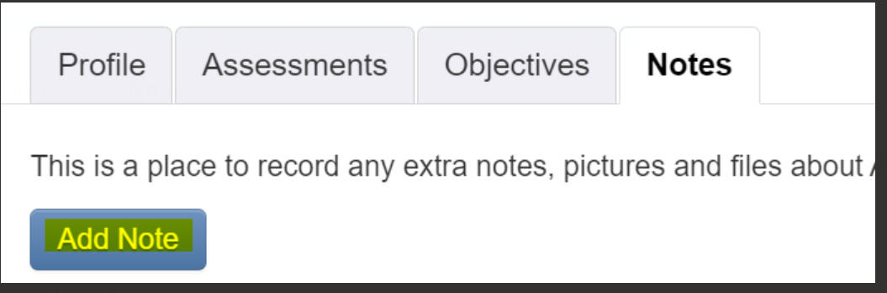
Then type in the box ‘Reception Baseline 2026’ and attach the relevant file
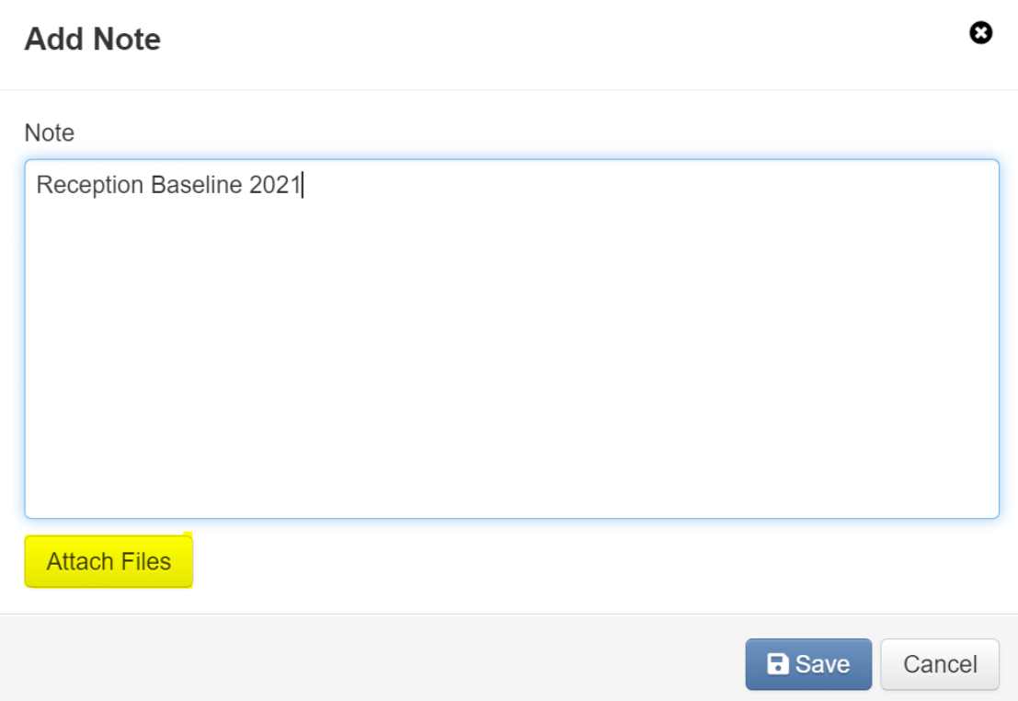

TO NOTE: Information for the academic years 2026-2027 onwards

From September 2026, schools will need two devices to administer the RBA. One device will be used by the teacher to administer the assessment and the pupil will need to use a separate touchscreen device to respond to some of the questions.
Please ensure both devices can connect to the services and pair with each other when administering the assessment (see ‘Check your devices can pair and connect to the service’ in Preparing for the assessment). Pairing the devices is important to ensure the assessment data is linked to the correct pupil. It also means practitioners can observe how the pupil interacts with their device and the assessment questions.

The assessment will remain interactive and retain the use of physical resources for other questions. This change supports accessibility and aligns with developments in classroom practice. If you are in any way unsure then there is training and guidance that can be completed beforehand. This is available through the school’s DfE sign in – please speak to your headteacher.
Most schools will already have the required devices and will not need to take any action. However, schools must ensure their devices meet the criteria within this guidance to successfully administer the RBA from the academic year 2025 to 2026:
Phonics placement assessments – please see the phonics assessment booklet. These assessments inform the phonics tracker (Y/N) The phonics tracker must be completed.
Internal Assessments on Insight
These are based around 6 areas, which incorporate the domains from the RBA and are called maths knowledge and reading knowledge.
COMMUNICATION
Can the child process and follow instructions? Do they have the confidence to communicate freely and express themselves as a learner? Are they able to listen attentively in a range of situations.
CONFIDENCE
Can the child negotiate and consider the ideas and needs of others, empathise and work successfully as part of a team, and focus on one thing for an appropriate amount of time, happily coming away if my name is called?
PHYSICAL
Can the child control and co-ordinate their movements when using large and small equipment? Can the child negotiate space appropriately?
SELF-HELP
Does the child understand the need for physical exercise and eating well? Are they dry by day, and able to dress, feed and go to the toilet independently?
READING (use the RBA assessments to support this)
Can the child sit with a book holding it the right way up and turning the pages. Does the child have favourite stories they talk about/recognise? Can they listen well to stories and join in with rhymes and games? Can they segment and blend CVC words orally?
MATHS (use the RBA assessments to support this)
Can they count objects to 5, recognise patterns around them and create patterns of their own? Are they developing a sense of space around then– this is bigger than that, taller than this, this is full up? Can they complete a simple puzzle?

INTERNAL BASELINE for RECEPTION
NB This is not a checklist, an assessment against each statement is NOT expected
Domain | What to look out for | When to be concerned
COMMUNICATION | SPEAKING  Begin to ask questions using how, why, where and when  Using sentences of 4-6 words using all the words e.g. I AM going to the park (not ‘I go park’)  Using words ‘like because, and or’ in a spoken sentence  Begin to use past tense e.g. I saw 2 cats  Name 3 items from a common category e.g. tell me things you can eat?  Can say 2 things about common objects e.g. for a ball they might say It’s round and I can throw it  Can name 5 different colours  LISTENING  Beginning to understand a range of prepositions e.g. under, on top of, behind between, middle of | Where speech is not easily understood by unfamiliar adults – (hearing test?)  For EAL children is - their home language is developing well? Check in case the child has a speech, language and communication delay.  Doesn’t respond to their name
CONFIDENCE | FEELINGS  Name the emotion they are feeling  Enjoy jokes and plays on words  Join a whole class carpet session  Can engage in pretend play  Can negotiate conflicts in play and find solutions with adult support  Understand taking turns as well as sharing  Can follow rules  Can play with a group (4-5 children) | Extremely upset by certain sounds, smells or tastes, and cannot be calmed, or appears completely unemotional  Worried, sad or angry for much of the time.  Flit from one thing to the next, or does the same thing for too long, becoming distressed if they are encouraged to do something different.  Struggles to talk with others about what they want, like and think  Will not communicate how they are feeling
PHYSICAL | GROSS MOTOR  Walk up stairs one to a step alternating feet  Stand on one foot for about 5 second without holding onto anything  Hopping up and down on right or left foot at least once without losing balance  Jump forward from a standing position with feet together  Can throw overhand whilst standing at least 2 m  Can walk on tiptoes for around 4 m  FINE MOTOR (writing knowledge)  Makes straight cuts in a piece of paper with scissors (may be able to cut it in half)  Can copy a vertical line, a circle, an addition sign and a capital letter L  Can unbutton one or more larger buttons  Can zip and unzip a zip (with support)  Colour mostly within the lines  Draw a figure with a face, trunk, legs, arms and usually fingers.  Can trace on a line with a pencil without going off the line more than twice  Complete a 5-7 piece puzzle | Can’t easily sit comfortably on chairs – may need to develop core muscles  Has an unusual ‘waddle like’ walk  Gets tired easily  Unable to run or kick a ball  Cannot negotiate stairs
SELF-HELP | TOILETTING  Reliably dry during the day  DRESSING  Can dress/undress without help (except for poppers, buttons and zips)  Put on/take off socks and shoes with help (no laces)  Can dress for the weather  EATING  Feed themselves independently (may need help cutting food)  Understands what to do if they are tired or hungry  Can tell you their first and last name and how old they are | Look out for children who appear to be overweight or to have poor dental health,  Not toilet trained  Not able to feed themselves with a spoon
READING | WORD READING/PHONICS/SOUNDS  Recognise and read my first name – distinguishing it from others  Know that sounds they hear and the beginning or ends of words are represented by letters  Can understand another if they segment and blend CVC words orally e.g. touch your l-e-g  Recognise some familiar letters – e.g. that letter is in my name  COMPREHENSION/BOOK KNOWLEDGE  Make and retell story maps in the right order  Tell a story that is easy to follow  Suggest how a story might end  I can describe imaginary characters and places  I can answer questions about a familiar story | Appears not to know any book behaviour  Cannot sit still for a story  Cannot isolate any speech sounds
MATHS | NUMBER  I can subitise to 5  I can represent numbers to 5 with tallies/fingers  I can count a set of objects knowing the last number is how many there are – matching numeral and object  Can count a quantity using 1-1 correspondence  I can solve real world number problems (to 5)  I know that 3 is always 3 no matter how it is arranged (conservation)  I know that 3 elephants is the same quantity as 3 mice. (abstraction)  I can count to 10 from a given number  PATTERN  Can say if something is the same or different  Can spot an error in a pattern  SHAPE AND SPACE  Able to perceive the shape or size of objects e.g. bigger/smaller  Combine shapes to make new shapes  Knows the difference between a straight line and a curved line  Knows the properties of triangles and squares in terms of sides and corners  Able to describe the position of something in space e.g. under, next to, behind, in front of | Unable to recite the number list  Does not understand the concepts of many more or less  Does not recognise any numerals  Unable to understand simple positional language

Entering Internal baseline data onto Insight for Reception
Each child will have 6 assessments entered, one for each of the 6 areas above, using EXS, WTS or WB. The information gathered from the statutory Reception baseline should give you enough for the reading and maths domains – do not do extra.
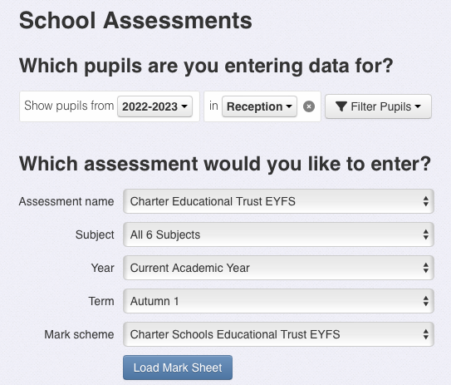

This will say 26-27

Please choose Charter EYFS (NOT Main Assessment)

Baseline goes here

When you click on ‘Enter Data’ please ensure all the options look like this
Once the marksheet has been loaded the screen will look like this.
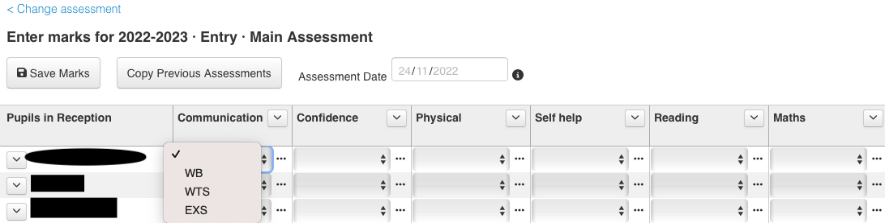

Entering data for Reception onto Insight for the rest of the year
After baseline there will be a mid year review (Spring 1) and an end of year review (summer 2) (see calendar above)
NB This is not a checklist, an assessment against each statement is NOT expected

Reception mid-year review
Each child will have 6 assessments entered, one for each of the 6 areas above, using EXS, WTS or CG (1-10)
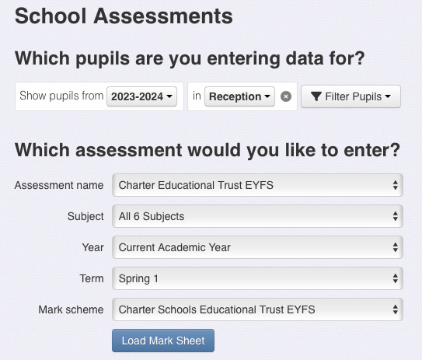

Choose Charter EYFS (NOT Main assessment)

Spring 1 for mid-year review data

The Reception Assessment Year
ELG | CHARTER DOMAIN | Mid year review around 60 months (by February half term) | End of year around 65 months (GLD) These are the ELG
SPEAKING AND LISTENING | COMMUNICATION | Uses comparison words like heavier, stronger, quieter e.g. a car is big but a bus is bigger  Repeats a sentence back to you without making any mistakes e.g Jane hides her shoes for Maria to find  knows what opposites are – demonstrate by finishing a sentence e.g. the elephant is big and a mouse is…….(small) | SPEAKING  Express themselves effectively using the past, present (branch 8) and future (branch 10) tenses and conjunctions  Participate in discussions with the class, in groups or 1-1 (branch 9 CLL)  Offer an explanation for why something happened (or might happen) (branch 8 CLL)  LISTENING  When being read to, during whole class discussion and small group interactions, children can listen attentively and respond to what they hear with relevant questions, comments and actions. (branch 9 CLL)  Make comments and ask questions about what they have heard to clarify their understanding. (branch 9 CLL)  Hold a back and forth conversation with their peers and adults (branch 9 CLL)
SELF-REGULATION  BUILDING RELATIONSHIPS | CONFIDENCE  (PSED) | SELF-REGULATION  Reattempts something after a failed attempt  BUILDING RELATIONSHIPS  Shows empathy and concern to those special to them (e.g. offers a toy)  Selects a peer to play with  Seeks out a person with a similar interest  Can say some qualities of a good friend  Approaches an adult when they need help | SELF-REGULATION  Can listen and pay attention and give appropriate responses (branch 9 CLL)  Set and work towards simple goals – can wait for what they want and control immediate impulses (branch 8 PSED)  Can talk about their feelings, the feelings of others and understand which types of behaviour are acceptable (branch 10 PSED)  BUILDING RELATIONSHIPS  Form positive relationships with adults and children (branch 10 PSED)  Can work and play co-operatively – taking turns and sharing (branch 10 PSED)  Form positive attachments to adults and friendships with peers (branch 7 PSED)
MANAGING SELF | SELF-HELP | MANAGING SELF  Names healthy foods  Makes appropriate choices for the weather (e.g. rain coats and wellies when it’s raining)  Controls their temperature (e.g. takes off jumper when they are hot)  Be able to re dress themselves if they had had a ‘wee’ accident | MANAGING SELF  Understand the importance of good health and manage their own basic hygiene needs (branch 10)  Have the confidence to ask for help (ranch 10)  Understand and follow instructions knowing right from wrong and trying to behave accordingly (branch 10)  Can try new things showing confidence, independence and resilience
GROSS AND FINE MOTOR  WRITING | PHYSICAL | GROSS MOTOR  Hop forward on one foot for a distance of about 2 m without putting down the other foot.  Skip using alternating feet  FINE MOTOR (writing)  Can negotiate buttons  Can zip and unzip a zip  Can copy a cross shape and square shape and a triangle shape – no tracing  Copy the letters V H T C A correctly without tracing  Copy the letters of their name (they may be large, backward or reversed)  All letters written are recognisable, but may not all be correctly formed | GROSS MOTOR  Negotiate space and obstacles safely with consideration for themselves and others (branch 9 PD)  Demonstrate strength, balance and co-ordination when playing (branch 9 PD)  Move energetically such as running, jumping climbing etc (branch 8 PD)  FINE MOTOR  Hold a pencil effectively – tripod grip (branch 9)  Use a range of small tools (scissors, cutlery) (branch 9 PD)  Begin to show accuracy and care when drawing  WRITING  Write recognisable letters, most of which are correctly formed (branch 9)  Write a simple phrase that can be read by others  Spell words phonetically (branch 9)
NUMBER, NUMERICAL PATTERNS, SHAPE AND SPACE | MATHS KNOWLEDGE  FROM MnP | NUMBER  Understands that 0 is an empty set  Count forwards and backwards to 10  Understand ordinal numbers and be able to name positions e.g. 1st 2nd 3rd  Write numbers to 10  Match number names with numerals to 10  Understand one more and one less within 10  Use a count all strategy to combine 2 sets up to 10 e.g. 5+4=9  Be able to subitise and partition numbers in different ways e.g. 4 could be a group of 3 and 1, or 2 and 2  NUMERICAL PATTERNS  To be able to copy continue and create AAB, ABC, AABC patterns  SHAPE AND SPACE  Be able to measure something using a unit of their choice e.g. I can line up 20 bricks along this table  Can use the language empty, full and half full to describe how much is in a container  Can identify 2D shapes within shapes – even when they are flipped over or rotated  Be able to recognise and build with 3D shapes (real-life objects) | NUMERICAL PATTERNS  Understand greater and less than within 10 (branch 9)  Verbally count beyond 20 recognising the pattern  Recognise, create and describe number patterns up to 10, odd, even doubles  Recognise numbers 1-20  Finds 1 more and 1 less within 10  NUMBER  Subitise up to 5  Have a deep understanding of number to 10 (branch 9)  Automatically recall bonds to 5 and some to 10 (including doubles)  Beginning to use bonds for addition and subtraction  Selects own method (including self selecting appropriate manipulatives) to solve problems  SHAPE SPACE AND MEASURE  Recognise and describe 2D and 3D shapes (branch 10)  Compare masses (branch 9)  Compares capacity (branch 9)  Compares heights and lengths (branch 9)  Beginning to recognise coins and solve simple money problems (branch 9)  Makes and continues a repeating pattern (branch 9)
 | READING KNOWLEDGE | WORD READING  Give the sound when shown any Phase 2/Level1+ grapheme  Find any Phase 2/Level 1+ letter, from a display, when given the sound  Blend most single-syllable words consisting of Phase 2/Level 1+ graphemes  Segment most single-syllable words making phonetically plausible attempts at spelling using phase 2/Level 1+ graphemes (branch 9)  Read some helpful/tricky words: the, to, I, no, go, he, she, we, me, be, was, my, you, her, they, all, are (branch 9)  (Set 1 sounds RWInc) | WORD READING  Read and understand simple sentences consistent with their phonics knowledge (branch 10)  Use phonics to read and write words (each letter of the alphabet and at least 10 digraphs) (branch 8)  COMPREHENSION  Offer explanations for why things might happen (branch 9)  Demonstrate understanding of what has been read to them (branch 9)  Use and understand new vocabulary  Anticipate – where appropriate key events in stories (branch 8)
 | CURRICULUM HUMANITIES | To be completed by each setting according to their curriculum | Understanding the World  Past and Present  Talk about the lives of the people around them and their roles in society  Know some similarities and differences between things in the past and now, drawing on their experiences and what has been read in class  Understand the past through settings, characters and events encountered in books read in class and storytelling  People Culture and Communities  Describe their immediate environment using knowledge from observation, discussion, stories, non-fiction texts, and maps;  Know some similarities and differences between different religious and cultural communities in this country, drawing on their experiences and what has been read in class  Explain some similarities and differences between life in this country and life in other countries, drawing on knowledge from stories, non-fiction texts and – when appropriate – maps.
 | CURRICULUM  SCIENCE | To be completed by each setting according to their curriculum | The Natural World  Explore the natural world around them, making observations and drawing pictures of animals and plants  Know some similarities and differences between the natural world around them and contrasting environments, drawing on their experiences and what has been read in class;  Understand some important processes and changes in the natural world around them, including the seasons and changing states of matter.
 | CURRICULUM  MUSIC ART DT | To be completed by each setting according to their curriculum | Expressive Arts and Design  Creating with Materials  Safely use and explore a variety of materials, tools and techniques, experimenting with colour, design, texture, form, and function;  Share their creations, explaining the process they have used;  Make use of props and materials when role playing characters in narratives and stories.  Being Imaginative and Expressive  Invent, adapt and recount narratives and stories with peers and their teacher  Sing a range of well-known nursery rhymes and songs  Perform songs, rhymes, poems and stories with others, and – when appropriate try to move in time with music.

Reception end of year assessment – (please see table above also)
This will be the EYFS profile that is submitted to the Local Authority
The table above shows how the 6 domains that have been assessed throughout the year translate into the ELGs for the EYFS profile

Insight domain | Corresponding ELG | Possible judgements
COMMUNICATION | Speaking  Listening | Each area for each child will have a judgement of EXS, WTS or CG (1-10), entered onto Insight,
CONFIDENCE | Self-regulation  Building relationships
PHYSICAL | Gross Motor  Fine Motor  Writing
SELF-HELP | Managing Self
READING | Word Reading  Comprehension
MATHS | Number  Numerical Patterns

The other ELGs have not been assessed through Insight, so this will be the first time you will be entering a judgement for these remaining areas, based upon the curriculum taught in your setting.

What it looks like on Insight
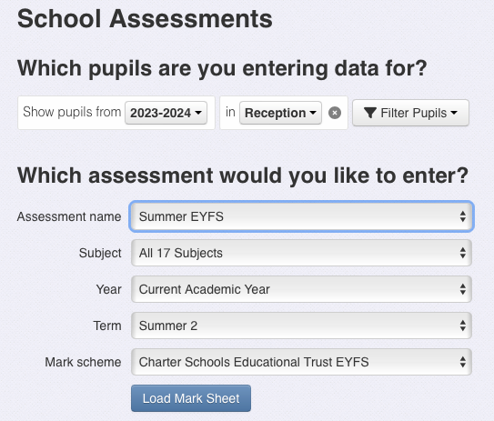

Choose Summer EYFS (NOT Main assessment or Charter EYFS)

Choose ‘All 17 subjects’

Choose Summer 2

Once you have clicked on ‘Load Mark Sheet’ it should look like this

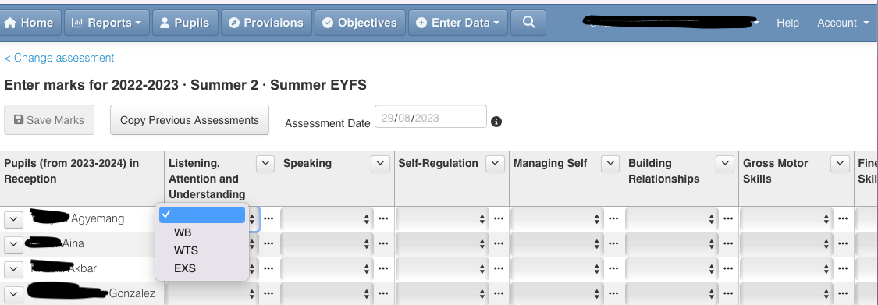
Insight itself will translate the judgements of EXS, WTS and WB into the national language of EXP and EME automatically, in a different area of the system – there is no need to enter any data twice.

To view your data ready to upload to the LA through a CTF
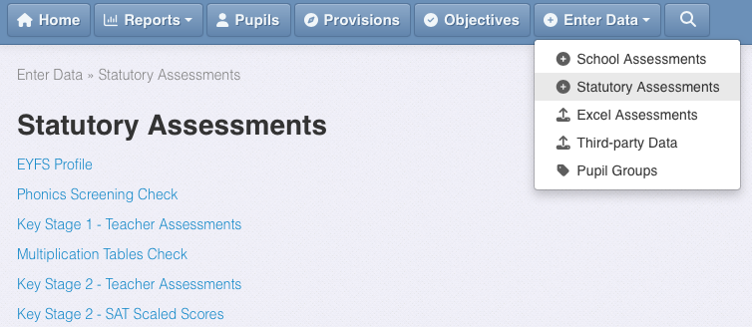
Click Enter Data then Statutory Assessments

Select EYFS Profile

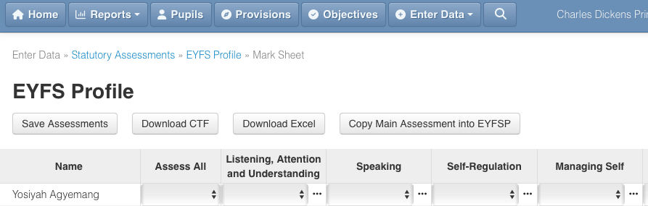
Load Mark Sheet and this screen will appear

Click here to copy your data from ‘Summer EYFS’ into this page

Click here to download the CTF ready to send to LA
Click here if you need to ‘flood fill’ all 17 areas
GLD is calculated for you in the ‘Reports’ section

Children new to the school joining at any time
Children’s data should be available on Insight at the end of half term nearest to their entry point.

Further information and guidance about uploading the EYFS data for submission to the LA is here, from Insight.

Being Year One Ready
https://www.gov.uk/government/publications/strong-foundations-in-the-first-years-of-school/strong-foundations-in-the-first-years-of-school
Common pitfalls and what we expect for teaching methods, timetables and classroom set ups.
Common pitfalls | What TCSET expect
Teaching and pedagogy  Adults tend not to interact with the pupils that need it most, as much as they do with other children, so the gap between them and their peers widens. Inequitable opportunities for learning  A lack of structure in the core, where the tasks for reading and writing are too complex and unstructured often results in insufficient practice before moving on  A focus on helping children to complete a task at the expense of long-term success in the subject (what are we doing rather than what are we learning)  Ineffective use of play-based learning (continuous provision) for all the reasons above | Pupils that need the most interaction will have this through whole class teaching of reading, writing and maths. Our approach is designed to ensure that children become fluent in the foundational knowledge.  There will be a daily lesson of phonics (following the chosen scheme) and a daily lesson of maths (following Maths no Problem)  Writing approaches will ensure that children are supported to construct proper sentences in the first instance.  There will be time in the day to focus on handwriting – which will be properly demonstrated by the teacher using the chosen scheme (incuding opportunities for dictation)
Timetabling  Timetable is not set or clear and therefore lessons / sessions tend to drift.  There are not explicit times for daily handwriting, phonics, reading and maths | Each timetable has daily, explicit sessions for handwriting, phonics , reading and maths  These sessions are not missed
Classroom set up  Not enough equipment for everyone – or equipment poorly kept  Inappropriate exercise books or no exercise books for the core areas  Tables and carpet set up so not everyone can face the teacher during whole class instruction. | Classroom set up  Equipment is easily accessible so pupils can be independent  There are maths no problem books, maths journals, handwriting books, writing books for each pupil  Each pupil has a table spot and a carpet spot

ELG | CHARTER DOMAIN | End of year around 65 months (GLD) These are the ELG | Year 1 ready
SPEAKING AND LISTENING | COMMUNICATION | SPEAKING  Express themselves effectively using the past, present and future tenses and conjunctions  Participate in discussions with the class, in groups or 1-1  Offer an explanation for why something happened (or might happen)  LISTENING  When being read to, during whole class discussion and small group interactions, children can listen attentively and respond to what they hear with relevant questions, comments and actions.  Make comments and ask questions about what they have heard to clarify their understanding.  Hold a back and forth conversation with their peers and adults | Executive functioning  Being able to sit on the carpet and pay attention for 20 minutes independently – focusing out what is not relevant  Being able to work with a talk partner on the carpet with the whole class, independently  Hold information in their minds in order to work on it  Focus on a goal and work out when it is necessary to change their approach to achieve it.  Demonstrate an understanding of good learning behaviour (because they have been taught)  - Stand in a line  - Sit in assembly with no talking  - Keep hands and feet to yourself  - Be able to say sorry if mistakes are made  - Be able to stay in the classroom when required
SELF-REGULATION  BUILDING RELATIONSHIPS | CONFIDENCE  (PSED) | SELF-REGULATION  Can listen and pay attention and give appropriate responses  Set and work towards simple goals – can wait for what they want and control immediate impulses  Can talk about their feelings, the feelings of others and understand which types of behaviour are acceptable  BUILDING RELATIONSHIPS  Form positive relationships with adults and children  Can work and play co-operatively – taking turns and sharing  Form positive attachments to adults and friendships with peers | Understand the emotions of happy, sad, angry, calm and be able to label these for themselves when they are feeling this way  Understand that others have these emotions too and respond appropriately
MANAGING SELF | SELF-HELP | MANAGING SELF  Understand the importance of good health and manage their own basic hygiene needs  Have the confidence to ask for help  Understand and follow instructions knowing right from wrong and trying to behave accordingly  Can try new things showing confidence, independence and resilience | Have one thing they know they can do to self soothe  Try things several times not giving up too easily
GROSS AND FINE MOTOR  WRITING | PHYSICAL | GROSS MOTOR  Negotiate space and obstacles safely with consideration for themselves and others  Demonstrate strength, balance and co-ordination when playing  Move energetically such as running, jumping climbing etc  FINE MOTOR  Hold a pencil effectively – tripod grip  Use a range of small tools (scissors, cutlery)  Begin to show accuracy and care when drawing  WRITING  Write recognisable letters, most of which are correctly formed  Write a simple phrase than be read by others  Spell words phonetically | Letter /number formation is consistent and correct (Letterjoin scheme)  Correct pencil grip (tripod)  Compose simple sentences orally (in preparation for writing) (supported sentences)
NUMBER, NUMERICAL PATTERNS, SHAPE AND SPACE | MATHS KNOWLEDGE  FROM MnP | NUMERICAL PATTERNS  Understand greater and less than within 10  Verbally count beyond 20 recognising the pattern  Recognise, create and describe number patterns up to 10, odd, even doubles  Recognise numbers 1-20  Finds 1 more and 1 less within 10  NUMBER  Subitise up to 5  Have a deep understanding of number to 10  Automatically recall bonds to 5 and some to 10 (including doubles)  Beginning to use bonds for addition and subtraction  Selects own method (including self selecting appropriate manipulatives) to solve problems  SHAPE SPACE AND MEASURE  Recognise and describe 2D and 3D shapes  Compare masses  Compares capacity  Compares heights and lengths  Beginning to recognise coins and solve simple money problems  Makes and continues a repeating pattern | Number knowledge  - understanding of the numbers to 20 including number bonds  - consistently recite the correct sequence of numbers and cross decade boundaries  - subitise up to 5 in a range of ways,  - compare two numbers and say which is the larger? •  - predict how many there will be if you add or take away one?  Language of maths  - Use positional vocabulary, including relative terms, to describe where things are  - make a range of constructions, talking about the decisions they have made  - find something that is longer, shorter, heavier, lighter (etc.) than a reference item?  - accurately use the relative terms ‘yesterday’ and ‘tomorrow’
 | READING KNOWLEDGE | WORD READING  Read and understand simple sentences consistent with their phonics knowledge  Use phonics to read and write words (each letter of the alphabet and at least 10 digraphs)  COMPREHENSION  Offer explanations for why things might happen  Demonstrate understanding of what has been read to them  Use and understand new vocabulary  Anticipate – where appropriate key events in stories | Phonics/reading  Be around the middle of phase 3 in phonics  Be able to share a book and engage in talk about that book  Spelling  Be able to spell common exception words as taught from the phonics scheme, holding the pencil with the correct grip and forming the letters correctly
 | CURRICULUM HUMANITIES | Understanding the World  Past and Present  Talk about the lives of the people around them and their roles in society  Know some similarities and differences between things in the past and now, drawing on their experiences and what has been read in class  Understand the past through settings, characters and events encountered in books read in class and storytelling  People Culture and Communities  Describe their immediate environment using knowledge from observation, discussion, stories, non-fiction texts, and maps;  Know some similarities and differences between different religious and cultural communities in this country, drawing on their experiences and what has been read in class  Explain some similarities and differences between life in this country and life in other countries, drawing on knowledge from stories, non-fiction texts and – when appropriate – maps.
 | CURRICULUM  SCIENCE | The Natural World  Explore the natural world around them, making observations and drawing pictures of animals and plants  Know some similarities and differences between the natural world around them and contrasting environments, drawing on their experiences and what has been read in class;  Understand some important processes and changes in the natural world around them, including the seasons and changing states of matter.
 | CURRICULUM  MUSIC ART DT | Expressive Arts and Design  Creating with Materials  Safely use and explore a variety of materials, tools and techniques, experimenting with colour, design, texture, form, and function;  Share their creations, explaining the process they have used;  Make use of props and materials when role playing characters in narratives and stories.  Being Imaginative and Expressive  Invent, adapt and recount narratives and stories with peers and their teacher  Sing a range of well-known nursery rhymes and songs  Perform songs, rhymes, poems and stories with others, and – when appropriate try to move in time with music.

