Guidance and Information Booklet
Cherry Garden Framework
2026-2027

Introduction Cherry Garden Branch Map Assessment Framework
The Cherry Garden Branch Maps is an assessment tool which tracks the typical development of a child from birth to 5 years. We use them from Nursery through to year 6
The table below outlines how it should be used in each key stage.
Year group/Phase | When to use Branch Maps
Nursery & Reception | At the first assessment point (which is baseline in October) and subsequent assessment points, where a child would previously have been assessed as ‘Well Below (WB)’ in Charter Educational Trust EYFS areas (Reading, Maths, Communication, Confidence, Physical, Self help)
Key Stage 1, 2, 3 & 4 | Where children are working below the Year 1 level (i.e. not yet accessing or scoring on Year 1 NFER assessments (<80 scaled score)

What are the Cherry Garden Branch Maps for?
The maps were created and developed by Cherry Garden School, a specialist school in Peckham for children who have severe and complex special educational needs and disabilities. The Branch Maps are shared freely with all schools to support their assessment of pupils with SEND who are working below Year 1 expectations.
There are 6 maps in total, covering the six areas of the Early Years Foundation Stage curriculum. Each Branch Map matches broadly to the in Charter Educational Trust EYFS areas.
Charter Educational Trust EYFS Areas | Charter Trust yr 1-6 assessments for pupils with SEND | Cherry Garden Branch Map
Reading | Reading | Communication, Language & Literacy
Communication | Some aspects of writing | Communication, Language & Literacy
Maths | Maths | Mathematical Development (Cognition)
Confidence (Feelings and relationships) |  | Personal, Social, Emotional Development
Physical | Some aspects of writing | Physical Development
Self Help |  | Physical Development

Within each Branch map, there are 10 Branches linked with expected progression in typically developing children from 0-5 years.
Cherry Branch | Branch 1 | Branch 2 | Branch 3 | Branch 4 | Branch 5 | Branch 6 | Branch 7 | Branch 8 | Branch 9 | Branch 10
Equiv. typical development | 0-5 months | 5-10 months | 10-15 months | Bridging Branch | 15-22 months | 22-29 months | 29-36 months | 36-48 months | 48-60 months  (If in Reception this might indicate ELG) | Emerging Year 1  (If in Year 1, this would be considered WTS.

Each Map is divided into strands which are indicated by colour. White boxes give additional information to ensure sufficient evidence of progress for particular objectives.
For example, the Communication, Language and Literacy Branch Map is broken into 4 strands indicated by the colours below:
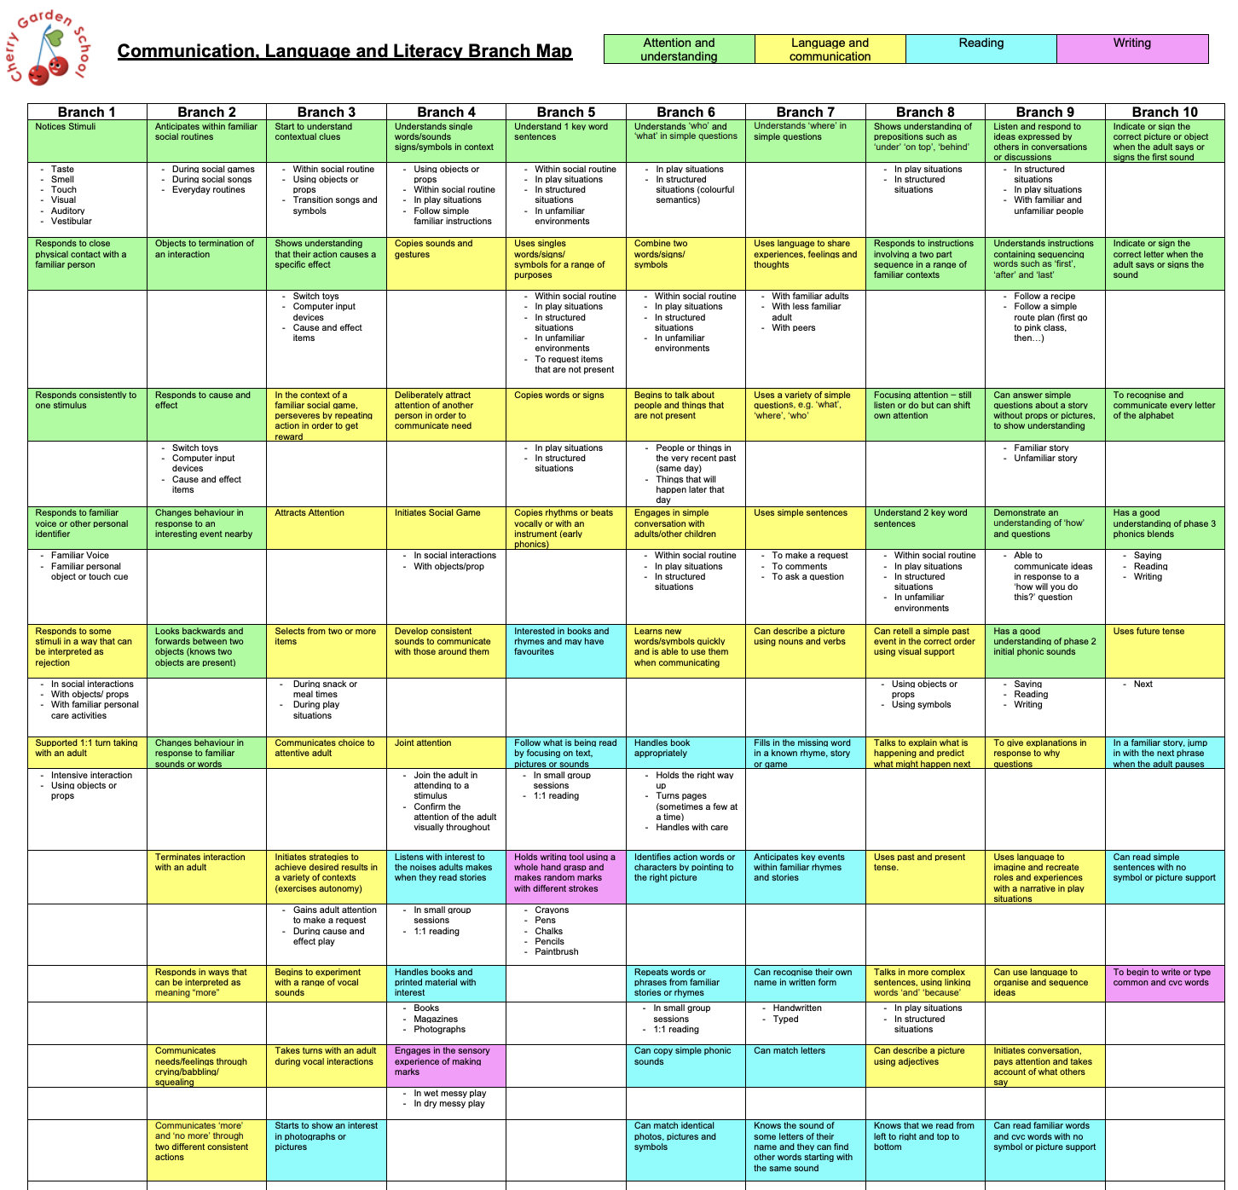

How do I decide whether Cherry Garden Branch Maps are appropriate?
Nursery or Reception,
Where a child is working well outside what would be considered normal development. They are working well outside their year groups. in Charter Educational Trust EYFS areas (Reading, Maths, Communication, Confidence, Physical, Self help)
Cherry Garden Branch Maps should only be used in relevant areas e.g. a child is working at expected for self-help and physical development but ‘WB’ for confidence. This is a pupil who would require assessment using the Personal, Social and Emotional Branch Map.
In Key Stage 1 and above
Where assessment evidence strongly suggests that a child is working below the Year 1 curriculum in any/all of the core subjects (Reading, Writing and Maths). Currently, this is defined as:
- any child who with reasonable adjustments either cannot yet access the Year 1 assessment materials or;
- a child who is likely to attain a standardised score of <80 in Year 1 assessments (to be discussed with SENCO)
If there is discrepancy between teacher assessment and scaled scores, a discussion with the SENCo is required in considering if Cherry Gardens Branch Maps would be appropriate.
Any pupil who has not taken any NFER test from any year group must have a cherry gardens teacher assessment
Any pupils who have taken a year 1 NFER test but scored less than 80 – discuss with the senco whether a CG assessment is needed

Case Study:
Child J in Year 3, has been given a Y1 NFER reading test and scored comfortably at Year 1 Level for reading in autumn and spring with scores of 107 and 108. However, in the summer term, Child J scored 78 in the Summer Y1 NFER test for reading. There is reasonable doubt that Child J may not be comfortably working at Y1 level and the Cherry Garden Branch Map should be considered. Therefore, for Child J, staff should consult the Communication, reading and literacy Branch map and cross check coverage of the reading Strand (blue).
In writing he has been assessed by the teacher as working at/below the level of a Reception pupil–therefore staff should consult the CLL branch map (pink areas) and/or Physical development (blue areas). In the summer, he was given a Y1 Maths assessment and scored 99 Maths.
In summary for the summer term child J will have on Insight, a cherry garden teacher assessment for reading and writing but a Yr 1 99 assessment recorded in NFER maths scaled score

How do I assess pupils using the Cherry Garden Branch Maps?

Stage | Process
Baselining | - Select the Branch Map(s) you want to focus on  - Baseline the pupil by highlighting each statement that they are secure in (not emerging or developing). If they are secure in a whole branch, just highlight the branch number at the top.  - Identify key next steps to focus on for the coming term – these might be recorded in an individual learning plan or separate central document.  - Best fit -
Data Drop Windows | - At the end of each term (or during assessment weeks), review progress against the statements and indicate the pupil’s refinement level* and highlight with the corresponding colour for the term. This will provide at a glance, where the pupil currently is developmentally. * Refinement level = E – Emerging, D – Developing, S – Secure.  - Use Branch Maps to inform planning and next steps.
Key:
Baseline ………. Autumn 2 ………. Spring 2 ………. Summer 2 ……….

Clarification on ‘refinement levels’
As a rule of thumb, emerging would indicate a child is beginning to demonstrate the skill independently (some of the time). Developing would indicate the child is independently demonstrating the skill some of the time. Secure would indicate the skill is demonstrated most/all of the time, independently. The refinement levels are not included in Insight – if you use these you need to make a note of these on paper.

How do I record assessment data on Insight for pupils on Cherry Garden Branch Maps?

Key Stage | Process
EYFS | When reporting against the Charter Trust EYFS Areas, they match to the following branch maps:  CG represents ‘Cherry Garden’  1-10 represents the most advanced branch of the Branch Map you are focused on which is fully secure.  Example: a pupil assessed as CG3 in maths is secure in all objectives in Branch 3 of the Mathematical Development Branch Map. The pupil may be emerging/developing/secure in discrete skills in more advanced branches but they are not secure in a higher branch until all objectives in a branch are secure.
  Charter Educational Trust EYFS Areas | Cherry Garden Branch Map
  Reading | Communication, Language & Literacy
  Communication | Communication, Language & Literacy
  Maths | Mathematical Development (Cognition)
  Confidence (Feelings and relationships) | Personal, Social, Emotional Development
  Physical | Physical Development
  Self Help | Physical Development
KS1, 2 & 3 | When reporting Cherry Garden Assessments for pupils in KS1+, pupils will be assessed only using the two branch maps linking to the core subjects (where applicable):  - Communication, Language and Literacy  - Mathematical Development (Cognition)  CG represents ‘Cherry Garden’  1-10 represents the most advanced branch of the Branch Map you are focused on which is fully secure.  Example: a pupil assessed as CG3 in maths is secure in all objectives in Branch 3 of the Mathematical Development Branch Map. The pupil may be emerging/developing/secure in discrete skills in more advanced branches but they are not secure in a higher branch until all objectives in a branch are secure.

Do I need to record steps of progress within branches on Insight?
Yes – The Cherry Garden Branch Maps have been uploaded to Insight under objectives. Once the overall assessment ‘code’ has been entered, it is necessary to transfer the objectives which have been observed from a paper copy of the branch map to insight. The same ‘refinement levels’ are used.

OPTIONAL: How can I record the objectives in Insight?
Recording objectives is optional – for guidance on this speak to Lucy or Will

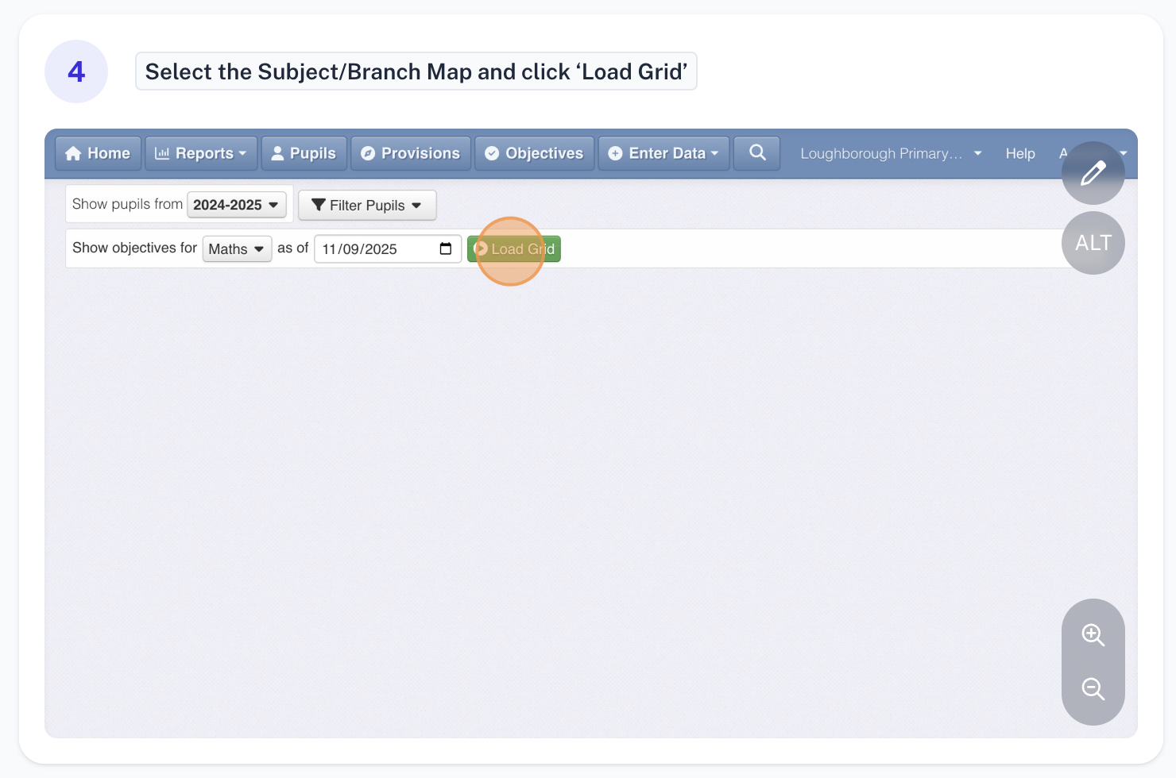
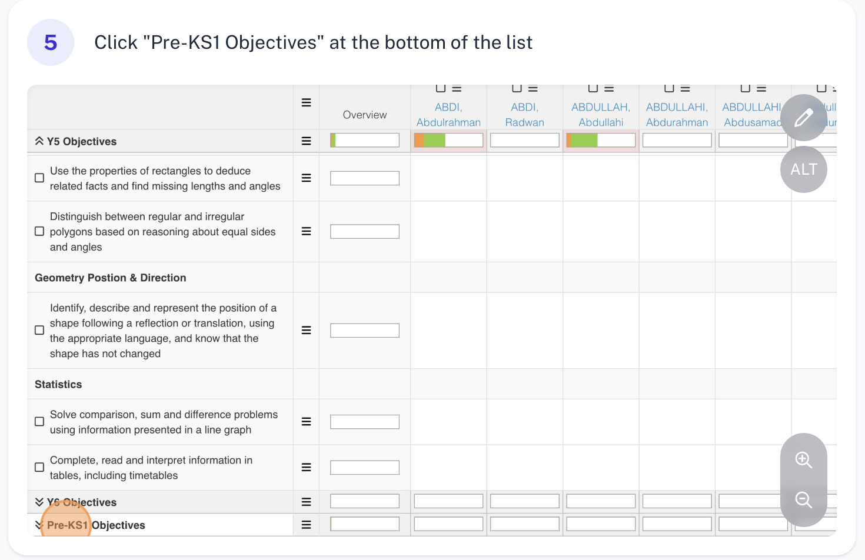
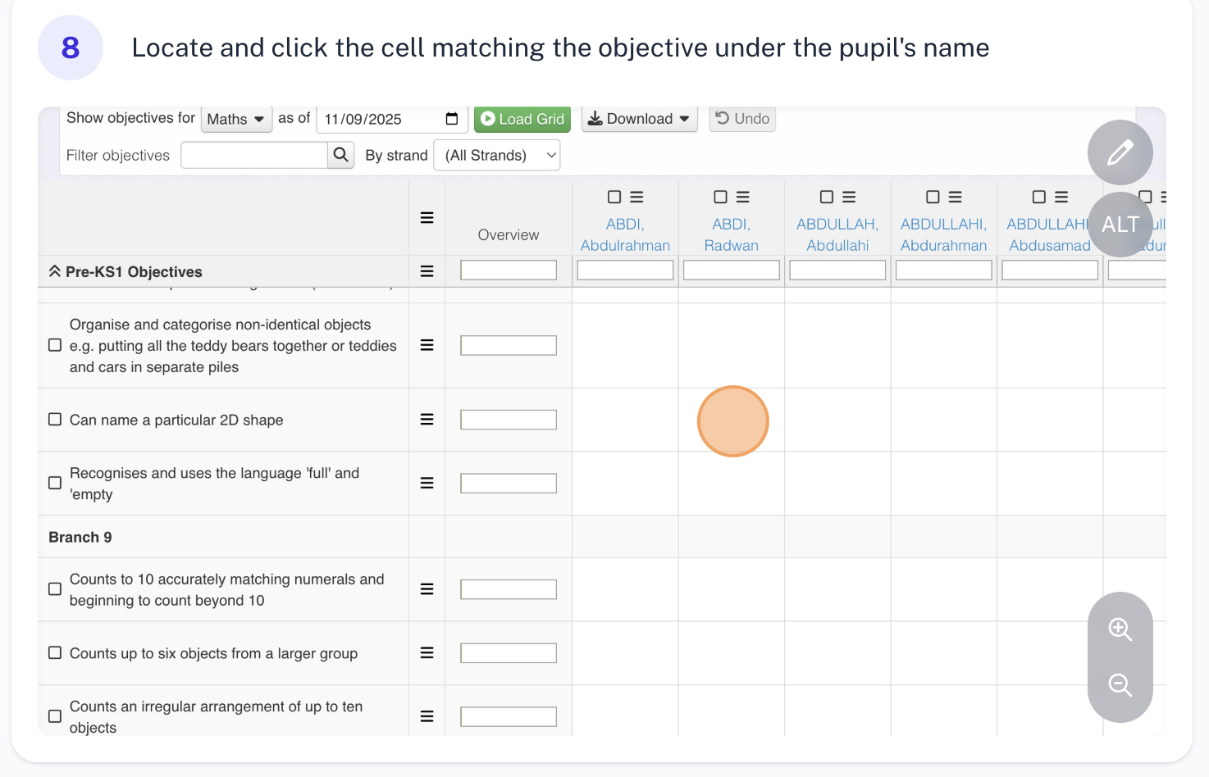
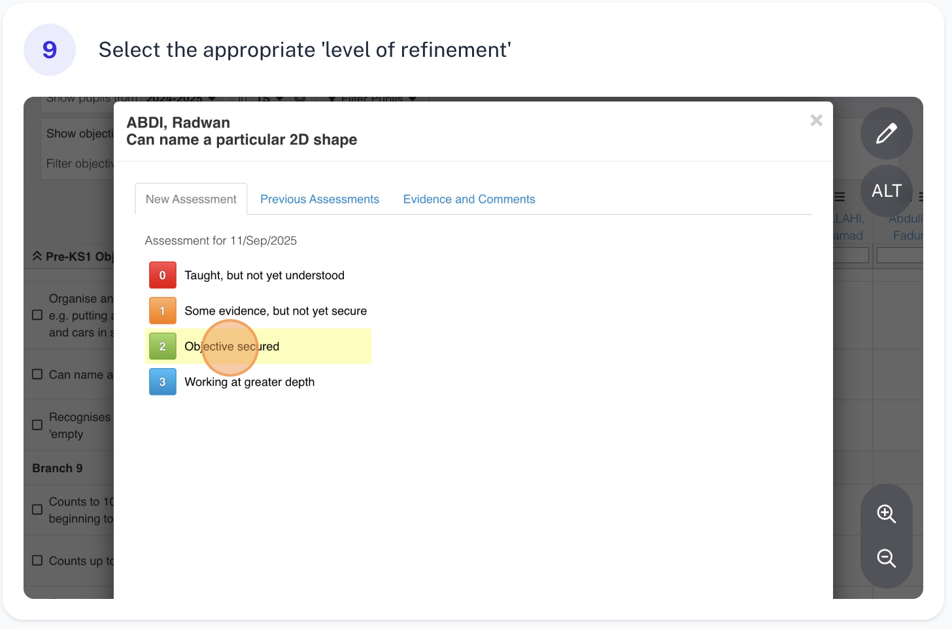
This process can be repeated each term, and will be updated.

APPENDIX

Below are links to each of the Cherry Garden Branch Maps. These should be printed and stored in a folder in your classrooms. All staff working with a child should be supported and encouraged to annotate and note progress on the physical copies of the maps which will make the process most effective and efficient.
Branch Map Links
Communication, Language & Literacy
Mathematical Development (Cognition)
Personal, Social, Emotional Development
Physical Development
Understanding of the World
Expressive Arts and Design

