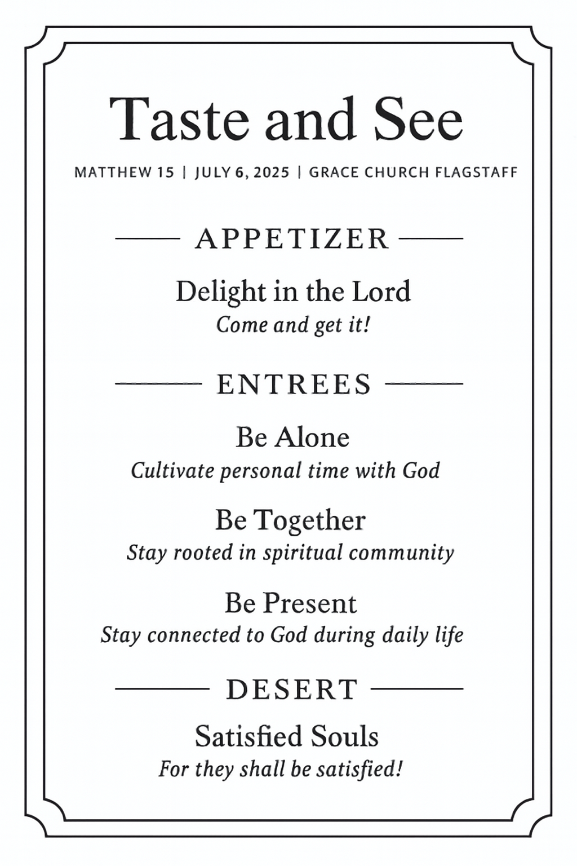
Oh, taste and see that the Lord is good! ~ Psalm 34:8
God provides new appetites for your renewed heart.

Be Alone
To be with God, we must regularly be alone with him.
This is not isolation; it is consecration.
Prayer includes: Praise, worship, gratitude, listening, submission, thanksgiving, supplication (requests), intercession (on other’s behalf)
  - Model Paul’s prayers for others
  - Model Jesus’ prayers
Center your time alone with God on Scripture
Scriptural “devotionals” include: Reading, reflecting, memorizing, meditating (extended and focused concentration), journaling, savoring
Suggestions: 1. Start the day 2. Avoid other input 3. Find a “thin place”

Be Together
Abiding is personal, but it is also communal.
We need encouragement, because we grow weary.
We need correction, because we are blind to our own faults.
We need community, because joy multiplies when shared.
Suggestions: 1. Church 2. Groups 3. Service 4. Hospitality

Be Present
God remains with you, always...
Our task is to remain present with him,
consciously aware of Immanuel, God with us
Being “spiritual” doesn’t mean being weird,
it means being awake go God.
“In all your ways acknowledge him” ~ Proverbs 3:6
Acknowledge: (v) To recognize, admit the existence, truth, or validity of something. To express gratitude or appreciation. To respond to someone's presence or communication.
Suggestions: 1. Leave the phone 2. Reframe tasks 3. Pray under your breath 4. Triggers for presence

