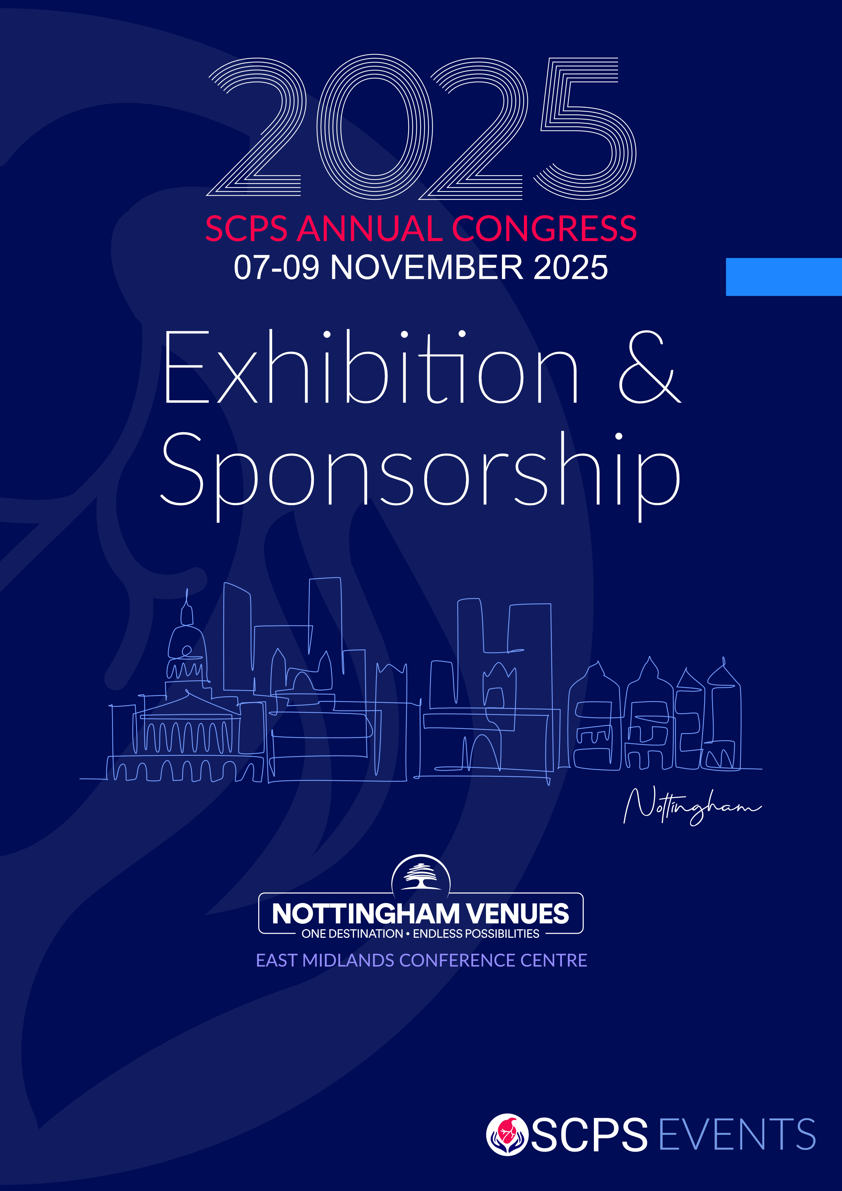

**Exhibition and Sponsorship**

The SCPS’s 2025 Annual Perfusion Congress will be held from Friday 7th to Sunday 9th November 2025 at the East Midlands Conference Centre (EMCC), Nottingham, UK.

The Congress is Ethical MedTech compliant, Ref: EMT-25-03253

We have a limited number of exhibition spaces available. Please contact Valerie Campbell / Zenia Simone for more information: [admin@scps.org.uk](mailto:admin@scps.org.uk)

The Exhibition will take place in the Banqueting Suite on the ground floor of the EMCC.

Please click **here** for the Exhibition Manual, EMCC Exhibitor Guidelines, and risk assessment form.

**Exhibition opening times**

The exhibition will be open during the following times (to be confirmed):

Friday 7th November:

9 am – 11 am, 12.30 pm – 1.30 pm, 3.30 pm – 4.00 pm, 5.30 pm – 7 pm.

Saturday 8th November:

8.30 am – 9 am, 10.30 am – 11 am, 1 pm – 2 pm

**Please Note:** There is no Exhibition on Sunday 9th November 2025.