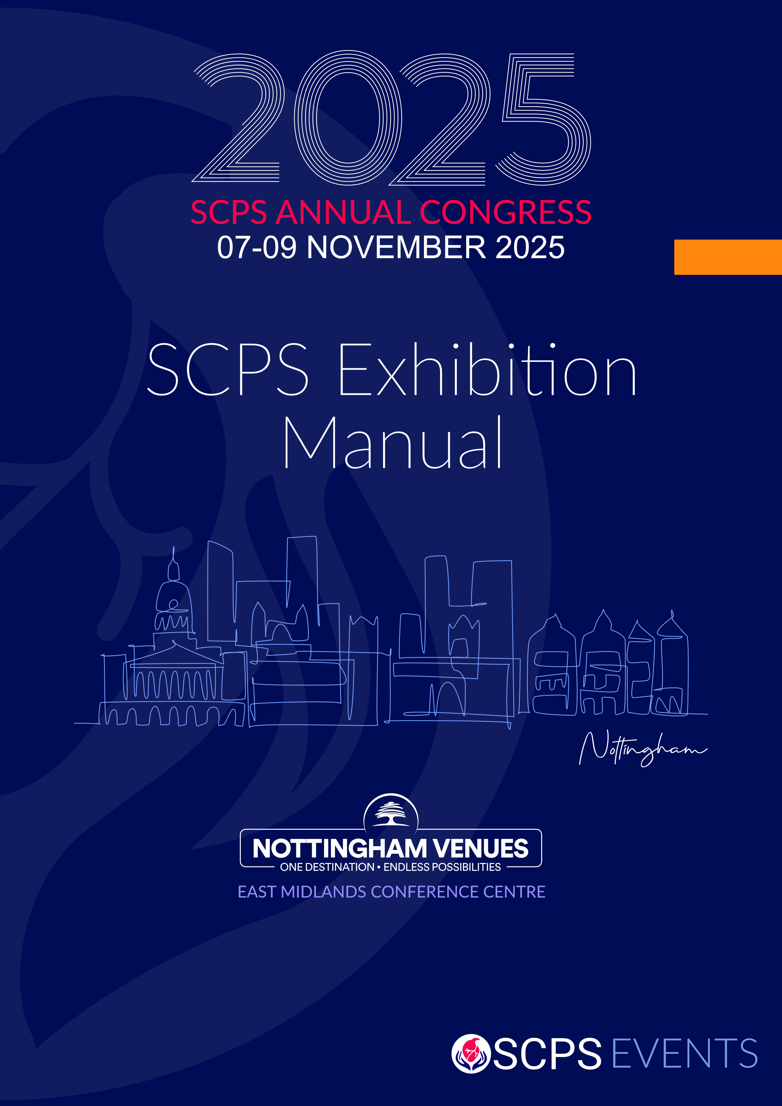

|  |  |
| --- | --- |
| The Society of Clinical Perfusion Scientists of Great Britain and Ireland |  |

Exhibition Manual 2025

Welcome to the 51st Congress of the Society of Clinical Perfusion Scientists (SCPS) at the East Midlands Conference Centre (EMCC), Beeston Lane, Nottingham NG7 2RJ. The Congress will be held on Friday 7th – Sunday 9th November 2025. The exhibition open days are Friday 7th and Saturday 8th November 2025. See below for further details.

The lead hotel is the Orchard Hotel, located in front of the Conference Centre. A sister hotel, The Jubilee Hotel, is situated about 7 minutes away by car. Additionally, there are a number of hotels within 10 minutes’ drive of the EMCC.

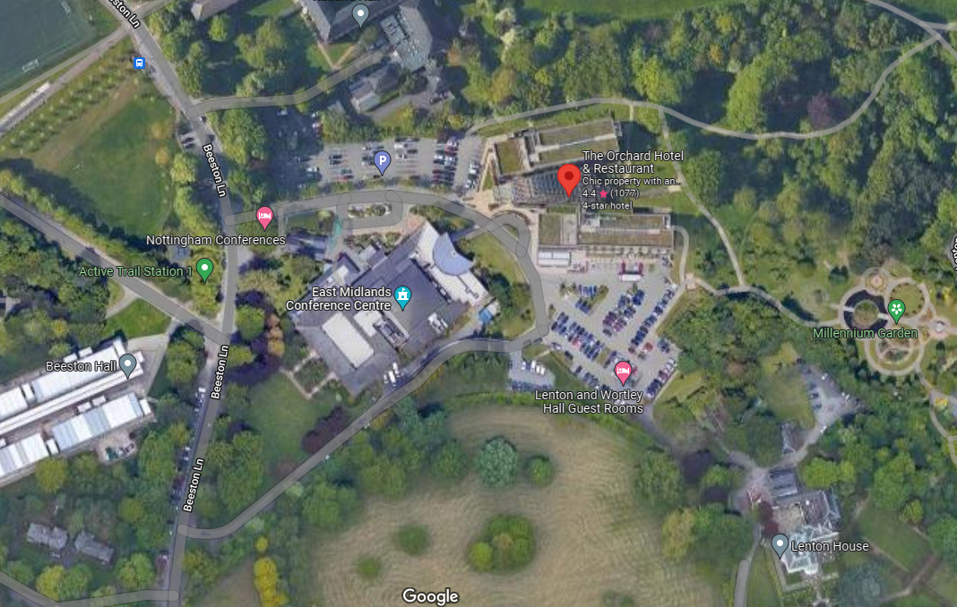

**C**

**D**

**C**

**B**

**A**

A – Main Entrance to the East Midlands Conference Centre

B – Main Entrance to the Orchard Hotel

C – Car Park: Guests are entitled to complimentary car parking.

D – Loading Zone: Exhibitors can use this entrance when setting up their Exhibition stands in the Banqueting Suite. Please see Appendix 1 for more information.

***Exhibition Hall***

The Banqueting Suite is set aside for the exhibition hall. A floor plan will be made available before arrival. Currently the floor plan is based on a first come, first served basis; however, due to the layout of the room, there will be careful consideration to make best use of space and promotion of traffic flow through the room. Lunch, tea and coffee are included in your package. These will be provided during the official breaks and will be served in the exhibition hall. Delegates will flow through the exhibition on their breaks and these will be your busiest times.

***Exhibition Set Up***

The Banqueting Suite will be accessible for build and set up from 8 am – 6 pm on Thursday 6th November 2025. Access times for builders will be phased, and exhibitors will be advised of their time slots by 15th October 2025.

***Exhibition Open Times***

The exhibition will be open during the following times (to be confirmed):

Friday 7th November:

9 am – 11 am, 12.30 pm – 1.30 pm, 3.30 pm – 4.00 pm, 5.30 pm – 7 pm.

Saturday 8th November:

8.30 am – 9 am, 10.30 am – 11 am, 1 pm – 2 pm

**Note:** There is no Exhibition on Sunday 9th November 2025.

***Exhibition Breakdown***

Stands will need to be dismantled from 2.15 pm on Saturday 8th November 2025.

The annual awards dinner will take place on Saturday 8th November at 7.30 pm in the Banqueting Suite, so we kindly request that all exhibition materials be removed by 5 pm.

***Stand Design and Risk Assessment***

Design and risk assessments must be submitted as per terms and conditions 2025.

Maximum height limit for the Banqueting Suite is 3.5m. We would ask that design be mindful of the floor plan disseminated and that stands do not physically impede the view of other stands or open spaces.

If a stand is free build, you must submit the following to the SCPS for approval:

* Detailed Scale Drawings Showing:  Plan and Section views of the stand with measurements.
* Elevations of the stand: No stand must exceed 3m in height. Stands less than 12m2, cannot exceed 2.5m in height.
* The width and position of all gangways within the stand.
* The type of floor and floor loading of the stand, and floor covering colour.
* Specification of the materials used.
* The stand plans must indicate number of electric outlets required along with the position where the main electric connection will be required.
* Full risk assessment (including Fire) and method statement.
* Details of the stand contractor and a copy of their Public liability insurance.

***Electricity***

The EMCC will provide sufficient power for stands at no additional cost. However, where high-voltage 3-phase power is required this is priced as follow:

* 63-amp 3 phase power point £600.00
* 125-amp 3 phase power point £750.00  
    
  This would be based on the duration of the event (not per day). Please advise Alan Rayner ([Alan.Rayner@HCAHealthcare.co.uk](mailto:Alan.Rayner@HCAHealthcare.co.uk)) and the admin team ([admin@scps.org.uk](mailto:admin@scps.org.uk)) by 15th September 2025 if you require 3-phase power.

***Rules of Entry to Exhibition Hall***

Only persons aged 18 and above may access the Exhibition Hall on build and breakdown days. You may be asked to provide ID if you are challenged.

Anyone suspected of being under the influence or having recently consumed alcohol or drugs will not be permitted into the working area, and will be asked to leave the site. The organisers’ decision is final.

Failure to comply with PPE regulations may result in contractors not being allowed on site or removed from site, as will any form of antisocial behaviour. The organisers’ decision is final.

***Personal Protective Equipment (PPE)***

Hi vis jackets are required all day Thursday 6th November 2025, in the exhibition hall.

Appropriate safety footwear must be worn during the build and breakdown days. This means shoes or boots suitable for working on site. It is required that contractors wear hard toed footwear.

***Compressed Gas & Liquids***

The use of compressed gas and liquids are strictly regulated within EMCC. Exhibitors should submit details of any proposed use of compressed gas and liquids no later than 28 days before the event. This should include the type of compressed gas or liquid being brought on site (e.g. CO2, O2, Helium, Nitrogen etc.); the size of cylinder or vessel with their working pressures; the intended use of said compressed gas or liquid; and a certificate in respect of recent pressure tests of each vessel. This should also be made available on-site for inspection if requested by the EMCC or the SCPS.

***Damage & Loss***

Neither the event organisers nor the EMCC will accept responsibility for damage or loss of any properties of the exhibitors or contractors. All exhibits are the sole responsibility of the exhibitors. The individual stands and exhibits lie with the responsibility of each exhibitor. Valuables should not be left unattended on stands and should be locked away overnight, and additional care should be taken during exhibition build and breakdown. In the unlikely event of theft, please report to the organisers immediately at the registration desk.

***Deliveries & Collections***

You are welcome to send items directly to the venue. The venue will accept deliveries from 1 pm on **Wednesday 5th November 2025.**  However, where possible please arrange this for the day of the event due to limited storage. Any deliveries attempted before this date may be turned away.

Deliveries before the Event

Deliveries for the Exhibition can be sent to the EMCC one working day before the event, from 1 pm on Wednesday 5th November 2025. Items will be stored in the Loading Bay Area. Please label up all packages with the following: -

Your Company Name / Contact Name

Event Name

East Midlands Conference Centre

University Park Campus  
Nottingham University  
Beeston Lane

Nottingham  
NG7 2RJ

Collection after the Event

EMCC Storage is limited so where possible please take all items away with you the day the exhibition finishes, Saturday 8th November 2025.

If you do need to arrange collection via courier, please make sure that you adhere to the following: -

* All Items are packed away properly
* Company Name and Contact
* Full Return Address
* Collection Date – MUST BE NO LATER THAN 1 DAY AFTER THE EVENT
* Courier Company name who are collection items
* EMCC Ltd does not take responsibly of items left for collection

For additional information, please refer to the EMCC’s Exhibitor Guidelines 2025 document – Appendix 2.

***Educational Breakout Sessions***

Depending on the package purchased, room hire is available to exhibitors for educational sessions.

***Awards Dinner***

Tickets are £80.00 each. The price includes a welcome drink reception and a three course dinner with wine. Some stand packages include complimentary tickets. Free tickets must be confirmed and table seating booked in advance, with the registration desk. Dress code: Black Tie, Cocktail Dress.

***Programme***

A provisional programme will be available on our website at <https://www.events.scps.org.uk/>

**Terms of agreement**

# *Definitions*

In these terms and conditions:

The word “ORGANISER” means “The Society of Clinical Perfusion Scientists of Great Britain and Ireland”.

The word “EXHIBITION” means “EXHIBITION of the 51st SCPS Annual Conference”.

The word “EXHIBITOR” means the person, company, firm or other organisation contracting with the “Organiser” to participate in the “Exhibition” and, in relation to any terms or conditions imposing any prohibition, shall include employees, servants or agents of the Exhibitor.

The word “VENUE” means the East Midlands Conference Centre, Nottingham.

***Application for and Allocation of Stand Space***

Application for stand space must be made on the exhibition application form provided by the Organiser. Applications will be dealt with in strict order of receipt save that in the event of a conflict regarding space or other imperative conditions (including without limit a need for the utilities’ services), the Organiser shall have the right to allocate space to the exhibitor, re-arrange the floor plan, and/or relocate any stand at any time before or during the period of the Exhibition.

While the Organiser attempts to accommodate Exhibitor location and other preferences, such accommodations cannot be guaranteed. The Organiser reserves the right to refuse any application. The stand application form must list all firms being represented by the Exhibitor. The Organiser undertakes to give the fullest sympathetic consideration to the interests of the Exhibitor and in the event of a question arising which is not provided for within the terms of these Terms and Conditions, the Organiser’s decision must be accepted as final.

The submission of the Stand Application Form, together with the allocation by the Organiser, shall be deemed to be a contract in acceptance of and in accordance with these Terms and Conditions.

***Charges and Payment for Stand Space***

The charges for stand space and details of what is included in the cost of the stand space are listed in the information on exhibition packages.

An invoice will be sent upon receipt of a completed booking form. All charges are inclusive of VAT. Full payment will be due 30 days from day of invoice. Payment methods include direct bank transfer or credit/debit card. Where payment is made by bank transfer, a copy of the Remittance Advice must be forwarded to the Organiser.

The Organiser shall have the right to refuse to permit the Exhibitor to occupy or use the allocated space until all sums due to the Organiser from the Exhibitor have been paid.

***Cancellation of Stand Space***

Notice of cancellation of allocated stand space must be given to the exhibition organiser/Society administrator in writing at the addresses provided on the application form.

Any cancellations made before the 1st October will be 100% refunded. For all cancellations made on/after the 1st October payment will not be refunded. The Organiser will endeavour to re-let the stand space not required by the exhibitor, but if they are unable to do so, the Exhibitor shall remain liable to pay the full charge for the stand space allocated. If the Organiser is able to re-sell the space, a cancellation charge of 20% of the total charge for the stand will be made.

Where additional exhibition space is requested after the initial allocation of stand space, the Organiser will endeavour to facilitate all requests and additional payments shall be made as appropriate.

Any participants who fail to arrive at the exhibition by the designated times shall be liable for any additional costs that may be incurred by the Organiser, due to non-participation.

***Alteration of Stand Space***

Whilst every endeavour will be made to adhere to the published layout of the Exhibition, the Organiser shall be entitled to alter the layout if, in their opinion, this is in the general interest of the Exhibition.

***Amendment or Cancellation by the Organiser***

The Organiser reserves the right to cancel any booking or offer alternative facilities without any liability on its part in the event of:

* Any occurrence beyond its reasonable control which shall prevent the Organiser from performing its obligations in connection with the booking.
* The booking being, in the Organiser’s opinion, prejudicial to the reputation of the Organiser, the Venue, or third-party suppliers.
* The Exhibitor being in arrears of payment due.
* The Organiser becoming aware of any alteration in the Exhibitor’s financial situation.

***Installation of Exhibits***

Loading Bay door measurement are as follows: Height – 260cm, Width - 230cm.

The Exhibitor will have access to the Banqueting suite on Thursday 6th November 2025 from 8 am to 6 pm, but access will be phased. Exhibitors will be advised of their access times by 15th October 2025.

All stands must be complete and ready for inspection prior to the official opening time. All stands must be open for viewing and staffed during the official opening hours.

Removal of exhibits and dismantling of stands may not commence until the official closing time of the Exhibition.

The Exhibitor can start removing all exhibits, displays, stand fittings, materials and other items brought into the Exhibition Hall by the exhibitor on Saturday 8th November 2025 after lunch from 14:15 pm to 16:30 pm as the room for the exhibition is to be used for the awards dinner.

No Exhibitor will be permitted to install an Exhibit in such a manner as, in the opinion of the Organiser, obstructs the light or impedes the view along the open spaces or gangways. Gangways must be kept clear and free for passage at all times and must not be littered or obstructed. No display shall overhang gangways or project outside the individual stand space.

Stands not adhering to hall layout plans must be dismantled and taken back to the recognised stand limit. No display or stand shall exceed the maximum height limit of 3 meters.

Smaller structures (e.g. features, towers, etc) no higher than 3 metres will be considered pending sight of stand plans and subject to physical height limitations of the venue.

In the event of an emergency or malfunction of an exhibit during the open period of the Exhibition, the Exhibitor must seek direction from the Organiser before any repairs are undertaken. Ladders and other access equipment are not permitted to be used in the Exhibition during the open period unless any malfunction of the Exhibit shall create a danger to visitors.

Storage rooms are available for exhibition and other deliveries from Wednesday 5th November 2025. Each box or delivery needs to have the following relevant information on the front: Exhibitor Name, Event Name, Location, and Date of the event. Any packaging materials must be removed before the exhibition opens and not brought back before the official closing time.

Exhibitors shall submit plans for their stand no later than 10th October 2025 for approval by the Organiser and Venue. The stand plans must indicate number of electric outlets required along with the position where the main electric connection will be required. Please advise Alan Rayner ([Alan.Rayner@HCAHealthcare.co.uk](mailto:Alan.Rayner@HCAHealthcare.co.uk)) and the admin team ([admin@scps.org.uk](mailto:admin@scps.org.uk)) by 15th September 2025 if you require 3-phase power.

Exhibitors should be aware that construction of stands at certain venues may be affected by the positioning of service outlets or pillars. In such an event the Exhibitor will be advised of such a situation prior to the event.

All electrical installations must comply with the relevant Institute of Electrical Engineers and Venue Regulations and may be subject to inspection and test by the Electrical Contractor, before electric power is provided to them.

Any additional lighting requirements (spotlights etc) are not included in the stand price but may be facilitated by the venue upon request. Costs associated with this are extra and will need to be agreed in advance with the Venue and paid directly to the Venue.

The main objectives of the rules above are to create a comfortable and open exhibition space for delegates and exhibitors alike, aiming to maintain the view through the Exhibition as free as possible, not overshadowing or obscuring the view of any neighbouring stands. It is the aim to keep open sided stands as accessible to exhibition traffic as possible. All exhibitors should endeavour to adhere strictly to these rules.

As there may be some instances where the interpretation of the guidelines is in dispute, we remind Exhibitors that the overall principle for guidelines to stand design is to ensure a well- designed and open Exhibition for the delegates and fairness for all Exhibitors. The Organiser, therefore, reserves the right to pass an overall judgement on a stand design in favour of this principle.

***Carpet***

All exhibition areas within the EMCC are carpeted. If you wish to install your own carpet on your stand, you must first lay down floor panels to protect the venue carpet. All installed carpets should be secured in place using double sided tape (Stikatak B7 Exhibition Tape or equivalent).

***Catering***

Lunch, tea and coffee are included in your package. These will be provided during the official breaks and will be served in the exhibition hall. Delegates will flow through the exhibition on their breaks.  These will be your busiest times.

***CLEANING***

General cleaning of the venue will take place during the event build and prior to the event opening each day. It is the responsibility of each exhibitor to make sure their stand is kept clean and tidy. If an exhibitor requires the EMCC to clean their stand, this can be arranged for a fee. Any unwanted paper or packaging will need to be removed by the exhibitors; the EMCC does not dispose of large quantities of rubbish. Rubbish should not be placed in the aisles or cause an obstruction.

***Health and Safety***

The Exhibitor will be responsible for ensuring compliance with all Health and Safety Regulations imposed by the Venue and Organiser.

Separate health and safety risk assessments and methods statements will be required for the build and open period of the Exhibition. Where these are supplied by a sub-contractor, the Exhibitor shall still remain responsible for ensuring compliance with this and shall be responsible for any infringement of the Health and Safety Regulations of the Venue.

Unloading allocation will not be given until all paperwork has been received. There are no waivers; all exhibitors must produce a risk assessment, even if the risk is low, stating that they have carried out an analysis, and find it low risk. Such things as use of a table and roller banners would be low risk. If using monitors/screens, please ensure cables are not a trip hazard.

Please submit your documents as soon as possible and in any event by 10th October 2025 to Alan Rayner ([Alan.Rayner@HCAHealthcare.co.uk](mailto:Alan.Rayner@HCAHealthcare.co.uk)) and ensure you cc [admin@scps.org.uk](mailto:admin@scps.org.uk).

Anyone wishing to gain access to the Exhibition area during the build and breakdown of the exhibition shall be required to wear high visibility waistcoats or jackets.

Fire extinguishers are available within the exhibition area. The Exhibitor must comply with any instructions given by the Venue, Local Authority and Organiser to avoid the risk of fire.

***Damage to Exhibition Hall, Fixtures and Fittings***

No painting should be carried out in the Exhibition Hall. No nails, screws, or other fixtures may be driven into any part of the Exhibition building, including floors. No part of the Venue should be damaged or disfigured in any way. Should any damage occur, the Exhibitor shall be liable for reparation charges incurred.

***Insurance and Security***

Whilst every precaution is taken to protect your property during the exhibition, the organiser is not responsible for any loss, damage or theft during the entire meeting. It is recommended that you secure your own insurance. Any damage that does occur will be charged to the exhibitor concerned. The Organiser will not be responsible for contractors hired by Exhibitors.

For the purposes of security we ask that identification badges are worn at all times by Exhibitors, their staff and subcontractors within those parts of the Venue being used for the conference and exhibition. Admission to these areas will not be permitted to personnel without badges.

The Organiser does not accept liability for any loss or damage from any cause whatsoever, in respect of any property brought to the Exhibition premises by the Exhibitor or his contractors.

The Exhibitor releases and indemnifies the Organiser in respect of any loss or damage to such exhibits and other property whether it is his property or not. The Exhibitor shall adequately insure all such property in the joint names of himself and the Organiser on a full “All Risks” basis for a sum insured equivalent to the full value of all exhibits and other property to the Exhibition. If required, the Exhibitor shall provide the Organiser with satisfactory evidence that adequate insurance is in force.

***Exhibitor Registration and Badges***

Each Exhibitor is entitled to several complimentary badges in accordance with the size of the exhibition stand (see table).

|  |  |
| --- | --- |
| **Stand Size** | **Number of Exhibitor Passes** |
| 3m2 | 2 |
| 9m2 | 3 |
| 16m2 | 4 |
| 24m2 | 6 |
| 30m2 | 8 |

The indicated number of complimentary Exhibitor Badges can be ordered free of charge until 15th October 2025. After this deadline badges can still be ordered, however the fee will change to £25 (including VAT) per badge, with additional badges purchased at £50. Therefore, Exhibitors are strongly advised to register their representatives and staff before this deadline. Please contact Valerie Campbell and Zenia Simone.

Exhibitors must apply for complimentary Exhibitor badges with individual names for all representatives on their stand. These badges entitle the holder to attend the Exhibition, the welcome reception and scientific sessions. They are personal, non-transferable and must be worn always. Replacing this identification with business cards, ribbons or company logos is not permitted.

Personnel from companies that do not have an exhibition stand can only attend the exhibition conference sessions if day registration tickets are purchased.

# *Useful contacts*

Laura Kerr: [Laura.Kerr@gosh.nhs.uk](mailto:Laura.Kerr@gosh.nhs.uk) Scientific programme coordinator

Alan Rayner: [Alan.Rayner@HCAHealthcare.co.uk](mailto:Alan.Rayner@HCAHealthcare.co.uk) Exhibition coordinator  
  
Graeme Nias: [graeme@cambridgeperfusion.com](mailto:graeme@cambridgeperfusion.com) Meetings and Seminars, Scientific programme

Ben Middleton: [ben.middleton2@nhs.net](mailto:ben.middleton2@nhs.net) Meetings and Seminars, Exhibition

Priya Joshi: [priyajoshi6@hotmail.com](mailto:priyajoshi6@hotmail.com) Meetings and Seminars

Valerie Campbell: [admin@scps.org.uk](mailto:admin@scps.org.uk) Society administrator  
  
Zenia Simone: [Zsimone@scps.org.uk](mailto:Zsimone@scps.org.uk) Society assistant administrator

*Orchard Hotel, Beeston Lane, Nottingham:*

Room bookings can be made by calling reservations on 0115 876 0900 option 2.

<https://nottinghamvenues.com/bedrooms-accommodation/rooms-orchard-hotel>

*Jubilee Hotel, Triumph Road, Nottingham:*

Room bookings can be made by calling reservations on 0115 876 0900 option 1

**Appendix 1**

EMCC Loading Bay outside

EMCC Loading Bay from inside

