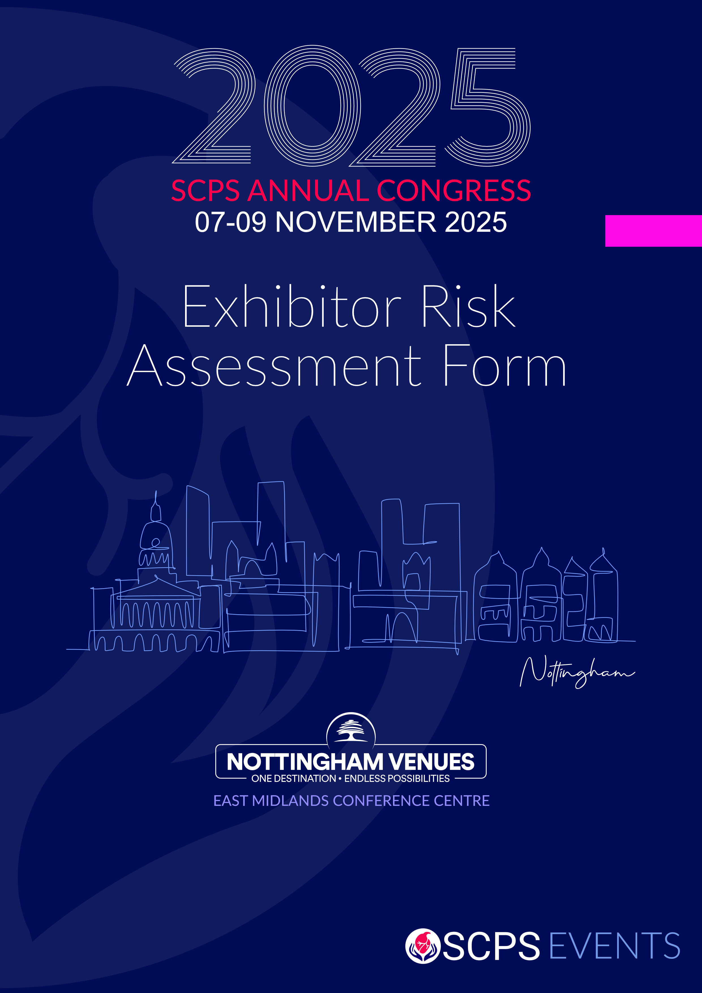

RISK ASSESSMENT FORM

EXHIBITOR: _____________________

|  |  |  |
| --- | --- | --- |
| **EVENT**: SCPS Congress 2025 | **DATE**: 7th – 9th November 2025 | **Risk Assessment undertaken by**: __________________ |
| **VENUE**: NOTTINGHAM VENUES EAST MIDLANDS CONFERENCE CENTRE | | **Signed**: ______________________________ |

|  |  |  |  |  |
| --- | --- | --- | --- | --- |
| **TASK/RISK** | **HAZARD** | **PERSON CONSIDERED TO BE AT RISK** | **RISK LEVEL**  **HIGH / MEDIUM / LOW** | **CONTROL MEASURES** |
| Manual handling | Potential back injury if items not lifted or moved correctly | Contractors; Exhibitors; Visitors |  |  |
| Working at height (ie: constructing & dismantling stands and working higher than  2m from the hall floor). | Personnel or equipment falling which could result in injury or death | Contractors; Exhibitors; Visitors |  |  |
| Use of hand  power tools | Injury | Contractors; Exhibitors; Visitors |  |  |
| Waste management | Slips or falls | Contractors; Exhibitors; Visitors |  |  |
| Vehicle access | Injury through vehicles | Contractors; Exhibitors; Visitors |  |  |
| Fire | Injury through being burnt | Contractors; Exhibitors; Visitors |  |  |
| Laying of cables and extension leads | Trips or falls | Contractors; Exhibitors; Visitors |  |  |
|  |  |  |  |  |
|  |  |  |  |  |