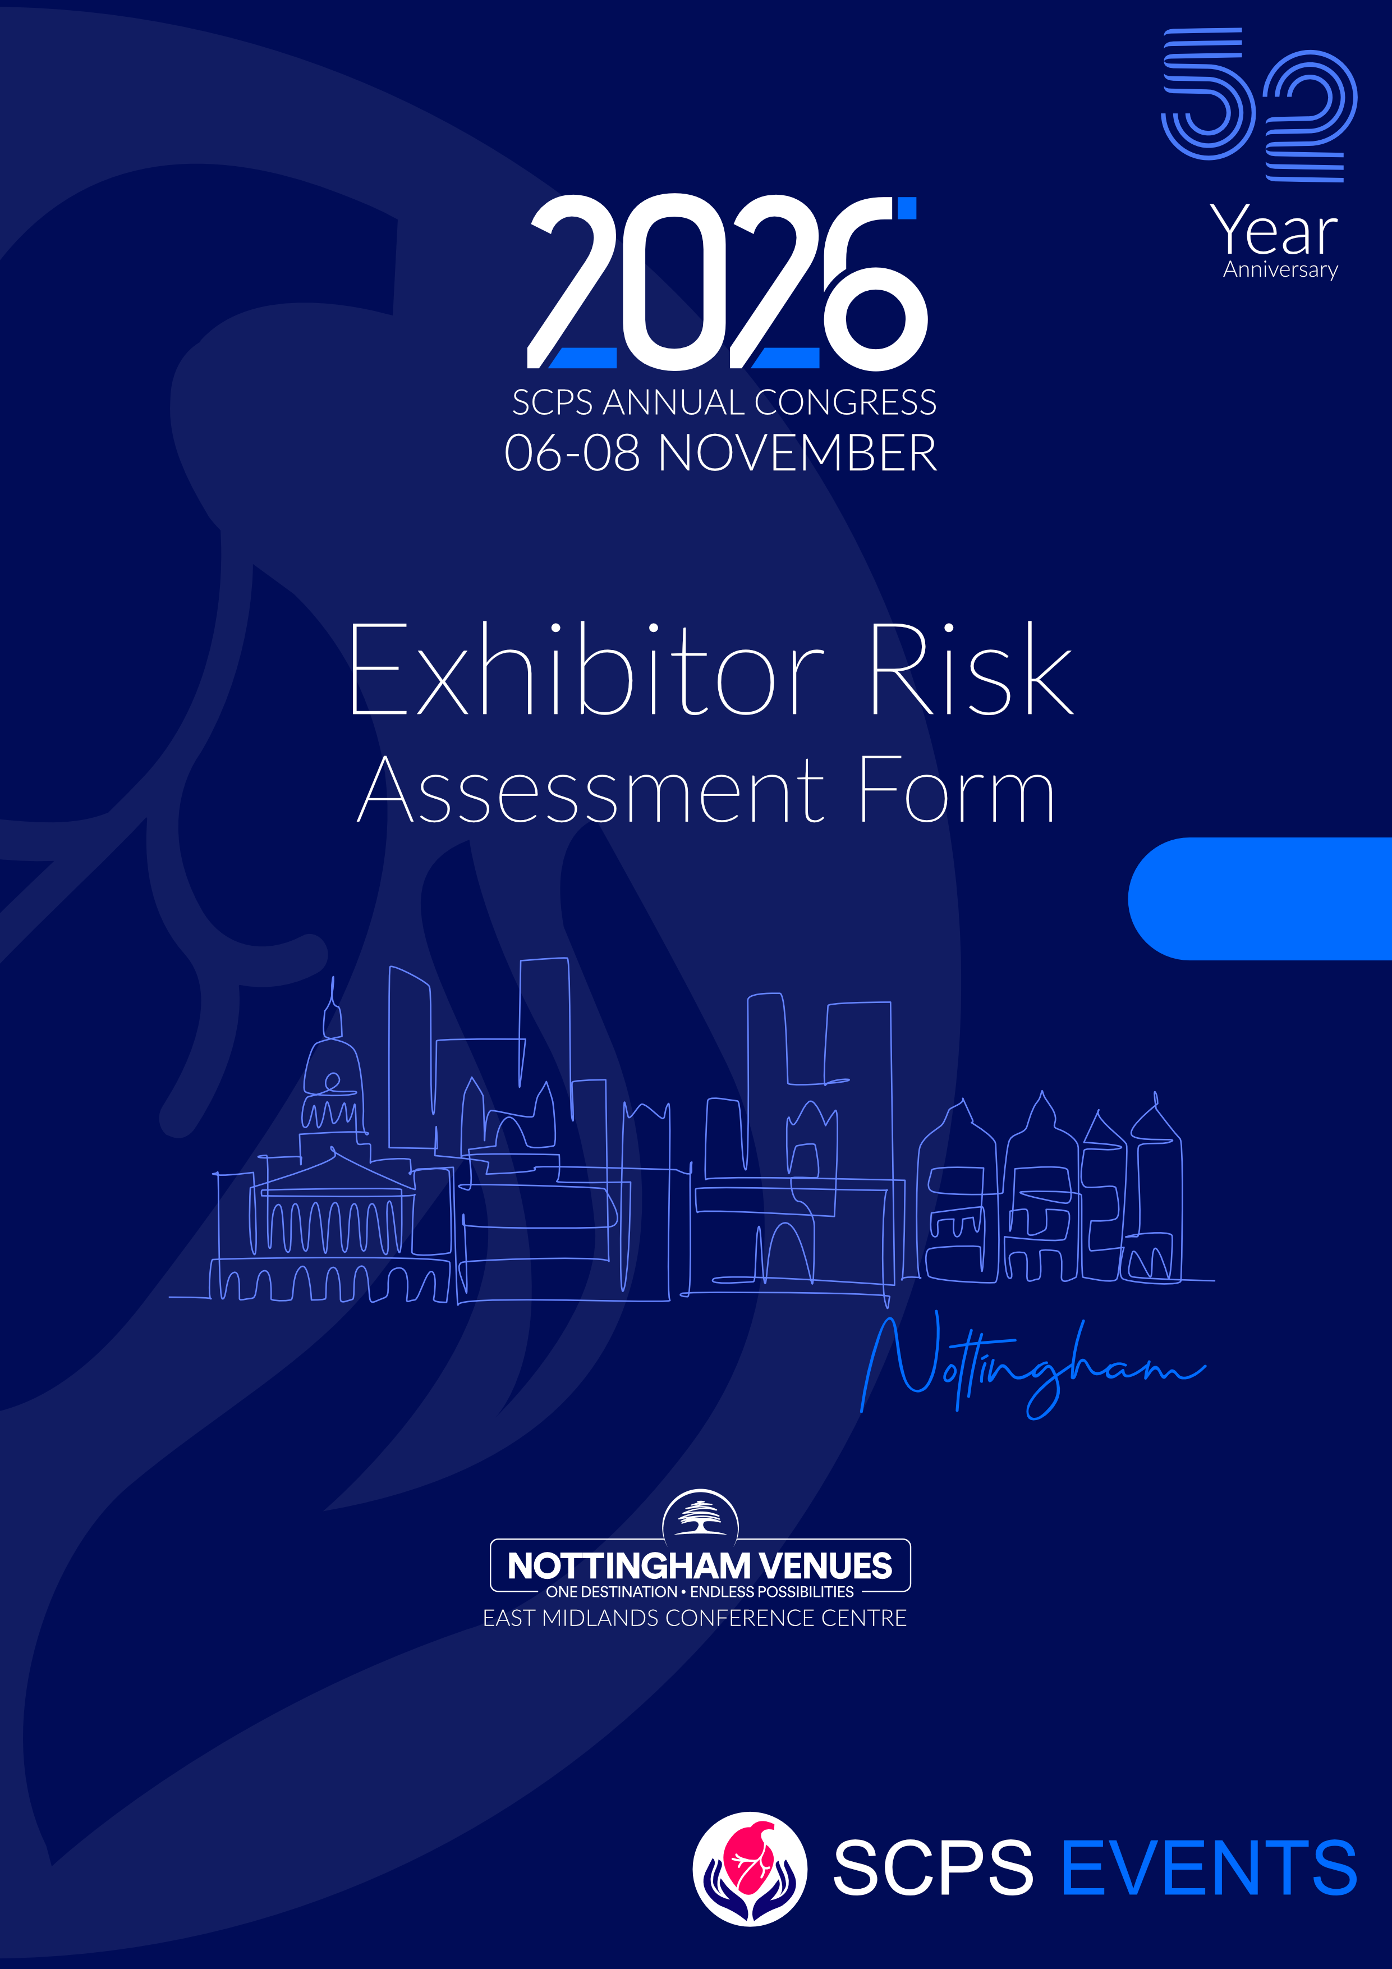

RISK ASSESSMENT FORM

EXHIBITOR: _____________________

EVENT: SCPS Congress 2026 | DATE: 6th – 8th November 2026 | Risk Assessment undertaken by: __________________
VENUE: NOTTINGHAM VENUES EAST MIDLANDS CONFERENCE CENTRE |  | Signed: ______________________________

TASK/RISK | HAZARD | PERSON CONSIDERED TO BE AT RISK | RISK LEVEL  HIGH / MEDIUM / LOW | CONTROL MEASURES
Manual handling | Potential back injury if items not lifted or moved correctly | Contractors; Exhibitors; Visitors
Working at height (ie: constructing & dismantling stands and working higher than  2m from the hall floor). | Personnel or equipment falling which could result in injury or death | Contractors; Exhibitors; Visitors
Use of hand  power tools | Injury | Contractors; Exhibitors; Visitors
Waste management | Slips or falls | Contractors; Exhibitors; Visitors
Vehicle access | Injury through vehicles | Contractors; Exhibitors; Visitors
Fire | Injury through being burnt | Contractors; Exhibitors; Visitors
Laying of cables and extension leads | Trips or falls | Contractors; Exhibitors; Visitors

