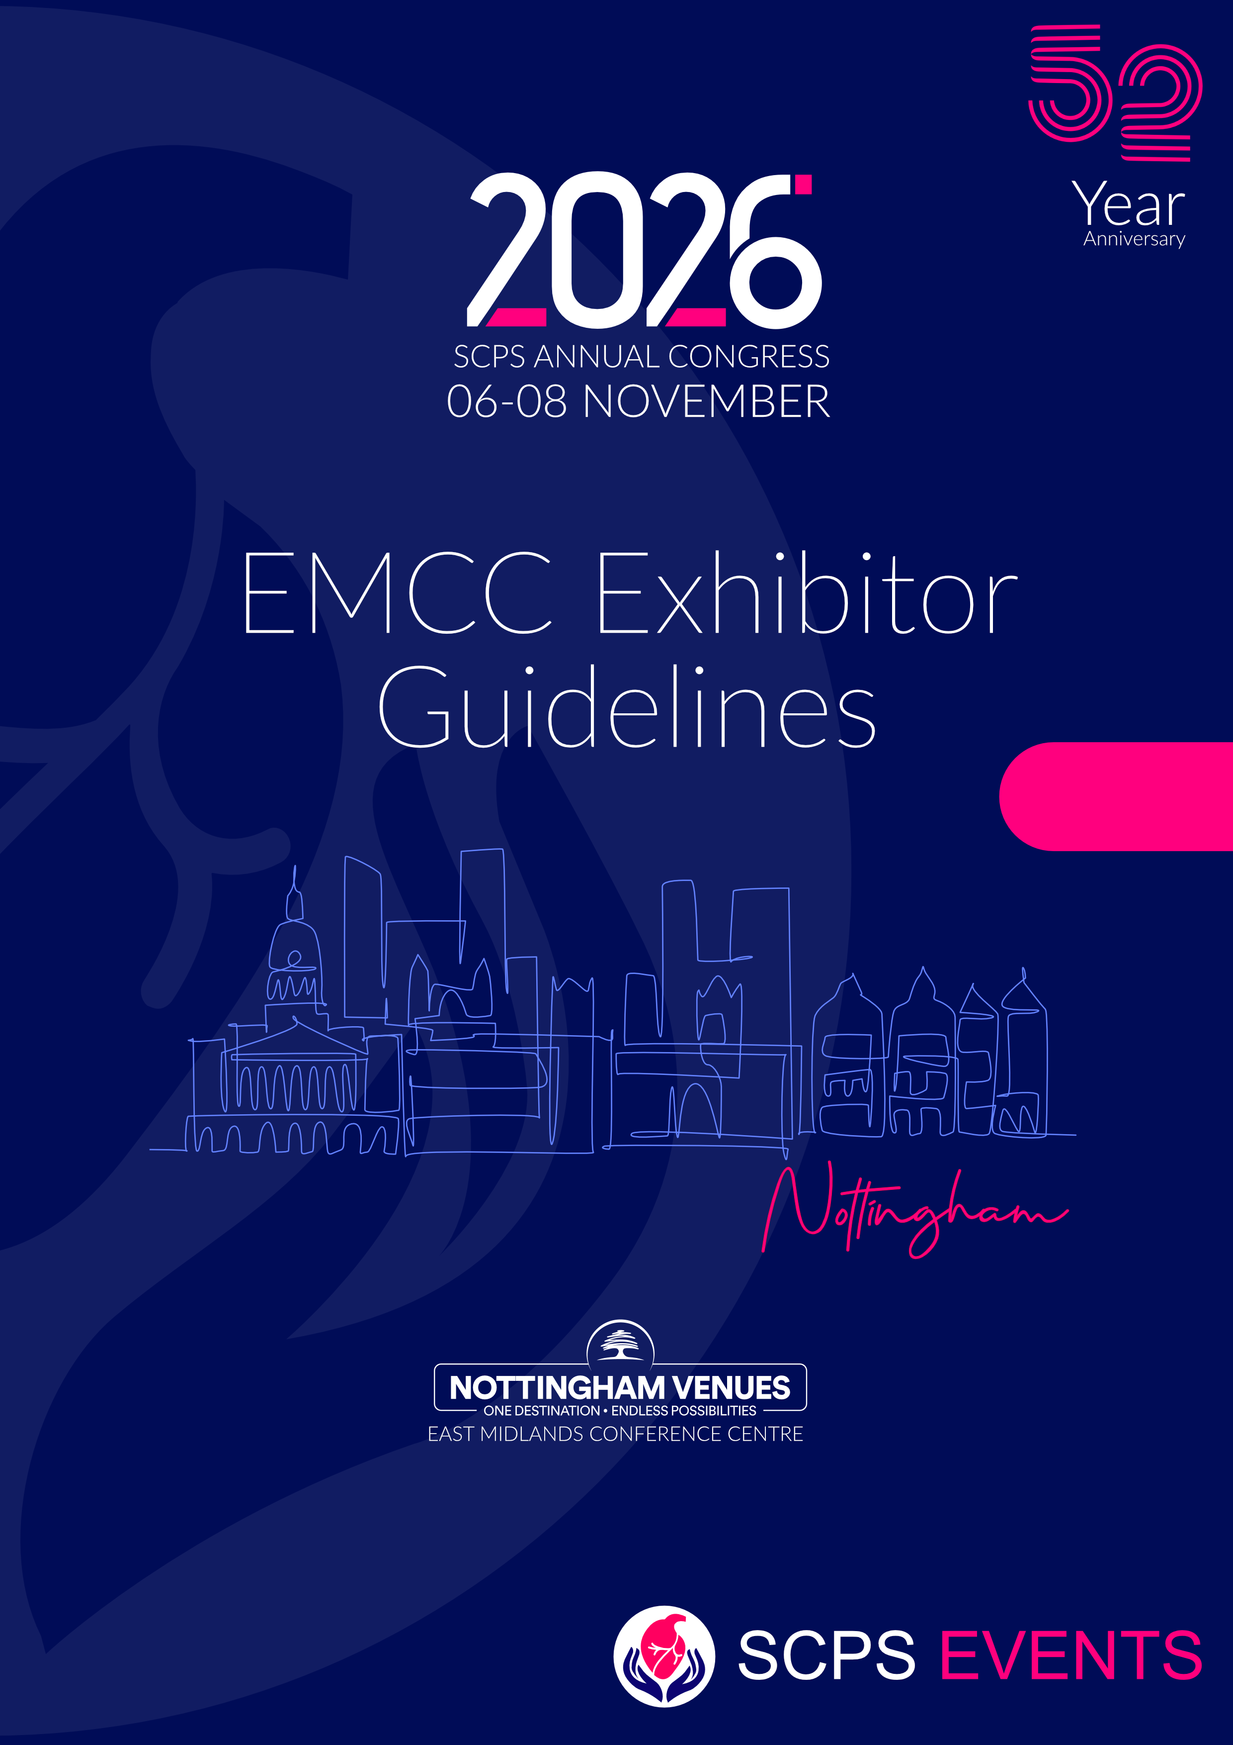

Appendix 2


EMCC – Exhibitor Guidelines

The Venue:
East Midlands Conference Centre (EMCC)
University Park Campus
Nottingham University
Beeston Lane
Nottingham
NG7 2RJ

Main Reception – 0115 876 0900

Deliveries before the Event
Deliveries for the Exhibition can be sent to the EMCC one working day before the event. However, where possible please arrange this for the day of the event due to limited storage.
Items will be stored in the Loading Bay Area.
Please label up all packages with the following: -
YOUR COMPANY NAME / CONTACT NAME
EVENT NAME.
East Midlands Conference Centre.
University Park Campus.
Nottingham University.
Beeston Lane.
Nottingham.
NG7 2RJ.

If items are not labelled up correctly it may result in the delivery being turned away.
Storage space is limited so if you have a large delivery, please contact katy.cumberland@nottinghamvenues.com to discuss further.
We do not have any equipment on-site to unload (pallet trucks, forklift trucks etc.). It will be the responsibility of your courier to unload items.



Unloading at the Venue
Please unload via the Loading Bay Entrance. This is located at the back of the building and can be accessed via a separate slip road marked “No Entry, Deliveries Only”.
The Loading Bay is on ground floor level.
Please bring your own moving equipment (trolleys etc.) as the EMCC does not have the equipment onsite.
Once you have finished unloading, please move your vehicle to the main car park at the front of the building.
The Car Park is free and on a first come first served basis.

Collections
EMCC Storage is limited so where possible please take all items away with you the day the event finishes.
If you do need to arrange collection via courier, please make sure that you adhere to the following: -
- All Items are packed away properly.
- COMPANY NAME AND CONTACT.
- FULL RETURN ADDRESS.
- COLLECTION DATE – MUST BE NO LATER THAN 1 DAYS AFTER THE EVENT
- COURIER COMPANY NAME WHO ARE COLLECTING ITEMS
- EMCC Ltd does not take responsibly of items left for collection

Documentation

Current PAT Test Certificates must be supplied 10 working days in advance of the event date covering any electrical equipment you plan to bring on site.
Please send this directly to the company organising your event katy.cumberland@nottinghamvenues.com
Public Liability Insurance Certificate must also be supplied as above.

