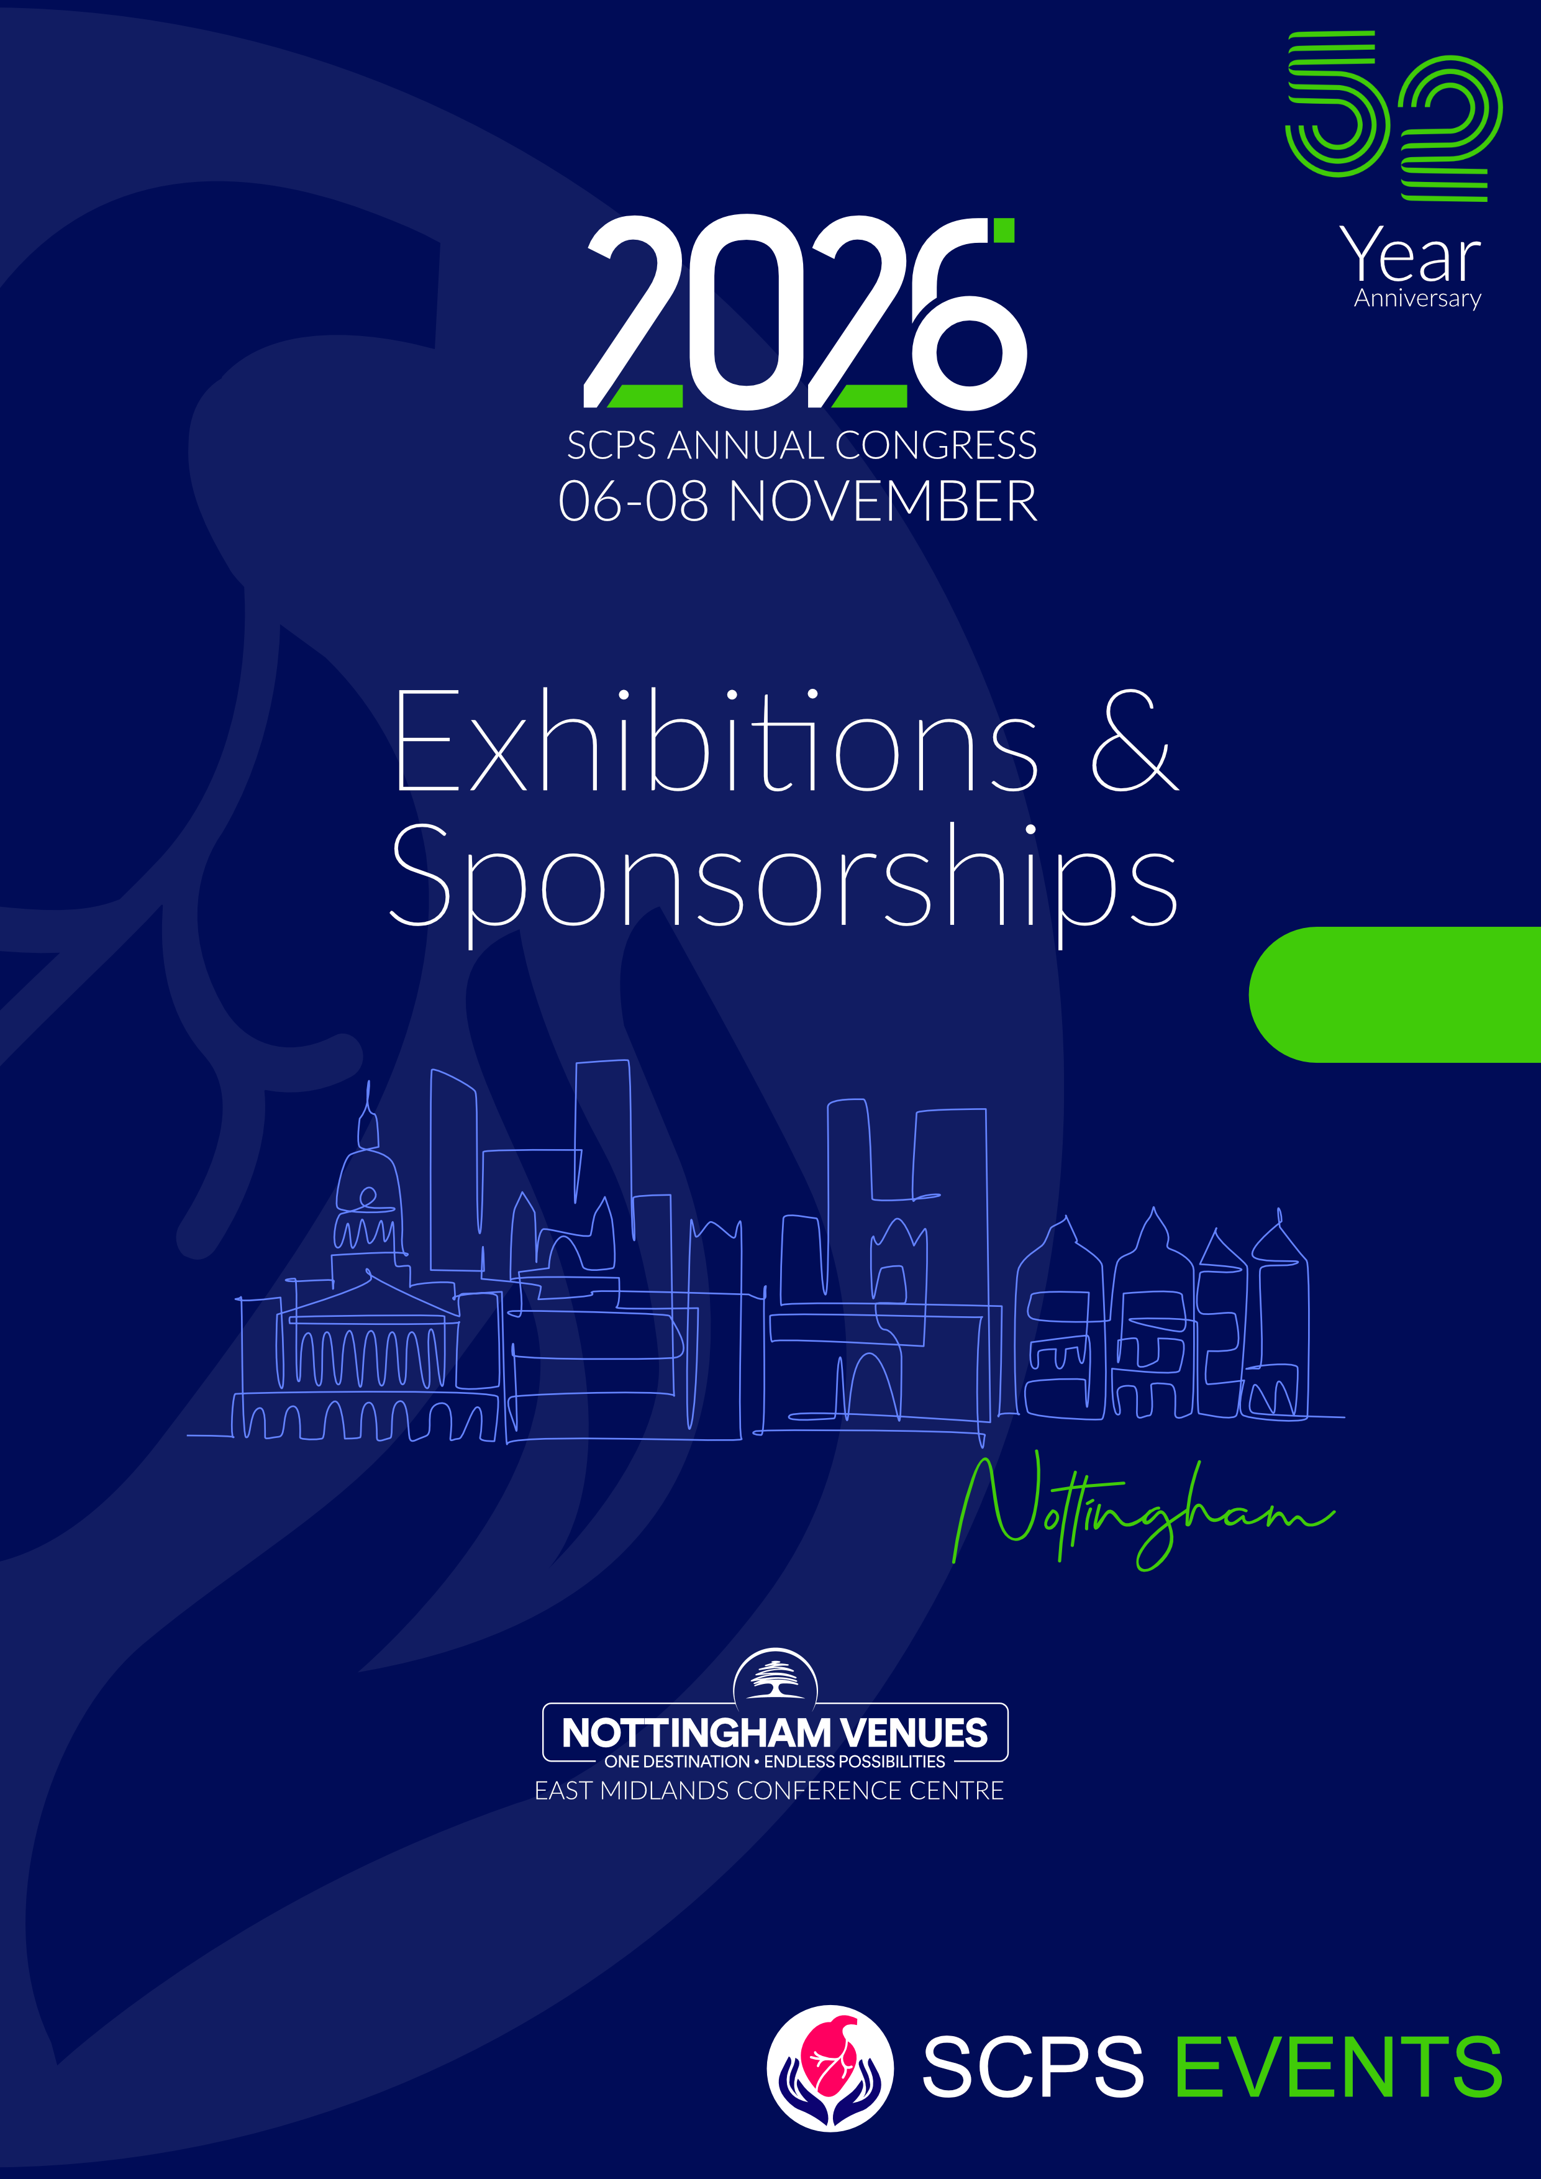

Exhibition and Sponsorship

The SCPS’s 2026 Annual Perfusion Congress will be held from Friday 6th to Sunday 8th November 2026 at the East Midlands Conference Centre (EMCC), Nottingham, UK.

The Congress is Ethical MedTech compliant, Ref: EMT-26-09628

We have a limited number of exhibition spaces available. Please contact Valerie Campbell / Zenia Simone / Karina Page for more information: admin@scps.org.uk

The Exhibition will take place in the Banqueting Suite on the ground floor of the EMCC.

Please click here for the Exhibition Manual, EMCC Exhibitor Guidelines, and risk assessment form.

Exhibition opening times

The exhibition will be open during the following times (to be confirmed):

Friday 6th November:
9 am – 11 am, 12.30 pm – 1.30 pm, 3.30 pm – 4.00 pm, 5.30 pm – 7 pm.

Saturday 7th November:
8.30 am – 9 am, 10.30 am – 11 am, 1 pm – 2 pm

Please Note: There is no Exhibition on Sunday 8th November 2026.

