Parent Handbook
2026

HANDBOOK GUIDE FOR PARENTS

Contents

Term dates | 6
Statutory holidays | 6
School hours | 6
Staff | 7
Management team | 7
Teachers | 7
Support staff | 7
Proprietors | 7
School Board | 7
Sonrise Christian School philosophy | 8
Enrolment | 9
Emergency procedures | 9
Smokefree policy | 9
Policy documents | 9
Absence and lateness | 9
Health, first aid and illness at school | 9
Allergies, Asthma etc. | 10
Dental clinic | 10
Road safety | 10
Pupils arriving/departing by car | 10
Bicycles | 10
Sports | 10
Swimming | 10
Physical education | 11
Field trips | 11
Lost property | 11
Money | 11
Lunches | 11
Specialist education services/resource teachers/learning behaviour | 11
Parent help | 11
Homework | 11
Purposes | 11
Reports on children’s progress | 11
Communication diaries | 12
Attendance dues | 13
Alternative financial support options to explore | 14
Textbooks, class materials | 15
Stationery | 15
Care of property | 15
Uniform policy | 15
Uniform rules | 15
Uniform prices | 16
Stationery: Te Whare Aroha Te Rito | 17
Stationery: Te Whare Aroha / Tu Tangata | 18-19
Stationery: Te Whare Rongopai / Manaakitanga | 20-21
Stationery: Te Whare Mataora / Hiranga | 22-23
Stationery: Te Whare Pono | 24
Stationery: Te Whare Te Ara o Poutama / Te Whare Te Whakamana | 25
Kia Ora, Kia Ako Healthy School Lunch Programme | 26
Behaviour and expectations | 27
Behaviour in the playground | 28

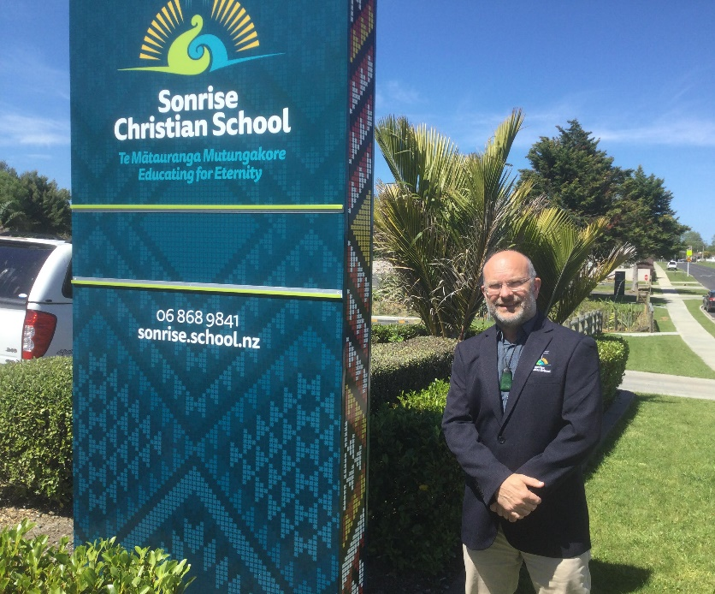
amended throughout the year.

Kia Ora Tātou,

We take pleasure in presenting this information booklet to parents as a guide to Sonrise Christian School.

Please take the time to read the meaning behind our foundational story and school logo.

We focus on a Christ-centered education; fostering learning in a supportive environment where everyone is valued as a person and that each child has the potential to achieve and gain satisfaction from their learning.

A positive partnership between you, as parents and the school, is vital and we invite you to become actively involved in the education of your child/children. We provide opportunities for you to participate in the school programme for the good of all pupils.

We have a very supportive School Board and Proprietors, who give unselfishly of their time and work very hard for the school.

Andrew Russell
Tumuaki (Principal)

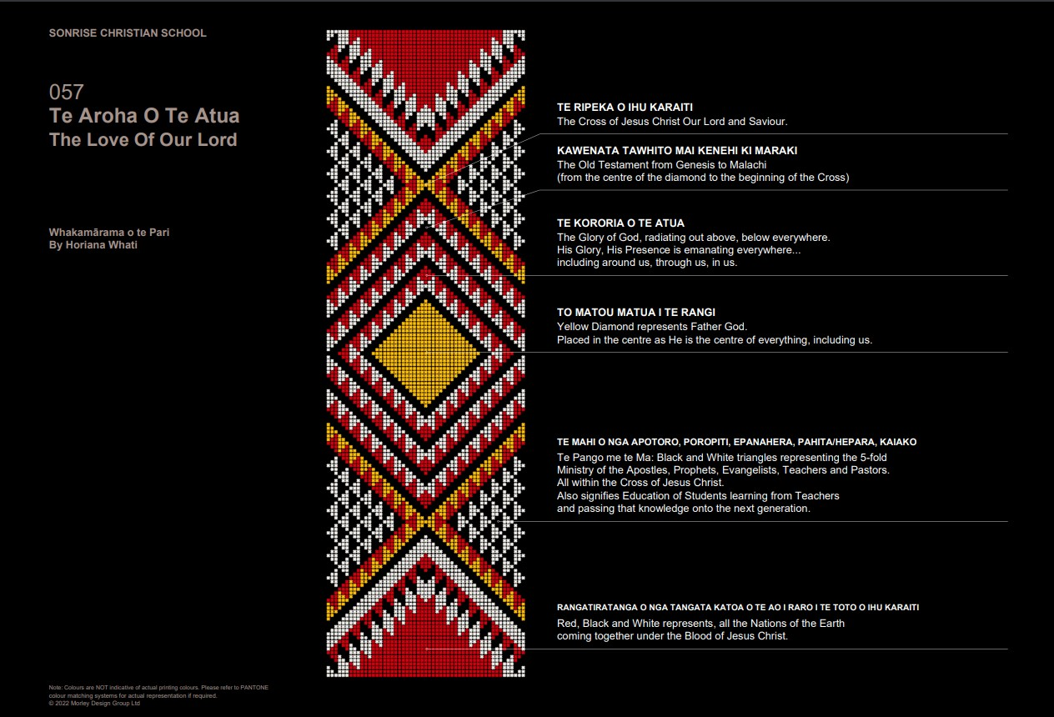

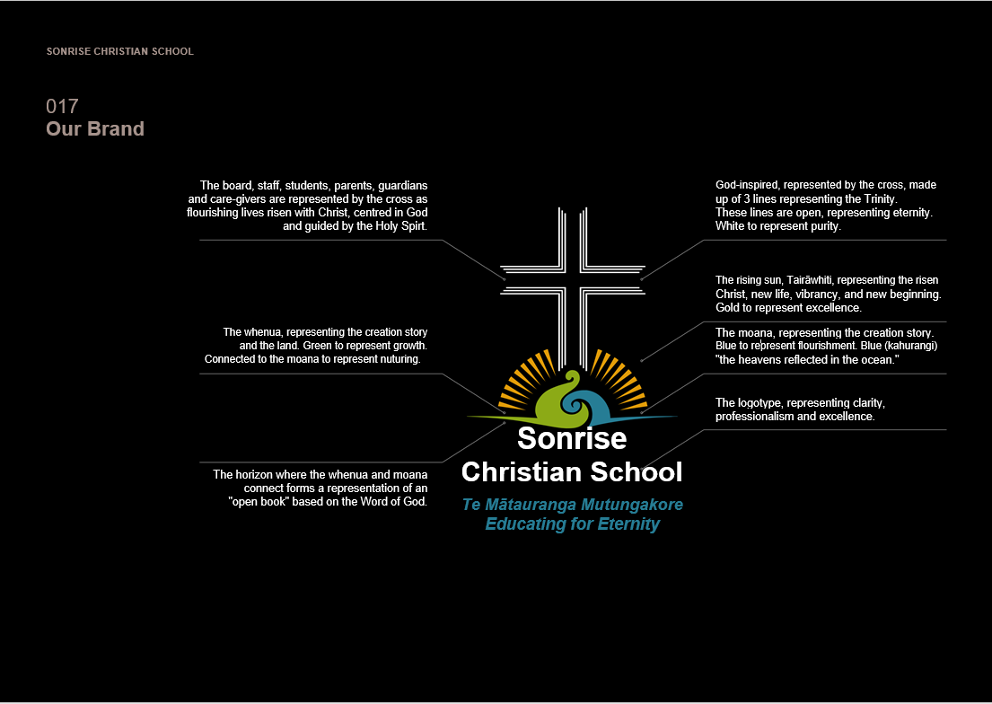

Term Dates 2026

Term 1 Monday 2 Feb to Thursday 2 Apr
Term 2 Monday 20 Apr to Friday 3 Jul
Term 3 Monday 20 Jul to Friday 25 Sep
Term 4 Monday 12 Oct to Friday 11 Dec

Statutory Holidays 2026

Waitangi Day Friday 6 Feb
Good Friday Friday 3 Apr
Easter Monday Monday 6 Apr
Easter Tuesday Tuesday 22 Apr
ANZAC Day Friday 27 Apr
King’s Birthday Monday 1 Jun
Matariki Friday 10 Jul
Labour DAY Monday 26 Oct

School Hours

Classes commence at 8:45am. Children should arrive by 8.30am to sort out their bags etc. The teaching staff meet at 8: 00am in the staffroom for prayer time.

10:15am to 10:35am Morning interval
12:15pm to 1:00pm Lunch interval
2:30pm School ends

Parents are requested to pick up their children no later than 3.00pm. After this time, contact people will be asked to come and get their children.

Staff

Management Team
Andrew Russell | Principal
Shawn Norris | Deputy Principal
Natalie Potini | SENCO
Paku Kingi | EA/Office Manager

Teachers
Raewyn Theobald | Te Rito | New entrant to Year 1
Natalie Potini | Aroha | Year 2-3

Sonja Mienie
Amber Akroyd | Tu Tangata | Year 3-4
Debbie Henare | Te Rongopai | Year 5-6
Bernadette Kapp | Manaakitanga | Year 6-7
Jessica Bergstrom | Mataora | Year 7-8
Ben Sutherland | Hiranga | Year 9-10
Horopapera Karauti | Te Reo Māori/Music

Secondary Teachers

John Drummond

Carmia Fuls
Nicholas Haslam | Careers Advisor

Shawn Norris
Ben Sutherland | Principal Nominee

Lorraine Venter

Support Staff
Office Administration Assistant | Cherrylaine Carroll
Teacher Aides | Sharon Craig
LAT/Teacher Aide/Sport Coordinator  LAT & Teacher Aide | Walton Sadlier  Jacqui Stevens

Proprietors - Gisborne Christian Education Trust
Walton Sadlier | Chairman
Paul White | Treasurer
Deryk Jenson | Member

School Board - Sonrise Christian School
Walton Sadlier |  | Proprietor Representative/PE Committee
Hokinga Wanoa |  | Presiding Member
Andrew Russell |  | Principal
Shawn Norris |  | Staff Representative
Paku Kingi |  | Secretary/Finance & Bicultural Committee
Amy Martin |  | Parent Representative
Luke Akroyd |  | Property/PE Committee
Tracy Clayton |  | Finance
Mahala Reynolds |  | Bicultural Committee
Natasha Oosthuizen |  | Proprietor Representative
Calla Kaa-Broughton |  | Student Representative

Sonrise Christian School Offers
Sonrise Christian School offers a Christ-centred education. We believe that God created the world and reveals Himself in His Word. A true and complete understanding of the world can occur only when God is the centre of the education process. The school aims to help students respond to God the Creator and find their place in His world, serving Him to their best with whatever skill and abilities He has given them.

Sonrise Christian School Philosophy

- Parents have a biblical responsibility for the education of their children.

- Sonrise Christian School aims to assist parents to prepare and guide their children towards maturity. The four main areas of development are spiritual, social, academic, and physical.

- The Bible is recognized as authoritative and infallible. Biblical principles are integrated into all facets of school life.

- Since God is Truth and His creation reveals Him, students are shown that Truth can be known and taught.

- Students are encouraged to know, love, serve and trust the Lord Jesus Christ, to commit their lives to Him and to love others as Christ loves us.

- Because God has made us unique, with individual skills and talents, each child is expected and encouraged to develop to their personal potential.

Enrolment
Because Sonrise Christian School is an integrated school of special character, families of children enrolled at the school must show that they agree with and support the Special Character of the school, and desire Christ centred education for their children, specifically by acknowledging their own Christian faith.
Ministry of Education guidelines require parents of 5-year-olds enrolling at Sonrise Christian School to supply a copy of their child’s Birth Certificate and Immunization Certificate.
All enrolment procedures must be completed and confirmation of acceptance at the school received prior to the student being able to commence at the school.

Emergency Procedures
Sonrise Christian School has a comprehensive emergency plan. In the case of an emergency that requires the school to close during school time, we follow the advice of Civil Defence and ensure the safety of all students and staff. Please take time to read the emergency policy and familiarize yourself with the details.

Smoke/Vape Free Policy
Sonrise Christian School is a designated ‘Smoke/Vape Free Area’. This means that there is no smoking or vaping within the school buildings, the fenced off area and car park.

Policy Documents
Sonrise Christian School Board of Trustees has developed policies covering the governance of the school.
Policies can be accessed here: https://www.sonrise.school.nz/school-information-downloads
username: sonrise password: sonrise.
These are available from the Principal and on our website www.sonrise.school.nz Please feel free to read them.

Absence and Lateness
A ‘check-safe’ scheme operates in the school. If your child is going to be absent or late, please contact the school – phone 868-9841 or text office administration on 027-4319-249 between
8:00am and 8:30am! If your child does not arrive at school and you have not contacted us, we will phone you or your emergency contact. Please immediately advise us of any changes of phone numbers or addresses. In the case of a foreseen absence from school please discuss an exemption with your child’s teacher.

Health, First Aid and Illness at School
In the case of an accident at school, first aid is carried out by the administrator, Paku and in serious cases, parents are notified. Parents will also be contacted if a child becomes ill at school. For this reason, our record for home, work, doctor, and other emergency contact numbers must be current. Please advise the school of any changes.

Allergies, Asthma etc.
The school keeps a record of children who require special and immediate attention in case of an insect sting or illness. If you have a child who falls into this category the school should be notified now so that the necessary safeguards can be taken. Parents must supply the school with the appropriate medication if it is likely to be needed.

Dental Clinic
Children attend the Mobile Dental Clinic. Dental treatment is available for children from the age of two and a half years. Appointments can be made by phoning 027 242 5120.

When children are enrolled at school for the first time, unless otherwise directed, they are placed on the dental clinic register and regular checks of teeth are made. Early enrolment and many visits with parents before school will give children confidence with dental examinations.

Road Safety
Children should be warned against stopping on the way to and from school and talking to strangers. If arrangements made with children about collecting them after school are altered, please contact the school so the children can be informed.

Children must stay behind the barrier until the parents arrive to pick them up.

Pupils Arriving / Departing by Car
The front of the school is considered the main drop-off point for students coming to school by car. We especially encourage our primary school students to come and leave by this entrance. There are many parking spaces around the school roadside, we encourage the older students to make a more regular meeting point with their parents for picking up after school including the use of the car park down by the senior school. We encourage the use of this as a safe area for parents to park after school while waiting for students to finish their school day. Please be aware that smaller children are still learning road safety and our job as parents is to watch out not only for our own children but all the students.

Bicycles/Scooters
All the roads leading to school are very busy and hazardous to cyclists. It is our recommendation that pupils younger than 11 years do not ride bicycles to school unsupervised, but the responsibility to allow a child to cycle is yours as a parent. Helmets must be worn.

Sports
Sport is a popular pastime and entertainment here in Aotearoa and at Sonrise Christian School it is no exception. We value fair play but also desire to win.
Our children have many varied talents and skills, and it is important for us to provide every opportunity possible for them to be involved in whatever sport they have a passion for as well as give them a chance to try something new.
Whatever we cannot provide here at school we help to make connections to those that can through our effective networks with other schools, School Partnership Coordinators for Primary and Intermediate levels and Regional Sports Directors for Secondary Schools.
Swimming
During the 1st and 4th terms children swim at the Enterprise Pool. Swimming is a compulsory component of the curriculum. The pool is heated and under cover, so it is not dependent on the weather. Please ensure that all clothing is named. Parent helpers are needed. Let the class teacher know if you’re available to help with swimming.

Physical Education
PE is a compulsory component of Sonrise Christian School’s curriculum. If your child is unable to participate, a signed permission slip from parents is required. If the condition is ongoing, a medical certificate is required.

Field Trips
Students take part in field trips that complement classroom studies. A permission slip will be sent out at the start of the school year to cover local school trips.

Lost Property
Lost property is stored in individual classrooms. Please name all belongings. We ask children to leave expensive and treasured items at home. While we do everything possible to locate lost items, we cannot be responsible for lost property.

Money
If children bring money to school, they should bring it in an envelope labeled with their name, the amount and purpose and hand it to their teacher when they arrive. The school has no place for the safekeeping of large amounts of money and can take no responsibility.

Lunches
We are part of the Ka Ora Healthy Lunches Programme provided by the government. Lollies, fizzy drinks, chewing gum are not permitted. Parents and pupils are reminded that there will be no opportunity for lunches to be purchased during the school day. Pupils will NOT be allowed offsite during school hours. Any purchases that need to be made will need to be made on the way to school. The exception to this rule is for Year 12-13 students with signed permission.

Specialist Education Services/Resource Teachers/Learning and Behaviour
These services may be called on by the school or parents to assess and advise on children with special needs in learning and behaviour. Please contact the school first as a joint approach to G.S.E.; is more likely to gain priority.

Parent Help
A much-appreciated aspect of the school day is the help parents can give teachers in various ways. This can take the form of regular help in the classroom with a wide range of non-teaching tasks and is not confined to the Junior Class. Parents can also help when classes go on education visits away from school, also with expertise in sport, hobbies, and craftwork. If you are interested do not hesitate to offer.

Homework
At Sonrise Christian School homework is set to allow children to practise and consolidate skills learnt at school.

Purposes
- The expectation is that homework is given throughout the school.
- Homework should support what is being done at school and should not be an academic exercise for parents.
- The level of homework should be appropriate for the child’s abilities.

Reports on Children’s Progress
Parents are invited to discuss your child’s progress with the class teacher – please make an appointment. Written reports are issued at the end of the second and fourth term and more formal parent teacher interviews are available at those times.

Communication Diaries
To aid communication, younger students will have a communication diary for daily messages between teachers and parents. Please make sure you read these and add any comments you wish to make. This diary is a useful method of communicating any concerns to your child’s teacher, seeking an appointment time to meet with the teacher or letting the teacher know of any family events that may affect your child’s learning at school.

Newsletters
Newsletters are sent home every second week, one per family.

FACEBOOK
The school has a FACEBOOK page to keep you up to date with current notices/events. We encourage all families to join this. Parents can join their children’s class pages. Talk to your child’s teacher about these. We also encourage you to join these pages. Contact the office and we will help you.

- SCS: Parent Prayer Partners
- Sonrise Christian School Uniform Exchange
- Sonrise School Fundraising Page
Attendance Dues
Sonrise Christian School is a state integrated school of Special Character. This means that the government funds the day-to-day operational costs of running the school but not the provision of land and buildings. The land and buildings are owned and administered by the proprietors of the school, the Gisborne Christian Education Trust. To fund the original purchase of the land and all the capital works involved with the school, the proprietors charge attendance dues, which are set in conjunction with the Ministry of Education. Attendance dues are compulsory and are payable to the Proprietors by all students attending Sonrise Christian School.
Attendance dues are set at $1,664 (including GST) per year per pupil, capped at $5,720 (including GST) for families of four or more pupils attending the school.
Attendance dues are charged at the beginning of each term and are due in advance. However, to make payment of the dues more achievable for families, payments may be made by regular automatic payment on a weekly, fortnightly, or monthly basis as per the following schedule.
Account Details Gisborne Christian Education Trust
Account No 06 0637 0178869 00
Ref (enter your child/s name)
Annual Payment | $1,664.00 | 1 Payment | Due in advance
Per Term Payment | $416.00 | 4 Payments | Due in advance
Monthly Payment | $138.67 | 12 Payments | Due monthly
Fortnightly Payment | $64.00 | 26 Payments | Due fortnightly
Weekly Payment | $32.00 | 52 Payments | Due weekly
Please note that if a regular payment plan is chosen, the payments need to start from the beginning of the calendar year and continue through holiday time.
In cases of hardship, an approach can be made to the Proprietors, who may reduce or waive the fee if necessary. This is done in the strictest confidence.
Please contact Paul White or email pbw@gisborne.net.nz for any queries.

Alternative Financial Support (options to explore)

Alternatives | Contact Details
Family Support
Scholarship/ Grants | Consider whether student may be eligible for education scholarship or grant through community, iwi or similar channels. i.e.  https://maorieducation.org.nz/  http://www.ngatiporou.com/nati-biz/our-community-services/education  http://www.mangatu.co.nz/news-and-events/  https://www.careers.govt.nz/courses/scholarships-grants-and-awards/scholarships-grants-and-awards-for-maori-students/  http://www.sunrisefoundation.org.nz/grants/  http://tindall.org.nz/apply-3/other-funding-resources/
Church | Education grants or Koha may be available, speak with your Church Leader, Pastor or Elder
Budget Services | Gisborne Budget Advisory Services, 43 Cobden St, Gisborne. Phone (06) 867 7173
Budget Services | CAP Debt & Budgeting Centre, Mangapapa Church, Gisborne. Phone 0508 227 111
Government Agencies | Working for Families https://www.workingforfamilies.govt.nz/  Work and Income https://www.workandincome.govt.nz/eligibility/children/index.html

Textbooks, Class Materials
Students are provided with all necessary textbooks. These books remain the property of the school and are issued on the understanding that they will be cared for and that any loss or damage will be paid for.

Stationery
Stationery lists will be provided at the end of each year. Each student is expected to have the necessary stationery needed for class. Stationery lists will be sent home with the end of year school reports.

Digital Devices
Chromebooks are supplied to all students from year 3 up. An ICT User Agreement is signed by all students and all online work is protected by the school monitoring systems.

Care of Property
All clothing, bags, lunchboxes etc. brought to school should be clearly named. Children are discouraged from bringing personal items not required for school activities to school. Children are encouraged to develop personal responsibility for their own gear and good stewardship of equipment at school. Children are expected to take good care of all property at the school and restitution is expected for any equipment willfully or carelessly damaged.

Uniform Policy
The following principles are used when considering the dress and appearance of children at Sonrise Christian School.
- Safety
- Practicality
- Cleanliness and tidiness
- Modesty

Uniforms help to standardise and simplify decision, providing a sense of unity, school pride, identity, and identification to others.

The Principal and teachers have been instructed to ensure the correct uniform is worn.

Uniform Rules
- School uniform must be worn.
- Jewellery - no more than one stud or sleeper in each ear. A wristwatch is permitted. No other jewellery to be worn except if a piece is culturally significant and provided it is consistent with the culture of the school. This includes birth bracelets, Maori pendants, and crosses.
- Hair can be worn long in either sex but must be neat, clean, and tied back off the face. Extravagant or unusual hairstyles such as Mohawks, outrageously dyed hair is not permitted.
- No make-up, false nails or nail polish will be worn with the uniform.
- Black school shoes or black school sandals are to be worn.
- Regulation hats must be worn outside during the summer terms.

Footwear
- Black sandals
- Black shoes

Other
- Socks – navy or black
- Stockings – black (senior girls)
- Hats – navy or black (bucket hats)
  - Available from The Warehouse or Postie Plus

Sonrise Christian School Uniform – (ALL purchases are through the school)

Item Description | Price
Uniform – Kids/Junior Sizes
Primary (Year1-6)
Navy/Gold Kids hoodie | $63.25
Navy/Gold Adult polo shirt | $44.85
Navy/Gold Adult hoodie | $66.00
Razor Navy/Gold Kids polo shirt | $44.85
CCC Navy Kids track pants | $65.00
CCC Navy Kids tactic shorts | $32.25
Navy/White Kids hoodie | $63.25
Balance Navy/White Ladies/polo shirt | $44.85
Balance Navy/White Men’s/polo shirt | $44.85
Navy Kids soft shell jacket | $102.35
Uniform - Adult Sizes
Intermediate & Junior Secondary (Year 7-10)
Balance Navy/White Ladies & Men’s polo shirt | $44.85
Navy/White Adult polo shirt | $44.85
Navy/White Adult hoodie | $63.25
CCC Navy Adult track pants | $79.00
CCC Navy Adult tactic shorts | $35.70
Navy Adult soft shell jacket | $109.00
Uniform - Adult Sizes
Senior Secondary (Year 11-13)
Navy Skirt (Sizes 4-24) | $52.00
Navy Tie Plain | $15.00
Navy Adult soft shell jacket | $103.50
Navy High School Short (Sizes 72-132) | $52.00
Black School Trouser (Sizes 72-127) | $57.00
Men’s Preston Long Sleeve Shirt Blue (Sizes S-5XL) | $71.00
Men’s Yarra Polos Sky/Navy (Sizes S-5XL) | $44.85
Ladies Preston ¾ Sleeve Shirt Blue (Sizes 6-22) | $71.00
Ladies Yarra Polos Sky/Navy (Sizes 6-26) | $44.85
Men’s Polyester Navy 2 Button Blazer (Sizes XS-6XL) | $159.00

Te Whare Te Rito (New entrant – Year 1)

5 Glue Sticks (AMOS or BIC)
3 ALWB4 exercise books (ruled lower half with blank top half for picture – handwriting)
2 Te Reo Matatini (tahi one) exercise books (Writing/Literacy)
3 3B1 notebooks (Homework)
7 Scrapbooks or project books white pages only please (Clever Kiwi Company)
Journal Bag or homework folder
Ringbinder with some plastic pockets
Pencil case (optional)

Te Whare Aroha (Year 2-3)
5 Glue Sticks (AMOS or BIC)
2 1F8 exercise books (Writing)
1 3B1 notebooks (Homework)
2 LWB5 exercise books
1 H5 Maths book (Maths)
7 Scrapbooks or project books white pages only please (Clever Kiwi Company)
Journal Bag or homework folder
Ringbinder with some plastic pockets

Tu Tangata for (Year 3-4)

2 Glue Sticks (AMOS or BIC)
1 3B1 notebooks (Homework)
1 H5 exercise book
1 Clear file book 20 leaf (RED) – year 3 ONLY
1 Clear file book 40 leaf
1 HB Pencils (5 pack)
1 HB Pencil Eraser Loose Black
2 Whiteboard Marker (Blue)
1 My topic Book 3 unruled and 9mm ruled 64 pages
Journal Bag or homework folder
Ringbinder with some plastic pockets
Pencil case (optional)

Te Whare Rongopai (Year 5-6)

1 Ream A4 paper
6 1B8 books
1 1E8 maths books
1 Everyday activity book (unruled - BLUE)
1 Everyday activity book (ruled – BLUE)
4 blue pens
2 red pens
4 HB mechanical pencils
1 6B pencil (art)
1 eraser
1 Yellow highlighter
1 pencil sharpener
1 ruler
2 glue sticks (Amos)
1 black vivid
1 set coloured pencils (optional)
1 set felts (optional)

Te Whare Manaakitanga (Year 6-7)

5 1B5 exercise books
2 1B8 exercise book
2 1E5 exercise book
1 3B1 notebook
Colouring pencils (Crayola or Faber Castell)
4 HB pencils (Staedler)
5 blue ballpoint pens (Bic are still the best)
3 red ballpoint pens
Pencil case
1 Ruler
2 Erasers
Pencil sharpener
Mathematical Drawing Set
2 Large glue stick
Felt Pens (optional)
1 Yellow highlighter
2 Whiteboard markers (Stephens are the best)
1 Clear file folder with 60 pockets

Note:
Students can put unused stationery into personal zip lock bags to use when required later in the year.

Te Whare Mataora (Year 7-8)

5 1B5 exercise books
1 1B8 exercise book
2 1E5 exercise book
1 3B1 notebook
1 Scrapbooks or project books white pages only please
Colouring pencils (Crayola or Faber Castell)
4 HB pencils (Staedler)
5 blue ballpoint pens (Bic are still the best)
3 red ballpoint pens
Pencil case
1 Ruler
2 Erasers
Pencil sharpener
1 Scissors
1 Headphones
Mathematical Drawing Set
2 large glue stick
Felt Pens (optional)
1 Yellow highlighter
2 Whiteboard markers (Stephens are the best)
1 Clear file folder with 60 pockets

Note:
Students can put unused stationery into personal zip lock bags to use when required later in the year.

Te Whare Hiranga (Year 9/10)

1 Ream of A4 Paper
5 1B8 exercise books (I require one of these)
2 large glue sticks
1 Pack of 4 colour whiteboard markers
2 1E8 exercise books
1 1E5 exercise book
1 A4 Visual Diary (cartridge paper)
1 Set colouring pencils (Crayola or Faber Castell)
1 Set felt Pens
2 HB pencils (Staedler)
5 Blue ballpoint pens
5 Black ballpoint pens
1 Red ballpoint pens
1 Very fine black permanent marker (for outlining)
1 Ruler
2 Erasers
1 Pencil sharpener
1 Mathematical Drawing Set
1 Highlighter set (4 colours)
1 Clear file folder with 60 pockets and preferably an insert cover
1 Scientific calculator - Casio FX-82

Te Whare Pono (Year 11)

1 Ream of A4 paper
2 1B8 exercise books
2 2B5 lecture books
1 1E5 exercise book
2 Refill
1 Large glue sticks
3 1E8 exercise books
2 Ring Binder – Lever Arch
1 Set of dividers (10)
1 20-page clear plastic folder
1 Set colouring pencils (Crayola or Faber Castell)
1 Set felt Pens
2 HB pencils (Staedler)
5 Blue ballpoint pens
5 Black ballpoint pens
1 Red ballpoint pens
1 Very fine black permanent marker (for outlining)
1 Ruler (30cm)
2 Erasers
1 Pencil sharpener
1 Highlighter set (4 colours)

Te Ara O Poutama (Year 12/13)

1 Ream of A4 paper
1 Ring Binder – Lever Arch
1 Set of dividers (10)
1 Large glue sticks
2 1B8 exercise books
2 1E8 exercise books
1 1E5 exercise book
1 Refill paper
1 20-page clear plastic folder
1 A4 Visual Diary (cartridge paper)
1 Set felt Pens
5 Blue ballpoint pens
5 Black ballpoint pens
1 Red ballpoint pens
5 2B pencils
2 HB pencils (Staedler)
1 Very fine tip black permanent marker (for outlining)
1 Ruler (30cm)
1 Paper scissors
1 Eraser
1 Pencil sharpener
1 Highlighter set (four colours)
1 Scientific calculator - Casio FX-9860 (all students need this calculator)

School Lunch Collective Programme

The School Lunch Collective will be delivering school lunches for the new model of Ka Ora, Ka Ako Healthy School Lunches Programme.
The name Ka Ora, Ka Ako means to be healthy and well in order to learn. The programme supports the hauora (wellbeing) of tamariki and rangatahi including their physical, mental, emotional, and educational development.
An important value of Ka Ora, Ka Ako is that all tamariki and rangatahi are provided with a lunch. This promotes a sense of belonging and inclusion as tamariki and rangatahi share kai together. If they want to bring snacks from home, we encourage them to bring snacks that fuel their bodies and minds to support the kaupapa (values) of the programme.
We are thrilled to be part of this programme that our tamariki and rangatahi, whānau and community benefit from!
Lunches will be bought in Mon, Tues, Wed, Thurs, and Fri, for all students enrolled at Sonrise Christian School in 2026.

Behaviour and Expectations

Sonrise students are expected to:

Obey the school rules at all times.

Show respect in speech and behaviour to all students, staff, and adults.

Respect school property and the property of others.

Play co-operatively and harmoniously.

Not use bad language, hit, or tease others.

Get permission before leaving the school grounds.

Sit quietly and practise proper eating manners during lunchtime.

Not take things which do not belong to them.

Complete assignments and homework to the best of their ability and hand it in on time.

Go to class prepared – proper stationery, uniform, footwear, PE, and swimming togs.

Live our School LIFE Values – Love, Integrity, Faithfulness and Excellence.

Behaviour in the Plan Year 1-6

The following are non-negotiable.

Non-negotiables:
- Deliberately and intentionally physically hurting others.
- Swearing at anybody.
- Back-chatting to adults.
- Disobeying the adults.
- Showing inappropriate signs e.g., showing the finger, etc.

Procedures to be followed when breaking the Non-negotiable:
- Remove person from situation.
- An incident report will be filled in by the duty teacher. 3 copies will be made i.e., 1 copy will be given to parent (to be signed and returned the next day; parents may request an interview.
1 copy will be given to class Teacher.
1 copy will be given to the Deputy Principal

Consequences for breaking a non-negotiable:
- Removal of student from playground.
- Play area will be restricted e.g., only allowed to play in a specific space.
- Targeted play (closely monitored by duty teachers).
- Follow duty teacher around.
- Restore e.g. a letter of apology.

- Repeated offences (3 per term):
- Parent interview.
- Referral to outside agencies e.g., RTLB, CAMHS.
- Individual Behaviour Plan with the support of RTLB.
- In-school suspension.

Behaviour in the Plan Year 7-13

Behaviour and expectations as for Years 1-6 but a copy of the secondary behaviour management plan can be viewed/asked for at the school office.

